3GPP TSG SA4 WG # 114-e S4-210774

Electronic Meeting, 19th-28th May, 2021
CR-Form-v12.0
PSEUDO CHANGE REQUEST
 | TR 26.803 | CR | – | rev | 3 | Current version: | 1.2.0
For HELP on using this form: comprehensive instructions can be found at
http://www.3gpp.org/Change-Requests.

Proposed change affects: | UICC apps |  | ME |  | Radio Access Network |  | Core Network | X

Title: | General Call flow for EAS relocation based on the EMSA architecture
Source to WG: | Huawei Technologies Co. Ltd
Source to TSG: | S4
Work item code: | FS_EMSA |  |  |  |  |  | Date: |  |  | 2021-5-10
Category: | B |  |  |  |  |  | Release: |  |  | Rel-17
Use one of the following categories:
F (correction)
A (mirror corresponding to a change in an earlier release)
B (addition of feature),
C (functional modification of feature)
D (editorial modification).
Reason for change: |  | The general call flow for the EAS relocation based on the EMSA architecture is missing.
Summary of change: |  | Add the EAS relocation analysis and generic call flows.
Consequences if not approved:
Clauses affected: |  | 4.2，6.X
 |  | Y | N
Other specs |  |  | X | Other core specifications
affected: |  |  | X | Test specifications
(show related CRs) |  |  | X | O&M Specifications
Other comments:
This CR's revision history:

FIRST CHANGE

2 References
(SNIPPED)
[xx] 3GPP TS 23.502: "Procedures for the 5G System (5GS)".
(SNIPPED)
NEXT CHANGE

4.2 SA6 Edge Architecture

4.2.1 Edge computing architecture
SA6 has taken significant steps towards the definition of normative edge computing architecture for 5GC in TS 23.558 [3]. Starting from common scenarios, described in the Annex, a set of requirements is defined, and the following architecture is proposed:
Figure 1 SA6 Edge data network architecture
The architecture defines the key nodes and functions as well as the interfaces between them.
The identified functions with a brief description are given here:
- Edge Enabler Server (EES): provides supporting functions needed for Edge Application Servers and Edge Enabler Client.
- Edge Enabler Client (EEC): provides supporting functions needed for Application Client(s).
- Edge Configuration Server (ECS): provides supporting functions needed for the Edge Enabler Client to connect with an Edge Enabler Server.
- Edge Application Server (EAS): the application server resident in the Edge Data Network, performing the server functions. The Application Client connects to the Edge Application Server in order to avail the services of the application with the benefits of Edge Computing.
- Application Client (AC): application resident in the UE performing the client function. Details of the Application Client are out of scope of this specification.
A typical sequence of steps to use edge computing services is as follows:
1. Service Provisioning:
- The EEC is provisioned with a list of EES instances, e.g. from the ECS.
2. Registration:
- EESs register with the ECS to publish their edge configuration capabilities.
- The EEC registers with a selected EES for further EAS discovery and Edge Computing Service usage.
- EAS instances register with EES instances to publish their edge capabilities.
3. EAS discovery:
- The EEC queries the EES to discover specific EASs. Different types of filtering information contained in the EAS discovery filters can be used during this discovery phase in the EAS discovery request.
- The EES identifies the appropriate EAS instance(s) according to the UE-specific service information and the UE location.
- Via the EAS discovery response, the EEC receives the discovered EAS instance(s) with the corresponding EAS profile which may include additional information regarding matched capabilities, e.g. service permission levels, service area, KPIs.
- The detailed information for key messages and elements of the EAS discovery procedures is shown as below in Tables 1, 2, 3, 4 and 5.
Table 1: EAS discovery request
Information element | Status | Description
Requestor identifier | M | The ID of the requestor (e.g. EECID)
UE Identifier | O | The identifier of the UE (i.e. GPSI or identity token)
Security credentials | M | Security credentials resulting from a successful authorization for the edge computing service.
EAS discovery filters | O | Set of characteristics to determine required EASs, as detailed in Table Y.

Table 2: EAS discovery filters
Information element | Status | Description
List of AC characteristics (NOTE 1) | O | Describes the ACs for which a matching EAS is needed.
> AC profile (NOTE 2) | M | AC profile containing parameters used to determine matching EAS. AC profiles are further described in Table 8.2.2-1 of TS 23.558 [3].
List of EAS characteristics (NOTE 1, NOTE 3) | O | Describes the characteristic of required EASs.
> EASID | O | Identifier of the required EAS.
> EAS provider identifier | O | Identifier of the required EAS provider
> EAS type | O | The category or type of required EAS (e.g. V2X)
> EAS schedule | O | Required availability schedule of the EAS (e.g. time windows)
> EAS Geographical Service Area | O | Location(s) (e.g. geographical area, route) where the EAS service should be available.
> EAS Topological Service Area | O | Topological area (e.g. cell ID, TAI) for which the EAS service should be available. See possible formats in Table 8.2.7-1 of TS 23.558 [3].
> Service continuity support | O | Indicates if the service continuity support is required or not.
> EAS status | O | Required status of the EAS (e.g. enabled, disabled, etc.)
> Service permission level | O | Required level of service permissions e.g. trial, gold-class
> Service feature(s) | O | Required service features e.g. single vs. multi-player gaming service
NOTE 1: Only one of the information elements shall be present.
NOTE 2: "Preferred ECSP list" IE shall not be present.
NOTE 3: The "List of EAS characteristics" IE must include at least one optional IE, if used as an EAS discovery filter.

Table 3: EAS discovery response
Information element | Status | Description
Successful response | O | Indicates that the EAS discovery request was successful.
> Discovered EAS list | O | List of discovered EAS(s). Each element includes the information described below.
>> EAS profile | M | Profile of the EAS. Each element is described in Table XX.
>> Lifetime | O | Time interval or duration during which the information elements in the EAS profile is valid and supposed to be cached in the EEC (e.g. time-to-live value for an EAS Endpoint)
Failure response | O | Indicates that the EAS discovery request failed.
> Cause | O | Indicates the cause of EAS discovery request failure.

Table 4: EAS Profile
Information element | Status | Description
EASID | M | The identifier of the EAS
EAS Endpoint | M | Endpoint information (e.g. URI, FQDN, IP address) used to communicate with the EAS. This information maybe discovered by EEC and exposed to ACs so that ACs can establish contact with the EAS.
ACID(s) | O | Identifies the AC(s) that can be served by the EAS
EAS Provider Identifier | O | The identifier of the EAS Provider
EAS Type | O | The category or type of EAS (e.g. V2X)
EAS description | O | Human-readable description of the EAS
EAS Schedule | O | The availability schedule of the EAS (e.g. time windows)
EAS Geographical Service Area | O | The geographical service area that the EAS serves. ACs in UEs that are located outside that area shall not be served.
EAS Topological Service Area | O | The topological service area that the EAS serves. ACs in UEs that are located outside that area shall not be served. See possible formats in Table 8.2.7-1 of TS 23.558 [3].
EAS Service KPIs | O | Service characteristics provided by EAS, detailed in Table YY
EAS service permission level | O | Level of service permissions e.g. trial, gold-class supported by the EAS
EAS Feature(s) | O | Service features e.g. single vs. multi-player gaming service supported by the EAS
Service continuity support | O | Indicates if the EAS supports service continuity or not. This IE may also indicate whether the EAS supports ACT.
List of EAS DNAI(s) | O | DNAI(s) associated with the EAS. This IE is used as Potential Locations of Applications in clause 5.6.7 of 3GPP TS 23.501 [2].  It is a subset of the DNAI(s) associated with the EDN where the EAS resides.
List of N6 Traffic Routing requirements | O | The N6 traffic routing information and/or routing profile ID corresponding to each EAS DNAI.
EAS Availability Reporting Period | O | The availability reporting period (i.e. heartbeat period) that indicates to the EES how often it needs to check the EAS's availability after a successful registration.
EAS Required Service APIs | O | A list of the Service APIs that are required by the EAS
EAS Status | O | The status of the EAS (e.g. enabled, disabled, etc.)

Table 5: Edge Application Server Service KPIs
Information element | Status | Description
Maximum Request rate | O | Maximum request rate from the Application Client supported by the server.
Maximum Response time | O | The maximum response time advertised for the Application Client's service requests.
Availability | O | Advertised percentage of time the server is available for the Application Client's use.
Available Compute | O | The maximum compute resource available for the Application Client.
Available Graphical Compute | O | The maximum graphical compute resource available for the Application Client.
Available Memory | O | The maximum memory resource available for the Application Client.
Available Storage | O | The maximum storage resource available for the Application Client.
Connection Bandwidth | O | The connection bandwidth in Kbit/s advertised for the Application Client's use.

4. EAS relocation:
Under certain circumstances, it is necessary to relocate an EAS instance to a different edge location. In such cases, it may also be necessary to relocate the application context currently associated with the EAS instance in order to support service continuity.
The EAS relocation procedure may be triggered for any of the following reasons:
- UE mobility, including predictive or expected UE mobility.
- Overload situations in the EAS instance or in the Edge DN.
- Maintenance aspects, such as graceful shutdown of an EAS instance.
- Temporal edge resource requirements, for example the application needs an EAS instance with a new capability not available in the current one.
Three roles are defined in the context of EAS relocation:
- The detection entity role can be potentially performed by the Application Client (AC), the Edge Enabler Client (EEC), an Edge Enabler Server (EES) and/or an Edge Application Server (EAS).
- A decision-making entity determines that application context relocation is required and instructs the execution entity to perform application context transfer.
- An execution entity performs application context relocation as and when instructed by the decision-making entity.
After successful application context relocation, the EES is informed of the completion by the EAS and the EEC is informed of the completion by the EES.

4.2.2 High-level call flows for EAS relocation scenarios
A complete set of call flows for the EAS relocation scenarios described in TS 23.558 [3] is depicted in figure 4.2.2-1 below.
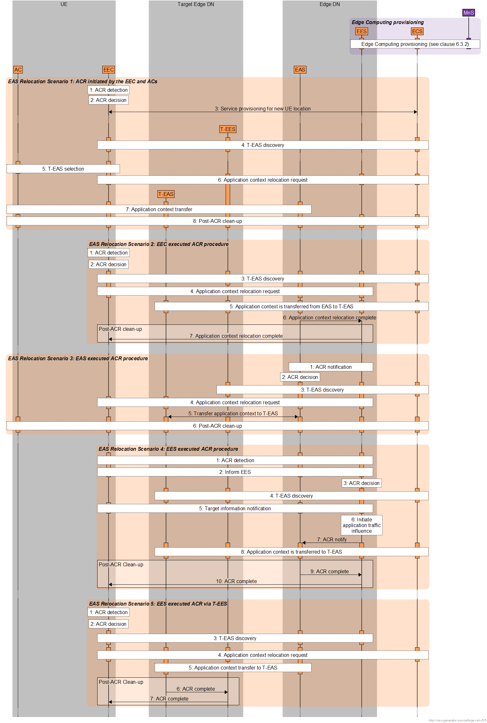
Figure 4.2.2-1: Call flows in EAS relocation scenarios defined in SA6
NEXT CHANGE

6.4 EAS relocation call flows

6.4.1 Introduction
A representative selection of the EAS relocation scenarios summarised in figure 4.2.2-1 may be further elaborated in the context of 5G Media Streaming, as detailed in the following clauses.

6.4.2 Scenario 1: EAS relocation decided by EEC
For the typical EAS relocation Scenario 1, a UE moves to a new location which is outside the service area of the serving EAS. The EEC in this scenario realizes that its location has changed and decides to initiate the EAS relocation procedure to a more appropriate target EAS instance, including the detection, decision and execution roles.
The detailed call flow in this scenario can be briefly detailed as shown in figure 6.4.2-1 below:
Figure 6.4.2-1: Detailed call flow breakdown for EAS relocation Scenario 1
It is assumed that Edge Computing resources to support 5G Media Streaming have already been provisioned, as described in clause 6.3.2.
It is assumed that 5G Media Streaming features have already been provisioned, as described in clause 6.3.2.
The detailed breakdown of steps for this scenario is:
1. The EEC detects UE mobility to a new location outside the service area of the current EAS which may need an application context transfer.
2. The EEC determines that EAS relocation is needed.
3. The EEC initiates a Service Provisioning request (including details of the application and the new UE location) with the ECS.
4. The ECS derives a list of Target EES instances that are relevant to the application indicated in the previous step and the new UE location.
5. The ECS returns a Service Provisioning response to the EEC with a list of candidate provisioned Target EES instances.
NOTE: Whether the ECS returns one or more Target EES instances is implementation-dependent.
6. The EEC performs EAS discovery by querying the Target EES instance.
NOTE: How the AC and/or EEC select the Target EES instance from multiple candidates is implementation-dependent.
7. The Target EES checks whether the EEC is authorized to discover the requested EAS class and compiles a list of suitable candidate Target EAS instance(s) via the EAS discovery filter mechanism and/or based on the UE location.
8. The EEC receives the EAS discovery response with one or multiple suitable candidate Target EAS instance(s).
9. If multiple candidate Target EAS instances were received in the EAS discovery response, the AC and/or EEC select one.
NOTE: How the AC and/or EEC select the Target EAS instance from multiple candidates is implementation-dependent.
10. The EEC may send an Application Context Relocation request to the Source EES with an ACR action included, e.g. influence application traffic between the UE and the chosen Target EAS.
11. The EES applies the AF traffic influence using the N6 routing information of the target EAS instance in the 3GPP CN as described in clause 4.3.6 of TS 23.502 [xx].
12. The Source EES responds to the EEC’s request with an Application Context Relocation response message.
13. The AC is triggered by the EEC to start the application context transfer from the Source EAS instance to the Target EAS instance.
NOTE: Whether and how the AC initiates the application context transfer is outside the scope of TS 23.558 [3].
14. All required entities perform clean-up.

6.5 Identified Gaps in Architecture and Procedures

6.5.1 General
(SNIPPED)

6.5.2 Justification of Identified Gaps

6.5.2.1 Gaps in client-driven edge discovery
(SNIPPED)

6.5.2.2 Gaps in AP-driven management of 5GMS edge processing
(SNIPPED)
End of CHANGE

