3GPP TR 26.804 V0.1.1 (2021-02)
Technical Report

3rd Generation Partnership Project;
Technical Specification Group Services and System Aspects;
Study on 5G media streaming extensions
(Release 17)
The present document has been developed within the 3rd Generation Partnership Project (3GPP TM) and may be further elaborated for the purposes of 3GPP.
The present document has not been subject to any approval process by the 3GPP Organizational Partners and shall not be implemented.
This Specification is provided for future development work within 3GPP only. The Organizational Partners accept no liability for any use of this Specification.
Specifications and Reports for implementation of the 3GPP TM system should be obtained via the 3GPP Organizational Partners' Publications Offices.

3GPP
Postal address

3GPP support office address
650 Route des Lucioles - Sophia Antipolis
Valbonne - FRANCE
Tel.: +33 4 92 94 42 00 Fax: +33 4 93 65 47 16
Internet
http://www.3gpp.org

Copyright Notification
No part may be reproduced except as authorized by written permission.
The copyright and the foregoing restriction extend to reproduction in all media.

© 2021, 3GPP Organizational Partners (ARIB, ATIS, CCSA, ETSI, TSDSI, TTA, TTC).
All rights reserved.

UMTS™ is a Trade Mark of ETSI registered for the benefit of its members
3GPP™ is a Trade Mark of ETSI registered for the benefit of its Members and of the 3GPP Organizational Partners
LTE™ is a Trade Mark of ETSI registered for the benefit of its Members and of the 3GPP Organizational Partners
GSM® and the GSM logo are registered and owned by the GSM Association

Contents
Foreword 5
1 Scope 7
2 References 7
3 Definitions of terms, symbols and abbreviations 9
3.1 Terms 9
3.2 Symbols 9
3.3 Abbreviations 9
5 Key Topics 9
5.1 Introduction 9
5.2 Content Preparation 9
5.2.1 Overview 9
5.2.2 Gap Analysis of 26.512 10
5.2.3 Use-cases 11
5.2.3.1 Basic CMAF/DASH/HLS multi-rate live streaming of user-generated content 11
5.2.4 Collaboration Scenarios 12
5.2.4.1 Content preparation before downlink streaming 12
5.2.4.2 Content preparation after uplink ingest streaming 13
5.2.4.3 Content preparation between uplink ingest and downlink streaming 14
5.2.5 Deployment Architectures 14
5.2.6 Mapping to 5G Media Streaming and High-Level Call Flows 15
5.2.7 Potential open issues 15
5.2.8 Candidate Solutions 15
5.3 Traffic Identification 15
5.4 Additional/new transport protocols 15
5.4.1 Description 15
5.4.2 Collaboration Scenarios 16
5.4.3 Deployment Architectures 16
5.4.4 Mapping to 5G Media Streaming and High-Level Call Flows 16
5.4.5 Potential open issues 16
5.4.6 Candidate Solutions 16
5.5 Uplink media streaming 17
5.5.1 Description 17
5.5.1.1 Overview 17
5.5.1.2 Gap analysis between TS 26.501 and TS 26.512 (5G Media Streaming) 17
5.5.1.3 Gap analysis between TS 26.238 (FLUS) and TS 26.512 (5G Media Streaming) 18
5.5.2 Collaboration Scenarios 18
5.5.2.1 Overview 18
5.5.2.2 Collaboration Scenario 1 18
5.5.2.3 Collaboration Scenario 2 19
5.5.2.4 Collaboration Scenario 3 19
5.5.2.5 Collaboration Scenario 4 20
5.5.2.6 Collaboration Scenario 5 20
5.5.2.7 Collaboration Scenario 6 21
5.5.3 Deployment Architectures 21
5.5.4 Mapping to 5G Media Streaming and High-Level Call Flows 21
5.5.5 Potential open issues 21
5.5.6 Candidate Solutions 21
5.6 Background traffic 22
5.6.1 Description 22
5.6.2 Collaboration Scenarios 22
5.6.3 Deployment Architectures 22
5.6.4 Mapping to 5G Media Streaming and High-Level Call Flows 23
5.6.5 Potential open issues 23
5.6.6 Candidate Solutions 23
5.7 Content-Aware Streaming 24
5.7.1 Description 24
5.7.2 Collaboration Scenarios 26
5.7.3 Deployment Architectures 27
5.7.4 Mapping to 5G Media Streaming and High-Level Call Flows 27
5.7.5 Potential open issues 27
5.7.6 Candidate Solutions 28
5.8 Network Event usage 28
5.8.1 Description 28
5.8.1.1 Events exposed by 5GMS AF 28
5.8.1.2 Events consumed by 5GMS AF 28
5.8.2 Collaboration Scenarios 29
5.8.3 Deployment Architectures 29
5.8.4 Mapping to 5G Media Streaming and High-Level Call Flows 30
5.8.5 Potential open issues 31
5.8.6 Candidate Solutions 31
5.9 Per-application-authorization 31
5.9.1 Description 31
5.9.2 Collaboration Scenarios 31
5.9.3 Deployment Architectures 31
5.9.4 Mapping to 5G Media Streaming and High-Level Call Flows 31
5.9.5 Potential open issues 31
5.9.6 Candidate Solutions 32
5.10 Support for encrypted and high-value content 32
5.10.1 Description 32
5.10.2 Collaboration Scenarios 32
5.10.3 Deployment Architectures 33
5.10.4 Mapping to 5G Media Streaming and High-Level Call Flows 33
5.10.5 Potential open issues 33
5.10.6 Candidate Solutions 33
5.11 TV-grade mass distribution of unicast Live Services 33
5.11.1 Description 33
5.11.2 Collaboration Scenarios 35
5.11.3 Deployment Architectures 35
5.11.4 Mapping to 5G Media Streaming and High-Level Call Flows 35
5.11.5 Potential open issues 35
5.11.6 Candidate Solutions 36
Annex <X> (informative): Change history 37
Error! Bookmark not defined.
Error! Bookmark not defined.
Error! Bookmark not defined.
Error! Bookmark not defined.
Error! Bookmark not defined.
Error! Bookmark not defined.
Error! Bookmark not defined.
Error! Bookmark not defined.
Error! Bookmark not defined.
Error! Bookmark not defined.
Error! Bookmark not defined.
Error! Bookmark not defined.
Error! Bookmark not defined.
Error! Bookmark not defined.
Error! Bookmark not defined.
Error! Bookmark not defined.
Error! Bookmark not defined.
Error! Bookmark not defined.
Error! Bookmark not defined.
Error! Bookmark not defined.
Error! Bookmark not defined.
Error! Bookmark not defined.
Error! Bookmark not defined.
Error! Bookmark not defined.
Error! Bookmark not defined.
Error! Bookmark not defined.
Error! Bookmark not defined.
Error! Bookmark not defined.
Error! Bookmark not defined.
Error! Bookmark not defined.
Error! Bookmark not defined.
Error! Bookmark not defined.
Error! Bookmark not defined.
Error! Bookmark not defined.
Error! Bookmark not defined.
Error! Bookmark not defined.
Error! Bookmark not defined.
Error! Bookmark not defined.
Error! Bookmark not defined.
Error! Bookmark not defined.
Error! Bookmark not defined.
Error! Bookmark not defined.
Error! Bookmark not defined.
Error! Bookmark not defined.
Error! Bookmark not defined.
Error! Bookmark not defined.
Error! Bookmark not defined.
Error! Bookmark not defined.
Error! Bookmark not defined.
Error! Bookmark not defined.
Error! Bookmark not defined.
Error! Bookmark not defined.
Error! Bookmark not defined.
Error! Bookmark not defined.
Error! Bookmark not defined.
Error! Bookmark not defined.
Error! Bookmark not defined.
Error! Bookmark not defined.
Error! Bookmark not defined.
Error! Bookmark not defined.
Error! Bookmark not defined.
Error! Bookmark not defined.
Error! Bookmark not defined.
Error! Bookmark not defined.
Error! Bookmark not defined.
Error! Bookmark not defined.
Error! Bookmark not defined.
Error! Bookmark not defined.
Error! Bookmark not defined.
Error! Bookmark not defined.
Error! Bookmark not defined.
Error! Bookmark not defined.
Error! Bookmark not defined.
Error! Bookmark not defined.
Error! Bookmark not defined.
Error! Bookmark not defined.
Error! Bookmark not defined.
Error! Bookmark not defined.
Error! Bookmark not defined.
Error! Bookmark not defined.
Error! Bookmark not defined.
Error! Bookmark not defined.
Error! Bookmark not defined.
Error! Bookmark not defined.
Error! Bookmark not defined.
Error! Bookmark not defined.
Error! Bookmark not defined.
Error! Bookmark not defined.
Error! Bookmark not defined.
Error! Bookmark not defined.
Error! Bookmark not defined.
Error! Bookmark not defined.

Foreword
This Technical Report has been produced by the 3rd Generation Partnership Project (3GPP).
The contents of the present document are subject to continuing work within the TSG and may change following formal TSG approval. Should the TSG modify the contents of the present document, it will be re-released by the TSG with an identifying change of release date and an increase in version number as follows:
Version x.y.z
where:
x the first digit:
1 presented to TSG for information;
2 presented to TSG for approval;
3 or greater indicates TSG approved document under change control.
y the second digit is incremented for all changes of substance, i.e. technical enhancements, corrections, updates, etc.
z the third digit is incremented when editorial only changes have been incorporated in the document.
In the present document, modal verbs have the following meanings:
shall indicates a mandatory requirement to do something
shall not indicates an interdiction (prohibition) to do something
The constructions "shall" and "shall not" are confined to the context of normative provisions, and do not appear in Technical Reports.
The constructions "must" and "must not" are not used as substitutes for "shall" and "shall not". Their use is avoided insofar as possible, and they are not used in a normative context except in a direct citation from an external, referenced, non-3GPP document, or so as to maintain continuity of style when extending or modifying the provisions of such a referenced document.
should indicates a recommendation to do something
should not indicates a recommendation not to do something
may indicates permission to do something
need not indicates permission not to do something
The construction "may not" is ambiguous and is not used in normative elements. The unambiguous constructions "might not" or "shall not" are used instead, depending upon the meaning intended.
can indicates that something is possible
cannot indicates that something is impossible
The constructions "can" and "cannot" are not substitutes for "may" and "need not".
will indicates that something is certain or expected to happen as a result of action taken by an agency the behaviour of which is outside the scope of the present document
will not indicates that something is certain or expected not to happen as a result of action taken by an agency the behaviour of which is outside the scope of the present document
might indicates a likelihood that something will happen as a result of action taken by some agency the behaviour of which is outside the scope of the present document
might not indicates a likelihood that something will not happen as a result of action taken by some agency the behaviour of which is outside the scope of the present document
In addition:
is (or any other verb in the indicative mood) indicates a statement of fact
is not (or any other negative verb in the indicative mood) indicates a statement of fact
The constructions "is" and "is not" do not indicate requirements.

1 Scope

The present document …
This Technical Report identifies and evaluates a set of potential improvements and extensions, referred to as key topics. The key topics are
- Content Preparation
- Traffic Identification
- Additional / New transport protocols
- Uplink media streaming
- Background traffic
- Content Aware Streaming
- Network Event usage
- Per-application-authorization
- Support for encrypted and high-value content
- Scalable distribution of unicast Live Services
For each of the above key topics, the following objectives are identified:
1. Document the above key topics in more detail, in particular how they relate to the 5GMS Architecture and protocols.
2. Study collaboration scenarios between the 5G System and Application Provider for each of the key topics.
3. Based on the 5GMS Architecture, develop one or more deployment architectures that address the key topics and the collaboration models.
4. Map the key topics to basic functions and develop high-level call flows.
5. Identify the issues that need to be solved.
6. Provide candidate solutions (including call flows) for each of the identified issues.
7. Coordinate work with other 3GPP groups e.g. SA2, SA3, SA5, and others as needed.
8. Coordinate work with external organizations such as DASH-IF, CTA WAVE, ISO/IEC JTC29 WG3 (MPEG Systems), or IETF, as needed.
9. Identify gaps and recommend potential normative work for stage-2 call flows and possibly stage-3.

2 References
The following documents contain provisions which, through reference in this text, constitute provisions of the present document.
- References are either specific (identified by date of publication, edition number, version number, etc.) or non-specific.
- For a specific reference, subsequent revisions do not apply.
- For a non-specific reference, the latest version applies. In the case of a reference to a 3GPP document (including a GSM document), a non-specific reference implicitly refers to the latest version of that document in the same Release as the present document.
[1] 3GPP TR 21.905: "Vocabulary for 3GPP Specifications".
[2] Akamai Blog, "A QUICk Introduction to HTTP/3", April 2020, https://developer.akamai.com/blog/2020/04/14/quick-introduction-http3
[3] Fielding, R., Nottingham, M., and J. Reschke, "HTTP/1.1", Work in Progress, Internet-Draft, draft-ietf-httpbis-messaging-13, 14 December 2020, http://www.ietf.org/internet-drafts/draft-ietf-httpbis-messaging-13.txt
[4] Belshe, M., Peon, R., and M. Thomson, Ed., "Hypertext Transfer Protocol Version 2 (HTTP/2)", RFC 7540, May 2015, https://www.rfc-editor.org/info/rfc7540
[5] draft-ietf-quic-http-33, "Hypertext Transfer Protocol Version 3 (HTTP/3)", 15 December 2020
[6] D. Bhat, A. Rizk, and M. Zink, "Not so QUIC: A Performance Study of DASH over QUIC," NOSSDAV'17: Proceedings of the 27th Workshop on Network and Operating Systems Support for Digital Audio and VideoJune 2017 Pages 13–18 https://doi.org/10.1145/3083165.3083175
[7] AWS, "Achieving Great Video Quality Without Breaking the Bank", Streaming Media June 2019, https://pages.awscloud.com/rs/112-TZM-766/images/GEN elemental-wp-achieving-great-video-quality-without-breaking-the-bank.pdf
[8] Netflix, "Optimized shot-based encodes: Now Streaming!", Netflix Blog, May 2018, https://netflixtechblog.com/optimized-shot-based-encodes-now-streaming-4b9464204830
[9] DASH-IF/DVB Report on Low-Latency Live Service with DASH, July 2017, available here: https://dash-industry-forum.github.io/docs/Report%20on%20Low%20Latency%20DASH.pdf
[10] DASH-IF IOP Guidelines v5, Low-latency Modes for DASH, available here: https://dash-industry-forum.github.io/docs/CR-Low-Latency-Live-r8.pdf
[11] ISO/IEC 23009-1, "Information technology — Dynamic adaptive streaming over HTTP (DASH) — Part 1: Media presentation description and segment formats"
[12] IETF RFC 8673, "HTTP Random Access and Live Content".
[13] 3GPP TR 26.939: "Guidelines on the Framework for Live Uplink Streaming (FLUS)".
[14] 3GPP TS 26.238: "Uplink Streaming".
[15] 3GPP TS 26.501
[16] 3GPP TS 26.512
[17] ISO/IEC 13818-1:2019 Information technology — Generic coding of moving pictures and associated audio information — Part 1: Systems
[18] SCTE STANDARD SCTE 35 2020 Digital Program Insertion Cueing Message https://www.scte.org/pdf-redirect/?url=https://scte-cms-resource-storage.s3.amazonaws.com/SCTE-35-2020_notice-1609861286512.pdf
[19] ISO/IEC 23000-19:2020 Information technology — Multimedia application format (MPEG-A) —Part 19: Common media application format (CMAF) for segmented media
[20] ISO/IEC 23009-1:2019/DAMD1 Information technology — Dynamic adaptive streaming over HTTP (DASH) — Part 1: Media presentation description and segment formats — Amendment 1: CMAF support, events processing model and other extensions
[21] VSF TR-06-01, RIST Simple Profile, https://www.videoservicesforum.org/download/technical_recommendations/VSF_TR-06-1_2018_10_17.pdf
[22] VSF TR-06-02, RIST Main Profile, https://www.videoservicesforum.org/download/technical_recommendations/VSF_TR-06-2_2020_03_24.pdf
[23] 3GPP TS 23.501.
[24] 3GPP TS 23.502.
[25] 3GPP TS 29.517.

3 Definitions of terms, symbols and abbreviations
This clause and its three subclauses are mandatory. The contents shall be shown as "void" if the TS/TR does not define any terms, symbols, or abbreviations.

3.1 Terms
For the purposes of the present document, the terms given in 3GPP TR 21.905 [1] and the following apply. A term defined in the present document takes precedence over the definition of the same term, if any, in 3GPP TR 21.905 [1].
Definition format (Normal)
<defined term>: <definition>.
example: text used to clarify abstract rules by applying them literally.

3.2 Symbols
For the purposes of the present document, the following symbols apply:
Symbol format (EW)
<symbol> <Explanation>

3.3 Abbreviations
For the purposes of the present document, the abbreviations given in 3GPP TR 21.905 [1] and the following apply. An abbreviation defined in the present document takes precedence over the definition of the same abbreviation, if any, in 3GPP TR 21.905 [1].
Abbreviation format (EW)
<ABBREVIATION> <Expansion>

5 Key Topics

5.1 Introduction

5.2 Content Preparation

5.2.1 Overview
[TS 26.501 includes the high-level concept of content preparation and/or modification within the 5G Media Streaming System. However, Content Preparation has not yet been defined in detail in TS 26.512. The extent of content preparation support (including. use- cases, functionalities and features, and resulting formats) needed in the existing 5G Media Streaming Architecture, and how these functions can be realized in with current 5GMS architecture are subject of this study.]
Content preparation may be applied in the following scenarios:
- In uplink streaming: on an uplinked stream, providing the resulting content to Application Provider.
- In downlink streaming: on an input stream from an Application Provider, providing the resulting content for distribution.
- Between uplink and downlink streaming: on an uplink stream, providing the resulting content for distribution.
Two aspects are of relevance for the discussion on Content Preparation:
- Uplink ingest content formats and protocols
- Content preparation instructions
On uplink ingest formats, a survey of existing formats is needed to understand the available options. Examples include
- MPEG-2 Transport Stream [17] with SCTE metadata [18].
- CMAF content [19] with timed metadata tracks.
- CMAF content [19] with a manifest such as the MPD [20].
- Reliable Internet Stream Transport (RIST) is an open source, open specification transport protocol designed for reliable transmission of video over lossy networks (including the internet) with low latency and high quality. It is currently under development under the Video Services Forum's "RIST Activity Group." To date, two open specifications have been produced:
  - TR-06-1 (RIST Simple Profile) [21], first released in 2018, defines the basic ARQ (Automatic Repeat Query) technology used to recover lost packets. It has been updated in 2020 to include an optional "RTT Echo" message that streamlines the process of configuring packet buffers.
  - TR-06-2 (RIST Main Profile) [22], released in 2020, defines additional functions required for commercial applications, including stream encryption, sender/receiver authentication, in-band data tunneling, and bandwidth optimization.
- Secure Reliable Transport (SRT) is an open-source video transport protocol maintained by the SRT Alliance.

5.2.2 Gap Analysis of 26.512
TS 26.512 [4] defines a very limited set of features for content preparation:
1. The location for content preparation template provisioning.
2. CRUD Operation for content preparation template.
The current specification neither defines the uplink ingest formats nor the content preparation instructions.

5.2.3 Use-cases

5.2.3.1 Basic CMAF/DASH/HLS multi-rate live streaming of user-generated content
Description
Kim is subscribed to an Application for live streaming of captured videos from her everyday life. Based on the previous number and diversity of Kim’s usual audience (e.g. close friends), the Application/Application Provider has an “audience codecs-rates” profile which represents the typical number of streams based on Kim’s previous streaming sessions and provides the corresponding Content Preparation Template to the MNO as Kim starts the session live stream session.
While Kim is streaming a single stream through her device’s uplink, the MNO processes the received content based on the Content Preparation Template and provides multi-rate tracks for distribution.
If new users join Kim’s streaming session which cannot be supported with the current codecs-rates, the Application/Application Provider may update the Content Preparation Template in the session, and the MNO updates the content preparation process accordingly.
Categorization
Delivery: Live Streaming
Device: Any device connected to the cell network
Preconditions
- On the device:
  - A 3GPP supported encoder is installed.
  - UE is 5GMS capable.
  - UE’s Application is installed which supports 5GMS.
- On the network:
  - The AS may or may not have resources for running a requested content preparation with the update to the Content Preparation Template and responds accordingly.
Nominal Cost Analysis
The cost of service increases linearly with the number of uplink ingest streams.
The cost of service increases less than linearly with the number of download streaming clients because the encoding and caching requirement are common to a large number of viewers.
Potential Standardization Status and Needs
The Content Preparation Template is expected to define uplink ingest format(s) as well as the following instructions for content preparation:
1. Input characteristics.
2, Outputs characteristics.
3. The media processes and/or functionalities applied.
4. Mechanism for updating the content preparation template.
Content preparation for CMAF streaming when the uplink ingest format in CMAF and output is CMAF content with DASH and HLS manifests for live and on-demand services. In this case, the Content Preparation Template should include the following:
- Uplink ingest characteristics such as:
  - Video characteristics
  - Audio characteristics
  - Format of the subtitle track(s)
  - Metadata tracks and presence of media track events
  - Ingest protocols
- Instructions such as:
  - CMAF/DASH publishing profile
  - Configuration of Switching sets:
    - Ladder of bit rate/quality
    - The encoder configuration for each track
    - Nominal and maximum segment duration
    - Frequency and characteristics of random access and switching points
    - Initialization segment characteristics
    - Content protection scheme and encryption mode
    - Metadata and annotation such as roles, languages, ratings, and accessibility
    - Metadata tracks associated with the switching set or individual tracks
    - Media track events to be included in each track
    - Chunk encoding for low latency streaming
  - Period structure, splicing opportunities, and conditions
  - 5GMSd AS URL exposed at M4
  - Segments Addressing modes
  - Trick mode and thumbnail navigation tracks
  - Service description
  - Content splicing/ad opportunity signaling
  - Subtitle generation from the uplink ingest audio track(s)
  - Multi-language support (when audio tracks for two or more languages are ingested).
  - Manifest format, annotations, and metadata

5.2.4 Collaboration Scenarios

5.2.4.1 Content preparation before downlink streaming
In this collaboration, the 5GMSd Application Provider requests content preparation for its stream before distribution. Figure 5.2.4.1-1 shows such a scenario.
UE
5GMSd
Client
5GMSd
Aware Application
5GMSd AS
External DN
5GMSd
Application Provider
M1d
M2d
Trusted DN
M4d
5GMSd AF
M5d
PCF
M8d
N5
Figure 5.2.4.1-1: Content preparation before downlink streaming
In this case:
1. The Application Provider defines the required content preparation and requests the 5GMSd AF to create the process using the Content Preparation Template (CPT) through M1d.
2. The 5GMSd AF configures the 5GMSd AS according to the media transformation(s) specified in the Content Preparation Template (M3d) and responds to the Application Provider (M1d).
3. The media is streamed from Application Provider to 5GMSd AS (M2d).
4. The content is transformed by 5GMSd AS according to the Content Preparation Template and provided for distributions (M4d).
5. The Application Provider may update, retrieve, or destroy the Content Preparation Template using M1d.
Editor’s Note: How does DistributionConfiguration relate to CPT? Does the CPT define the initial/generic formats (such as HLS and DASH) and DistributionConfiguration defines a subset of it for distribution?

5.2.4.2 Content preparation after uplink ingest streaming
In this collaboration, the 5GMSu Application Provider or 5GMSu Aware Application requests content preparation for the uplink ingest stream and delivery to 5GMSu Application Provider. Figure 5.2.4.2-1 shows such a scenario.
UE
5GMSu
Client
5GMSu
Aware Application
5GMSu AS
External DN
5GMSu
Application Provider
M1u
M2u
Trusted DN
M4u
5GMSu AF
M5u
PCF
M8u
N5
Figure 5.2.4.2-1: Content preparation after uplink ingest streaming
In this case:
1. The Application Provider defines the required content preparation and requests the 5GMSu AF to create the process using the Content Preparation Template (CPT) through M1u.
2. The 5GMSu AF configures the 5GMSu AS according to the media transformation(s) specified in the Content Preparation Template (M3u) and responds to the Application Provider (M1u).
3. The media is streamed from 5GMSu Client to 5GMSu AS (M4u).
4. The content is transformed by 5GMSu AS according to the Content Preparation Template and egested to the Application Provider (M2u).
5. The Application Provider/Application may update, retrieve, or destroy the Content Preparation Template using M1u/M5u.

5.2.4.3 Content preparation between uplink ingest and downlink streaming
In this collaboration, the 5GMSu Application Provider requests content preparation for the uplink ingest stream from one UE and before downlink streaming to other UEs. Figure 5.2.4.3-1 shows such a scenario.
UE
5GMSu Client
5GMSu Aware Application
5GMSu AS
External DN
5GMS Application Provider
M1u
Trusted DN
M4u
5GMSu AF
M5u
PCF
M8u
N5
5GMSd AS
5GMSd AF
M1d
UE
5GMSd Client
5GMSd Aware Application
M4d
M5d
M3u
M3d
I2
I1
M8d
Figure 5.2.4.3-1: Content preparation after uplink ingest streaming
In this case:
- The Application Provider defines the required content preparation and requests the 5GMSd AF to create the process using the Content Preparation Template (CPT) through M1d.
- The 5GMSd AF configures the 5GMSd AS according to the media transformation(s) specified in the Content Preparation Template (M3d) and responds to the Application Provider (M1d).
- The 5GMSu AF configures the 5GMSu AS according to the media transformation(s) specified in the Content Preparation Template (M3u) and responds to the Application Provider (M1u).
- The content is transferred to 5GMSd AS and transformed according to the Content Preparation Template (I2). I2 is an implementation specific interface and is considered out of scope of this document.
- The content is streamed to the 5GSd Client from 5GMSd AS (M4d).
- The Application Provider/Application may update, retrieve, or destroy the Content Preparation Template (M1d).
NOTE 1: In the above steps, the I1 interface is not used for the simplicity. In section 5.6, two alternative call flows are presented that use I1 interface. I1 is an implementation specific interface and is considered out of scope of this document.
NOTE 2: In the deployment of this collaboration scenario, 5GMSu AS and 5GMSd AS may be co-located and therefore the I2 interface is not exposed. Similarly, 5GMSu AF and 5GMSd AF may be co-located.

5.2.5 Deployment Architectures
Editor’s Note: Based on the 5GMS Architecture, develop one or more deployment architectures that address the key topics and the collaboration models.

5.2.6 Mapping to 5G Media Streaming and High-Level Call Flows
Editor’s Note: Map the key topics to basic functions and develop high-level call flows.

5.2.7 Potential open issues
Editor’s Note: Identify the issues that need to be solved.

5.2.8 Candidate Solutions
Editor’s Note: Provide candidate solutions (including call flows) for each of the identified issues.

5.3 Traffic Identification

5.4 Additional/new transport protocols

5.4.1 Description
Media streaming applications are continued to use HTTP-based distribution protocols, but newer versions of HTTP such as HTTP/2 or HTTP/3 are introduced, see for example also TR 26.925 [5], clause 6.1.4. The architectural and performance impacts of such protocols for 5G-based media distribution is unclear and requires study. The study also considers how Media Players may use functionalities existing in new transport protocols, and also investigate the impact of new transport protocols on 5GMS usage and traffic identification (e.g. Service Data Flow Descriptions).
Based on [X], HTTP protocol (also known as web protocol), powers most websites, mobile apps, and videos. It was created by Tim Berners-Lee at CERN in 1989 and has been enhanced over the years to keep up with the ever-changing World Wide Web. Currently, the web is a mixture of HTTP/1.1 [3] and HTTP/2 [4] adoption. Most well-known websites are running HTTP/2, while smaller websites and late adopters plan to migrate to HTTP/2 in the near future as it is relatively easy to implement. HTTP/2 is used by about 45% of websites and supported by all major web browsers. HTTP/3 is only used by about 5% of websites now and not well-supported by web browsers yet. However. significant HTTP/3 deployments are emerging. For example, YouTube™ has for a long time been offering a pre-RFC draft version to any client that wants to use it, especially the Chrome™ browser. Other browsers are expected to follow soon after waiting for the QUIC and HTTP/3 RFCs to be published before mainlining that feature.
HTTP/2 provides on average a 5% to 15% performance improvement on page load times over HTTP/1.1. HTTP/1.1 allows persistent TCP connections, but requests still had to be serialized, resulting in the well-known "HTTP head of queue blocking". In order to improve downloads, many TCP flows still needed to be parallelized to speed up delivery.
HTTP/2 introduces the "Streams" concept at HTTP level and each stream can have different priorities. All objects can from a web-page can be multiplexed in single long-lived TCP connection. Also, HTTP/uses header compression (HPACK) to avoid verbose/clear text. Also, HTTP/2 pseudo-mandates TLS to prevent “middle boxes” from messing up with the content. However, HTTP/2 does not remove the drawbacks of TCP’s head-of-line blocking - packet loss on one stream will block all other streams until recovery even if packets for all other streams are correctly received.
HTTP/2 testing shows [2] that the delivery of large objects over HTTP/2 can be slower than over HTTP/1.1 when there is packet loss. This is because HTTP/2 uses a single TCP connection, versus about six connections which most web browsers open over HTTP/1.1. In addition, the TCP congestion control algorithms reduce the TCP congestion window size, resulting in fewer bytes sent over the wire when using just one TCP connection.
The solution to this problem is to use HTTP/2 over a different transport protocol that provides more efficient congestion control. One option would be to upgrade and modify TCP. Replacing TCP still needs to be checked carefully. For example, middle boxes such as NAT, Firewalls, Load balancers are problematic, they get rarely upgraded which prevents any updates to TCP. TCP is also hard to evolve as it is tied to OS Kernel. Hence, it was considered easier to introduce transport functions on top of UDP in the user space – referred to as QUIC.
That, in essence, is what HTTP/3 is: HTTP/2 over User Datagram Protocol (UDP) based on IETF QUIC. HTTP/3 is a thin layer on top of QUIC including QPACK header compression. The main QUIC functions are connection and stream multiplexing, fast startup, TLS1.3 (messages), loss recovery, in-order delivery (within stream), congestion control and flow control.
By multiplexing multiple concurrent logical streams over a single UDP-based transport association, and by giving each stream its own independent loss detection and recovery context, packet loss in one stream does not block progress on other logical streams in the same QUIC connection. (However, the affected stream will still block when packets are lost, so as to guarantee in-order delivery of payloads to the application.).
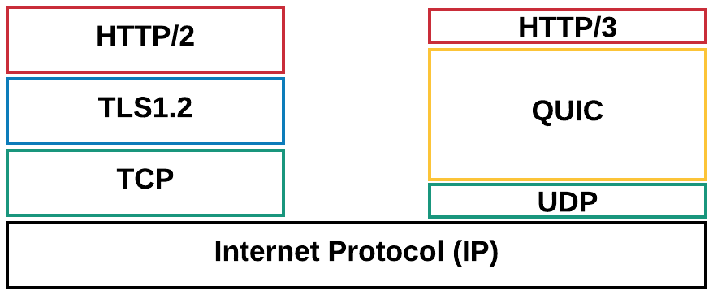
Figure 5.4-1: HTTP/2 and HTTP/3 protocol stacks
For an entertaining introduction to QUIC and HTTP/3, please check https://www.youtube.com/watch?v=B1SQFjIXJtc.
However, using QUIC for adaptive streaming still requires study as under certain circumstances, the quality using QUIC may even degrade for DASH-based streaming than it would increase [6]. The evaluation results show that using the unmodified DASH algorithms on top of QUIC may not provide the anticipated performance boost when compared to the standard DASH over TCP.
The main expected benefit of QUIC is being able to multiplex requests for all Adaptation Sets onto the same transport association, and then to manage the network QoS on that aggregate connection. This has a valuable operational benefit to a CDN operator (including the 5GMS AS) in reducing the number of UDP ports that a server needs to keep open. Another benefit is being able to migrate connections from one IP address to another with minimal interruption to either client or server. This is useful when the client moves, but it is also useful when the server changes (e.g. in edge computing relocation Use Cases).

5.4.2 Collaboration Scenarios
A service provider/content provider runs an adaptive media streaming service between HTTP/3 and QUIC enabled 5G Media Streaming AS and an HTTP/3 and QUIC enabled UE using 5G Media Streaming over M2d and M4d.
Editor’s Note: Study collaboration scenarios between the 5G System and Application Provider for each of the key topics.

5.4.3 Deployment Architectures
Editor’s Note: Based on the 5GMS Architecture, develop one or more deployment architectures that address the key topics and the collaboration models.

5.4.4 Mapping to 5G Media Streaming and High-Level Call Flows
Editor’s Note: Map the key topics to basic functions and develop high-level call flows.

5.4.5 Potential open issues
Editor’s Note: Identify the issues that need to be solved.

5.4.6 Candidate Solutions
Editor’s Note: Provide candidate solutions (including call flows) for each of the identified issues.

5.5 Uplink media streaming

5.5.1 Description
Editor’s Note: Document the above key topics in more detail, in particular how they relate to the 5GMS Architecture and protocols.

5.5.1.1 Overview
Uplink media streaming functionality is currently under-specified in TS 26.512 [4]. This part of the study investigates the gaps and potential solutions for completing the uplink streaming procedures, and associated protocols and APIs.

5.5.1.2 Gap analysis between TS 26.501 and TS 26.512 (5G Media Streaming)
Editor’s Note: Consider reformulating the description in this clause more succinctly in the form of bullet points.
The original focus of Rel-16 stage 2 and stage 3 specifications of 5G Media Streaming in 3GPP TS 26.501 [15] and TS 26.512 [16], respectively, is on the functional entities, control plane interface procedures and corresponding APIs pertaining to downlink media streaming services.
In TS 26.501, there is significant imbalance in the scope and details of the described procedures for downlink vs. uplink media streaming. Key issues include the following:
- The procedures for downlink media streaming include session establishment, provisioning of various types of configuration information, metrics reporting, consumption reporting, dynamic policy and network assistance. In comparison, the described procedures for uplink media streaming are limited to session management, remote control, and network assistance. It is unclear for uplink streaming whether and how the configurations for content preparation, content protocols discovery, dynamic policy, metrics reporting, etc., should be defined and how the associated functions will operate.
- For downlink streaming, it is described that access to Service Access Information by the 5GMSd Client may be provided either over M8d by the Application Provider, or else fetched by the Client via M5u. For uplink streaming, the solely described method for the 5GMSu Client to obtain Service Access Information is via application metadata delivery over M8u. The only exception to this rule is the alternative method for provisioning Service Access Information to the 5GMSu Client by the 5GMSu AF, associated with remote control sessions in reference to remote control use cases and operational mechanisms in the context of FLUS (Framework for Live Uplink Streaming) as described in TR 26.939 [13] and TS 26.238 [14]. However, it should be noted that due to the limited description of the relationship between the uplink streaming framework and use cases, defined procedures and APIs in TS 26.512, it is unclear whether or how remote control sessions associated with uplink streaming delivery can make use of those interface procedures and APIs.
Similarly, in TS 26.512, the originally-defined features, protocols and APIs for 5GMS services mainly pertain to downlink media streaming services. More recently, as part of the specification maintenance process, additional descriptive, clarification and corrective text towards supporting uplink streaming services has been incorporated. However, that activity is centered on identifying relevance of existing and downlink streaming centric interface functionality for uplink streaming. For instance, provisioning and subsequent execution of content protocol discovery, dynamic policy invocation, and metrics reporting are regarded as applicable to support for uplink media streaming services. Also, content preparation via M1-based configuration of Content Preparation Templates may be considered a means for defining manipulations by a 5GMSu AS of media content uploaded from the 5GMSu Client. Such content manipulation may be associated with network-based media processing (NBMP) of uplink-delivered streaming media content (e.g., user-generated content of social media services, professionally-produced uplink streaming of sports events or concerts) as defined in FLUS [13] and further evaluated in the FS_FLUS_NBMP study item. However, further assessment of the potential linkage between content preparation and NBMP should be conducted.
Up to now, in the development of the 5GMS architecture and associated protocols and APIs, very little attention has been given to defining control plane functionality that can offer unique/beneficial features to the end-user, network operator or Application Provider in the context of uplink media streaming service operation. Such value-added functionality could be enabled by leveraging the information available in the 5GMS network (e.g., subscription class, service characteristics, user/device mobility, network conditions) and which may be static or dynamic in nature. This is also an area that should be further studied.

5.5.1.3 Gap analysis between TS 26.238 (FLUS) and TS 26.512 (5G Media Streaming)
TS 26.238 provides the following features:
1. The FLUS Control Source may discover multiple FLUS sinks.
2. The FLUS Control Source may discover the capabilities of each discovered FLUS Sink, including its network-based media processing capabilities.
3. The FLUS Control Source may also request a FLUS Sink to perform media processing.
4. The UE capabilities (formats, connectivity protocol, remote control) may be discovered by a FLUS Control Sink.
TS 26.512 uplink streaming currently lacks the above features.

5.5.2 Collaboration Scenarios
Editor’s Note: Study collaboration scenarios between the 5G System and Application Provider for each of the key topics.

5.5.2.1 Overview
A set of key collaboration scenarios between an 5GMSu Application Provider and the 5G System Provider is described below.
Scenarios associated with Media Plane only collaboration and which may also involve downlink media distribution are presented first. Subsequently, scenarios pertain to both Control Plane and Media Plane collaboration and which may or may not involve downlink media distribution are presented.
NOTE: In the collaboration scenario descriptions and diagrams below, an interface or API marked with a prime (′), e.g., M1′ or M2u′, denotes that while that interface/API functionally maps to its 3GPP-defined counterpart (e.g., M1 or M2u), its protocol and format are defined by the 5GMSu Application Provider. The implementation of these interfaces is up to the 5GMSu Application Provider discretion.

5.5.2.2 Collaboration Scenario 1
This scenario pertains to a media plane only collaboration for which the 5GMSu AS is deployed in the trusted domain. Here, the 5GMS System Provider is assumed to offer uplink streaming capabilities as a service to an external 5GMSu Application Provider.
NOTE: Although a Provisioning Session is shown in Figure 5.5.2.2-1 between the (external) 5GMSu Application Provider and the 5GMSu AF, due to the absence of the M5u interface in this diagram, there is no control plane collaboration between the 5GMSu Application Provider and the 5GMS System Provider.
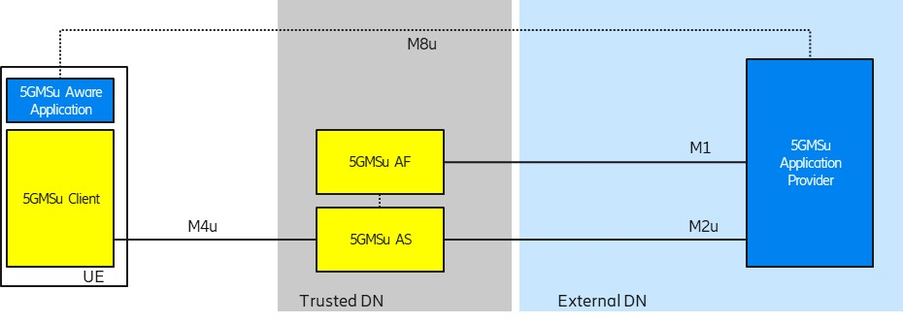
Figure 5.5.2.2-1: Collaboration 1

5.5.2.3 Collaboration Scenario 2
This scenario pertains to a media plane only collaboration for which the 5GMSu AS is deployed in the external domain and the 5GMSu AF is not involved. Specifically, the M1′ and/or M2u′ protocols do not follow 3GPP specifications.
Figure 5.5.2.2-1: Collaboration 2

5.5.2.4 Collaboration Scenario 3
In this collaboration scenario, both the 5GMSu AS and 5GMSu AF are present. The 5GMSu AS resides in the external domain and does not employ 5GMS protocols and formats for uplink media reception from the 5GMSu Client, nor for content egest. The 5GMSu AF is used to interact with the 5G System, e.g., for dynamic policy invocation and/or other uplink streaming related network features such as metrics reporting and network assistance).
Figure 5.5.2.3-1: Collaboration 3

5.5.2.5 Collaboration Scenario 4
In this collaboration scenario, both the 5GMSu AS and 5GMSu AF are present and follow 3GPP specifications. Both the 5GMSu AS and 5GMSu AF reside in the external DN/domain.
Figure 5.5.2.4-1: Collaboration 4

5.5.2.6 Collaboration Scenario 5
This scenario is similar to collaboration scenario 4, with the exception that the 5GMSu AS and 5GMSu AF reside in the trusted DN/domain. An additional difference from collaboration scenario 4 is that the M2u API is used by the external 5GMSu Application Provider for content egest.
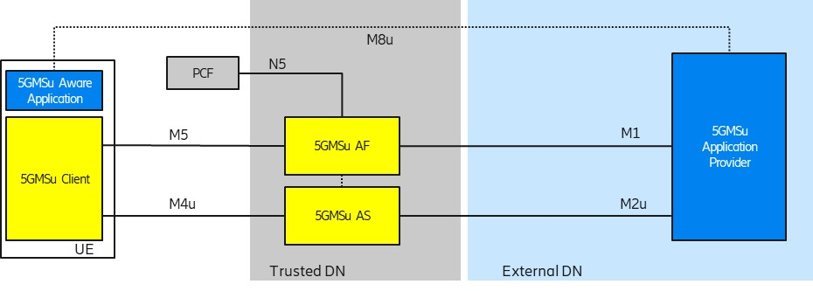
Figure 5.5.2.5-1: Collaboration 5

5.5.2.7 Collaboration Scenario 6
This scenario represents a hybrid, i.e. end-to-end form of collaboration across uplink media streaming and downlink media streaming services. An external 5GMS Application Provider relies on the 5GMS System Provider to support both the uplink streaming media transmission by 5GMSu Clients and subsequent distribution of that content via downlink media streaming for reception by 5GMSd Clients.
Editor’s Note: The study on the key topic “Content Preparation” includes a use case whereby content preparation is used between uplink and downlink media streaming, and that use case can be considered as a specific example of this collaboration scenario.

5.5.3 Deployment Architectures
Editor’s Note: Based on the 5GMS Architecture, develop one or more deployment architectures that address the key topics and the collaboration models.

5.5.4 Mapping to 5G Media Streaming and High-Level Call Flows
Editor’s Note: Map the key topics to basic functions and develop high-level call flows.

5.5.5 Potential open issues
Editor’s Note: Identify the issues that need to be solved.

5.5.6 Candidate Solutions
Editor’s Note: Provide candidate solutions (including call flows) for each of the identified issues.

5.6 Background traffic

5.6.1 Description
Mobile Network Operators (MNO) are faced with the challenge of overload of their networks during peak hours. The following diagram shows a typical distribution of traffic over the day hours in a residential area:
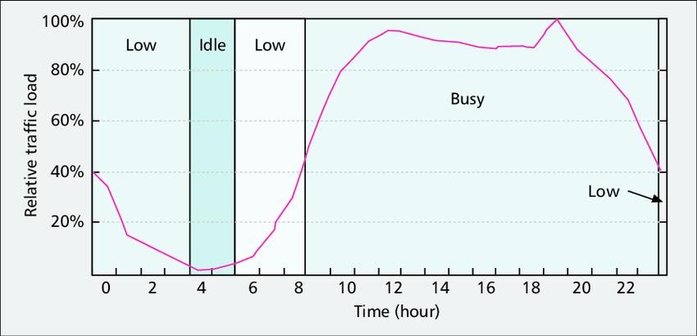
Figure 5.6.1-1: Example of traffic distribution over time
Note that the traffic distribution is also highly dependent on the geographic area. For instance, traffic distribution in a residential area maybe quite different from traffic distribution in a business or commercial area. Another example is traffic along roads during commute hours, which maybe higher by orders of magnitude than traffic during other hours.
As can be seen from the diagram, the traffic distribution is non-uniform/uneven throughout the day, which leads to congestion during the peak hours and very low utilization during off-peak hours. To alleviate this situation, the MNO may incentivize offloading traffic to off-peak hours to balance the network resource usage throught the day. The incentives may be provided in terms of preferential charging and guaranteed QoS.

5.6.2 Collaboration Scenarios
MNO and content provider enter an SLA that allows the content provider to distribute its content during off-peak hours to a set of receivers in a pre-determined geographic location.
Collaboration scenarios 2,4,5,7, and 8 from [TS256.501] are potential collaboration scenarios for traffic offloading using Background Data Transfer.

5.6.3 Deployment Architectures
There is no anticipated change to the 5G media streaming architecture to enable the usage of Background Data Transfer (BDT) for media distribution.

5.6.4 Mapping to 5G Media Streaming and High-Level Call Flows
The following is a potential high-level call flow for the configuration and usage of a BDT session in 5G media streaming:
Figure 5.6.4-1: Potential call flow for BDT session configuration and establishment

5.6.5 Potential open issues
The extensions to the client APIs, Provisioning API, and 5GMSd AF services to enable signaling and management of background data traffic sessions need to be specified.

5.6.6 Candidate Solutions
Editor’s Note: Provide candidate solutions (including call flows) for each of the identified issues.

5.7 Content-Aware Streaming

5.7.1 Description
Content-Aware Encoding and statistical multiplexing of services are important and relevant technologies in the media industry. The impacts and opportunities of such technologies for 5GMS is not fully understood and requires study. For example, the currently-defined 5GMSd Application Function (AF) based network assistance solution is exclusively triggered by the Media Player, which instructs the Media Session Handler to interact with the Network. It might be more efficient for such network assistance functionality to be obtained directly from the content provider based on dynamic content complexity. Greater interaction with the 5GMS Application Provider during the lifetime of a session should be studied.
According to [2], if one analyses, almost any movie or television show scene by scene, you’ll notice the content has varying needs in terms of its fundamental complexity. Scenes with a lot of action and detail need a lot more bits in order to hit a quality target, whereas other scenes—say, a newsreader delivering a monologue—can achieve the same quality target with a reduced number of bits.
As an example, a game sequences provided for XR Traffic was encoded with x265 over 1 minute in Figure 5.7.1-1. One can see that at the same quality, the number of bits required to represent the content can be quite different.

Figure 5.7.1-1: Bit rate and quality over time for an example sequence.
(Blue bits, red PSNR in dB × 100)
Ideally, to maintain quality, one wants the bit rate to vary over time to maintain consistent quality regardless of the complexity of the scene. Four different scene types may be considered, and they differ in complexity- easy, moderate, hard, and very hard to compress. The “very hard” content might be a panning shot over a crowd, a shot of confetti falling, or simply a scene with a lot of high motion. Scenes such as these require more bits to convert all the motion and detail into a high-quality output that can be decoded and recreated accurately. A moderate scene, perhaps a close-up of a car, or an easy scene, like a single person speaking with no camera movement, will require fewer bits to deliver the same quality target as the harder scenes. In order to most efficiently encode the entire video, ideally a rate control mode that allocates more bits to the complex scenes, and fewer bits to the easier ones.
Different rate control algorithms exist:
- CBR: Constant-Bit Rate encoding keeps the bit rate at a constant level, but the quality fluctuates. In ancient systems such as MPEG-2 TS, this is even addressed by sending lots of filler data just to keep the pipe constant
- VBR: Variable Bit Rate encoding following the principle from above to keep the quality constant. This is often also referred to as Content-Aware Encoding nowadays (CAE).
- Capped VBR: in this case the basic idea is to ensure that you have a mix of the above, i.e. a certain bit rate is never exceeded, but in case the content does not need the data rate, less data is sent.
The below diagram attempts to address and show these issues, but is more confusing then helpful.
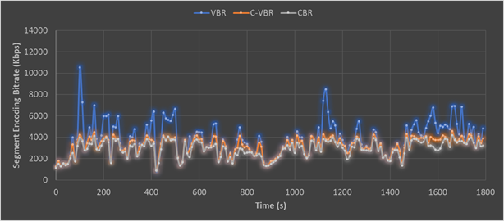
Figure 5.7-2: Capped VBR rate control encoding compared with CBR and VBR
Variance in bit rates for different users may also result on the device and the consumption model. For a smaller screen, quite likely quality and bit rate requirements can be lower than for example going to a large screen such as a 4K TV.
The 3GPP QoS model contradicts this, as typically resources and QoS parameters are assigned for a session and only GBR is addressed.
From a adaptive bitaret streaming perspective, this content model needs to also be viewed as part on the streaming model, as the complexity of the content may be addressed based on the buffer availability, and also the situation of the network needs to be studied.
1) On-demand Streaming:
a. Stationary streaming of C-VBR/CBR content: Typically one operates with receiver buffer levels of 5-30 seconds [check details in TS 26.512]. One tries to keep the buffer filled. As soon as your buffer drains below some threshold, the client triggers a down-switch to a more sustainable bit rate. Switching typically can happen at segment boundaries, for example every 2 seconds.
b. Start-up and seek. In this case, one starts basically starts from an empty buffer. In order to have quick and stable start up and good quality right away, there may be a benefit to get a higher short-term bit rate from the network to fill the buffer quicker to at least the switching threshold as you would not start playback until the threshold is reached. This is a very instantaneous action and needs to be fulfilled instantanteously, at most after 1 second.
c. Stationary streaming of VBR/CAE content: In this case you basically operate on buffers of 5-30 seconds as above. The client typically has a map of the bit rate over time profile. In this case the client knows how much bit rate it needs for the next 5-10 seconds in order to keep the buffer stable and it can provide this information in a continuous manner to the network. The network will then grant a certain bit rate. This aspect may be fulfilled with using existing 5GMS functionalities.
2) Live Streaming and especially low-latency live streaming:
a. General: In this case the buffer is something of duration 1-5 seconds, it can be kept really low for low-latency streaming. Typically, one operates e2e latency of 3-5 seconds, so the buffer in the client is low. In addition, the client does not know the exact bit rate of the content as it is produced on the fly. Switching can typically be done every 1–2 seconds.
b. Stationary streaming CBR: the buffer is much more susceptible, and you may have a threshold of maybe 500 ms when the client needs a fast arriving Segment is not arriving fast enough. This aspect may be fulfilled with using existing 5GMS functionalities.
c. Start-up is similar to on-demand streaming as your buffer is anyways low. So no difference.
d. Yet another and probably the most interesting case is the live case, for which the content and each of Representations are VBR encoded, but more following the content complexity and VBR/CAE is done as shown below. The content complexity is not known in advance, but it needs to be provided on an content ingest interface to the network. In this case, the network should provision very fast and dynamically the bit rate if needed, but can relax.
There are many other cases, where content complexity and device characteristics need to be taken into account when addressing quality of service.

5.7.2 Collaboration Scenarios
In the following, difference collaboration scenarios are provided. In Figure 5.7-3, content is generated by a third-party content provider in different formats and configurations, taking into account for example:
- Different device types (resolution, frame rates, codecs).
- Different streams (target qualities and bit rates).
- Encoding parameters (CBR, VBR, etc.).
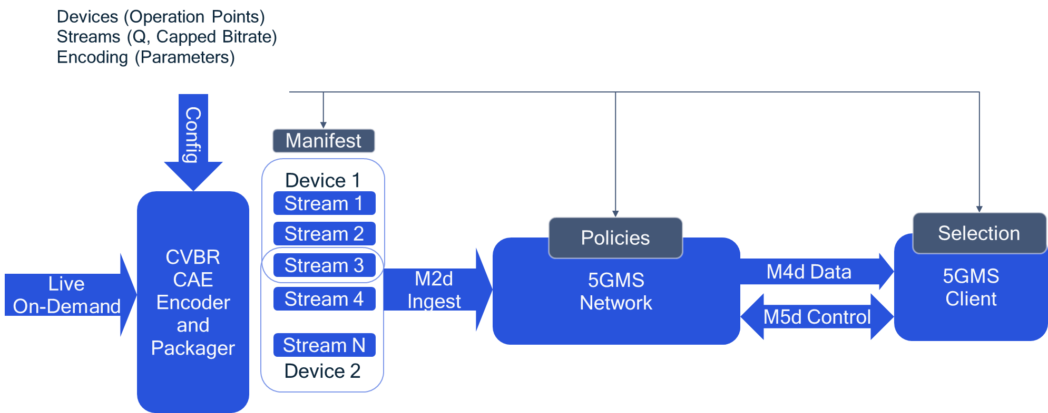
Figure 5.7-3: Content-Aware Streaming based on static parameters
The network and client can make use of this information in order to optimize the streaming.
In a second variant, not only static information is provided, but also dynamic information with the media stream. This data is provided from the content provider to the 5G Media Streaming system and the client.
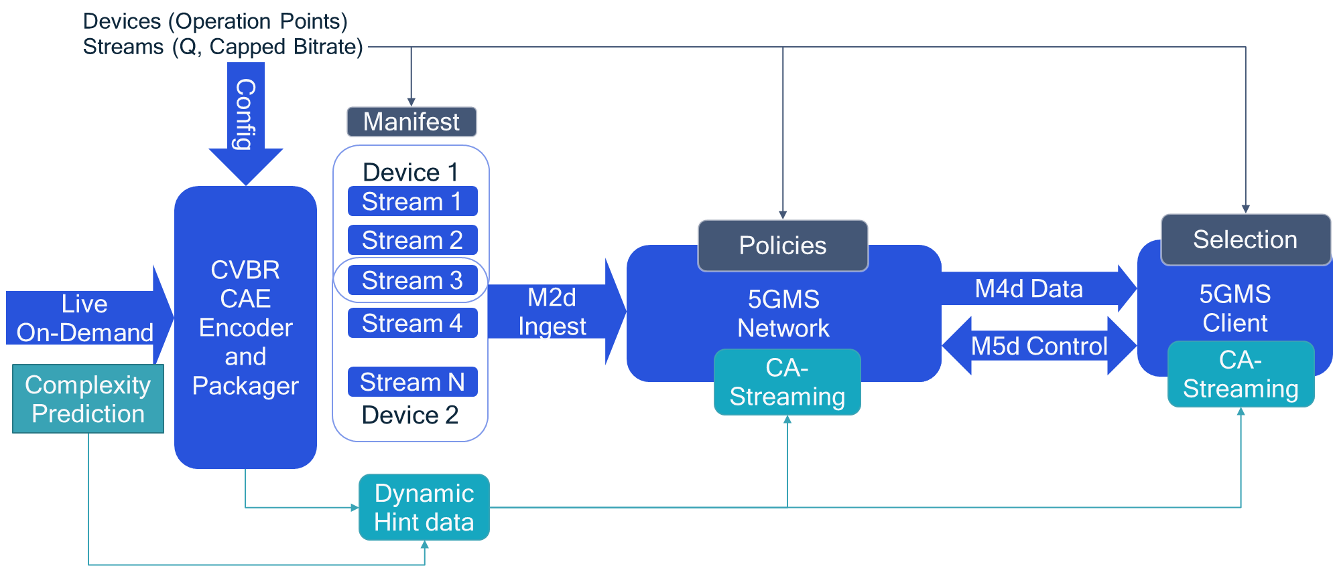
Figure 5.7-4: Content-Aware Streaming based on dynamic parameters
The client can use the information for:
- Optimizing its own quality.
- Acting fairly in a way that it only requests higher bit rates when the content is more complex, but leaves remaining capacity to the community.
In an On-Demand service, the use of the information is client controlled, i.e. the network is unaware of content complexity.
- Client downloads a description of the content variations and the associated quality initially.
- Client now brokers with the network for an average bit rate, but ability to request higher bit rate when content is complex
- DASH client includes logic to use the VBR options smartly to ask for “boosts” ahead of time when content is complex
Live Streaming and Ingest (network more actively included in streaming):
- Encoder provides as early as possible indication that content for same quality is getting a complex.
- Network uses this and identifies, if and how to fulfill this for the clients that request it.
- To not confuse client throughput estimation, communication between network and client is necessary.

5.7.3 Deployment Architectures
Editor’s Note: Based on the 5GMS Architecture, develop one or more deployment architectures that address the key topics and the collaboration models.

5.7.4 Mapping to 5G Media Streaming and High-Level Call Flows
Editor’s Note: Map the key topics to basic functions and develop high-level call flows.

5.7.5 Potential open issues
Editor’s Note: Identify the issues that need to be solved.

5.7.6 Candidate Solutions
Editor’s Note: Provide candidate solutions (including call flows) for each of the identified issues.

5.8 Network Event usage

5.8.1 Description

5.8.1.1 Events exposed by 5GMS AF
The 5GMS AF performs several critical support operations for media streaming sessions. It also is responsible for collecting information about the progress and status of media streaming sessions. This information may be of interest to the AP or to other NFs in the network.
Thee 5G architecture defines event exposure mechanisms by the AF to other NFs in the network. TS 23.501 [23] and TS 23.502 [24] define the stage 2 Exposure service that can be offered by the AF. In TS 29.517 [25], the stage 3 realization of the Event Exposure service is specified as a RESTful API.
The resource structure is replicated in the following figure for convenience:
An Event Consumer subscribes to an application event and provides a URL on which it desires to receive the related event notifications. Both periodic reporting and immediate event reporting options are available. Event Filter Information and Event Reporting Information definitions as specified in TS 23.502 [24] and TS 29.517 [25] are used by the Event Consumer to indicate the desired event parameters and method of reporting for the selected event set.
So far, the following AfEvents are defined:
Enumeration value | Description | Applicability
SVC_EXPERIENCE | Indicates that the event subscribed is service experience data for an application. | ServiceExperience
UE_MOBILITY | Indicates that the event subscribed is UE mobility information. | UeMobility
UE_COMM | Indicates that the event subscribed is UE communication information. | UeCommunication
EXCEPTIONS | Indicates that the event subscribed is exceptions information. | Exceptions

Additional AFEvents may be defined.

5.8.1.2 Events consumed by 5GMS AF
The 5GMSd AF may subscribe for event notifications related to application sessions, and receive event notifications for these sessions. Currently, TS 26.512 [16] requires the 5GMSd AF to subscribe with the PCF for the following types of event notifications:
- Service Data Flow QoS notification control;
- Service Data Flow deactivation;
- Resources allocation outcome.
Additional events of interest to the 5GMSd AF are for further study.

5.8.2 Collaboration Scenarios
The Application Provider (AP) is outsourcing part of its content hosting to the MNO. The AP makes use of the Provisioning APIs to configure its content distribution. The AP would like to track the usage of the network resources for the distribution of its content as well as the QoE for its mobile subscribers. At the same time, it may choose to limit access to this information by the MNO to protect the AP’s service interests and/or user’s privacy. The AP configures data collection from UEs and the 5GMSd AS(s) to identity the data to be collected as well as the permitted entities and access levels to that data. The 5GMSd AF triggers the data collection accordingly and uses the AF Event Exposure framework to notify Event consumers about collected data and events.

5.8.3 Deployment Architectures
The deployment architecture for the data collection and exposure by the 5GMSd AF is depicted by the following figure:
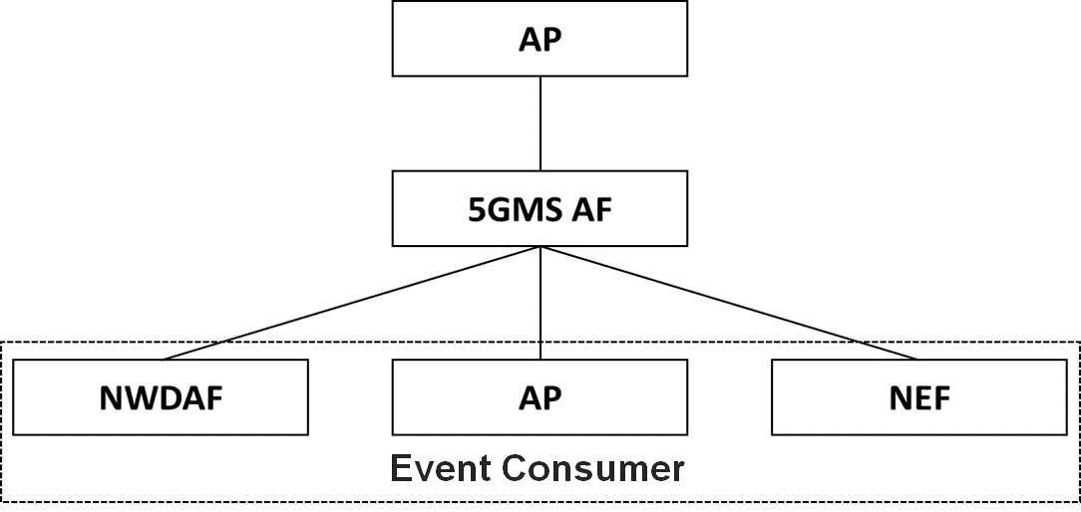
Figure 5.8.3-1: Provisioning and Exposure Architecture

5.8.4 Mapping to 5G Media Streaming and High-Level Call Flows
The following is a sample call flow of the operation of the data collection and exposure by the 5GMSd AF:
Figure 5.8.4-1: Call flow for event exposure
A description of the steps is as follows:
1. Provision data collection: The Application Provider provisions the data collection by configuring the data that is to be collected for all streaming sessions of this Provisioning Session.
2. Trigger data collection: The 5GMS AF determines the data that is to be collected from the UE and provides this configuration to the Media Session Handler.
3. Trigger data collection: The 5GMS AF determines the data that is to be collected by the 5GMS AS and uses the M3 interface to configure the 5GMS AS.
4. Subscribe-notify pattern – Subscribe: In this phase, Event Consumers subscribe for the reception of notifications from the 5GMS AF. This phase may happen at any time. Subscriptions may be updated and canceled.
5. Consumption and QoE reports: The Media Session Handler collects logs and information and sends them to the 5GMS AF.
6. Access logs: The 5GMS AS collects logs and sends the information to the 5GMS AF
7. Data aggregation and filtering: In this phase, the 5GMS AF aggregates the information received in the data collection phase, determines for each Event consumer the allowed level of access, and provides the information to the Event Consumers.
8. If an Event Consumer opted for the subscribe-notify pattern, the 5GMS AF sends a notify message to that Event Consumer.
9. In case the Event Consumer opted for the Query pattern, by setting the immRep flag to true, the 5GMS AF sends a one-time response with the event information to that Event Consumer.

5.8.5 Potential open issues
The following events are expected to be defined:
- Consumption reporting: this event contains reports sent by the UE about the consumption of the service, in terms of streaming session establishment.
- Quality of Experience Metrics reporting: this event contains reports sent by the UE about the QoE of the streaming sessions.
- Network Assistance: this event contains reports collected by the AF on the usage of network assistance such as bitrate recommendation and bitrate boost requests that have been offered for a streaming session.
- QoS and Charging usage: this event contains reports about QoS and charging policy requests made by the 5GMS AF for a streaming session.
- Access logs: this event contains reports about the access to the streaming content that is hosted by the network.
The granularity of the access to this information depends on the authorized access level. For each of these events, the triggers for the data collection and the levels of access to the collected data need to be defined as well.

5.8.6 Candidate Solutions
Editor’s Note: Provide candidate solutions (including call flows) for each of the identified issues.

5.9 Per-application-authorization

5.9.1 Description
[Operation of certain 5GMSA and 5G System enabled services include an SLA between the Application Provider and the 5GMS System provider. Different solutions to enable per-application authorization should be studied.]
Editor’s Note: Document the above key topics in more detail, in particular how they relate to the 5GMS Architecture and protocols.

5.9.2 Collaboration Scenarios
Editor’s Note: Study collaboration scenarios between the 5G System and Application Provider for each of the key topics.

5.9.3 Deployment Architectures
Editor’s Note: Based on the 5GMS Architecture, develop one or more deployment architectures that address the key topics and the collaboration models.

5.9.4 Mapping to 5G Media Streaming and High-Level Call Flows
Editor’s Note: Map the key topics to basic functions and develop high-level call flows.

5.9.5 Potential open issues
Editor’s Note: Identify the issues that need to be solved.

5.9.6 Candidate Solutions
Editor’s Note: Provide candidate solutions (including call flows) for each of the identified issues.

5.10 Support for encrypted and high-value content

5.10.1 Description
Content is increasingly encrypted for distribution for different reasons, e.g. Content Protection, Conditional Access, or integrity of playback. The management of keys for different use cases is a prime concern. Examples include scalable access to keys, secure storage of keys, key availabilities. It is envisioned that an MNO can provide key management and/or key distribution services for content providers. In particular, providing scalable and secure key management within 5GMS for multiple different devices needs further study.
Examples for secure media specification are for example provided by the MovieLabs ECP requirements and other content providers requirements.
In a specific example, a live sports service provider wants to offer a live stream. Examples include where the content needs to be delivered with low latency (typically encoder to glass in 3–10 seconds) in order to be on par with regular TV distribution means. Other services may also be considered.
The service may require different tools and functionalities levels of security:
1. Conditional access supported by DRM management. As an example, users need to get a master key for decrypting the secondary level keys.
2. Key rotation in order to support live streaming. As an example, these keys are changed periodically but protected by the master key.
3. DRM and key management to ensure playback rules, for example to avoid that clients attempting early playback of the content too early and have advantages in betting/wagering, skipping content, etc.
4. Watermarking. The content is distributed and a unique signature is added at the latest possible time (in the device, at the Edge). An example of such approach can be found here https://learn.akamai.com/en-us/webhelp/adaptive-media-delivery/adaptive-media-delivery-implementation-guide/GUID-3F89E64C-415D-452D-9541-BB650CD783B9.html.
5. Content encryption.
6. A secure implementation (use of TEE, Secure Media Path).

5.10.2 Collaboration Scenarios
It is assumed that the content provider provides DRM protections for the content. However, beyond this different collaboration models between the content provider and 5G System operator/MNO exist.
As examples, the MNO provides infrastructure to the content service provider in order to support security related functions.
- The service provider may want to provide scalable access to the content and in particular the key distribution. Hence it uses 5G Media streaming servers to support secure key distribution.
- The streaming service provider wants to rule playback, for example to avoid that the situation whereby users can see the streamed content too early while at the same time, the streaming service provider does not want to delay the distribution artificially either and want to give the clients the ability to download the main content (without buffer underruns).
- The service provider asks for fairness in the client, but the client cannot be trusted to act fairly. Hacked clients are possible. Clients may have DRM systems that the service providers will use.
- The service provider asks for a watermarking solution from the MNO.
Encryption (as already defined in TS 26.511 [3]) and secure keys may be used for other purposes, for example for conditional access or DRM systems. In some cases, keys are also provided in hierarchically, depending on business rules, security levels and deployment scenarios.
In an extension of the above use case, the content is distributed via multiple operators network. In this case, the encryption may be done by the service provider and the service provider provides the keys to the MNO. In another case, the service is offered by the MNO and the MNO does encryption and key management.
Editor’s Note: Study collaboration scenarios between the 5G System and Application Provider for each of the key topics.

5.10.3 Deployment Architectures
Editor’s Note: Based on the 5GMS Architecture, develop one or more deployment architectures that address the key topics and the collaboration models.

5.10.4 Mapping to 5G Media Streaming and High-Level Call Flows
Editor’s Note: Map the key topics to basic functions and develop high-level call flows.

5.10.5 Potential open issues
Editor’s Note: Identify the issues that need to be solved.

5.10.6 Candidate Solutions
Editor’s Note: Provide candidate solutions (including call flows) for each of the identified issues.

5.11 TV-grade mass distribution of unicast Live Services

5.11.1 Description
Live TV services of different scale (professional, user-generated, session-based, etc.) are increasingly distributed over broadband and mobile networks. Live TV services are characterized by:
- scalability (in terms of concurrent users),
- consistent quality,
- high bandwidth requirements, and
- target latency constraints.
Consistent support of the distribution of such services to a different scale of users and in a concurrent fashion is a prime concern. 5G Media Streaming is expected to support such service distribution and end-to-end optimizations. Improvements and optimizations on the architectural level and stage 3 are expected to be studied.
Based on a report developed jointly between DVB and DASH-IF on Low-Latency DASH [9], this clause defines details on how to support consistent latency in DASH for linear TV services. In [9], several definitions had been introduced, repeated here for consistency.
- End-to-End Latency (EEL): The latency for an action that is captured by the camera until its visibility on the remote screen.
- Encoder-Display Latency (EDL): The latency of the linear playout output (which typically serves as input to distribution encoder(s)) to the screen.
- Packager-Display Latency: The latency after the output of the distribution encoder to the screen.
- CDN latency: The delay caused by the CDN delivery from CDN input to CDN output.
- Live Edge Start-up Delay (LSD): The time between a user action (service access or service join) and the time until the first media sample of the service is perceived by the user when joining at the live edge. Typically also the channel change time.
- Seek Start-up Delay (SSD): The time between a user action (service access or service join) and the time until the first media sample of the service is perceived by the user when seeking to a time shift buffer.
Those two categories, latency and delay are subject to be controllable by the service provider for a consistent service offering. In the remainder, primarily the Encoder-Display Latency (EDL) and the Live Edge Start-up Delay are considered, but for some use cases also the End-to-End Latency (EEL) may be relevant. Figure 5.11.1-1 provides a schematic overview of the different latencies.
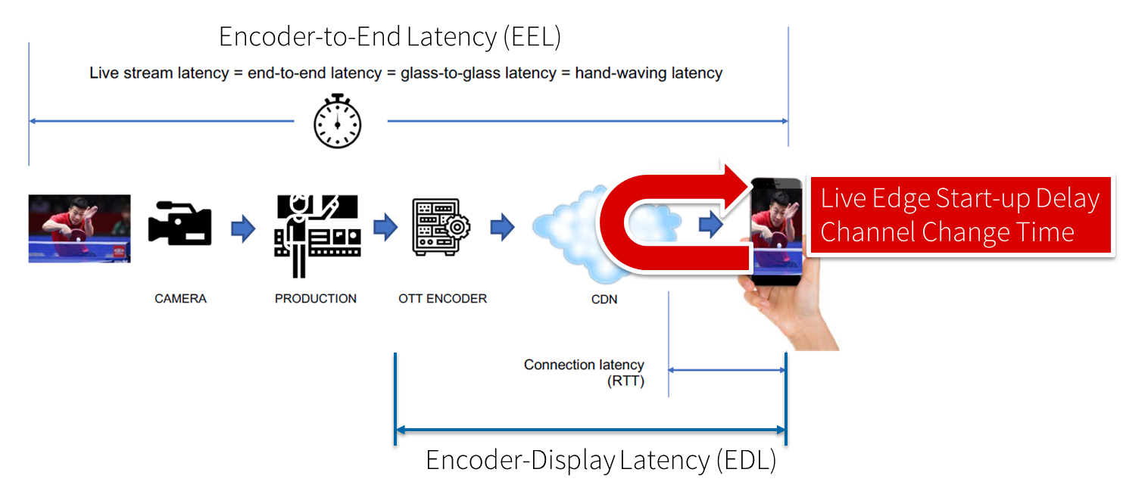
Figure 5.11.1-1: Different latencies and delays relevant for low-latency distribution
The Low Latency DASH scenario is a variant of the Live Services recommended approach focused on ensuring that the Encoder-Display Latency of the DASH Media Presentation is comparable to the latency when distributing over terrestrial, cable or satellite broadcast. Latency in broadcast is not a unique universal value, as it is influenced by many factors such as the duration of the broadcast encoding pipeline, the latency of the transport channel which can slightly differ per type (satellite, cable, IPTV or, DTT...), or the artificial delays introduced by local content moderation regulations. However, most of the measurements converge on a 3 - 10 seconds latency between the moment where the source signal is acquired for encoding and the moment when it's played back on the TVs, i.e the EDL. Start-up delay requirements are typically in the range of 1-2 seconds. For details refer to [9].
Low-latency mode are supported to minimize the architectural impacts on existing workflows. Figure 5.11.1-2 provides a basic flow of information for operating a low-latency DASH service as defined in DASH-IF’s Low-latency Modes for DASH [10]. The DASH packager gets information on the general description of the service as well as the encoder configuration. The encoder produces CMAF chunks and fragments. The chunks are mapped by the MPD packager onto Segments and provided to the network in incremental fashion using HTTP/1.1 chunked transfer.
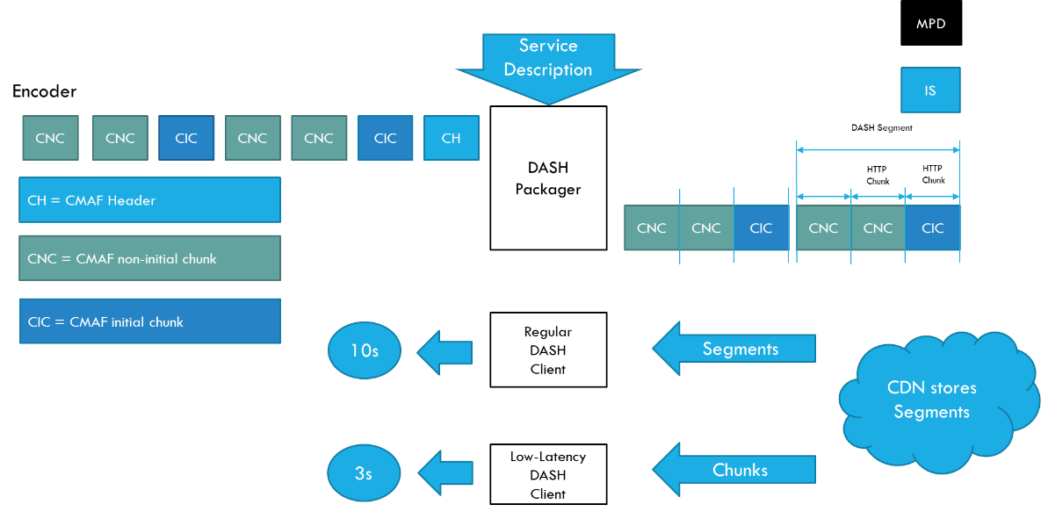
Figure 5.11.1-2 Basic operation flow Low-Latency DASH
HTTP chunked transfer coding needs to be supported up from the ingest into the packager up to the CDN edge, whereas the last mile delivery is expected happen using HTTP chunked transfer coding or HTTP in regular mode. If HTTP chunked transfer coding is supported by the DASH player, it basically means that a media segment carrying the latest moment of the program (also known as the "live edge time" as defined in clause 4 of this document) could be consumed on the player while it's still being produced by the encoder and the packager.
In case chunked segments are used, clients may want to access partially available Segments for example for fast random access, see ISO/IEC 23009-1 [11]. However, requesting available byte ranges of a partially available Segment, i.e., Segments still being produced, is not consistently supported in CDNs, but solutions are provided in RFC8673 [X6]. This functionality may also be needed to support common segment handling for low-latency DASH and low-latency HLS.
Key aspects for low-latency live distribution include:
- Consistent support for chunked transfer from ingest to client.
- Support for partially access of non-complete resources.
- End-to-end optimizations to support the latency requirements.

5.11.2 Collaboration Scenarios
Editor’s Note: Study collaboration scenarios between the 5G System and Application Provider for each of the key topics.

5.11.3 Deployment Architectures
Editor’s Note: Based on the 5GMS Architecture, develop one or more deployment architectures that address the key topics and the collaboration models.

5.11.4 Mapping to 5G Media Streaming and High-Level Call Flows
Editor’s Note: Map the key topics to basic functions and develop high-level call flows.

5.11.5 Potential open issues
Editor’s Note: Identify the issues that need to be solved.

5.11.6 Candidate Solutions
Editor’s Note: Provide candidate solutions (including call flows) for each of the identified issues.

Annex <X> (informative):
Change history

Change history
Date | Meeting | TDoc | CR | Rev | Cat | Subject/Comment | New version
Jan 2021 | SA4#112 | S4-210136 |  |  |  | Initial version | 0.0.1
Feb 2021 | SA4#112 | S4-210305 |  |  |  | S4-210054: Key Topic Content Aware Streaming  S4-210056: Key Topic Per-application-authorization  S4-210298: Key Topic Additional / New transport protocols  S4-210302: Key Topic Support for encrypted and high-value content  S4-210303: Key Topic Scalable distribution of unicast Live Services | 0.1.0
 |  |  |  |  |  | S4aI201129: Key Topic Uplink media streaming  S4aI201126: Key Topic Background traffic  S4aI201134: Key Topic Content Preparation (online edited)  S4aI201154: [FS_5GMS-EXT] Updated text for Content Preparation (only agreed parts from Clause 5.2.4)  S4aI201158: Updates on Key Topic: Network Event usage | 0.1.1

