3GPP TSG-SA4 Meeting #113e S4-210523

Electronic Meeting, Telco, Apr 06-14, 2021
CR-Form-v12.1
Pseudo CHANGE REQUEST
 | 26.804 | CR | <CR#> | rev | <Rev#> | Current version: | <Version#>
For HELP on using this form: comprehensive instructions can be found at
http://www.3gpp.org/Change-Requests.

Proposed change affects: | UICC apps |  | ME |  | Radio Access Network |  | Core Network

Title: | [FS_5GMS-EXT] Collaboration scenario proposal for KI “per-application-authorization”
Source to WG: | Ericsson LM
Source to TSG: | S4
Work item code: | 5GMS_EXT |  |  |  |  |  | Date: |  |  | <Res_date>
Category: | <Cat> |  |  |  |  |  | Release: |  |  | <Release>
 | Use one of the following categories:  F (correction)  A (mirror corresponding to a change in an earlier release)  B (addition of feature),  C (functional modification of feature)  D (editorial modification)  Detailed explanations of the above categories can  be found in 3GPP TR 21.900. |  |  |  |  |  |  |  | Use one of the following releases:  Rel-8 (Release 8)  Rel-9 (Release 9)  Rel-10 (Release 10)  Rel-11 (Release 11)  …  Rel-15 (Release 15)  Rel-16 (Release 16)  Rel-17 (Release 17)  Rel-18 (Release 18)
Reason for change: |  | The current “per-application authorization” KI is a bit empty. The pCR starts clarifying the KI by proposing a collaboration scenario.
Summary of change:
Consequences if not approved:
Clauses affected:
 |  | Y | N
Other specs |  |  |  | Other core specifications |  |  |  | TS/TR ... CR ...
affected: |  |  |  | Test specifications |  |  |  | TS/TR ... CR ...
(show related CRs) |  |  |  | O&M Specifications |  |  |  | TS/TR ... CR ...
Other comments:
This CR's revision history:

5.9 Per-application-authorization

5.9.1 Description
Operation of certain 5GMSA and 5G System enabled services include an SLA between the Application Provider and the 5GMS System provider. Different solutions to enable per-application authorization should be studied. “Per-application authorization” refers to scenarios where one or more 5GMS-Aware Applications are hosted on the same UE (e.g. a SmartPhone) and may access services only from the associated 5GMS Application Provider.
The 5G System provider may offer one common 5GMSd AF or dedicated 5GMSd AFs. In the later case, the one 5GMSd AF instance services only a single 5GMSd Application Provider.
An example collaboration scenario is depicted below.

5.9.2 Collaboration Scenarios
Editor’s Note: Study collaboration scenarios between the 5G System and Application Provider for each of the key topics.

5.9.2.1 Collaboration A: UE hosting multiple Applications
This collaboration scenario focuses on cases where one or more 5GMSd-Aware Applications are hosted on the same UE and are using the same 5GMSd Client. This may be the case when the 5GMSd Client is provided as an Operating System level service. The 5GMSd Client supports isolation of the different 5GMSd-Aware Applications.
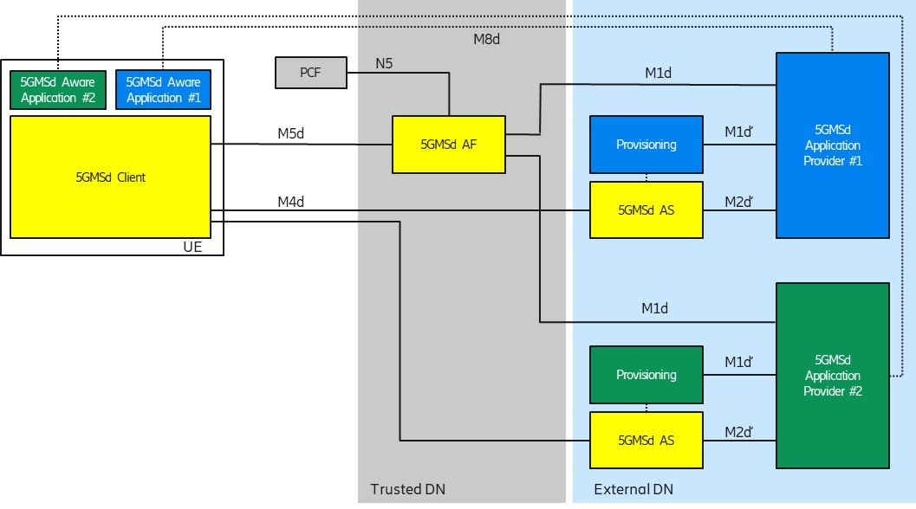
Figure 5.9.2-1: Per-Application Authorization Collaboration Scenario
Each 5GMSd-Aware Application uses an M8d reference point instance to connect to its 5GMSd Application Provider.
The 5G System provider offers a common 5GMSd AF within the trusted DN. The 5GMSd AF supports request and provider isolation so that 5GMSd Application Provider #1 and #2 are not interfering with each other. For example, 5GMSd Application Provider#1 has agreed different charging conditions than Provider #2 and the 5G System should ensure that only 5GMSd-Aware Application #1 can benefit from the conditions. Another example is different QoS levels, e.g. 5GMSd-Aware Application #1 is entitled to receive higher QoS than Application #2.

5.9.2.2 Collaboration B: Applications with multiple subscription levels
This collaboration scenario focuses on cases where an Application Provider is offering multiple subscription levels to its consumers, for example 4K Premium or SD Standard QoS. This example is inspired by the use case from TS 26.512 [X], Annex A.2.
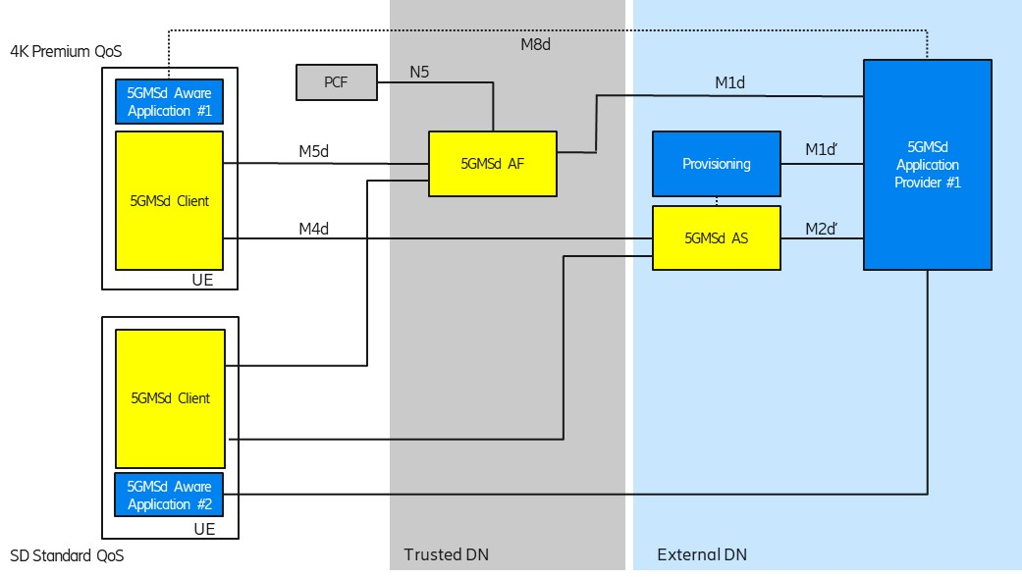
Figure 5.9.2-2: Per-Application Authorization Collaboration Scenario
Each 5GMSd-Aware Application uses an M8d reference point instance to connect to its 5GMSd Application Provider. The 5GMSd Application Provider is aware about the different subscription levels of the user.
The 5G System provider offers a common 5GMSd AF within the trusted DN. The 5GMSd AF needs to determine that 5GMSd Aware Application #1 is entitled to higher bit rates than 5GMSd-Aware Application #2.

5.9.3 Deployment Architectures
Editor’s Note: Based on the 5GMS Architecture, develop one or more deployment architectures that address the key topics and the collaboration models.

5.9.4 Mapping to 5G Media Streaming and High-Level Call Flows
Editor’s Note: Map the key topics to basic functions and develop high-level call flows.

5.9.5 Potential open issues
Editor’s Note: Identify the issues that need to be solved.

5.9.6 Candidate Solutions
Editor’s Note: Provide candidate solutions (including call flows) for each of the identified issues.

