3GPP TSG-SA WG4 Meeting #112-e S4-210279
Electronic Meeting, 1 - 10 February 2021 (revision of S4-210212)

Title: Discussion Paper on SA4 support for XR and other media application in 5G
Agenda Item: 10.8
Source: Qualcomm Incorporated
Contact: Thomas Stockhammer <tsto@qti.qualcomm.com>

Abstract: This document motivates the update for the FS_XRTraffic work item and also provides some general thoughts on how SA4’s role on media services in 3GPP can be improved.

1. Background & Motivation
The work on FS_XRTraffic has taken more efforts and time than initially anticipated, in particular with the support of RAN1’s study item FS_NR_XR on XR Evaluations for NR. Based on extensive collaborations, it became obvious that the work requires not only providing high-level traffic characteristics, but also detailed system design, simulation and quality models for relevant XR services and applications.
SA4 also regularly receives LSs from SA1 and SA2 to support their work on defining service requirements and 5QIs for new types of services, in particular related to media. Note that these services quite often are not yet fully defined in 3GPP or they are not even expected to be fully specified, for example for third-party services.
3GPP SA4 has also updated its Terms of References (SP-200929) to address new developments in the media industry. Of the in total 7 explicit responsibilities, the following 4 are explicitly highlighted
- Definition of unicast and multicast/broadcast streaming and real-time communication media services and architectures (including media-centric cloud and edge computing architectures), interfaces and media APIs, media profiles, session descriptions, and content delivery protocols;
- Guidance to other 3GPP groups concerning required QoS parameters, traffic characteristics and other system implications, imposed by different multimedia codecs, systems and service needs;
- Speech, audio, video, and multimedia quality evaluation including new evaluation methods, testing, verification, characterisation, selection criteria, quality of experience (QoE) metrics and reporting, and UE media data analytics reporting;
- Support of third-party media services and applications to benefit from 3GPP defined system and radio functionalities by providing suitable network and client interfaces/APIs;
In Release-16, SA4 prepared to react to some of these needs by defining TR 26.925 to document “Typical traffic characteristics of media services on 3GPP networks”. This document includes typical data rates of services. Preparatory work to address traffic characteristics was also done in TR 26.928 to identify needs to XR services when delivered on top of 5G. At the same time, SA1, SA2 and RAN have ongoing work in Rel-17 and sent more detailed questions to SA4 asking questions including:
Exact
bitrates in uplink and downlink
- Delay requirements in uplink and downlink, as well as round-trip
- Detailed
- Traffic patterns on IP level
- Traces and or statistical models
- Assessment of media quality for such services
- Etc.
3GPP SA4 is not equipped and prepared to respond to such requests, in particular also by the absence of a consolidated and agreed information.
This document proposes some ways forward with a concrete implementation for XR Traffic and by extending the study item in FS_XRTraffic provided in S4-210280.

2. Example on what happens
The below figure explains a bit on what happens and happened as of today for example XR type of services in 3GPP.
- SA4 had some preliminary work started in Rel-16 in FS_5GXR and TyTraC documented in TR26.928 and TR26.925, respectively. However, no agreed system design.

- SA1 defines new media centric use cases and asked SA4 on detailed service requirements
  - SA4 is not able to answer in detail as there no system design is available. TRs may have some information.
- RAN1 asks for detailed traffic models, simulation models and quality metrics
  - SA4 cannot answer in detail as there is no system design and no detailed information on traffic
- SA2 asks for verification of QoS and 5QIs settings and other information
  - SA4 cannot answer in detail as no agreed system design and quality evaluation is available.

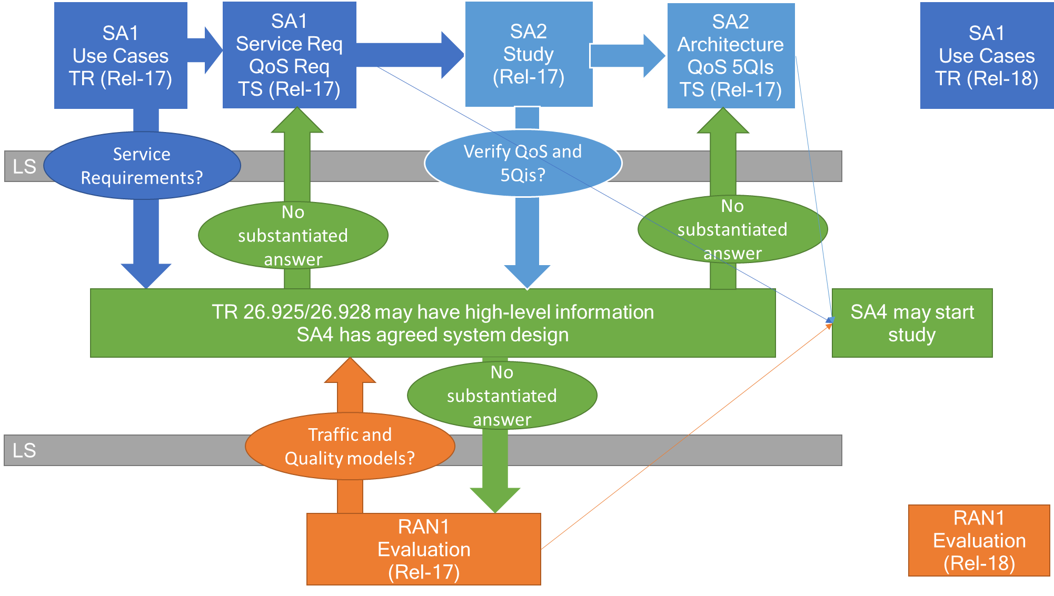

In the exchange of information, complex questions need to be answered:
- Delays
- Loss rates
- Bitrates
- Qualities
- Protocols
- Codecs
- Tradeoffs
- Audio/Video
- And and and

In order to respond to complex questions,
- SA4 needs to prepare itself to be able to answer in principle.
- SA4 needs to ask other 3GPP groups for more preparation time such that SA4 can provided substantiated answers in time as part of the Release
- SA4 needs to be the group of confidence, trust and authority in 3GPP to answer any questions around media services.

A proposed better approach is documented in the diagram below
- SA1 starts a SID and develops use cases
- SA4 early in the process and creates a work stream documenting
  - Example Services
  - Reference System Design
  - Media Architecture
  - Traffic models
  - Quality Evaluation
  - QoS requirements
  - Simulation models
- This information can be used to influence
  - SA1 on service requirements
  - SA2 work on architecture and QoS
  - RAN1 work on Traffic simulation
- After this TR is completed, new specs may be generated in SA4 services and codecs.
- The traffic information is documented in TR 26.925.

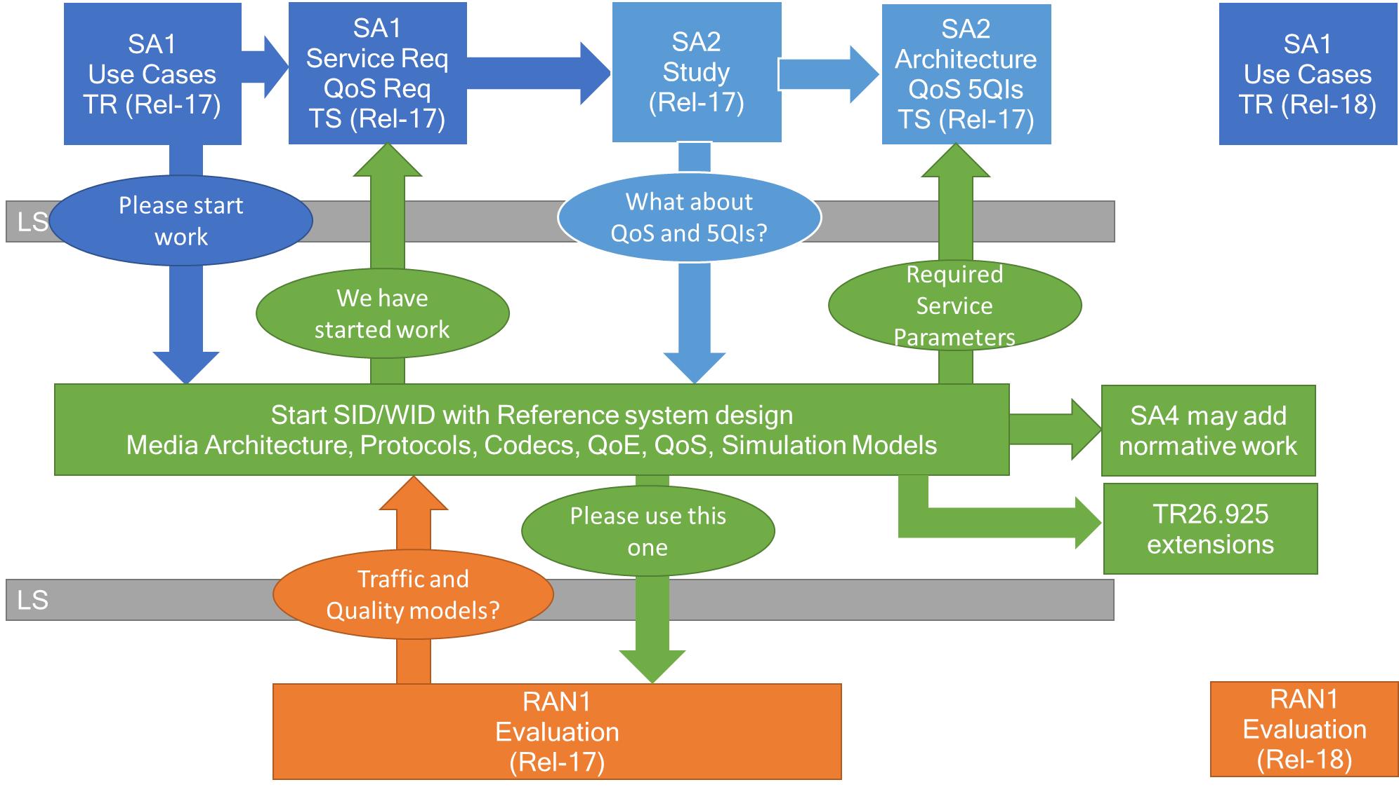

3. Mapped to XR Traffic
In XR traffic, we have been attempting to catch up as much as possible, but we were until now documenting the information in a Permanent Document. Hence the work item update is proposed to document the work on
- Example Services
- Reference System Design
- Media Architecture
- Traffic models
- Quality Evaluation
- QoS requirements
- Simulation models

in a dedicated TR, possibly even in a spec in the future. Such an update is provided in S4-210280.

4. Proposal
It is proposed to
- Adopt the updates in S4-210280 based on the discussion here
- Improve the processes in the future to support SA1, SA2 and RAN1 on detailed media services
  - by starting work early in Releases on media related aspects of services
  - In this work developing a TR/TS details on
    - Example Services
    - Reference System Design
    - Media Architecture
    - Traffic models
    - Quality Evaluation
    - QoS requirements
    - Simulation models

