3GPP TSG-S4 Meeting #112e S4-210153

Online, Still safe at home, 1st - 10th February 2021
CR-Form-v12.1
PSEUDO CHANGE REQUEST
 | 26.802 | CR | <CR#> | rev | <Rev#> | Current version: | 0.1.8
For HELP on using this form: comprehensive instructions can be found at
http://www.3gpp.org/Change-Requests.

Proposed change affects: | UICC apps |  | ME |  | Radio Access Network |  | Core Network

Title: | New Key Issue on “Collaboration and deployment scenarios”
Source to WG: | Ericsson LM
Source to TSG: | S4
Work item code: | FS_5GMSA_Multicast |  |  |  |  |  | Date: |  |  | <Res_date>
Category: | <Cat> |  |  |  |  |  | Release: |  |  | <Release>
 | Use one of the following categories:  F (correction)  A (mirror corresponding to a change in an earlier release)  B (addition of feature),  C (functional modification of feature)  D (editorial modification)  Detailed explanations of the above categories can  be found in 3GPP TR 21.900. |  |  |  |  |  |  |  | Use one of the following releases:  Rel-8 (Release 8)  Rel-9 (Release 9)  Rel-10 (Release 10)  Rel-11 (Release 11)  …  Rel-15 (Release 15)  Rel-16 (Release 16)  Rel-17 (Release 17)  Rel-18 (Release 18)
Reason for change: |  | The discussion on collaboration and deployment discussion has started in S4aI201094. This document contains a text proposal to be inserted into TR 26.802
Summary of change: |  | A new Key Issue around collaboration and deployment scenarios depict the various combinations of function deployments
Consequences if not approved:
Clauses affected:
 |  | Y | N
Other specs |  |  |  | Other core specifications |  |  |  | TS/TR ... CR ...
affected: |  |  |  | Test specifications |  |  |  | TS/TR ... CR ...
(show related CRs) |  |  |  | O&M Specifications |  |  |  | TS/TR ... CR ...
Other comments:
This CR's revision history:

5.x Key Issue #X: Collaboration and deployment scenarios

5.x.1 Description
In the following, four different deployment models are presented. The key guiding assumption here is that the MBSF contains key IP Multicast related BM-SC functions such as a FLUTE Sender (which belongs to the “MBMS Download and Streaming Delivery Function”). The intention is to identify important collaboration scenarios for the normative work.
The existing 5GMSA APIs M1d, M2d, M4d and M5d maybe be extended during 3GPP Release 17 with 5MBS (and other) functions.
It is further assumed that MB-M1 is an evolution of xMB-C and MB-M2 an evolaution of xMB-U.
A general assumption for all the collaboration scenarios is that the 5GMSd functions are used for unicast content distribution, e.g. CDN functionality for DASH streaming is used.

5.x.2 Collaboration A
Collaboration A depicts a deployment where all 5MBS and 5GMSd functions are deployed inside the trusted DN. Three different variants are depicted.
The 5GMSd AF and AS are responsible for unicast content distribution (e.g. CDN), i.e. M5d and M4d are exposed by the 5GMSd functions.
The MBSF and MBSU functions are for 5MBS distribution. The MBSF is the control and interacts with the MB-SMF using Nmbsmf.
- A0: The MBSF is integrated within the 5GMSd AF.
- A1: Fully separated functions.
- A2: Integrated control and user plane functions.
Collaboration A0 describes a model where the MBSF function is integrated into the 5GMSd AF and the MBSU function is still standalone. Background here is that the user plane functions are more specialized, i.e. optimized HTTP servers for unicast and optimized multicast delivery functions for multicast. The 5GMSd AF uses the newly developed MB-M3 (Nmbsu) API to configure and control the multicast delivery functions. The 5GMSd AS might be extended to cut-though any push ingest into the MB-M2.
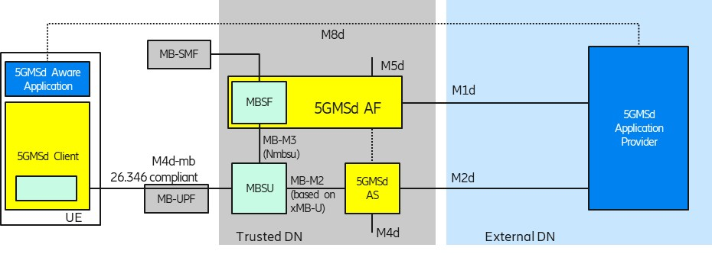
Figure 5.x.2-1: Collaboration A0: MBSF integrated within the 5GMSd AF
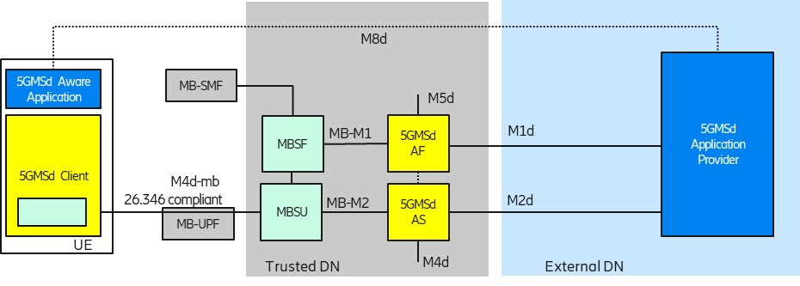
Figure 5.x.2-2: Collaboration A1: Fully separated functions
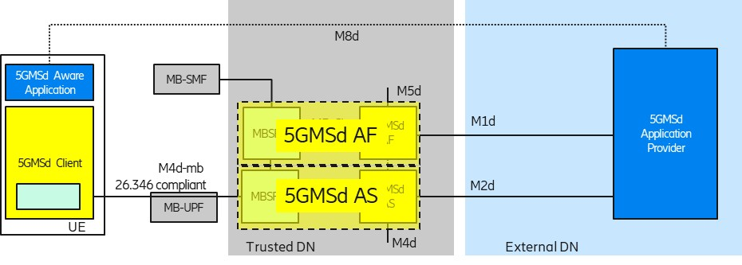
Figure 5.x.2-3: Collaboration A2: Integrated Control and User Plane functions

5.x.3 Collaboration B
Collaboration B depicts a mixed deployment where only the 5MBS related-functions are deployed in the trusted DN. Configuration B in Figure A.3.2-2 (TR 23.757) indicates that an external AF uses the NEF as control plane entry point. It is assumed that the MB-M1 interface is passed through the NEF and that the NEF adds security-related functions transparently.
Like in Collaboration A (and C), the 5GMSd functions are used for unicast content distribution, e.g. CDN functionality for DASH streaming is in an external DN. The functions in the trusted DN are leveraged to prepare the content for 5MBS delivery. Here is it assumed that unicast functions such as unicast content reception (e.g. DASH) and features like file repair are offered by the 5GMSd AS from the external DN.
Also, for Collaboration B, three different variants are depicted.
- B0: The MBSF is presented in the trusted DN for service management.
- B1: The MBSF is absent and only an MBSU is used.
- B2: Only 5MBS functions, without 5GMSA functions.
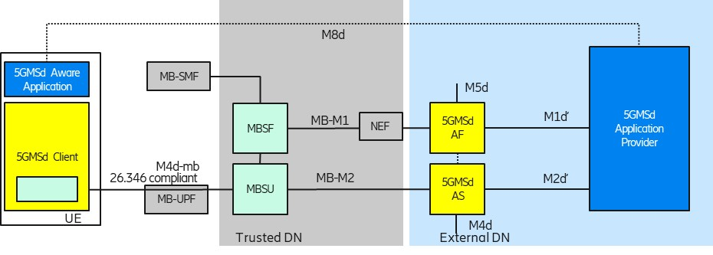
Figure 5.x.3-1: Collaboration B0: Mixed external and trusted DN functions
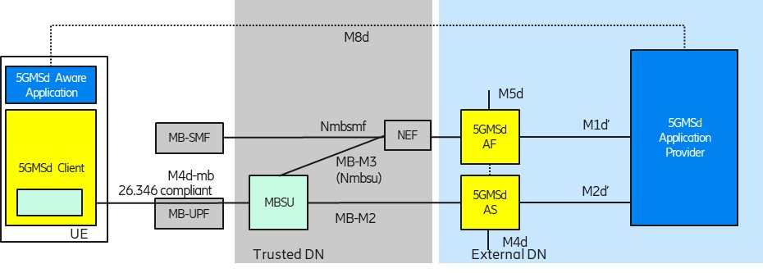
Figure 5.x.3-2: Collaboration B1: Mixed external and trusted DN functions
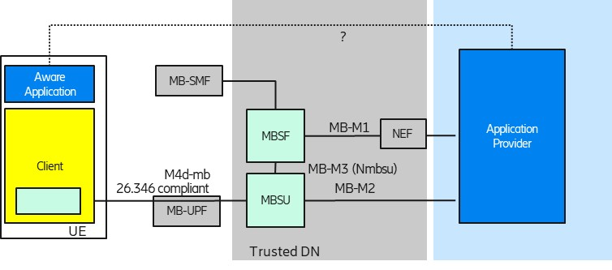
Figure 5.x.3-3: Collaboration B2: Mixed external and trusted DN functions deployedwithout 5GMS functions

5.x.4 Collaboration C
Collaboration C depicts a deployment where all media related functions are deployed in an external DN and the 5G System offers only connectivity services, i.e. either unicast connectivity or 5MBS transport-only connectivity.
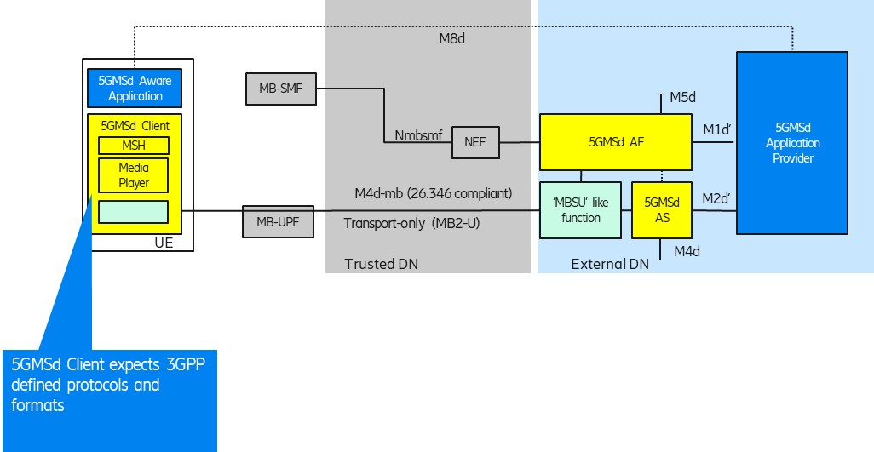
Figure 5.x.4-1: Collaboration C: All media functions in external DN
One could wonder why 3GPP should consider this deployment option. The consideration here is that a 5GMSd Client (including a new 5MBS Client) in the UE can still be leveraged as a multicast receiver, supporting reception of 3GPP-defined “DASH over 5MBS” generic file delivery and RTP streaming. An “MBSU-like” function would generate a bit stream compliant with TS 26.346. An external Application Function (AF) may use Nmbsmf (via NEF) to activate a transport-only type of delivery into the MB-UPF (according to Configuration 1 in Figure A.3.2-2 of TR 23.757).

5.x.5 Collaboration D
Collaboration D depicts a deployment similar to Collaboration #4 in TS 26.501. Here, the media plane does not follow 3GPP specifications. An Application Function (AF) may use Nmbsmf (via NEF) to activate a transport-only type of delivery into the MB-UPF (according to Configuration 1 in Figure A.3.2-2 of TR 23.757). Still, a 3GPP-defined Media Session Handler is interacting with a 3GPP-defined 5GMSd AF.
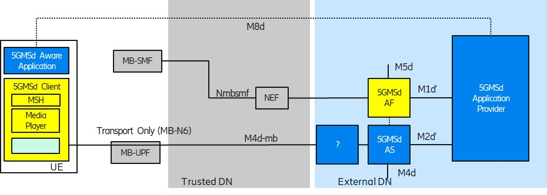
Figure 5.x.5-1: Collaboration D: Usage of transport-only delivery with non-3GPP protocols at M4d-mb

5.x.6 Identified gaps
Editor’s Note: Gaps to be identified
Which scenarios should be supported and what does it mean for APIs / interfaces.

