3GPP TSG SA WG4#112-e meeting S4-210140
1st – 10th February 2021

Agenda item: 8.5
Source: Qualcomm Incorporated, Comcast, Orange, Dolby Laboratories, Tencent
Title: 3GPP DASH – More relevant than ever?
Document for Consideration

Introduction
MPEG and 3GPP developed DASH jointly in 2010. To not be harmed by different publication timelines, MPEG and 3GPP both documented DASH in their own specifications. , MPEG in ISO/IEC 23009-1 and 3GPP in TS26.247. The core specifications was were completely aligned,, and only profiles and extensions were done specified individuallyindependently., Since then, MPEG has extended DASH and 3GPP did continue to adopt text changes at appropriate times to keep the text aligned., However, this had been proven complex over time as two specifications were needed to be maintained in sync.
To maintain and progress MPEG-DASH and 3GP-DASH in an aligned fashion, 3GPP decided to remove the duplicated text in its specification and referenced MPEG-DASH in ISO/IEC 23009-1 under the assumption that the standard remains publicly and freely available.
While ISO/IEC 23009-1 remained public and freely available for the first three editions since 2012 until early 2020, new ISO policies disallowed the standard to remain public and freely available. This document provides a proposal for a possible ressurrection of 3GP-DASH after final checking with ISO.

History
In July 2010, 3GPP members responded to MPEGs CfP on HTTP Streaming with 3GPP Adaptive HTTP Streaming in M17875.
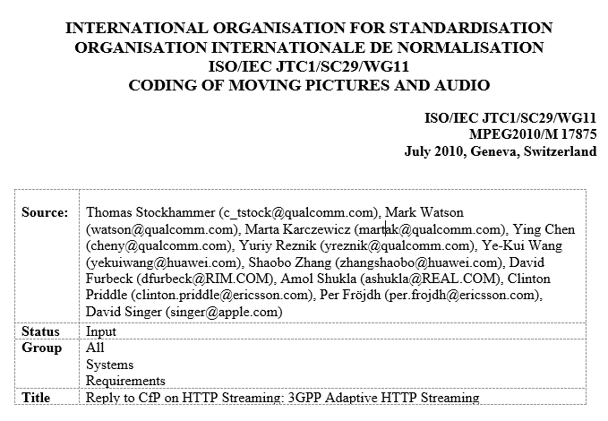
The proposed solution, referred to as 3GPP Adaptive HTTP Streaming (AHS), was the result of a standardization activity in 3GPP SA4. 3GPP AHS was part of the Release-9 Transparent end-to-end Packet-switched Streaming Service (PSS) as defined in 3GPP TS 26.234 (PSS Codecs and Protocols) [2] and its satellite specification 3GPP TS 26.244 (3GP File Format) [3]. Specifically, clause 12 of TS 26.234 defined the 3GPP AHS solution, referencing clauses 5.4.9, 5.4.10, and 13 in TS 26.244.
From the meeting in July 2010, MPEG informed 3GPP in N11443, that AHS was selected as the baseline and MPEG wishes to continue collaboration for a harmonized solution.
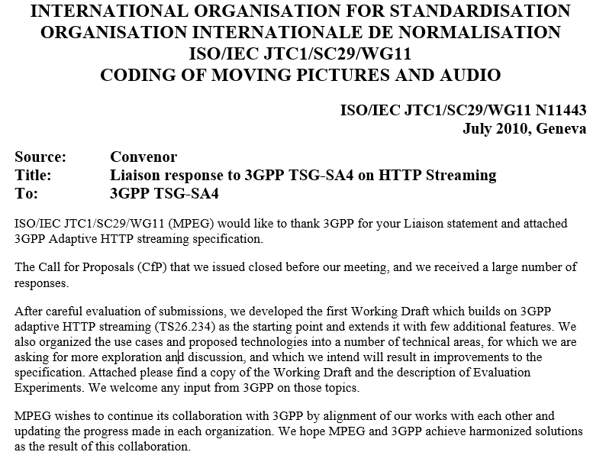
Based on these efforts and collaboration, MPEG and 3GPP developed jointly the work and published the specifications in
- TS 26.247: Transparent end-to-end Packet-switched Streaming Service (PSS); Progressive Download and Dynamic Adaptive Streaming over HTTP (3GP-DASH)
- ISO/IEC 23009-1: Dynamic Adaptive Streaming over HTTP
In addition, in 2011, it was requested and agreed to make DASH a publicly available standard as it was also a 3GPP standard on DASH which is also available for free here: https://standards.iso.org/ittf/PubliclyAvailableStandards.
Resolution 14.2.1 of the Nov 2011 MPEG-98 meeting in Geneva states
14.2 Part 1 Media Presentation Description and Segment Formats
14.2.1 The Systems subgroup recommend that WG11 respectfully asks ITTF to make 23009-1 freely available on the ITTF website, since ISO/IEC 23009-1 and 3GPP TS26.247 specifications share identical technical content in their common parts, and since 3GPP provides its specifications free of charge to the public.
This is a common procedure by ISO also for other standards and follows the ISO Directives (clause 3.2 - https://www.iso.org/sites/directives/current/consolidated/index.xhtml#_idTextAnchor230) defines a PAS as
" A PAS may be an intermediate specification, published prior to the development of a full International Standard, or, in IEC may be a “dual logo” publication published in collaboration with an external organization. It is a document not fulfilling the requirements for a standard. A PAS is a normative document."
This request was granted, and hence, it was assumed that the standard would be and remain free and publicly available.
After one year of intense collaboration, MPEG informed 3GPP in November 2011 as follows:
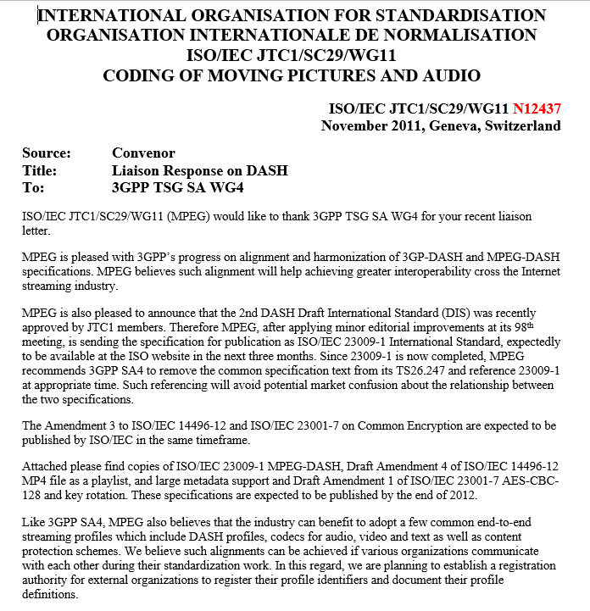
In 2011, MPEG suggested to 3GPP the removal of common text and reference MPEG instead.
In 2013, 3GPP finally decided as course of the work in Rel-12 IS-DASH to follow the proposal and replied
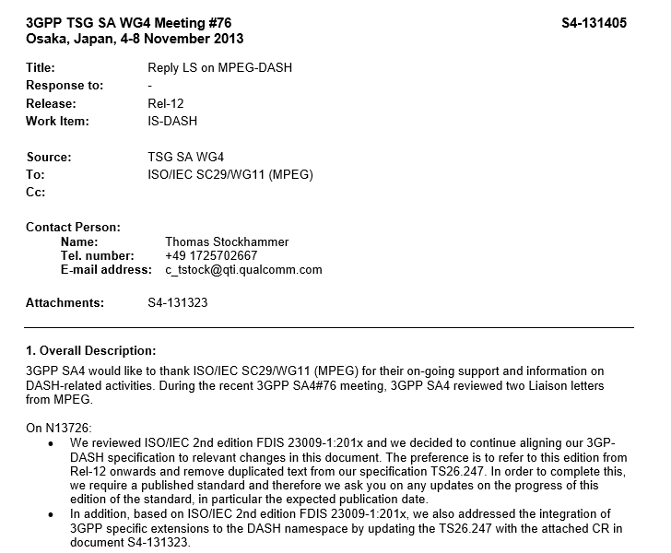
MPEG responded to this by providing the following information

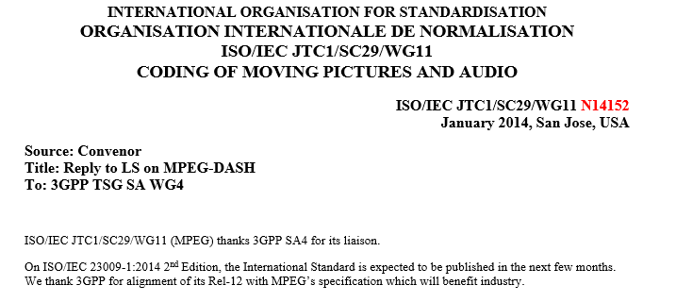
After completion as part of the eDASH work item, 3GPP approved the CR to remove the duplicated text from its specification.
3GPP TSG-SA4 Meeting #85 S4-151201

Kobe, Japan, 24-28 August, 2015 revision of S4-151118
CR-Form-v11.1
CHANGE REQUEST
 | 26.247 | CR | 0082 | rev | 3 | Current version: | 13.0.0
For HELP on using this form: comprehensive instructions can be found at
http://www.3gpp.org/Change-Requests.

Proposed change affects: | UICC apps |  | ME | X | Radio Access Network |  | Core Network

Title: | Alignment with ISO/IEC 23009-1:2014 (MPEG-DASH)
Source to WG: | Qualcomm Incorporated, Ericsson LM
Source to TSG: | S4
Work item code: | eDASH |  |  |  |  |  |  | Date: |  | 2015-08-28
Category: | F |  |  |  |  |  |  | Release: |  | Rel-13
 | Use one of the following categories:  F (correction)  A (mirror corresponding to a change in an earlier release)  B (addition of feature),  C (functional modification of feature)  D (editorial modification)  Detailed explanations of the above categories can  be found in 3GPP TR 21.900. |  |  |  |  |  |  |  | Use one of the following releases:  Rel-8 (Release 8)  Rel-9 (Release 9)  Rel-10 (Release 10)  Rel-11 (Release 11)  Rel-12 (Release 12)  Rel-13 (Release 13)  Rel-14 (Release 14)
Reason for change: |  | MPEG and 3GPP developed DASH jointly in 2010. To not be harmed by different publication timelines, MPEG and 3GPP both documented DASH in their own specifications. MPEG in ISO/IEC 23009-1 and 3GPP in TS26.247. The core specification was completely aligned, only profiles and extensions were done individually, Since then, MPEG has extended DASH and 3GPP did continue to adopt text changes at appropriate times to keep the text aligned, However, this has proven complex over time as two specifications need to be maintained in sync.  As a precedence, the 3GP file format in TS26.244 is also an instantiation of the ISO base media file format (see ISO/IEC 14496-12) and 3GPP referencing to the base spec has worked well.  Therefore, in order to maintain and progress MPEG-DASH and 3GP-DASH in an aligned fashion it is of utmost relevance that duplicated text in 3GPP is removed and reference is provided to MPEG-DASH whereever this is the case.
Summary of change: |  | Update TS26.247 in order to remove all duplicated text and refer to ISO/IEC 23009-1. The updates are considered entirely editorial, i.e. no technical feature has been added or removed. Only corrections that have been applied by MPEG are now also inherited by 3GPP.
Consequences if not approved: |  | Maintaining and progressing MPEG-DASH and 3GP-DASH in an aligned fashion will not be possible leading to expected incompatibilities.
Clauses affected: |  | 2, 3.1, 3.2, 3.3, 4, 7.1. 7.3.1, 7.3.4, 8.1, 8.2.1, 8.3, 8.4.1, 8.4.2.1, 8.4.2.2, 8.4.3.2, 8.4.3.3, 8.4.3.4, 8.4.3.5, 8.4.3.6, 8.4.4, 8.5.1, 8.6.2, 8.6.3, 8.7, 9.2.2, 9.2.3.1, 9.2.3.2, 9.2.3.3, 9.2.3.4, 9.2.4, 9.2.5.1, 9.2.5.2, 9.2.5.3, 9.4.1.2, 9.4.1.3, 9.4.3, 9.4.4, 10.2.2, 10.2.3, 10.2.6, Annex A, A.1, A.2, A.3, A.4, A.5, A.6, A.7, A.8. Annex B.2, Annex C.1, Annex C.2, Annex C.3, Annex G, G.1, G.2, G.3,G.4, G.5, G.6, Annex H.1.1
 |  | Y | N
Other specs |  |  | X | Other core specifications |  |  | TS/TR ... CR ...
affected: |  |  | X | Test specifications |  |  | TS/TR ... CR ...
(show related CRs) |  |  | X | O&M Specifications |  |  | TS/TR ... CR ...
Other comments: |  | ISO/IEC 23009-1 is freely available at http://standards.iso.org/ittf/PubliclyAvailableStandards/c065274_ISO_IEC_23009-1_2014.zip

Since then, 3GP-DASH referenced specifications published in ISO, for example in recent updates to to align deployments across the industry.
MPEG has meanwhile published 4 editions and the 5th edition is technically frozen. DASH is a major component of 5G Media Streaming, please refer to TS 26.512.

3 ISO rationale for the status change
After the request by common participants of ISO and 3GPP as well as other groups in the industry such as DASH-IF and SCTE (see incoming LS in S4-210004), if and when the 4th edition and the 5th edition will be available as freely available standards, ISO stopped to offer this service and no resolution is observed. In particular it is stated by ISO/IEC JTC1 SC29 WG3 (MPEG systems):
On the free availability of the 4th and 5th editions of the DASH specification, we have requested that but it has not been granted because those editions no longer appear to meet the criteria of freely available specification by ISO.

This means that for 3GPP as well as for many other organizations a significant amount of information is not freely available and this status would harm the goal of industry alignment on a single specification.
One can assume that the initial 'request' was honoured but was based on the premise that 3GPP makes the same (or nearly the same) specification freely available. As 3GPP no longer does this, it could be argued (by ISO) that there are no longer reasonable or useful grounds for free publication by ISO. MPEG should have stated this when recommending to avoid duplicate publication.
We also observe that similar problems occur with the 3GPP File format in TS 26.244 as ISO/IEC 14496-12 is also is no longer publicly available.

Proposal
It is proposed to
- send an LS from SA4#112-e to ISO/IEC JTC1
  - requesting the publication based on the historical facts presented in this document asking for publication of ISO/IEC 23009-1 and possibly ISO/IEC 14496-12 on ISO’s publicly available website. This should also hold for all future editions.
  - providing the alternative that 3GPP resumes the publication of its DASH specifications to ensure accessibility of the specification. In the latter case, it would be good to understand if any specific rights issues need to be taken into account.
    - 3GPP may revert its own CR (26.247 CR#0082) and recover the previous specification text with no copyrights issues.
    - As for evolution since the CR in question, company contributions would be needed.
- Revisit the situation in 3GPP after JTC1 response lates in September 2021. If no response is received, 3GPP should take all efforts to resurrect the DASH specification independent of ISO/IEC 23009-1, possibly as part of the 5G Media Streaming series.

