**Agenda Item:** 8.6

**Source:** Tencent

**Title:** FS_EMSA: Architecture update

**Document for:** Discussion

# Summary

This contribution intends to provide a common ground on the edge architecture for media applications based on the contributions and discussion at the Dec 2 ad-hoc call, and also propose some additional considerations

# The potential common architecture

Figure 16 shows the architecture suggested by Richard Bradbury over email after the ad-hoc meeting:

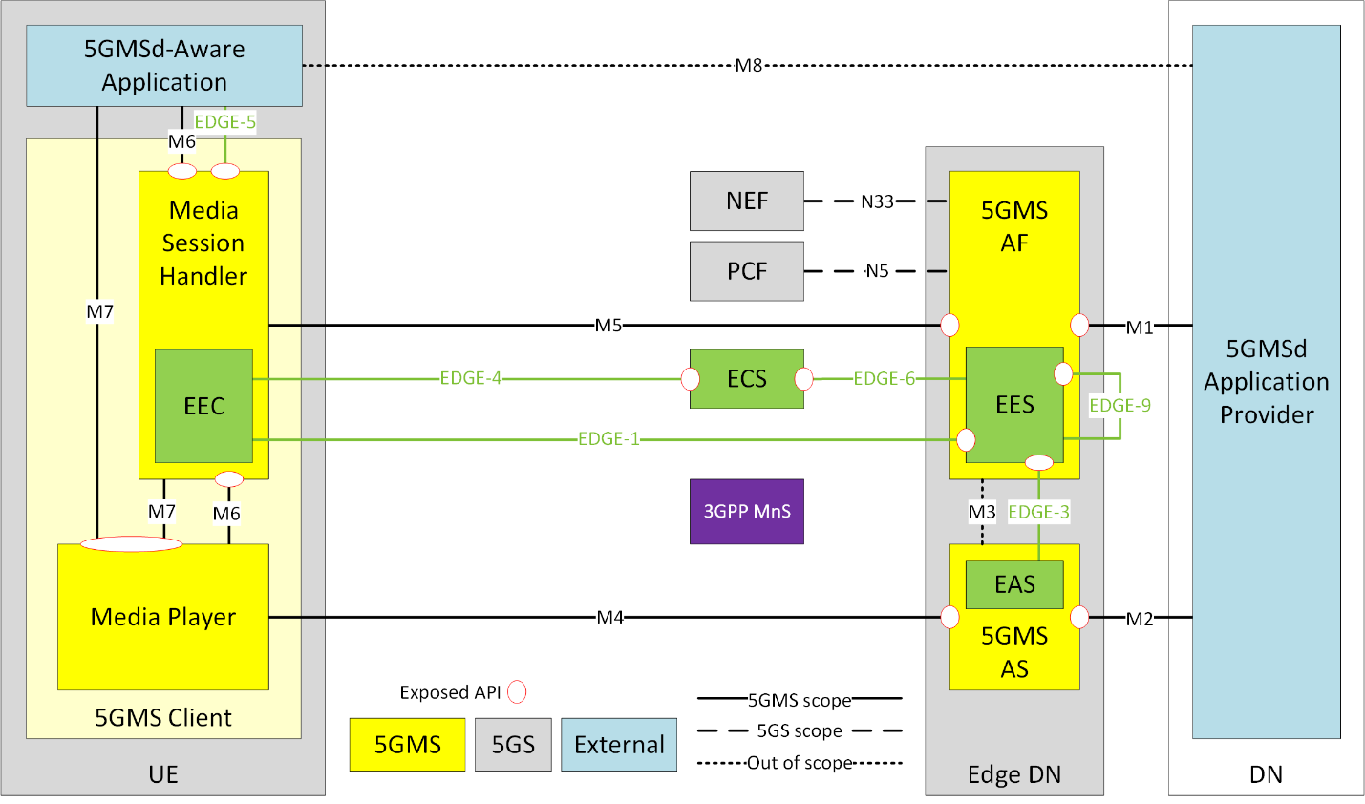

Figure 1: The previously proposed architecture

# Proposed changes

1. In SA6 design, EES can discover multiple EASs. In 5GMSA design only one logical AF and AS are considered. If EAS is part of 5GMS AS, does it mean that a AS may contain multiple EAS’s, or multiple EAS is not allowed? Alternatively, EAS may be a considered as a separate entity from AS. The AF using EES discovers and selects an EAS. Then the 5GMS AS runs on the corresponding hardware defined by EES.
2. Interface support:
   1. Since 5GMA AF support EES, it may optionally support Edge-2 as part of EES.
   2. EAS may optionally support Edge-7
   3. Edge-3 needs to be extended to support media processing support
   4. M1 needs to be extended to indicate the following:
      1. The support of EES and EAS to the Application Provider (Edge-enabled)
      2. Expose the relevant additional information of EES to the Application Provider including the current availability
   5. M6 needs to be extended to indicate:
      1. The support of EEC by MSH (EEC-enabled)
      2. The address of Edge-5 or supporting Edge-5 APIs

# Modified architecture

The proposed modified architecture is as the following:

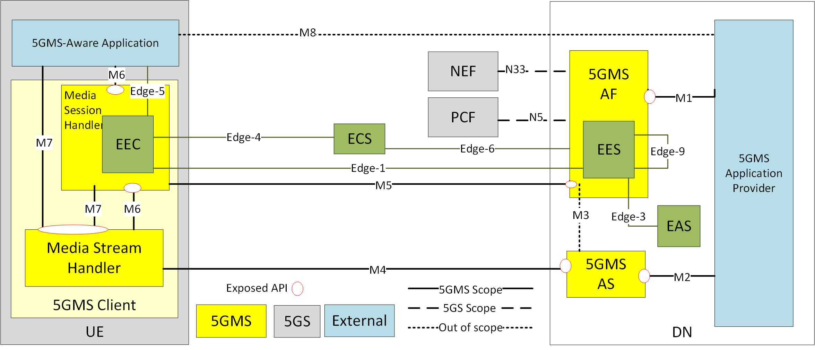

Figure 2: The proposed modified architecture

# Callflow for running media services requested by Application Provider

Figure 3 demonstrates such call flow:

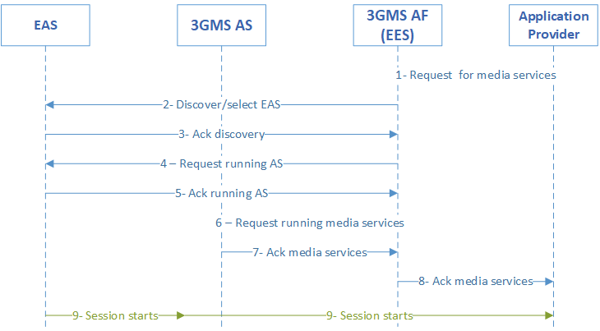

Figure 3: Call flow for running media services on edge, requested by Application Provider

As shown in Figure 3:

1. Application Server Provider (ASP) ASP requests provisioning of specific media services from AF.
2. AF through EES optionally discovers available EAS’s.
3. EAS responds to EES requests.
4. AF requests EAS to instantiates an AS.
5. EAS acknowledges.
6. AF requests AS to run the media services
7. AS acknowledges to AF.
8. AF responds to ASP that the media service is running.
9. The media session starts.

# Callflow for running media services requested by Application on UE

Figure 4 demonstrates such call flow:

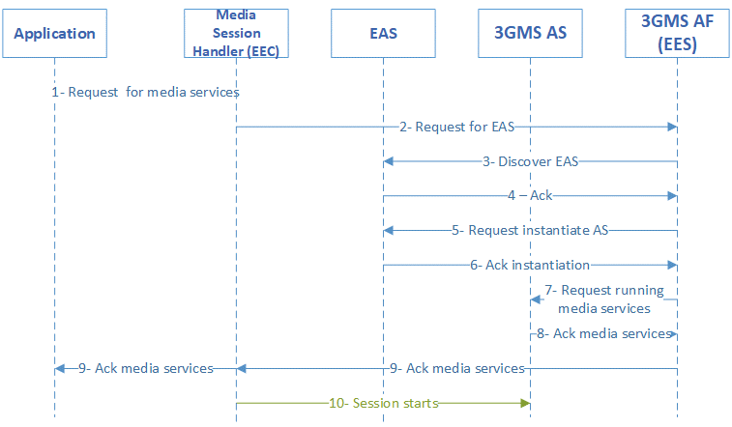

Figure 4: Call flow for running media services on edge, requested by Application on UE

As shown in Figure 4:

1. Application requests provisioning of specific media services from Media Session Handler (MSH).
2. MSH through EEC requests EES to run services.
3. EES optionally discovers available EAS’s.
4. EAS responds to EES requests.
5. AF requests EAS to instantiates an AS.
6. EAS acknowledges.
7. AF requests AS to run the media services
8. AS acknowledges to AF.
9. AF responds to MSH and then the Application that the media service is running.
10. The media session starts.

# Conclusion

We proposed the updated architecture and text in sections 3-6 to be included in TR as one possible deployment scenario.