3GPP TSG SA WG4 #112e S4-21xxxx

E-meeting, 1st – 10th February 2021
CR-Form-v12.0
Pseudo CHANGE REQUEST
 | 26.8xx | CR | <CR#> | rev | - | Current version: | 0.0.0
For HELP on using this form: comprehensive instructions can be found at
http://www.3gpp.org/Change-Requests.

Proposed change affects: | UICC apps |  | ME | X | Radio Access Network |  | Core Network | X

Title: | [FS_5GMS-EXT] Key Topic Scalable distribution of unicast Live Services
Source to WG: | Qualcomm Incorporated
Source to TSG: | SA4
Work item code: | FS_5GMS-EXT |  |  |  |  |  | Date: |  |  | 2021-01-25
Category: | B |  |  |  |  |  | Release: |  |  | Rel-17
 | Use one of the following categories:  F (correction)  A (mirror corresponding to a change in an earlier release)  B (addition of feature),  C (functional modification of feature)  D (editorial modification)  Detailed explanations of the above categories can  be found in 3GPP TR 21.900. |  |  |  |  |  |  |  | Use one of the following releases:  Rel-8 (Release 8)  Rel-9 (Release 9)  Rel-10 (Release 10)  Rel-11 (Release 11)  Rel-12 (Release 12)  Rel-13 (Release 13)  Rel-14 (Release 14)  Rel-15 (Release 15)  Rel-16 (Release 16)
Reason for change: |  | The study item description identifes the key topic “Scalable distribution of unicast Live Services”.
Summary of change: |  | Adds the structure and description for this key topic
Consequences if not approved: |  | Key topic not addressed
Clauses affected:
 |  | Y | N
Other specs |  |  | X | Other core specifications |  |  |  | TS/TR ... CR ...
affected: |  |  | X | Test specifications |  |  |  | TS/TR ... CR ...
(show related CRs) |  |  | X | O&M Specifications |  |  |  | TS/TR ... CR ...
Other comments:
56
This CR's revision history:

===== CHANGE =====

2 References
The following documents contain provisions which, through reference in this text, constitute provisions of the present document.
- References are either specific (identified by date of publication, edition number, version number, etc.) or non-specific.
- For a specific reference, subsequent revisions do not apply.
- For a non-specific reference, the latest version applies. In the case of a reference to a 3GPP document (including a GSM document), a non-specific reference implicitly refers to the latest version of that document in the same Release as the present document.
[1] 3GPP TR 21.905: "Vocabulary for 3GPP Specifications".
[2] 3GPP TS 26.501: " 5G Media Streaming (5GMS); General description and architecture".
[3] 3GPP TS 26.511: "5G Media Streaming (5GMS); Profiles, codecs and formats".
[4] 3GPP TS 26.512: "5G Media Streaming (5GMS); Protocols".
[X3] DASH-IF/DVB Report on Low-Latency Live Service with DASH, July 2017, available here: https://dash-industry-forum.github.io/docs/Report%20on%20Low%20Latency%20DASH.pdf
[X4] DASH-IF IOP Guidelines v5, Low-latency Modes for DASH, available here: https://dash-industry-forum.github.io/docs/CR-Low-Latency-Live-r8.pdf
[X5] ISO/IEC 23009-1, "Information technology — Dynamic adaptive streaming over HTTP (DASH) — Part 1: Media presentation description and segment formats"
[X6] IETF RFC 8673, "HTTP Random Access and Live Content".

===== CHANGE =====

4 Introduction to 5G Media Streaming

4.1 Introduction

4.2 Collaboration Scenarios

4.3 Architectures

4.4 Summary of Stage-3 enablers

===== CHANGE =====

5 Key Topics

5.1 Introduction

5.11 Scalable distribution of unicast Live Services

5.11.1 Description
Live TV services of different scale (professional, user-generated, session-based, etc.) are increasingly distributed over broadband and mobile networks. Live TV services are characterized by scalability (in terms of concurrent users), consistent quality, high bandwidth requirements, and latency constraints. Consistent support of the distribution of such services to a different scale of users and in a concurrent fashion is a prime concern. 5G Media Streaming is expected to support such service distribution and end-to-end optimizations. Improvements and optimizations on the architectural level and stage 3 are expected to be studied.
Based on a report developed jointly between DVB and DASH-IF on Low-Latency DASH [X3], this clause defines details on how to support consistent latency in DASH for linear TV services. In [X3], several definitions had been introduced, repeated here for consistency.
End-to-End Latency (EEL): The latency for an action that is captured by the camera until its visibility on the remote screen.
Encoder-Display Latency (EDL): The latency of the linear playout output (which typically serves as input to distribution encoder(s)) to the screen
Packager-Display Latency: The latency after the output of the distribution encoder to the screen
CDN latency: The delay caused by the CDN delivery from CDN input to CDN output.
Live Edge Start-up Delay (LSD): The time between a user action (service access or service join) and the time until the first media sample of the service is perceived by the user when joining at the live edge. Typically also the channel change time.
Seek Start-up Delay (SSD): The time between a user action (service access or service join) and the time until the first media sample of the service is perceived by the user when seeking to a time shift buffer.
Those two categories, latency and delay are subject to be controllable by the service provider for a consistent service offering. In the remainder, primarily the Encoder-Display Latency (EDL) and the Live Edge Start-up Delay are considered, but for some use cases also the End-to-End Latency (EEL) may be relevant. Figure 1 provides a schematic overview of the different latencies.
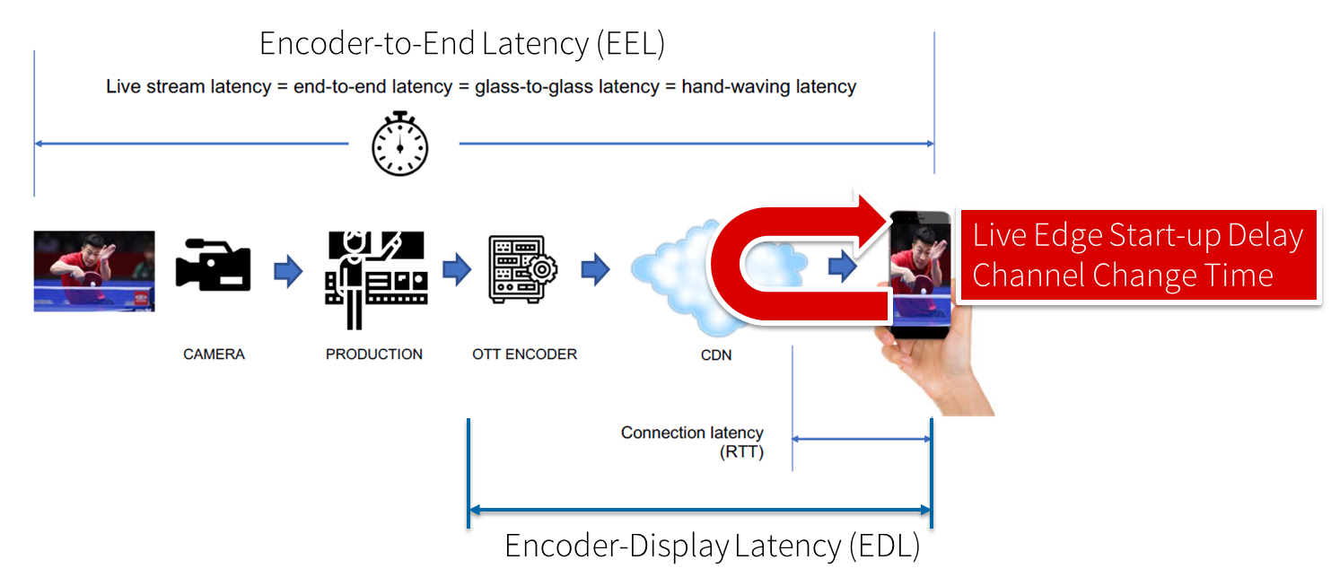
Figure 1 Different latencies and delays relevant for low-latency distribution
The Low Latency DASH scenario is a variant of the Live Services recommended approach focused on ensuring that the Encoder-Display Latency of the DASH Media Presentation is comparable to the latency when distributing over terrestrial, cable or satellite broadcast. Latency in broadcast is not a unique universal value, as it is influenced by many factors such as the duration of the broadcast encoding pipeline, the latency of the transport channel which can slightly differ per type (satellite, cable, IPTV or, DTT...), or the artificial delays introduced by local content moderation regulations. However, most of the measurements converge on a 3 - 10 seconds latency between the moment where the source signal is acquired for encoding and the moment when it's played back on the TVs, i.e the EDL. Start-up delay requirements are typically in the range of 1-2 seconds. For details refer to [X3].
Low-latency mode are supported to minimize the architectural impacts on existing workflows. Figure 3 provides a basic flow of information for operating a low-latency DASH service as defined in DASH-IF’s Low-latency Modes for DASH [X4]. The DASH packager gets information on the general description of the service as well as the encoder configuration. The encoder produces CMAF chunks and fragments. The chunks are mapped by the MPD packager onto Segments and provided to the network in incremental fashion using HTTP/1.1. chunked transfer.
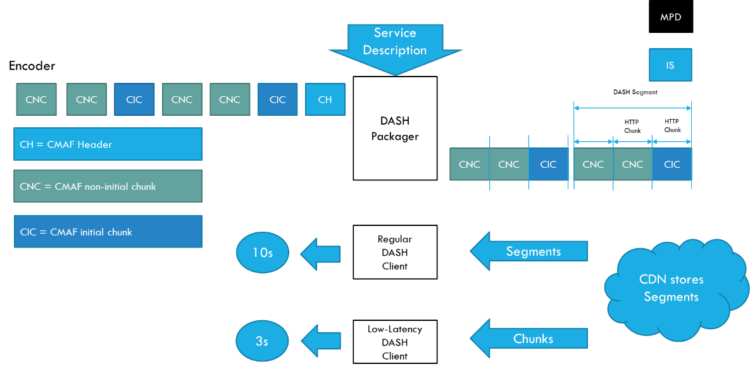
Figure 5.11.1-2 Basic operation flow Low-Latency DASH
HTTP chunked transfer encoding needs to be supported up from the ingest into the packager up to the CDN edge, whereas the last mile delivery is expected happen using HTTP chunked transfer encoding or HTTP in regular mode. If HTTP chunked transfer encoding is supported by the DASH player, it basically means that a media segment carrying the latest moment of the program (also known as the "live edge time" as defined in clause 4 of this document) could be consumed on the player while it's still being produced by the encoder and the packager.
In case chunked segments are used, clients may want to access partially available Segments for example for fast random access, see ISO/IEC 23009-1 [X5]. However, requesting available byte ranges of a partially available Segment, i.e., Segments still being produced, is not consistently supported in CDNs, but solutions are provided in RFC8673 [X6]. This functionality may also be needed to support common segment handling for low-latency DASH and low-latency HLS.
Key aspects for low-latency live distribution include:

- consistent support for chunked transfer from ingest to client.
- support for partially access of non-complete ressources
- end-to-end optimizations to support the latency requirements

5.11.2 Collaboration Scenarios
Editor’s Note: Study collaboration scenarios between the 5G System and Application Provider for each of the key topics.

5.11.3 Deployment Architectures
Editor’s Note: Based on the 5GMS Architecture, develop one or more deployment architectures that address the key topics and the collaboration models.

5.11.4 Mapping to 5G Media Streaming and High-Level Call Flows
Editor’s Note: Map the key topics to basic functions and develop high-level call flows.

5.11.5 Potential open issues
Editor’s Note: Identify the issues that need to be solved.

5.11.6 Candidate Solutions
Editor’s Note: Provide candidate solutions (including call flows) for each of the identified issues.

