3GPP TSG-SA4#112e Meeting S4-210XXX
1st -10th February 2021

Agenda item 11.5
Source: Tencent
Title: Update to: Audio mixing of multiple streaming in ITT4RT
Document for Agreement

Introduction
This contribution relates to audio downmixing signaling, for immersive and overlay streams, so that the receiving device mixes the audio streams correctly and in a meaningful way. Here, the ITT4RT-Tx client sends recommendations about mixing gain to the ITT4RT-Rx client. This recommendation maybe based on factors like dominating or subsiding any overlay audio. It is upto the ITT4RT-Rx client to accept the recommendations or may as well define its own mix.
We think at this point, the contribution should be considered in phase 1, since audio mixing may be considered independent of the audio streams being mono or stereo, particularly for the codecs that are not object based. The intention of this contribution is not to interfere with IVAS standardization progress and scope, i.e. IVAS may provide an alternative method of audio mix in furture. However, we want to provide some use-case scenarios and some recomended solutions for audio mixing in ITT4RT phase 1. Currently to our knowledge, MTSI does not recommend any techniques for audio mixing.

Usecase
The assumptions are as the following:
- The sender’s conference room has a 360 video with one audio stream (In reality, it may have multiple streams but for simplicity of the usecase, we only consider one audio stream).
- The sender may have one or more overlays each of which may have its own audio stream.
- The receiver receives the audio stream from the sender’s room as well as the audio streams from one or more overlays.
The above assumption is shown in the following figures:

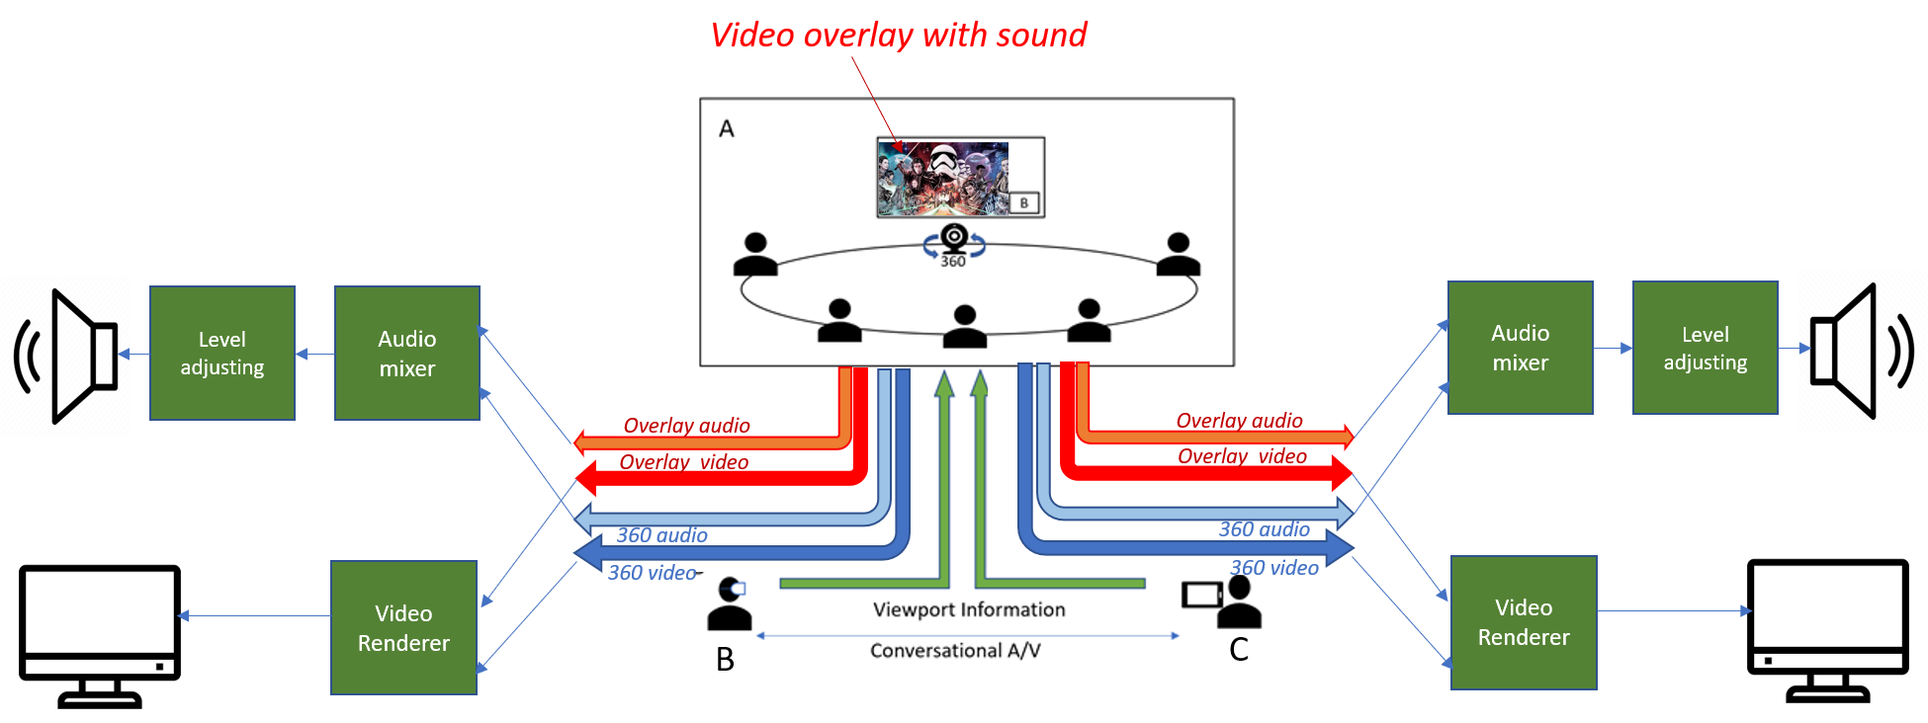
Figure 1 - 360-degree conference call
Note that as is shown in the figure the overlay video has its own overlay audio. Its audio either has to be mixed at the sender with the room’s audio and sent as a single stream, or it needs to be delivered as a separate stream. If it is mixed in the sender, the sender needs to decode the overlay’s audio, mix it with the room’s audio and encode the mix again for transmission. If it is sent as a separate streams, then it must be mixed with the room’s audio at the receiver. This contribution focuses on the audio mixing at the receiver.
The following use-cases are considered for audio mixing:
- Case 1: Providing the recommended mixing gain at the receiver’s end for rooms and overlay audios.
- Case 2: Changing the recommended mixing gain by sender during a portion of the session to dominate the overlay audio (e.g. reducing the room’s chatter when the overlay audio is important) or the room audio (e.g. when speaker in the room wants the remote audience focus on his speech)

Recommended solution
When multiple audio streams are transmitted from the ITT4RT-Tx client, the ITT4RT-Rx client decodes and downmixes these audio streams before rendering. The ITT4RT currently doesn’t address the audio mix of different sources. In this proposal, the recommended mixing gain of different audio streams may be defined by the ITT4RT-Tx client and may be updated during the session. This setting is used by the ITT4RT-Rx client to mix the audio streams if it chooses to accept ITT4RT-Tx’s recommendation. The user at ITT4RT-Rx client may overwrite this setting at any time.
For downmixing multiple audio streams, the sender may send the recommended mixing gain for each audio source of that sender: r₀, r₁, .., r_{N} for the 360 video (a0) and overlay videos a₁, a₂, .., a_{N} respectively and therefore recommend the mix of r0*a0+r1*a1+……+rn*a_{n}.
The ITT4RT-Rx client mixes the audio sources proportionally to their mixing gain. Using this gain function, the following scenarios are possible among others:
- Use case 1: The sender may send the recommended mixing gain at initial SDP negotiation to the receivers.
- Use case 2: The sender may send updated recommended mixing gain in the middle of the session.

Further details and clarifications

- Wrt to this proposal, overlay video (AV content) is in a file (like a r-noercre ecorded v is distributed to the room (local playback) and users as separate streams. These overlay streams are pre-encoded canned media and hence no adjustments can be made at the sender side unlesswithu ti ecodinge n eecoding thesreamsmed. To When someone stsenting it, it is directly streamed from the files to the room/users. The conference room (local playback) only needs a projector and a speaker. As the audio and video streams of the overlay content are directly streamed to user/room, the overlay audio is not captured in the conference room. Similarly for multiple overlay streaming, each stream is independently sent to the users/room where they are downmixed, assuming the room has multiple projectors but one speaker. It is assumed thatThe pr ceskoldeo h eeso the overlay canned media may allows the client to determine what would be th recommended mixing gain.The playback of audio overlays in the 360-room will bleed into the microphones. It is assumed that processing (such as echo cancelling) is used to successfully eliminate this bleed from being transmitted. Hence, issues like double audio may be avoided.

- The goal of the proposal is to provide control (in form of recommendation) for mixing different audios (from conf room and overlay(s)) in a meaningful way. A practical use-case of it is when someone is speaking in the room about a video overlay that is being played at the same time. On some occasions s/he wants to lower overlay’s audio, so s/he can be heard more easily or other times s/he may want to raise the volume of the overlay because s/he wants the remote audience to pay attention to the important detail in the overlay’s audio. At the same time, the receiver-mix approach provides flexibility for each remote recipient to overwrite that recommendation with his/her own choice.

- The audio mixing gain recommendation by the sender only applies to the audio streams (360 + overlays) originating/shared by the sender.
- It is recommended to perform the mixing at the receiver because of the following reasons:
- If the sender performs the mixing, then a single downmixed audio stream is sent to all the remote receivers without the receiver having the flexibility to change the mix (eg. mute/reduce any audio stream). Howerever, the intention is to give the receiver the flexibility to change audio level of different audio streams.
- Level adjustment should be considered independent of audio mixing. Level adjustment is equivalent to normalizing the output audio stream after individual audio streams are downmixed with the corresponding audio weights.

Proposal
We propose to add section 2 of this contribution to section 3 under new section “Audio mixing of multiple streaming in ITT4RT ” in the permanent document. The specific signaling semantics for the audio mixing will be provided in the next contribution.

