3GPP TSG-SA4#112e Meeting S4-210129
1st -10th February 2021

Agenda item 11.5
Source: Tencent
Title: Update to: Audio mixing of multiple streaming in ITT4RT
Document for Agreement

Introduction
The ITT4RT permanent document specifies the use of NBMP for network-based stitching at MRF/MCU. In this case, different 2D captures are sent from the conference room to MRF/MCU which performs decoding, stitching, and re-encoding to produce the immersive video, which is then distributed to the remote participants. This happens when the end device does not have enough processing capability or when the end device is not MTSI compatible.
We think at this point, the contribution should be considered in phase 1, since audio mixing may be considered independent of the audio streams being mono or stereo, particularly for the codecs that are not object based. This contribution relates to audio downmixing signaling, for immersive and overlay streams, so that the receiving device mixes the audio streams correctly or by using network-based media processing in the media-aware network elements such as MRF/MCU, thereby offloading the processing from the end devices.
The intention of this contribution is not to interfere with IVAS standardization progress and scope, i.e. IVAS may provide an alternative method of audio mix in furture. However, we want to provide some use-case scenarios and some recomended solutions for audio mixing in ITT4RT phase 1. Currently to our knowledge, MTSI does not recommend any techniques for audio mixing.

Usecase
The assumptions are as the following:
- The sender’s conference room has a 360 video with one audio stream (In reality, it may have multiple streams but for simplicity of the usecase, we only consider one audio stream).
- The sender may have one or more overlays each of which may have its own audio stream.
- The receiver receives the audio stream from the sender’s room as well as the audio streams from one or more overlays.
The above assumption is shown in the following figures:

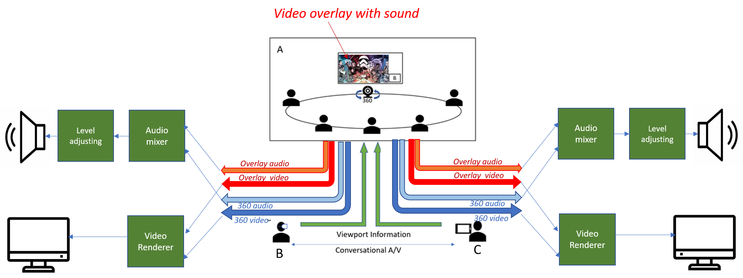
Figure 1 - 360-degree conference call
Note that as is shown in the figure the overlay video has its own overlay audio. Its audio either has to be mixed at the sender with the room’s audio and sent as a single stream, or it needs to be delivered as a separate stream. If it is mixed in the sender, the sender needs to decode the overlay’s audio, mix it with the room’s audio and encode the mix again for transmission. If it is sent as a separate streams, then it must be mixed with the room’s audio at the receiver. This contribution focuses on the audio mixing at the receiver.
The following use-cases are considered for audio mixing:
- Case 1: Providing the default/recommended mixing level weights at the receiver’s end for rooms and overlay audios.
- Case 2: Changing the recommended mix level by sender during a portion of the session to dominate the overlay audio (e.g. reducing the room’s chatter when the overlay audio is important) or the room audio (e.g. when speaker in the room wants the remote audience focus on his speech)

Basic solution
When multiple audio streams are transmitted from the ITT4RT-Tx client, the ITT4RT-Rx client decodes and downmixes these audio streams before rendering. The ITT4RT currently doesn’t address the audio mix of different sources. In this proposal, the default mixing level weight of different audio streams may be set by the ITT4RT-Tx client and may be updated during the session. This setting is used by the ITT4RT-Rx client to mix the audio streams. The user at ITT4RT-Rx client may overwrite this setting at any time.
For downmixing multiple audio streams, the sender may send the mixing level weight for each audio source of that sender: r₀, r₁, .., r_{N} for the 360 video (a0) and overlay videos a₁, a₂, .., a_{N} respectively and therefore recommend the mix of r0*a0+r1*a1+……+rn*a_{n}.

Downmix at MRF/MCU
If the end device’s capabilities is limited due to battery power, a certain or all processings for mixing may be offloaded to the MRF/MCU. These audio streams may include streams for 360-degree, as well as streams for overlays. When the audio processing is offloaded to MRF/MCU, multiple audio streams may be downmixed into a single stereo or mono stream, which may be sent to the end device for rendering. The ITT4RT-Rx client may also offload only a portion of the process to the MRF/MCU. For example, downmixing of overlay streams maybe offloaded to MRF/MCU and dowmixing of the (downmixed) overlay stream with 360-stream maybe processed at the ITT4RT-Rx client side.

Mixing at ITT4RT-Rx
The ITT4RT-Rx client or MRF/MCU mixes the audio sources proportionally to their weights. Using this weight function, the following scenarios are possible among others:
- Use case 1: The sender may send the recommended mixing level weights at initial SDP negotiation to the receivers.
- Use case 2: The sender may send updated recommended mixing level weights in the middle of the session. I a s D eoito hnteudtsaeocsoa.Hwvr hnteudtsaednmc h pae ab et i T edretnin rRC.

- Further details and clarifications
- The playback of audio overlays in the 360-room will bleed into the microphones. It is assumed that processing (such as echo cancelling) is used to successfully eliminate this bleed from being transmitted. Hence, issues like double audio may be avoided.

- The audio weights recommendation by the sender only applies to the audio streams (360 + overlays) originating/shared by the sender.
- It is recommended to perform the mixing at the receiver because of the following reasons:
- If the sender performs the mixing, then a single downmixed audio stream is sent to all the remote receivers without the receiver having the flexibility to change the mix (eg. mute/reduce any audio stream). Howerever, the intention is to give the receiver the flexibility to change audio level of different audio streams.
- Level adjustment should be considered independent of audio mixing. Level adjustment is equivalent to normalizing the output audio stream after individual audio streams are downmixed with the corresponding audio weights.

Proposal
We propose to add section 2 of this contribution to section 6.5 “Potential Solutions for Network-based Stitching” in the permanent document. The specific SDP signaling semantics for the audio weights will be provided in the next contribution.

