3GPP TSG SA WG4#115-e meeting S4-211202
18th– 27th August 2021 revision of S4-211188

CR-Form-v12.0
PSEUDO CHANGE REQUEST
 | 26.955 | CR | pseudo | rev | 2 | Current version: | 1.2.5
For HELP on using this form: comprehensive instructions can be found at
http://www.3gpp.org/Change-Requests.

Proposed change affects: | UICC apps |  | ME |  | Radio Access Network |  | Core Network

Title: | [FS_5G_Video] Characterization
Source to WG: | Qualcomm Incorporated, Tencent
Source to TSG:
Work item code: | FS_5GVideo |  |  |  |  |  | Date: |  |  | 11/08/2021
Category: | B |  |  |  |  |  | Release: |  |  | 17
 | Use one of the following categories:  F (correction)  A (mirror corresponding to a change in an earlier release)  B (addition of feature),  C (functional modification of feature)  D (editorial modification)  Detailed explanations of the above categories can  be found in 3GPP TR 21.900. |  |  |  |  |  |  |  | Use one of the following releases:  Rel-8 (Release 8)  Rel-9 (Release 9)  Rel-10 (Release 10)  Rel-11 (Release 11)  Rel-12 (Release 12)  Rel-13 (Release 13)  Rel-14 (Release 14)  Rel-15 (Release 15)  Rel-16 (Release 16)
Reason for change:
Summary of change:
Consequences if not approved:
Clauses affected:
 |  | Y | N
Other specs |  |  |  | Other core specifications |  |  |  | TS/TR ... CR ...
affected: |  |  |  | Test specifications |  |  |  | TS/TR ... CR ...
(show related CRs) |  |  |  | O&M Specifications |  |  |  | TS/TR ... CR ...
Other comments:
This CR's revision history: |  | S4-211026 [FS_5G_Video] Characterization Qualcomm Incorporated Thomas Stockhammer  Presenter: Thomas Stockhammer, Qualcomm  Online Discussion:  - Change 1:  - Lukasz: Correct to not leave it in the characterization. Moving up is ok, can check details.  - Alexis: Everything should be 10-bit as agreed, it needs some work  - Thomas: Will fix by offline discussion.  - Change 2:  - Alexis: against weighting number of frames  - Thomas: ok by not weighting, reason was that we use the number of pixels.  - Rajesh: let’s not weigh, it is not used in JVET.  - Thomas: explains that we have different length, so we implicitly weight.  - Gilles: could also be different for 1 hour sequence.  - Dmytro: averages across sequences  - Alexis: also min and max can be reported  - Gilles: should we look at  - Dave: It is useful to have min and max, encoder manufacturers aim for the best worst quality not for the best quality on average.  - Thomas: Good discussion, but prefer to close this before we get results  - Dmytro: Can we do a revision with the comments  Decision:  - We revise based on the discussion.  S4-211026 is revised to S4-211188.  S4-211188 [FS_5G_Video] Characterization Qualcomm Incorporated Thomas Stockhammer  Online Presenter: Thomas Stockhammer (Qualcomm)  Online Discussion:  - Rajesh: Can we remove last bullet?  - Thomas: ok  - Fabrice: please fix SSIM settings  - Lukasz: will do  Decision:  - Revise based on above.  S4-211188 is revised to S4-211202.

===== CHANGE =====

5.5.7 Reference computation of SDR metrics

Computation of PSNR(Y), PSNR(U) and PSNR(V) metrics as defined in clause 5.5.3 is performed with HDRMetrics tool [67] with the following parameters specified:

- EnablePSNR=1
- EnableJVETPSNR=1
- MaxSampleValue=1020.0

Computation of MS-SSIM metric as defined in clause 5.5.4 is performed with HDRMetrics tool with the following parameters specified:

- EnableJVETMSSSIM=1
- MaxSampleValue=1020.0
NOTE: in HDRMetrics v22 log transformation of MS-SSIM values is not available and is expected to be implemented in a future release of HDRTools

Computation of VMAF using FFMPEG build with integrated libvmaf (such as available at https://www.gyan.dev/ffmpeg/builds/) is performed using the following command line:
.\ffmpeg -s $WxH -pix_fmt $PIX_FMT -r $FRAME_RATE -i ref.yuv -s $WxH -pix_fmt yuv420p10le -r $FRAME_RATE -i test.yuv -lavfi libvmaf=model_path=$PATH_TO_MODEL -f null –
$WxH: specifies resolution of the video e.g., 1920x1080, 3840x2160,
$PIX_FMT: specifies pixel format e.g., yuv420p10le,
$FRAME_RATE: specifies video frame rate e.g., 30, 60,
$PATH_TO_MODEL: specifies path to VMAF model.
For the computation of VMAF, SSIM and MS-SSIM, the C++ executable “vmafossexec” [59], open source provided by Netflix could be used (Licence BSD + Patent) (Note: a tag need to be defined for libvmaf and vmafossexec). MS-SSIM is computed in Vmafossexec with the default 11 Gaussian Window and default K1=0.01 and K2=0.03.
Here is the command line:
vmafossexec $VMAF_FMT $WIDTH $HEIGHT ref.yuv test.yuv $VMAFMODEL --thread 1 --psnr --ssim --ms-ssim --log metrics.vmaf
$VMAF_FMT: describe yuv subsampling (yuv420p10le or yuv420p8In10leOut)
$VMAFMODEL: vmaf_4k_v0.6.1.pkl (4K and more) or vmaf_v0.6.1.pkl (HD and lower res)
thread: 0 to use all threads available
Note: the VMAF executable allows to extract the psnr which could also be used to check if it matches reference software output.

Additional libvmaf parameters phone_model and enable_transform are set to 0.

5.5.8 Reference computation of HDR metrics
Editor’s Note: The parameter settings still need to be confirmed. The configuration files will be attached to the report once confirmed.
Computation of wPSNR(Y), wPSNR(U) and wPSNR(V) metrics as defined in clause 5.5.5 is performed with HDRMetrics tool with the following parameters specified:
[
- EnableJVETPSNR=1
- EnableWTPSNR=1
- WeightTableFile="hdrTable.txt"
]
where hdrTable.txt is available in cfg/hdrTable.txt of HDRTools repository.
Computation of DeltaE100 and PSNRL100 metrics requires conversion from YUV to linear light RGB data which is performed with the use of HDRConvert and reference config file cfg/JCTVC_CTC_cfgFiles/YCbCr/HDRConvertYCbCr420ToEXR2020.cfg
After the conversion for reference and decoded video clips is done, computation of DeltaE100 and PSNRL100 metric as defined in clause 5.5.5 is performed with HDRMetrics tools with the following parameters specified:
[
- MaxSampleValue=10000.0
- WhitePointDeltaE1=100.0
- EnableDELTAE=1
- DeltaEPointsEnable=1.
]

===== CHANGE =====

5.7 Characterization
Characterization is the comparison of a codec under test with an anchor based on the framework introduced in this clause. Characterization in this report is based on Bjöntegard-Delta (BD)-rate information according to [44].
Characterization is expected to provide a summary of the expected gains a codec under test would provide, compared to a reference codec. For characterization, the metric results in this Technical Report are used to derive summary numbers. It is important for a codec to understand the performance for individual scenarios, for individual configurations within a scenario, but also for individual reference sequences. At the same time, a summary comparison is beneficial to provide an overview of the overall performance. A summary based on averages of selected sequences as an example can only provide indication of the performance if the reference sequences would be fully representative. However, it is also of interest to understand maximum and minimum gains.

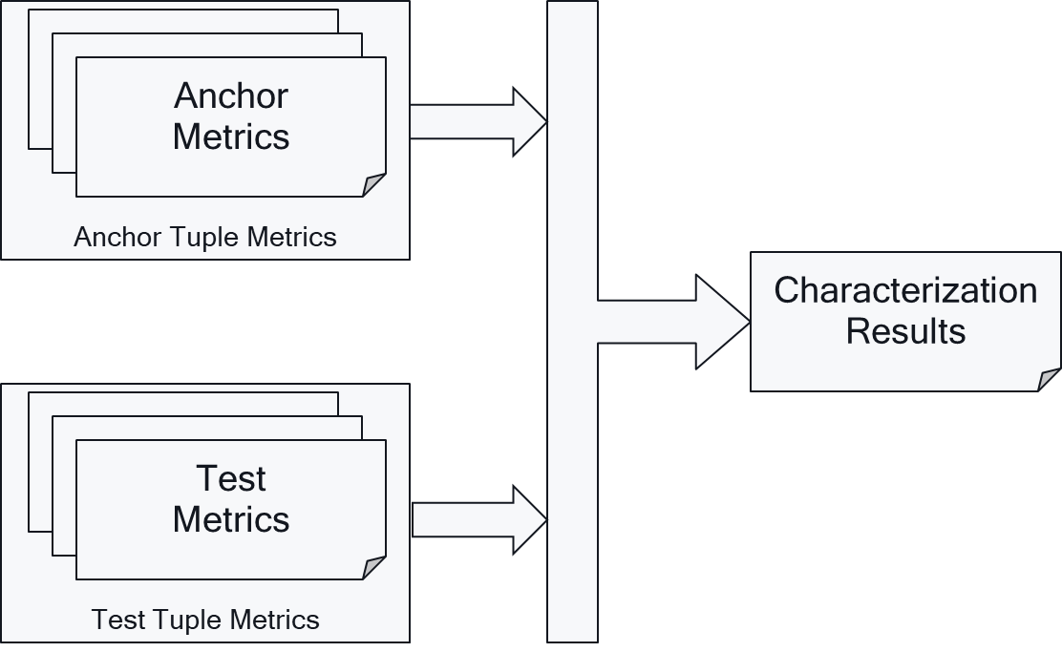
Figure 5.7-1: Characterization Framework
Based on this, a full characterization of a codec for a scenario against a 3GPP codec is expected to provide at least the following metrics
- The BD-rate gain (for a given metric and a given anchor codec) for each reference sequence in the test configuration.
- The minimum, maximum and average BD-rate gain (for a given metric and a given anchor codec) across all reference sequences in the test configuration.
Note that this results typically in the following results for a codec under test:

- For each scenario and for each configuration, a table is provided to compare against each anchor codec
- where the row header documents the reference sequence for the test, e.g. S5-R<i> to the specific configuration.
- where the column header documents the key of the metric
- that documents in the cell with BD-Rate gain
- the above is extended with three summary rows, where the column header documents average, minimum and maximum gain
An example is provided in Table 5.7-1.
Table 5.7-1 BD-Rate gain example table for a given codec under test, a given anchor codec and given test configuration
Reference sequence | y_psnr | u_psnr | v_psnr | psnr | ms-ssim | vmaf
S5-R01
S5-R02
S5-R03
S5-R04
S5-R05
S5-R06
S5-R07
S5-R08
S5-R09
S5-R10
S5-R11
S5-R12
S5-R13
Average
Minimum
maximum

BD-Rate is computed according to the CTC method used in JVET and specified in [44] from the tools publicly available: Reference codec software, Excel file available in [57] for SDR and in [58] for HDR.
The Excel files include the VBS script bdrate( ) to compute the BD-Rate performance between a test codec and a reference from four or five rate-distortion points.
These excel files have been extended in the Random-Access and low delay tabs to contain new columns for the new metrics: VMAF and MS-SSIM, in the SDR case only. The “SA4 extended excel files” for SDR and HDR are attached as S4-template-HDR.xlsx and S4-template-SDR.xlsx.
Editor’s Note: Need to decide what to do if a metric does not have a monotonic behavior for a particular sequence.
Editor’s Note: At this stage the BD-Rate is defined as result of the above excel sheets. In an updated version of the TR, an independent metric computation tool may be provided that allows to generate the BD-Rate values based on the metrics results. The reference for an extended version with 5 points is still tbd.

