Source: KPN N.V.
Title: ITT4RT example flow for presentation overlay
Agenda Item: 16.2 - ITT4RT (Support of Immersive Teleconferencing and Telepresence for Remote Terminals)
Document for: Discussion & Agreement
Introduction
In the #113-e meeting a solution for presentation-type overlays was presented and accepted. In this follow-up contribution we like to add an example message flow to clarify the use of presentation overlay further. Proposed changes to the permanent document of ITT4RT are indicated with change marks.
Text from PD & example flow

6.3.5 Presentation overlay (screen share)
One common situation in a meeting is to present additional material (e.g., slides, screen share video, notes, etc.) on a display (screen or projector). When capturing such a display with a 360-degree camera, this can lead to significant quality degradations, based on the characteristics of the camera, display and lighting conditions. Simply most setups will not allow to capture both users and a display in high detail and ideal lighting, further the display refresh rate and camera capture rate are often mis-aligned. To mitigate this problem the ITT4RT client allows to replace the captured content with the original presentation material. Further the replacement might have benefits in terms of reduced bandwidth and processing load the to the receiving Rx client (compared to transmitting the presentation content as overlay parallel to the 360-degree content). We can consider the replacement of image data in the 360-degree video as a special case of overlays that should either be handled in the sending client of the 360-video or in the network (MRF/MCU) in the following way:
- Signal that content replacement is available
- Signal material as display content in 360-recording
- Analyse and determine the position of content in the 360-recording
- Replace content or signal overlay parameters

Signal that content replacement is available
Currently the 360-degree video is indicated with the “a=3gpp_360video” attribute in the SDP negotiation (section 6.1). In order to indicate that content overlay replacement is available, the SDP negotiation includes an additional new attribute “a=3gpp_360video_replacement”.
This is signalled as part of the SDP negotiation between the 360-degree ITT4RT-Tx client and the MRF/MCU by signalling and acknowledging the “a=3gpp_360video_replacement” attribute.
If the replacement is fully handled in the 360-degree sending client (i.e., this client both is responsible for capturing the 360-degree content and the display of the presentation content), it will not signal the “a=3gpp_360video_replacement” attribute.
Note: The main importance of the “a=3gpp_360video_replacement” attribute is to distinguish who can perform the replacement in case both the 360-degree capture client and the MRF/MCU support replacement.

Signal material as display content in 360-recording
The availability of the presentation content is signalled with the SDP parameter “a=content:slides”[29].
Note: this step can be skipped if the replacement is fully handled in the 360-degree sending client (i.e. this client both is responsible for capturing the 360-degree content and the display of the presentation content)

Analyse and determine the replacement configuration in the 360-recording
How the replacement configuration (i.e., configuration in terms of sphere-relative overlay coordinates) is determined should be left as implementation detail that does not need further specification. The output of this analysis includes the position of the content in the 360-degree video with the associated overlay characteristics to overlay/replace the image accordingly.
Note: Ideally while receiving both the 360-degree video and the presentation content the region should be identified automatically (e.g., with image recognition tasks like pattern matching [28]). However, a manual process could also be possible when handled directly by the sending UE.
Note: Assuming a static configuration of the 360-degree camera the content position only needs to be identified once for the lifetime of a ITT4RT communication session. Even if the presentation content changes positional parameters in the 360-degree video might be reused.

Replace content or signal overlay parameters
The replacement implies a decoding, replacement of the captured presentation content at the (exact) display coordinates in the 360-degree video and finally encoding the new 360-degree video (i.e., with the same encoding parameters as the original 360-degree video).
The solution is based on the definition of OMAF edition 1 that the remote users “viewing position is the centre of the unit sphere” [4] of the 360-degree image of the conference room. This means that all users view the 360-degree conference from the centre of the sphere, which is the capture position of the 360-degree camera.
Two options to replace content are possible, a) replace content directly in the 360-degree video (by injecting and re-encoding an adjusted version of the content given the identified overlay characteristics) and b) sending the video separately as overlay in the way specified in chapter 6.3.
Replacing the content directly in the 360-degree video can be done either in the sending client of the 360-degree video or in the network (MRF/MCU).

6.3.5.1 Presentation overlay example message flow
Based on the above four steps we can end up in 4 situations between the ITT4RT-Tx and ITT4RT-MRF negotiation:
- The 360-conent from the ITT4RT-Tx is suitable for replacement and the ITT4RT-MRF does support replacement
- The 360-conent from the ITT4RT-Tx is suitable for replacement and the ITT4RT-MRF does NOT support replacement – Replacement is executed in the ITT4RT-Tx
- The 360-conent from the ITT4RT-Tx is suitable for replacement and the ITT4RT-MRF does NOT support replacement – no replacement is executed
- The 360-conent is not suitable for replacement but the ITT4RT-MRF does support replacement
- The 360-conent is not suitable for replacement (e.g. the presentation is not visible in the conference room) and the ITT4RT-MRF does not supported replacement
Note: In the following examples we focus on the flows where the ITT4RT-Tx is initiating the SDP negotiation. However, the flow would remain very similar for the case ITT4RT-MRF initiates the SDP negotiation, in terms of added SDP parameters.
Case 1 - The 360-conent from the ITT4RT-Tx is suitable for replacement and the ITT4RT-MRF does support replacement
Both ITT4RT-Tx and ITT4RT-MRF signal “a=3gpp_360video_replacement” in the SDP negotiation and the replacement is executed in the ITT4RT-MRF.
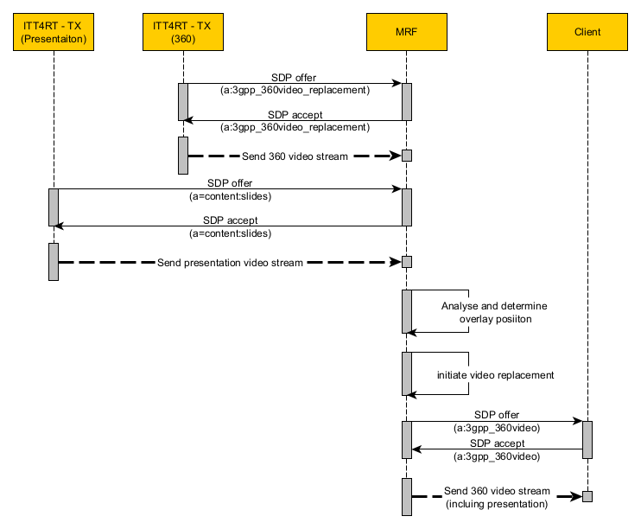
Figure 6.3.5.1.1 Replacement Flow – replacement in the ITT4RT-MRF

Case 3 - The 360-conent from the ITT4RT-Tx is suitable for replacement and the ITT4RT-MRF does NOT support replacement
In this case the ITT4RT-Tx includes the “a=3gpp_360video_replacement” in the SDP negotiation, but any answer or offer by the ITT4RT-MRF does NOT include the “a=3gpp_360video_replacement” attribute. The ITT4RT-Tx will execute the replacement.
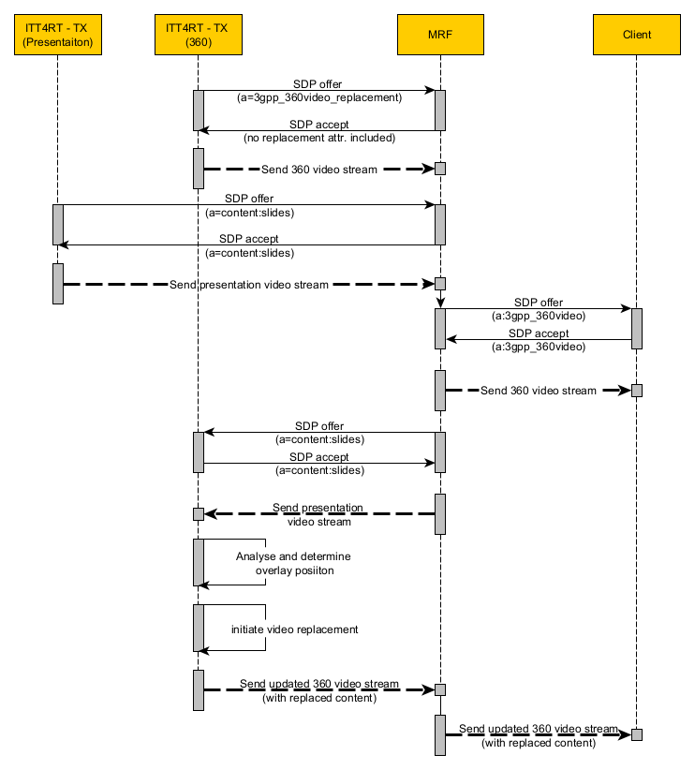
Figure 6.3.5.1.2 Replacement in Tx Flow – the ITT4RT-MRF does not support replacement and ITT4RT-Tx is executing the replacement

Note: The flow (ITT4RT-Tx executed the replacement) depicted in 6.3.5.1.2 could also be directly enforced by the application logic by not adding the “a=3gpp_360video_replacement” in the initial offer of the ITT4RT-Tx.
Case 3 - The 360-conent from the ITT4RT-Tx is suitable for replacement and the ITT4RT-MRF does NOT support replacement
In this case the ITT4RT-Tx includes the “a=3gpp_360video_replacement” in the SDP negotiation, but any answer or offer by the ITT4RT-MRF does NOT include the “a=3gpp_360video_replacement” attribute. In the following we can distinguish between two cases: A the ITT4RT-Tx will execute the replacement and B the presentation content is signalled by other means (send directly to the client).
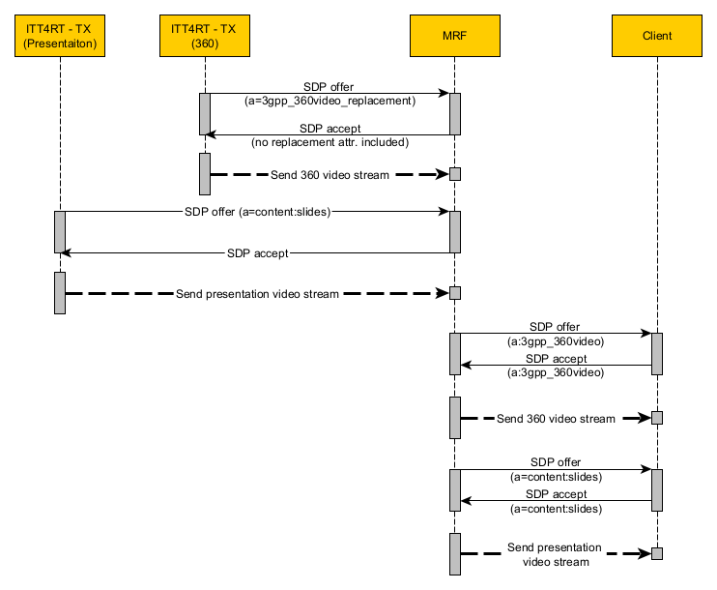
Figure 6.3.5.1.3 No Replacement Flow – the ITT4RT-MRF does not support replacement and additional content is signalled directly to the client as individual stream

Note: Figure 6.3.5.1.1 depicts one potential outcome of Case 3, but other might be possible based on the application logic. E.g. signaling the presentation content as sphere-relative overlay.
Note: The presentation content could also be signaled between the MRF and the Client with the 3gpp overlay properties (t instruct the client with suitable overlay characteristics).
Note: In case the MRF would initiate the SDP negotiation the call flow would be very similar, but the MRF would send an offer that does not include the replacement attribute (while the Tx client would answer without the replacement attribute as well).
Case 3 - The 360-conent is not suitable for replacement but the ITT4RT-MRF does support replacement.
In this case the ITT4RT-Tx does not include the “a=3gpp_360video_replacement” in the SDP negotiation. In case the SDP negotiation is initiated by the ITT4RT-MRF, the ITT4RT-MRF includes the “a=3gpp_360video_replacement” attribute, followed by an SDP response of the ITT4RT-Tx that does NOT include the “a=3gpp_360video_replacement” attribute. Replacement will not be executed, and any additional presentation material can be signalled by other means (e.g. as sphere relative overlay).
Case 4 - The 360-conent is not suitable for replacement (e.g. the presentation is not visible in the conference room) and the ITT4RT-MRF does not supported replacement
In this case no specific replacement related signalling will happen. Neither the ITT4RT-Tx nor the ITT4RT-MRF includes “a=3gpp_360video_replacement” in the SDP negotiation and no replacement will be made. Any additional presentation material can be signalled by other means (e.g. as sphere relative overlay).
Proposal
With this contribution we propose to add the example flow (section 6.3.5.1) and minor text corrections in section 6.3.5 into the permanent document of ITT4RT.

