3GPP TR 26.805 V0.1.1 (2021-04)
Technical Report

3rd Generation Partnership Project;
Technical Specification Group Services and System Aspects;
Study on Media Production over 5G NPN Systems
(Release 17)
The present document has been developed within the 3rd Generation Partnership Project (3GPP TM) and may be further elaborated for the purposes of 3GPP.
The present document has not been subject to any approval process by the 3GPP Organizational Partners and shall not be implemented.
This Specification is provided for future development work within 3GPP only. The Organizational Partners accept no liability for any use of this Specification.
Specifications and Reports for implementation of the 3GPP TM system should be obtained via the 3GPP Organizational Partners' Publications Offices.

3GPP
Postal address

3GPP support office address
650 Route des Lucioles - Sophia Antipolis
Valbonne - FRANCE
Tel.: +33 4 92 94 42 00 Fax: +33 4 93 65 47 16
Internet
http://www.3gpp.org

Copyright Notification
No part may be reproduced except as authorized by written permission.
The copyright and the foregoing restriction extend to reproduction in all media.

© 2019, 3GPP Organizational Partners (ARIB, ATIS, CCSA, ETSI, TSDSI, TTA, TTC).
All rights reserved.

UMTS™ is a Trade Mark of ETSI registered for the benefit of its members
3GPP™ is a Trade Mark of ETSI registered for the benefit of its Members and of the 3GPP Organizational Partners
LTE™ is a Trade Mark of ETSI registered for the benefit of its Members and of the 3GPP Organizational Partners
GSM® and the GSM logo are registered and owned by the GSM Association

Contents
Foreword 4
Introduction 5
1 Scope 6
2 References 6
3 Definitions of terms, symbols and abbreviations 7
3.1 Terms 7
3.2 Symbols 7
3.3 Abbreviations 7
4 7
Annex <X> (informative): Change history 8

Foreword

This Technical Report has been produced by the 3rd Generation Partnership Project (3GPP).
The contents of the present document are subject to continuing work within the TSG and may change following formal TSG approval. Should the TSG modify the contents of the present document, it will be re-released by the TSG with an identifying change of release date and an increase in version number as follows:
Version x.y.z
where:
x the first digit:
1 presented to TSG for information;
2 presented to TSG for approval;
3 or greater indicates TSG approved document under change control.
y the second digit is incremented for all changes of substance, i.e. technical enhancements, corrections, updates, etc.
z the third digit is incremented when editorial only changes have been incorporated in the document.
In the present document, modal verbs have the following meanings:
shall indicates a mandatory requirement to do something
shall not indicates an interdiction (prohibition) to do something
The constructions "shall" and "shall not" are confined to the context of normative provisions, and do not appear in Technical Reports.
The constructions "must" and "must not" are not used as substitutes for "shall" and "shall not". Their use is avoided insofar as possible, and they are not used in a normative context except in a direct citation from an external, referenced, non-3GPP document, or so as to maintain continuity of style when extending or modifying the provisions of such a referenced document.
should indicates a recommendation to do something
should not indicates a recommendation not to do something
may indicates permission to do something
need not indicates permission not to do something
The construction "may not" is ambiguous and is not used in normative elements. The unambiguous constructions "might not" or "shall not" are used instead, depending upon the meaning intended.
can indicates that something is possible
cannot indicates that something is impossible
The constructions "can" and "cannot" are not substitutes for "may" and "need not".
will indicates that something is certain or expected to happen as a result of action taken by an agency the behaviour of which is outside the scope of the present document
will not indicates that something is certain or expected not to happen as a result of action taken by an agency the behaviour of which is outside the scope of the present document
might indicates a likelihood that something will happen as a result of action taken by some agency the behaviour of which is outside the scope of the present document
might not indicates a likelihood that something will not happen as a result of action taken by some agency the behaviour of which is outside the scope of the present document
In addition:
is (or any other verb in the indicative mood) indicates a statement of fact
is not (or any other negative verb in the indicative mood) indicates a statement of fact
The constructions "is" and "is not" do not indicate requirements.

1 Scope
The present document identifies standardization needs and potential standards gaps when using 5G Systems for media production. More specifically the following aspects are addressed in this document:
- To identify the relevant media production use cases (professional, semi-professional, production, contribution), based on existing use-cases from TR 22.827 as well as requirements from TS 22.263, that may benefit from 5G System functionalities. This includes collaboration use cases between media producers and 5G System operators.
- To develop one or several reference media production architectures and to map the variety of different media and control flows (such as uplink video, return video, tally, etc) involved in media production onto 5G System delivery components.
- To identify relevant QoS requirements for media production workflows, including required bit rates, loss rates, formats, latencies and jitter, and to identify their impact on the relevant KPIs for media production workflows (reliability, mean-time-between failure, service-level agreements, etc.).
- To identify relevant 5G System features like NPNs, Network Slicing, QoS classes, network event reporting and assistance, etc. that are useful for media production, and to clarify their usage for media production.
- To identify the suitability of existing media production content delivery protocols, codecs and service layers for 5G System usage, evaluate benefits and gaps, and recommend profiles or extensions in collaboration with organizations that develop and deploy existing protocols and codecs.
- To study media device and network orchestration solutions (such as AMWA NMOS), and their integration/interactions with the 5G exposure framework.
- To collaborate with relevant other 3GPP groups and external organizations (VSF, 5G-MAG, EBU, etc.) on media-related aspects of Media Production use cases.
- To identify potential normative work on media level for media production use cases in 5G Systems.
The document primarily focuses on the usage of 5G Systems including NPNs (both Standalone NPN and Public Network Integrated NPN).

2 References
The following documents contain provisions which, through reference in this text, constitute provisions of the present document.
- References are either specific (identified by date of publication, edition number, version number, etc.) or non-specific.
- For a specific reference, subsequent revisions do not apply.
- For a non-specific reference, the latest version applies. In the case of a reference to a 3GPP document (including a GSM document), a non-specific reference implicitly refers to the latest version of that document in the same Release as the present document.
[1] 3GPP TR 21.905: "Vocabulary for 3GPP Specifications".
[2] 3GPP TS 22.261: "Service requirements for the 5G system".
[3] 3GPP TS 22.263: "Service requirements for Video, Imaging and Audio for Professional Applications (VIAPA)".
[4] 3GPP TS 22.827: "Study on Audio-Visual Service Production".
[5] M.P. Sharabayko, M.A. Sharabayko, J. Dube, JS. Kim, JW. Kim: "The SRT Protocol", draft-sharabayko-mops-srt-01
[6] VSF: "Reliable Internet Stream Transport (RIST) Activity Group", https://www.videoservicesforum.org/RIST.shtml
[7] VSF TR 06-1: "Reliable Internet Stream Transport (RIST) Protocol Specification – Simple Profile", https://vsf.tv/download/technical_recommendations/VSF_TR-06-1_2018_10_17.pdf
[8] VSF TR 06-2, "Reliable Internet Stream Transport (RIST) Protocol Specification – Main Profile", https://www.vsf.tv/download/technical_recommendations/VSF_TR-06-2_2020_03_24.pdf
[9] NewTek: "NDI Encoding/Decoding", https://support.newtek.com/hc/en-us/articles/218109667-NDI-Encoding-Decoding
[10] NewTek: "NDI Network Bandwidth, https://support.newtek.com/hc/en-us/articles/217662708-NDI-Network-Bandwidth
[11] David Aleksandersen: "What is NDI® (Network Device Interface)?", https://newsandviews.dataton.com/what-is-ndi-network-device-interface
[12] Kieran Kunhya and Ciro Noronha: "RIST and SRT: What’s the difference?", https://www.tvbeurope.com/ip-migration/rist-and-srt-whats-the-difference
[13] Tofik Sonono: "Interoperable Retransmission Protocols with Low Latency and Constrained Delay: A Performance Evaluation of RIST and SRT", Masters Thesis, KTH Stockholm, 2019, http://kth.diva-portal.org/smash/get/diva2:1335907/FULLTEXT01.pdf
[14] EBU: "Minimum User Requirements to Build and Manage an IP-Based Media Facility", 15 July 2020, https://tech.ebu.ch/files/live/sites/tech/files/shared/tech/tech3371.pdf.
[15] AMWA: "NMOS Overview", https://www.amwa.tv/nmos-overview.
[16] EBU: "The Technology Pyramid For Media Nodes", https://tech.ebu.ch/publications/technology_pyramid_for_media_nodes.
[17] EBU: "Technology Pyramid Media Node Maturity Checklist", September 2021, https://tech.ebu.ch/publications/technology-pyramid-media-node-maturity-checklist?rec=1.
[18] AMWA: "NMOS Technical Overview", https://specs.amwa.tv/nmos/branches/main/docs/2.0._Technical_Overview.html.
[19] AMWA: "Networked Media Systems – the Big Picture",
https://static.amwa.tv/networked-media-systems-big-picture-2021-03-05.pdf.
[20] AMWA: "NMOS specification repository", https://specs.amwa.tv/nmos.
[21] SMPTE 2110

3 Definitions of terms, symbols and abbreviations
This clause and its three subclauses are mandatory. The contents shall be shown as "void" if the TS/TR does not define any terms, symbols, or abbreviations.

3.1 Terms
For the purposes of the present document, the terms given in 3GPP TR 21.905 [1] and the following apply. A term defined in the present document takes precedence over the definition of the same term, if any, in 3GPP TR 21.905 [1].
Definition format (Normal)
<defined term>: <definition>.
example: text used to clarify abstract rules by applying them literally.

3.2 Symbols
For the purposes of the present document, the following symbols apply:
Symbol format (EW)
<symbol> <Explanation>

3.3 Abbreviations
For the purposes of the present document, the abbreviations given in 3GPP TR 21.905 [1] and the following apply. An abbreviation defined in the present document takes precedence over the definition of the same abbreviation, if any, in 3GPP TR 21.905 [1].

NPN Non-Public Network

4 Review of existing orchestration and control solutions

4.1 General
Editor’s Note: This is a placeholder section for some general text around orchestration
The professional broadcast industry uses a range of legacy and proprietary approaches that have been developed over many years to provide operational control. The lack of a consistent approach to interoperability has caused complexity in the architecture and integration of broadcast facilities. The Networked Media Open Specifications [15] have been developed as a response to this problem as the industry transitions to an all-IP approach. The set of specifications are primarily used for media orchestration and control purposes. Media orchestration refers to the procedures of instantiate needed media processing functions in virtualized environments and provide the control functionality for workflow management. The control functionality can be broken down into three main areas:
- Discovery and registration: procedures to register and identify all available functions in the media production network and their capabilities.
- Media Routing configuration: define sources and sinks for media related traffic flows.
- Operational control: changes during operations, like changing capture setting, etc.

4.2 AMWA Network Media Open Specification (NMOS)
The Networked Media Open Specifications (NMOS) [15] is a family of specifications produced by the Advanced Media Workflow Association (AMWA) and are related to networked media for professional applications. They were created to help enable automation in live IP-based architectures through control plane APIs that are built on typical patterns used for web services (REST, publish-subscribe). NMOS specifications are increasingly being adopted for applications using SMPTE ST 2110, and are part of the EBU’s Technology Pyramid for Media Nodes [14][16].
Editor’s Note: EBU has acknowledge the use of the figure in the TR.
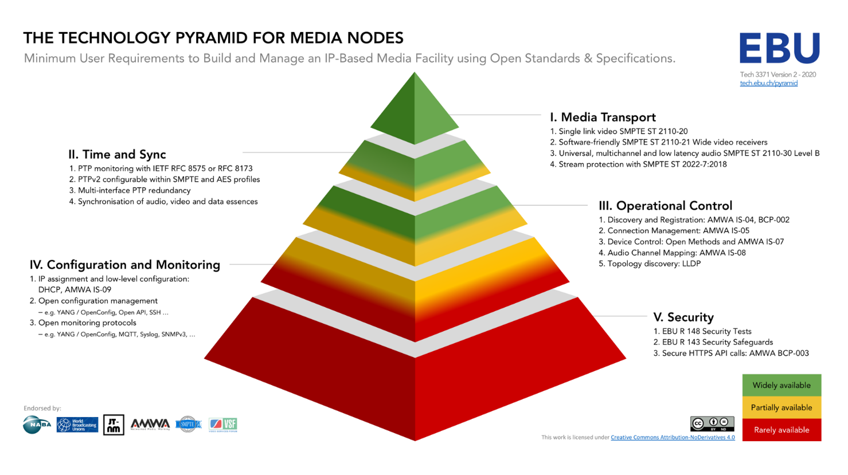
Figure 4.2-1: EBU’s Technology Pyramid for Media Nodes (with the permission of EBU)
AMWA has defined a system template containing several building blocks in [18]. The system template contains four distinct layers, namely Media & Infrastructure, Control, Monitoring and Security. Figure 4.2-2 depicts Figure 3 from [18] for convenience.
Editor’s Note: AMWA has acknowledge the use of the figure in the TR.

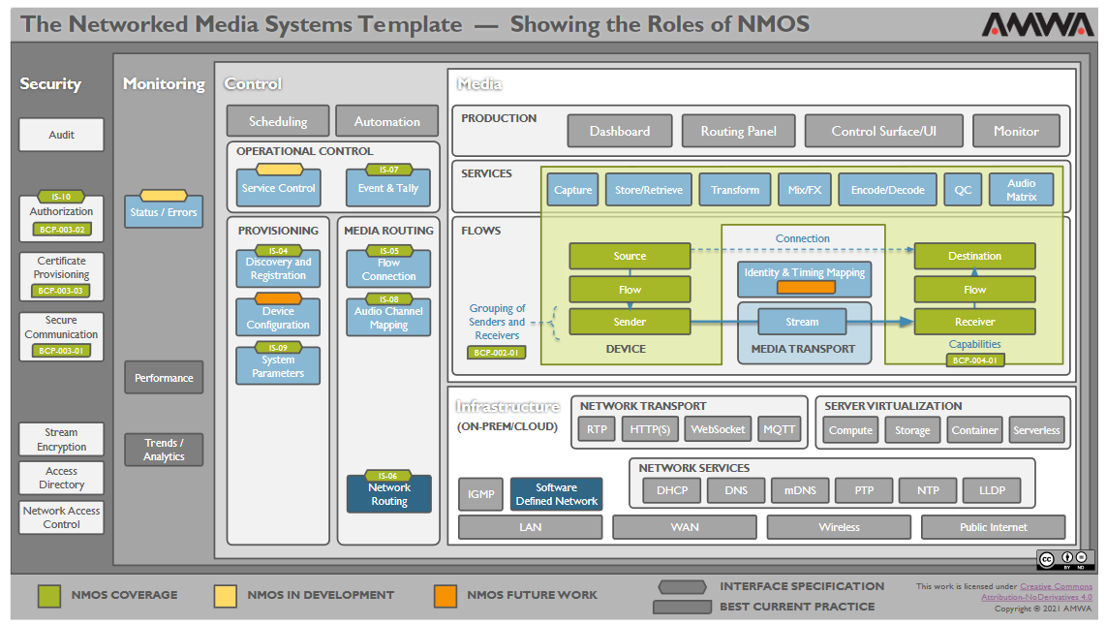Figure 4.2-2: Networked Media Systems Template – Showing the Roles of NMOS (Figure 3 from [18]) (with the permission of AMWA)
The Control layer contains:
- Provisioning, containing Discovery and Registration, Device Configuration and System Parameters.
- Media Routing, containing Flow Connection, Audio Channel Mapping and Network Routing.
- Operational Control functions (Service Control and Event & Tally).
The Media layer is subdivided into Production, Service and Flows. For the present study, the content within the Flows box is mostly of interest. Flows are configured and controlled using the Flow Connection tool from the Control layer.
Further details of NMOS can be found at [15], and the specifications are documented at [20].
The most relevant NMOS specifications are depicted in also Figure 4.2-2:
- AMWA IS-04 allows media nodes (i.e. networked media devices) to register themselves, along with what they are (or are capable of) sending or receiving, and allows control applications to query this information.
- AMWA IS-05 allows control applications to set up and remove connections between media nodes.
- AMWA IS-07 provides a publish-and-subscribe channel for sending time-based events such as tally information.
- AMWA IS-08 specifies how to handle audio channels in NMOS APIs.
- AMWA BCP-003 suite of specifications (including IS-10) covers secure communication and authorisation of NMOS APIs.
- AMWA BCP-004-01 defines NMOS Receiver Capabilities.
To date NMOS has mostly been used with ST 2110 [21] uncompressed multicast video and audio streams within wired facilities. However, NMOS can be used with other types of streams, including unicast. There is growing interest in other areas, such as professional audio-visual applications using compressed video, and where media is streamed between facilities over WAN connections (VSF WAN group).

5 Review of existing media protocol solutions

5.1 General
Editor’s Note: (text from the SID) To identify the suitability of existing media production content delivery protocols, codecs and service layers for 5G System usage, evaluate benefits and gaps, and recommend profiles or extensions in collaboration with organizations that develop and deploy existing protocols and codecs.

<This should include a short overview of relevant SMPTE solutions, like ST 2110, ST 2022. It should also include an overview of the different RIST profiles. We should also review NDI and SRT from a connectivity usage perspective.>
Editor’s Note: This is a placeholder for some general introduction.
Editor’s Note: Explain that NACK refers to Negative ACKnowledgement.
Editor’s Note: Existing media protocols are used between different production functions in various combinations. The protocol end-points are deployment specific and will be clarified.

5.2 Secure Reliable Transport (SRT)
Secure Reliable Transport (SRT) [5] is an open-source media transport protocol that uses the UDP transport protocol. SRT provides connection and control, reliable transmission similar to TCP at the application layer. It supports packet recovery while maintaining low latency. SRT also supports encryption using AES.
The protocol was derived from the UDT project, designed for fast file transmission. UDT provides its reliability mechanism by using similar methods for connection, sequence numbers, acknowledgements and retransmission of lost packets. UDT uses selective and immediate (NACK-based) retransmission.
SRT has all these features, but also adds several more to support live streaming mode:
1. Controlled latency, with source time transmission (timestamp-based packet delivery).
2. Sender bandwidth control.
3. Conditional "too late" packet dropping (prevents head-of-line blocking caused by a lost packet that wasn't recovered on time).
4. Eager packet re-transmission (periodic NACK report).

5.3 Reliable Internet Stream Transport (RIST)
Reliable Internet Stream Transport [6] is an open source, open specification transport protocol designed for reliable transmission of media over lossy networks (including the internet) with low latency and high quality. It is currently being developed and maintained by the Video Services Forum (VSF).
Technically, RIST seeks to provide reliable, high performance media transport by using RTP/UDP at the transport layer to avoid the limitations of TCP. Reliability is achieved by using NACK-based retransmissions to realise an Automatic Repeat Query (ARQ) capability. SMPTE-2022 Forward Error Correction can be combined with RIST but is known to be significantly less effective than ARQ.
RIST Simple Profile [7] was published by the VSF in October 2018 and includes the following features:
- The base stream uses RTP for compatibility with existing equipment.
- Retransmission requests use RTCP. Two types of retransmission requests are defined:
- A Bitmask-based NACK, defined in RFC 4585.
- A Range-based NACK, defined as an application-specific (APP) RTCP packet.
- Bonding of multiple links for load sharing.
- Seamless switching using SMTPE-2022-7.
- Out-of-band transmission of protection data (retransmissions may use a separate link).
RIST Main Profile [8] was published in March 2020 and adds the following features to Simple Profile:
- GRE-in-UDP encapsulation based on RFC 8086, with bidirectional send/receive in the same tunnel.
- Multiplexing of multiple streams into the same tunnel.
- In-band data support in the tunnel, useful for remote management.
- Client/Server architecture.
- Firewall traversal.
- DTLS encryption or Pre-Shared Key encryption, with multicast support, access control, and authentication.
- Advanced authentication options using either public key certificates or TLS-SRP.
- Bandwidth optimization based on NULL packet deletion.
- Support for high bit-rate streams by extending the size of the RTP sequence number space.

5.4 Network Device Interface NDI
Network Device Interface (NDI®) [11] is a software solution developed by NewTek™ to enable video-compatible products to communicate, deliver, and receive high-definition video over a network in a high-quality, low-latency manner that is frame-accurate and suitable for switching in a live production environment. In contrast to SRT and RIST, NDI is intended to transfer media streams within a facility, not for contribution over the public networks.
NDI is designed to run over gigabit Ethernet. The table below lists the approximate bandwidth required by NDI codec [x6] for different video streams.
Table 5.4-1:
Video stream | Approximate bit rate  required by NDI codec
2160p60 | 250 Mbps
2160p30 | 200 Mbps
1080p60 | 125 Mbps
1080i60 | 100 Mbps
720p60 | 90 Mbps
SD | 20 Mbps

By default, NDI uses the multicast DNS (mDNS) discovery mechanism to advertise sources on a Local Area Network (LAN), although two other discovery modes (NDI Access, NDI Discovery Server) allow for operations across different subnets. When a source is requested, a TCP connection is established on the appropriate port with the NDI receiver connecting to the NDI sender. NDI 3.x has options to use UDP multicast or unicast with Forward Error Correction (FEC) instead of TCP, and can load balance streams across multiple Network Interface Controllers (NICs) without using link aggregation. NDI 4.0 introduces multi-TCP connections.
NDI carries video, multichannel uncompressed audio and metadata in XML form. Metadata messages can be sent in both directions allowing the sender and receiver to message one another over the connection with arbitrary metadata. This directional metadata system allows for functionality such as active tally information (on-air program/preview). NDI Receivers can opt to connect to various combinations of streams, to support things like audio-only or metadata-only connections where video is not required.

5.5 Comparison Table
Table 5.5-1: Comparison
Parameter | SRT | RIST | NDI
Intended use | Contribution over unreliable links (e.g., public internet) | Contribution over unreliable links (e.g., public internet) | Transfer of media streams within a facility
Proprietary/Opensource | Opensource | Opensource | Proprietary
Based on protocol | UDT | RTP, e.g. TS-over-IP | TCP/UDP
Interoperability | Can be limited between different vendors | Good | Partially limited due to proprietary nature
Latency | Configurable, 4 × RTT of the link is recommended | Configurable, 4 × RTT of the link is recommended | Practically one field latency, might be as low as 8 scan lines
Error correction | FEC/ARQ | FEC/ARQ | TCP or FEC
Encryption | Supported | Supported | Not supported natively
Authentication | Supported, PSK based | Supported, PSK and DTLS based | Not supported natively
Multicast | Not supported | Supported | Supported
Multiple links | Not supported | Supported | Supported
Codec | Codec agnostic | Codec agnostic | Built in

6 Relevant media production use cases

6.1 General

6.2 Use-Case X: Audio Visual production

6.2.1 Description
Audio/Visual (AV) production includes television and radio studios, outside and remotely controlled broadcasts, live news gathering, sports events and music festivals, among others. All these applications require a high degree of reliability, since they are related to the capturing and transmission of data at the beginning of a production chain. This differs drastically when compared to other multimedia services because the communication errors will be propagated to the entire audience that is consuming that content both live and recorded for later distribution. Furthermore, the transmitted data is often post-processed with nonlinear filters which could actually amplify defects that would be otherwise not noticed by humans. Therefore, these applications call for high quality data, and very low probability of errors. These devices will also be used alongside existing technologies which have a high level of performance and so any new technologies will need to match or improve upon the existing workflows to drive adoption of the technology.
The performance aspects that are covered by/in TS 22.263 [3] (Service requirements for Video, Imaging and Audio for professional applications) also target the latency that these services experience.
In recent years, production facilities have moved from bespoke unidirectional highly specialised networks to IP-based systems and software-based workflows. This migration is expected to continue, and wireless IP connectivity is key to a number of these workflows.
Typical set ups require multiple devices such as cameras, microphones and control surfaces that require extremely close synchronisation to maintain consistency of pictures and audio. Often devices need to communicate directly to each other for instance a camera to a monitor or a microphone to a Public Address (PA) system.
Video and audio applications also require extremely high quality of service metrics as the loss of a single packet can cause picture or sound breakup in the downstream processing or distribution. Often this is a legal, regulatory or contractual agreement to maintain a high-quality, stable and clear video or audio signal.
Today’s digital AV network transport is typically handled separately for wireless and wired transfers. Wireless AV transmissions are implemented with application-specific solutions that allow deterministic data transport of a single isolated audio or video link. Wired AV transmissions are typically either Ethernet- or IP-based. Network Quality of Service in AV IP networks is mainly achieved with IP DiffServ/DSCP-based prioritization of packets in network switches. This method is sufficient for most AV use cases since jitter resulting from packet collisions is small, for example in the order of 10 µs per concurrent data stream in gigabit Ethernet.
Live video production is a complex subset of production activity that typically is served by evolving specialized technologies, networks and radio solutions. The high bandwidth and low latency required to produce real-time high-definition video requires dedicated point-to-point connections that have evolved from analogue production, via digital, to IP-based solutions. Current IP solutions for the studio are based on managed wired networks and the mobility required by cable-free cameras, microphones and monitoring have been adapted to interface with these networks via gateway devices but still supporting legacy integrations.
The COVID-19 pandemic has also led to an increase in distributed production where control surfaces are not necessarily co-located with the equipment they control. Cloud-based solutions are emerging to support these workflows and this use case should support distributed compute functionality.
Other technologies used include optical fibre for fixed links, satellites and the physical transport of media storage devices with previously recorded content. In this sense, wireless connectivity plays a major part in production where there is a need to have mobility, flexibility and reliability.

6.2.2 Wireless camera workflows

6.2.2.1 Scenario 1: Wireless cameras within a production workflow
Different types of network may be deployed depending on how the camera is used. For a single point-to-point (PTP) link, a dedicated peer-to-peer solution can be achieved with a simple transmitter and receiver set up. These may use either omnidirectional or directional antennas. For more complex setups, such as a studio or sporting event, a mesh network with multiple receivers may be set up. This allows the cameras to move freely within the coverage area while maintaining Quality of Service. Finally, for large area events, aerial relays may be deployed to cover a moving camera on the ground.
While these solutions are extremely robust, they do require specialist skills and knowledge to set up.
When deployed in real world scenarios these types of camera are usually matched against other cameras that are connected directly to the production network by fibre or coax connections. It is important that in this scenario the latency of any radio-connected device is minimised and any cuts between a wired and wireless camera are synchronised. This is currently done by sending a special signal to an on-board clock generator that times the various functions of the camera to match other cameras in the network.
There are also requirements for near-real-time responses to instructions or control of a camera. If, for instance, the focus of the camera is controlled remotely then the operator will need to see the image in under 100 ms in order to be able to respond and control the lens on the camera.
The types of camera used for this type of production are usually highly specialised and have a modular design with various elements such as a lens, viewfinder and microphones added as required. Different cameras rely on different protocols to control various elements but there are also some standard protocols that are used where specialist control is not required. Some signals, such as lens control, will pass through the camera unit itself, while others will connect directly to the end user device.
Within Media Production scenarios, the wireless camera act as a UE. Multiple, partially optional application flows are between the wireless camera and one or more network side media production function.
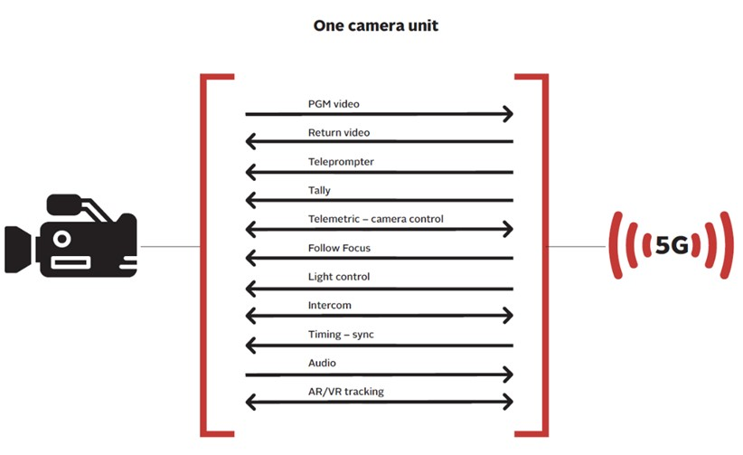
Figure 6.2.2.4-1: Flows by one camera unit
Figure 6.2.2.4-1 illustrates a set of important data flows, namely:
- PGM Video (Program Video): The uplink video stream.
- Return video: In some production events the camera receives a return video and renders the video e.g. in the view finder. The return video may be a CGI enhanced version of the own video or a video from a different camera. The camera operator considers the return video within the own capturing.
- Teleprompter: In some production events a speaker in front of the camera sees the text to spell out.
- Tally: the small red light indicating which camera is “on-air”.
- Telematics – Camera Control: Different functions of the camera like the shutter speed, iris, etc can be locally or remote controlled. The telematics signal may also contain information about the camera status, such as battery level.
- Follow Focus: A focus control mechanism to help the operator be more precise while adjusting the focus and maintaining it while the camera is moving relative to the subject/object.
- Intercom: In some production events, the camera operators can talk to each other and the programe director using a separate speech channel.
NOTE: Intercom is traditionally integrated into a camera. However, Intercom might become more and more independent devices in media production, since intercom typically is setup first and torn down last.
- Timing – Sync: The camera needs to time synchronized, (A) for timestamping the media packets and (B) for synchronizing the frame capture pulse (GenLock).
- Audio: In some production events (specifically news gathering), the camera is equipped with a microphone to capture audio. In other production events (like sports), the microphone positions are different from camera positions to capture “atmosphere”.
- AR/VR tracking: Accurate camera positioning is of paramount importance to incorporate virtual and augmented reality studio sets in live productions.

6.2.2.2 Scenario 2: Outside broadcast contribution
Over the past few years, broadcasters have been using mobile networks for some workflows, specifically using 4G networks to send a live video stream to a production centre. This type of communication has helped revolutionise the way news and events are produced, as reporters and teams can work from anywhere, at any time if an acceptable coverage is available. To do this, a backpack or camera-mounted device is used to encode and broadcast video without the need for mobile units (vans) and/or many cables and devices.
However, the use of 4G networks can bring several disadvantages. For example, due to the bandwidth required, mobile solutions require multiple connections and therefore multiple SIM cards to provide adequate service; this method of connection aggregation is known as “link bonding”. Additionally, when these devices are outside the mobile network provider coverage area, other SIM cards are required to use an alternate network. The video must be highly compressed due to network bandwidth restrictions, which degrades content quality in later stages of the production and distribution chains. These technologies tend provide a single video link and so if more than one camera is required it either needs multiple units that are often timed differently or people and infrastructure on site to support multiple camera operation. There is also no differentiation between the networks to which these devices connect and public networks, so in large events 4G connections become unreliable as they struggle for connectivity and bandwidth with other users.
It can be expected that 5G solutions will evolve to meet these workflows with little or no interventions but there is also a demand for a technology that allows multiple audio and video sources to be connected and synchronized as well as better interoperability with existing workflows.
The scenarios for contribution may be focused on newsgathering and lower budget production. In these scenarios content may be more static with less temporal change or fixed backgrounds, so more intense compression may be applied.

6.2.2.3 Considerations on cloud-based production
Productions typically require long preparation times with large audio and video equipment that is physically moved to external event sites, as well as configured and adjusted for a specific production activity. 5G networks themselves, despite the advantages they introduce, do not solve this problem. Some solutions such as cloud-based production are being investigated, which together with 5G networks may significantly change production workflows, as it will reduce the requirement to move all production equipment to the event site. This may lead to cost reductions or allow more coverage of complex events. For example, multimedia sources such as cameras or microphones would be deployed at the event site, but much of the equipment may be in production centres and be connected over the network to the remote site. Examples include audio and video mixers, switching matrixes, storage devices and multi-viewers.
Some functions are coordinated in master control rooms (MCRs). These MCRs pull together multiple internal and outside sources and organise them for presentation to operational galleries. Large broadcast centres have signal routing matrices that allow multiple audio and video signals to be organised and packaged for both incoming and outgoing feeds.
<describe the different flows, potentially traffic characteristics (events vs continuous), and potentially the need for separate prioritization>

6.2.2 Collaboration models and deployment architectures
Editor’s Note: No input yet.
<Should we add a Remote Production use-deployment, with an SNPN on-prem and then remote functions?>

6.2.3 Identified 5G System features
Editor’s Note: No input yet.

6.2.4 High level call flows
Editor’s Note: No input yet.

6.2.5 Potential issues
Editor’s Note: No input yet.

[6.x Use-Case X

6.x.1 Description
Editor’s Note: (text From the SID) To identify the relevant media production use cases (professional, semi-professional, production, contribution), based on existing use-cases from TR 22.287 as well as requirements from TS 22.163, that may benefit from 5G System functionalities. This includes collaboration use cases between media producers and 5G System operators.

<Use-cases from TR 22.827 are preferably broken down into smaller use-cases such as
- Multi-camera aspects like synachronization
- Usage and purpose of different per-camera flows (like return video)
>
State of the art (current issues in content production)
o Focus on multiple cameras for live video production controlled remotely
o Focus on multiple microphone for live audio production

Workflows/architectures/deployment scenarios
o Live video
o Live Audio

6.x.2 Collaboration models and deployment architectures
Editor’s Note: (text from the SID) To develop one or several reference media production architectures and to map the variety of different media and control flows (such as uplink video, return video, tally, etc) involved in media production onto 5G System delivery components.

6.x.3 Identified 5G System features
Editor’s Note: (text from the SID) To identify relevant QoS requirements for media production workflows, including required bit rates, loss rates, formats, latencies and jitter, and to identify their impact on the relevant KPIs for media production workflows (reliability, mean-time-between failure, service-level agreements, etc.).
Editor’s Note: (text from the SID) To identify relevant 5G System features like NPNs, Network Slicing, QoS classes, network event reporting and assistance, etc. that are useful for media production, and to clarify their usage for media production.
< e.g. TSN in future 3GPP releases, QoS, Network Slicing>

6.x.4 High level call flows
Editor’s Note: (text from the SID) To identify the suitability of existing media production content delivery protocols, codecs and service layers for 5G System usage, evaluate benefits and gaps, and recommend profiles or extensions in collaboration with organizations that develop and deploy existing protocols and codecs.

6.x.5 Potential issues
]

7 Candidate Solutions

< this section should describe, how identified 5G features are used in context of media production>

8 Summary and Conclusions

Annex <X> (informative):
Change history

Change history
Date | Meeting | TDoc | CR | Rev | Cat | Subject/Comment | New version
Apr 2021 | SA4#113 | S4-210519 |  |  |  | Initial version | 0.0.1
Apr 2021 | SA4#113 | S4-210678 |  |  |  | S4-210527: Structure of the technical report  S4-210641: Description of existing media protocols in media production | 0.1.0
1164,
1165
S4aI211164: Description of camera media flows in a Multi-Camera production
S4aI211165: Overview of NMOS functionality

