**3GPP TSG- S4 Meeting #117e - Post *S4aI221321***

**, 2nd March – 11th May 2022**

|  |  |  |  |  |  |  |  |  |
| --- | --- | --- | --- | --- | --- | --- | --- | --- |
| *CR-Form-v12.2* | | | | | | | | |
| **Psuedo CHANGE REQUEST** | | | | | | | | |
|  | | | | | | | | |
|  |  | **CR** |  | **rev** |  | **Current version:** |  |  |
|  | | | | | | | | |
| *For* [***HE******LP***](http://www.3gpp.org/3G_Specs/CRs.htm#_blank)*on using this form: comprehensive instructions can be found at* [*http://www.3gpp.org/Change-Requests*](http://www.3gpp.org/Change-Requests)*.* | | | | | | | | |
|  | | | | | | | | |

|  |  |  |  |  |  |  |  |  |
| --- | --- | --- | --- | --- | --- | --- | --- | --- |
| ***Proposed change affects:*** | UICC apps |  | ME |  | Radio Access Network |  | Core Network |  |

|  |  |  |  |  |  |  |  |  |  |  |
| --- | --- | --- | --- | --- | --- | --- | --- | --- | --- | --- |
|  | | | | | | | | | | |
| ***Title:*** | [FS_NPN4AVProd]: Description of KI#4 (Standby and Program Cameras), incl solutions | | | | | | | | | |
|  |  | | | | | | | | | |
| ***Source to WG:*** |  | | | | | | | | | |
| ***Source to TSG:*** |  | | | | | | | | | |
|  |  | | | | | | | | | |
| ***Work item code:*** | FS_NPN4AVProd | | | | |  | ***Date:*** | | |  |
|  |  | | | |  | |  | | |  |
| ***Category:*** |  |  | | | | | ***Release:*** | | |  |
|  | *Use one of the following categories:* ***F*** *(correction)* ***A*** *(mirror corresponding to a change in an earlier release)* ***B*** *(addition of feature),* ***C*** *(functional modification of feature)* ***D*** *(editorial modification)*  Detailed explanations of the above categories can be found in 3GPP [TR 21.900](http://www.3gpp.org/ftp/Specs/html-info/21900.htm). | | | | | | | | *Use one of the following releases: Rel-8 (Release 8) Rel-9 (Release 9) Rel-10 (Release 10) Rel-11 (Release 11) … Rel-16 (Release 16) Rel-17 (Release 17) Rel-18 (Release 18) Rel-19 (Release 19)* | |
|  |  | | | | | | | | | |
| ***Reason for change:*** | |  | | | | | | | | |
|  | |  | | | | | | | | |
| ***Summary of change:*** | |  | | | | | | | | |
|  | |  | | | | | | | | |
| ***Consequences if not approved:*** | |  | | | | | | | | |
|  | |  | | | | | | | | |
| ***Clauses affected:*** | |  | | | | | | | | |
|  | |  | | | | | | | | |
|  | | **Y** | **N** |  | | | |  | | |
| ***Other specs*** | |  |  | Other core specifications | | | | TS/TR ... CR ... | | |
| ***affected:*** | |  |  | Test specifications | | | | TS/TR ... CR ... | | |
| ***(show related CRs)*** | |  |  | O&M Specifications | | | | TS/TR ... CR ... | | |
|  | |  | | | | | | | | |
| ***Other comments:*** | |  | | | | | | | | |
|  | |  | | | | | | | | |
| ***This CR's revision history:*** | |  | | | | | | | | |

**** First Change ****

## 6.5 Key Issue #4: Different bit rates for Standby vs Program Cameras

Editor’s Note: This clause should describe implications on protocol usage, when only the program camera(s) send a high quality stream. Standby cameras only send a video stream with preview quality or no data.

### 6.5.1 General

In professional multi-camera production use-cases, several cameras simultaneously capture an event, with each camera focusing on different parts of the scene, for example close-up shots of certain performers, wide angle shot, audience reaction shot. The video of all cameras is displayed in the local studio gallery(which could be in an Outside Broadcast van). The program director selects which of the cameras contribute to the outgoing program feed. On request from the program director, the video mixer changes the source from from one camera to another.

- The camera currently used for the program feed is referred to as the Program Camera in the following. In case of fast cutting between cameras, typically only a single camera is the Program Camera at any given point in time. However, when cross-fading effects are applied during the transition from one camera to the next, two or more cameras are contributing to the program feed at the same time. The tally light is typically illuminated whenever a camera is the active Program Camera.

- All other cameras, which are not directly contributing to the program feed, are just rendered on the display gallery, and are referred to as Standby Cameras.

In principle, the video quality from Standy Cameras does not need to be as high as that from Program Cameras. This key issue explores how the output quality of a video camera can be varied under the control of the video mixer function using a dedicated control flow.

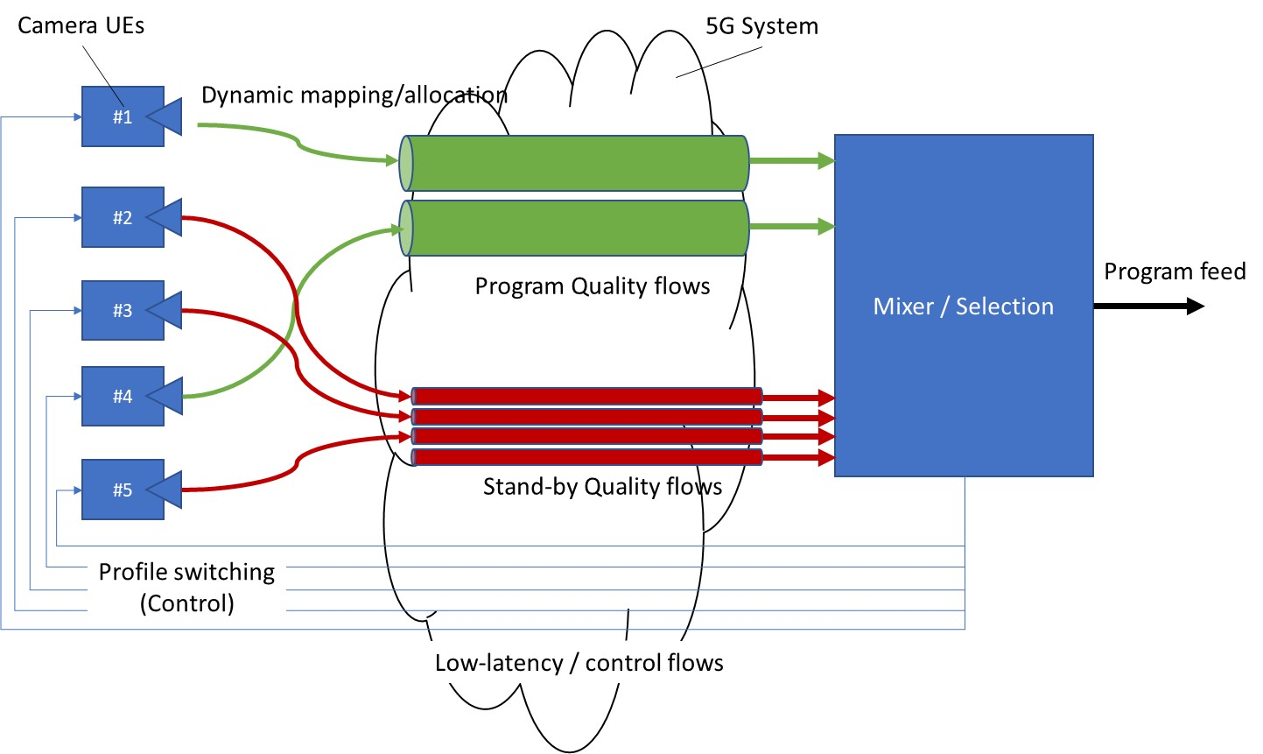

Figure 6.5.1-1: Multi-camera setup showing current Program Cameras and Standby Cameras

The setup is depicted in figure 6.5.1-1. Five Cameras UEs are depicted on the left side. The different Camera UEs are assumed to offer equivalent functionality. However, Camera UE #1 and Camera UE #4 are currently configured to operate in a program quality profile, while Camera UEs #2. #3 and #5 are operating in a stand-by quality profile. The Mixer/Selection function is controlled based on the input from from the program director.

### 6.5.2 Solutions leveraging QoS

#### 6.5.2.1 General

In this set of solutions, the 3GPP QoS Framework is used to separate the different data flows. Figure 6.5.2-1 illustrates the usage of QoS flows in the multi-camera setup introduced by figure 6.5.1‑1.

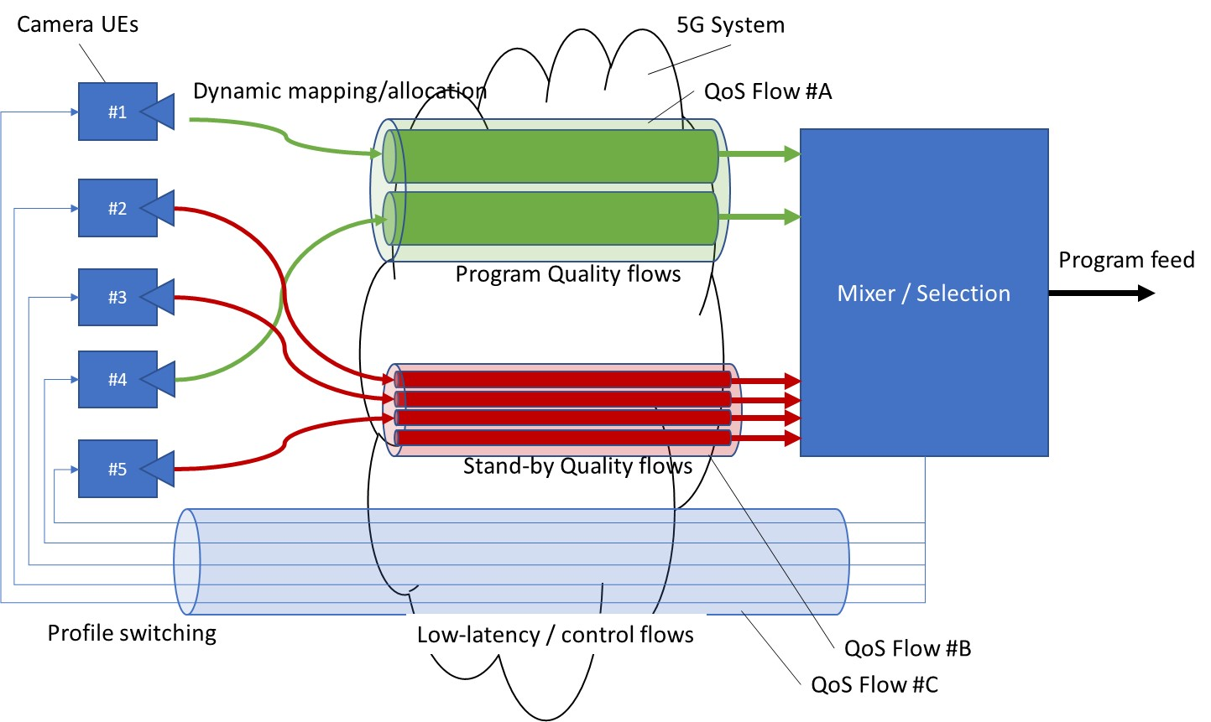

Figure 6.5.2-1:

In the figure:

- The video outputs of Camera UE #1 and Camera UE #3 are mapped to program quality QoS flows.

- All other camera outputs are mapped to stand-by quality QoS flows.

- The traffic for switching the camera profile configuration is handled by yet another QoS flow.

Two basic solution alternatives for realising the above QoS flow configuration are described in the following clauses:

A: Modify the QoS rule within a Camera UE whenever the quality profile is switched between program and stand-by.

B: Pre-install a unique QoS rule for each camera quality profile with different packet filters.

#### 6.5.2.2 Solution A: QoS rule modification

Solution alternative A leverages the procedure to modify a QoS rule. When switching a camera quality profile from program to standby, the QoS rule is modified and a new QoS policy (with a different QFI) is installed on the UE and the UPF.



Figure 6.5.2-2: Solution Alternative A

Steps:

Editor’s Note: TODO.

#### 6.5.2.3 Solution B: Multiple pre-installed QoS rules

For Solution alternative B, two QoS flows (one for program quality and one for standby quality) are established in advance for each camera. The Packet Filters for the two QoS flows are different, e.g. using different 5-tuples or different ToS/DSCP values.



Figure 6.5.2-3: Solution Alternative B

Steps:

Editor’s Note: TODO.

**** Last Change ****