3GPP TSG-<TSG/WG> Meeting # <MTG_SEQ><MTG_TITLE> S4aI221298

<Location>, <Country>, <Start_Date> - <End_Date>
CR-Form-v12.2
CHANGE REQUEST
 | 26.805 | CR | <CR#> | rev | <Rev#> | Current version: | 1.0.1
For HELP on using this form: comprehensive instructions can be found at
http://www.3gpp.org/Change-Requests.

Proposed change affects: | UICC apps |  | ME |  | Radio Access Network |  | Core Network

Title: | [FS_NPN4AVProd]: Definition of Collaboration Scenarios
Source to WG: | S4
Source to TSG: | Ericsson LM
Work item code: | <Related_WIs> |  |  |  |  |  | Date: |  |  | <Res_date>
Category: | <Cat> |  |  |  |  |  | Release: |  |  | <Release>
 | Use one of the following categories:  F (correction)  A (mirror corresponding to a change in an earlier release)  B (addition of feature),  C (functional modification of feature)  D (editorial modification)  Detailed explanations of the above categories can  be found in 3GPP TR 21.900. |  |  |  |  |  |  |  | Use one of the following releases:  Rel-8 (Release 8)  Rel-9 (Release 9)  Rel-10 (Release 10)  Rel-11 (Release 11)  …  Rel-16 (Release 16)  Rel-17 (Release 17)  Rel-18 (Release 18)  Rel-19 (Release 19)
Reason for change:
Summary of change: |  | This contribution introduces a set of collaboration scenarios for Media Production. For the collaboration scenarios, a simplfied architecture is introduced.
Consequences if not approved:
Clauses affected:
 |  | Y | N
Other specs |  |  |  | Other core specifications |  |  |  | TS/TR ... CR ...
affected: |  |  |  | Test specifications |  |  |  | TS/TR ... CR ...
(show related CRs) |  |  |  | O&M Specifications |  |  |  | TS/TR ... CR ...
Other comments:
This CR's revision history:

5.5 Collaboration models and deployment architectures

5.5.1 General
This clause describes various collaboration models with different NPN deployments, targeting the different media production scenarios, which are introduced in previous clauses.
The following (simplified) media functions are deployed in different models:
- Technical Manager: This function represents a role within the media producer that decides on various options, e.g. how many media production devices (cameras, monitors, etc) are used in the deployment, their connections, etc.
- Dynamic Configuration: This function translates the decisions of the technical manager role into (dynamic) configurations. For each device, it determines the network connectivity and media configuration, such as codec configuration (separately for uplink and return path), selection of Media Gateway (IP address and Port), media protocols, etc. When the traffic crosses trust domains, the Dynamic Configuration function also configures security functions, e.g. to secure the media plane traffic. When the configuration setup is finished, the Dynamic Configuration function provisions the needed QoS flows with the PCF/NEF. For each QoS flow, the Dynamic Configuration function provides traffic detection information (e.g. a Packet Filter Set or a PFD) and information about the needed QoS class.
- Configuration Application: A UE side component, which interacts with the network-based Dynamic Configuration function. Typically, the Configuration Application listens to dyanamic configuration instructions from the Dynamic Configuration Function.
- Media Client (sender and receiver): The media level function. In the case of a wireless camera, this function is captures, encodes and sends the media data (typically video, optionally with audio). When return video is configured, this function is also capable of receiving, decoding and rendering the media. When the device is a display, then this Media Client only receives, decodes and renders media data.
- Media Gateway: A network-side function for sending or receiving encoded media. The media gateway may act as proxy.

5.5.2 Deployment #1: On-site wireless production with Standalone NPNs
A straightforward realization of Scenario 1 (clause 5.2) is the usage of a Standalone NPN. Here, a dedicated 5G System is deployed for exclusive use for media production. The media producer also acts as the Mobile Network Operator; thus, all Application Functions are trusted and may interact with other network functions as needed.
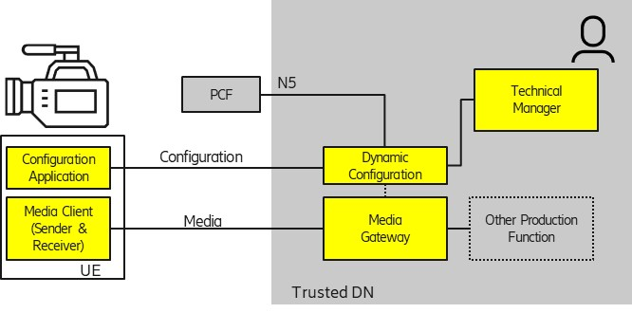
Figure 5.5.2-1: On-site production with a Standalone NPN

5.5.3 Deployment #2: On-site wireless production with PNI-NPN or Outside Broadcast Contribution
This deployment model contains three sub-scenarios, based on the distance between media production site and the media production network.
1. Local PNI-NPN production with support for on-site edge computing: A media producer may leverage the network of a Mobile Network Operator for an on-site media production event. When a local breakout in a local edge computing environment is provided, the deployment is very similar to an on-site wireless production with an SNPN (clause 5.5.2). For example, the media producer connects the equipment of an OB Van through a local breakout at an event location with the 5G PNI-NPN. Low latency communication is enabled due to close proximity of devices.
2. Remote production: A media producer may leverage the network of a Mobile Network Operator for remote media production. Here, media production equipment is kept more centrally in the network in order to reduce equipment and people movement, as described in clause 5.4.
3. Contribution: A media producer may leverage the network of a Mobile Network Operator for an Outside Broadcast contribution event, for example Electronic News Gathering (ENG). Here, the media production network elements are located more centraly within the studio facility of the media producer.
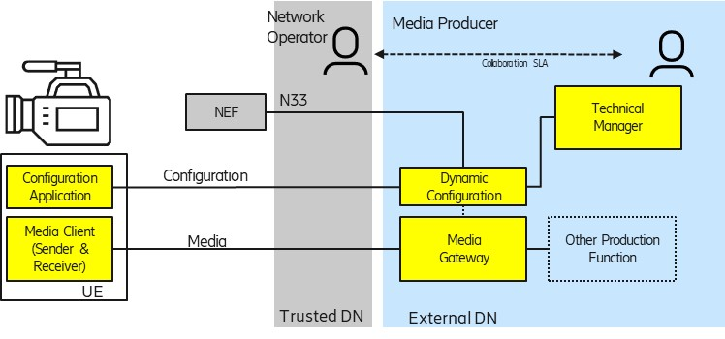
Figure 5.5.3-1: PNI-NPN collaboration model for on-site productions or OB contributions
In this collaboration scenario, the NEF APIs are the key enabler for the collaboration. Some procedures, such as the SLA definition and agreement, may be outside of the scope of the NEF APIs.

5.5.4 Remote wireless production with Standalone NPNs
This deployment model addresses remote production scenarios, reducing the need for moving equipment (and people) to a local production site. Remote production is described with cloud production in clause 5.4.
NOTE: The usage of cloud computing does not necessarily refer to remote production. Cloud computing instances may be deployed anywhere, including locally at the event production site.
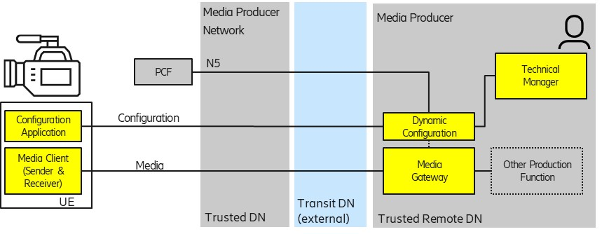
Figure 5.5.4-1: Remote production with SNPNs
This deployment model specifically addresses the use of Standalone NPNs for remote production (clause 5.5.3 describes the usage of a PNI-NPN for remote production).
No extra Service Level Agreement is needed between the Mobile Network Operator and the media producer because the network is operated by the same entity. However, SLAs may be needed for Transit DNs, which connect the Local SNPN to the Remote Data Network.
In some cases, the Local SNPN may leverage a 5G System as a Transit Data Network, so that the Media Production Network becomes portable. For example, an SNPN system for local production could be installed in an Outside Broadcast van together with other media production equipment.

