3GPP TSG- S4 Meeting #115e S4-211161

Electronic Meeting, 18th August – 27th August 2021
CR-Form-v12.1
Pseudo CHANGE REQUEST
 | 26.805 | CR | <CR#> | rev | <Rev#> | Current version: | <Version#>
For HELP on using this form: comprehensive instructions can be found at
http://www.3gpp.org/Change-Requests.

Proposed change affects: | UICC apps |  | ME |  | Radio Access Network |  | Core Network

Title: | [FS_NPN4AVProd]
Source to WG: | Ericsson LM, BBC
Source to TSG: | S4
Work item code: | FS_NPN4AVProd |  |  |  |  |  | Date: |  |  | <Res_date>
Category: | <Cat> |  |  |  |  |  | Release: |  |  | <Release>
 | Use one of the following categories:  F (correction)  A (mirror corresponding to a change in an earlier release)  B (addition of feature),  C (functional modification of feature)  D (editorial modification)  Detailed explanations of the above categories can  be found in 3GPP TR 21.900. |  |  |  |  |  |  |  | Use one of the following releases:  Rel-8 (Release 8)  Rel-9 (Release 9)  Rel-10 (Release 10)  Rel-11 (Release 11)  …  Rel-15 (Release 15)  Rel-16 (Release 16)  Rel-17 (Release 17)  Rel-18 (Release 18)
Reason for change:
Summary of change:
Consequences if not approved:
Clauses affected: |  | 5.2.5.3
 |  | Y | N
Other specs |  |  |  | Other core specifications |  |  |  | TS/TR ... CR ...
affected: |  |  |  | Test specifications |  |  |  | TS/TR ... CR ...
(show related CRs) |  |  |  | O&M Specifications |  |  |  | TS/TR ... CR ...
Other comments:
This CR's revision history:

**** First Change ****

5.2.5.3 Key Issue #2: Media Protocols on 5G: Using QoS for traffic segregation

5.2.5.3.1 General
This clause focuses on the usage of 5G Systems, assuming that multiple application flows – either from multiple cameras or from a single camera unit (see Figure 5.2.2.4-1) – would experience a different priority treatment by the RAN traffic scheduler and likely by the traffic policing function in 5GC. Different protocols may be used to carry media and other data.
An application flow is typically described by a 5-tuple, i.e. source and destination IP addresses (Layer 3), Layer 4 protocol and Layer 4 source and destination ports. Some protocols may multiplex multiple elementary streams (and potentially other data) into one application flow. Other protocols map one elementary stream to one application flow.
The traffic characteristics and the main flow direction (uplink or downlink) depend on the usage. For example, a program video stream, produced by a camera, is typically of a higher bit rate than a return video stream.
NOTE: Some application flows may carry non-media content, for example camera control, telematics (e.g. battery status), and position information for AR tracking.
Editor’s Note: Solutions may use IP multicast or IP unicast packet routing to transport media streams. IP multicast is popular in AV Production because the same feed from a camera, microphone or talkback circuit can then be consumed by monitoring devices (screens, headphones, etc.) as well as feeding into vision mixers, sound mixers, etc. However, there are challenges to be overcome in using IP multicast over Wide-Area Networks and therefore in Remote Production scenarios.

5.2.5.3.2 Application flow prioritisation
Figure 5.2.5.3.2-1 depicts the relative priority of media flows of a single camera. The different media flows are categorized into three groups. Group 1 comprises essential media essence flows, Group 2 comprises communications flows and Group 3 comprises control flows.
Depending on the media production scenario, a certain set of media flows are present. For example, a telepromter application flow is only present when a telepromter (autocue) device is attached to the camera.
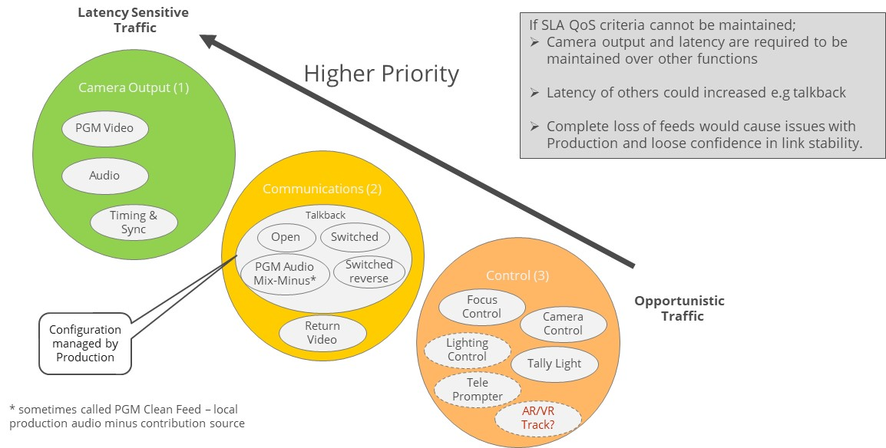
Figure 5.2.5.3.2-1: Flow Priority
Highest priority is program (PGM) video, which is always present when using a 5G-enabled camera. An audio media flow related to the program video flow is only present in some scenarios. When present, it often has an even higher priority than the program video. A time synchrinization related media flow (e.g. PTP or NTP) is always present and is essential for production.

5.2.5.3.3 Applying Quality of Service to application flows
Quality of Service (QoS) is a tool which only becomes relevant at times of high network utilisation. In these situations, the 5G System may need to prioritize some packets over others. In a well-planned production scenario, the 5G Systems is dimensioned to fit the needs of the media production and high network utilisation only occurs rarely. However, such good planning and dimensioning cannot be achieved in all media production scenarios. Thus, it might be preferred to degrade the output of a camera, keeping the most essential traffic intact. Depending on the scenario, different media flows are more essential than others to the media production.
An example communication protocol stack is illustrated in Figure 5.2.5.3.3-1 below. The different media flows may use different higher layer protocols. For audio and video streams, the RTP protocol is often used, which typically uses UDP as its Layer 4 protocol. Data streams such as tally light control may be carried using, for example, MQTT (NMOS recommendation) which uses TCP as its Layer 4 protocol.
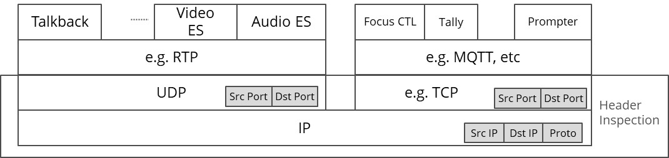
Figure 5.2.5.3.3-1: Example protocol stacks for different media application flows
The 3GPP Quality of Service framework contains many tools to define media flow specific treatment with respect to relative priority, target bitrate, packet delay budget and packet error rate. To apply these tools, the 5G System must be able to identify the associated media flow, based on network level parameters like a UDP port number or an IP address. The 5G System (UE and UPF) is using packet header inspection techniques for traffic detection. Based on header instection, each individual IP packet is assocuiated to a QoS flow and marked accordingly in the 5G System.
The exact combination of media flows illustrated in the above figure depends on the media production scenario. In the following clauses, the mappings of some example scenarios are presented and discussed.

5.2.5.3.4 Solution Example A: Coarse-grained separation with separated media
It is very common in IP based media production scenarios to keep elementary streams like audio and video separated in independent UDP/IP flows. Thus, audio and video are not multiplexed together.
It is assumed here that all media flows within one group can be treated with the same QoS class. Thus, audio is equally important as video. All the control data flows are also treated with equal priority.
For Group 1, the application traffic can be identified by a (wildcarded) 5-tuple of packet headers:
- Layer 3 parameters:
- UE IP: Any (wildcard).
- Server IP: IP address of media gateway or vision/sound mixer.
- Transport Protocol: Indicating that UDP is used as the Layer 4 protocol.
- Layer 4 Parameters:
- UE UDP Port: Any
- Server UDP Port: Separate UDP ports for audio and video on the Media Gateway / Vision Mixer side
For Group 3, the application traffic can be identified by a (wildcarded) 5-tuple:
- Layer 3 parameters
- UE IP: Any (wildcard).
- Server IP: IP address of MQTT Broker or WebSocket server.
- Transport Protocol: Indicating that TCP is used as the Layer 4 protocol.
- Layer 4 parameters
- UE TCP Port: Any.
- Server TCP Port: TCP Port of the MQTT Broker or WebSocket server.
In cases where all video and audio elementary streams are treated with the same priority, the elementary streams can be multipled onto the same UDP/IP flow, e.g. using a multi-programme MPEG-2 Transport Stream.
NOTE: When using MPEG-2 TS as a payload format, all multiplexted elementary streams are treated with the same QoS by the 5G System.

5.2.5.3.5 Solution Example B: Fine-grained separation with separated media
In this example, a finer-grained separation of media is used:
- Within Group 1, the audio elementary stream has a higher priority than the video elementary stream.
- Talkback (Group 2) audio should have a lower priority than group 1 traffic.
- In Group 3, tally light control has a higher priority than general camera control.
As result, the individual media flows should be separated into separate application flows, e.g. UDP/IP flows or TCP/IP flows.
In order to enable the 5G System to prioritise the audio elementary stream higher than the video elementary stream in Group 1, the elementary streams need to be carried as individual UDP/IP media flows.
- RIST Simple profile allows usage of separated RTP sessions for different elementary streams, when a native RTP payload format (like RFC 7798 [?] for HEVC or RFC 6416 [?] for AAC) is used.
- RIST Main profile uses GRE tunnelling to encapsulate all media flows in order to simplify NAT/firewall traversal. However, the usage of a GRE tunnel also disables the 5G System capability of providing media flow based QoS.
The talkback audio flow needs to be separated from the main output using dedicated TCP/IP or UDP/IP transmission resources.
If tally light control requires a higher priority than other camera control messages, the event messages should be carried using uniquely identifiable network resources. When MQTT is used for carrying control event messages, the camera needs to set up two MQTT/TCP connections, which can then be clearly prioritized by the 5G System. When WebSockets are used for carrying the event message, the camera needs to set up two WebSocket/TCP connections to enable separate message prioritisation.
**** Last Change ****

