Post 3GPP TSG SA4 Meeting #111e Conf Calls S4aI201094
Online, 11. – 20. November 2020 revision of S4-201441
Agenda item: 8.6
Source: Ericsson LM
Title: 5MBS Deployment Discussion
Document for: Discussion and Agreement

1 Introduction
The SA2 5MBS architecture was reviewed and discussed during the MBS conf call on 29th of October. SA2 delegates from different companies attended the call to guide though the SA2 TR and to highlight the most important sections and discussion points. Several aspects were clarified.
The intention of this discussion paper is to identify important collaboration and deployment scenarios for the SA4 FS_5GMSA-Multicast work and to start mapping of existing BM-SC functions to the new 5MBS architecture.

2 Short recap of TR 23.757 v1.1.0
The converged architecture is depicted in Annex A.3 of TR 23.757. It is copied below for convenience.
Figure A.3.2-1: Reference Architecture

Figure A.3.2-2: Configuration options at Service and/or Application
There are a couple of aspects to point out.
- SA2 separates between the “Transport only Mode” and a “Service Mode” / “Full Service Mode”. The Full Service Mode refers to a service layer as defined for the MBMS User Services TS 26.346. The MBSF contains the functionality for the full service mode.
- The function names MBSF-C and MBSF-U are still under discussion.
- The usage of the xMB interface name does not preclude potential modifications. It is up to SA4 to identify the need for changes.
- The term “AF” refers to the role of the Content Provider according to TS 23.246 / 26.346. According to the conf call discussion, SA2 architecture allows a control plane / user-plane split of the AF function.

3 Deployment Options and discussions
In the following, three different deployment models are presented. The key guiding assumption here is that the MBSF contains key Multicast related BM-SC functions such as a FLUTE Sender (which belongs to the “MBMS Download and Streaming Delivery Function”).
NOTE 1: The new M4d-mb interface is introduced to separate the unicast M4d protocols and formats from the Multicast protocols.
NOTE 2: SA4 needs to discuss, how much 5MBS related configuration information should be exposed via M1d and M2d. It is assumed here, that the 5GMSd AF & AS are used for unicast and likely hide the usage of Multicast to north functions.
A general assumption for all the collaboration scenarios is that the 5GMSd functions are used for unicast content distribution, e.g. CDN functionality for DASH streaming is in an external DN.
Collaboration A depicts a deployment where all 5MBS and 5GMSd functions are deployed inside the Trusted DN. The 5GMSd AF and AS are responsible for unicast content distribution (e.g. CDN), i.e. M5d and M4d are exposed by the 5GMSd functions.
The MBSF functions are for 5MBS distribution. The MBSF-C is the control and interacts with the MB-SMF using Nmbsmf.

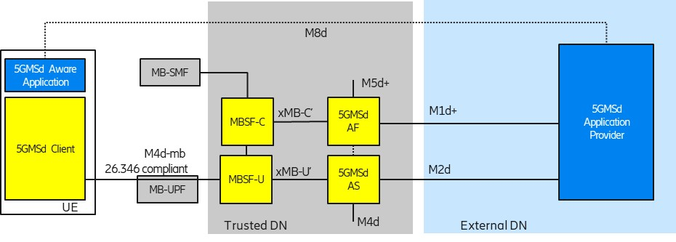
Figure 1: Collaboration A: Functions in Trusted DN

When the MBSF-C is co-located with the 5GMSd AF (and the MBSF-U with the 5GMSd AS) (dashed lines), then the M3d API is combined with the Nmbsf API.
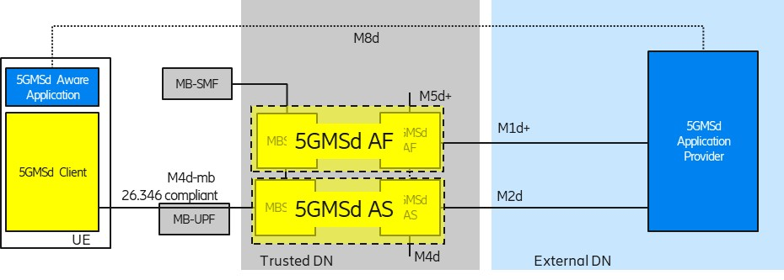
Figure 2: Collaboration A1: Co-located functions
Collaboration A1 describes a model where the MBSF-C and MBSF-U functions are integrated into (respectively) the 5GMSd AF and 5GMSd AS functions.
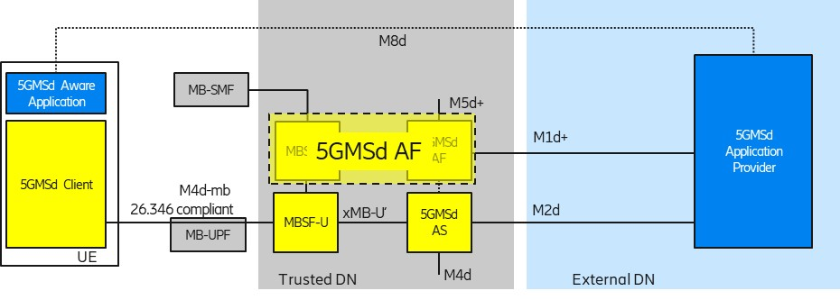
Figure 3: Collaboration A2: Integrated Control Plane, Separated User-Plane functions
Collaboration A2 describes a model where the MBSF-C function is integrated into the 5GMSd AF and the MBSF-U function is still a standalone function. Background here is that the user plane functions are more specialized, i.e. optimized HTTP servers for unicast and optimized delivery functions for multicast. The 5GMSd AF uses the newly developed Nmbsu API to configure and control the multicast delivery functions. The 5GMSd AS might be extended to cut-though any push ingest into the xMB-U′.
Collaboration B depicts a mixed deployment where unicast related functions are deployed in an External DN and all 5MBS related functions are in the Trusted DN.
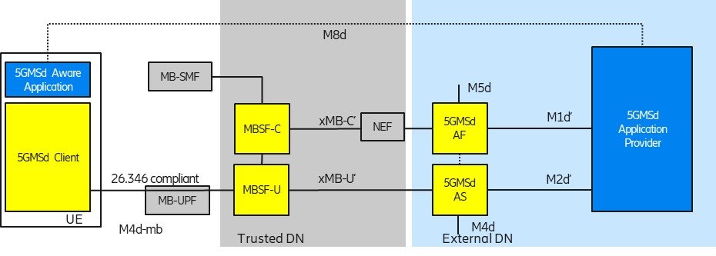
Figure 4: Collaboration B: Mixed External DN and Trusted DN functions
Configuration 2 in Figure A.3.2-2 (TR 23.757) indicates that an external AF uses the NEF as the control plane entry point. It is assumed that the xMB-C′ interface is passed through the NEF and the NEF adds security related functions transparently.
Like in Collaboration A (and C), the 5GMSd functions are used for unicast content distribution, e.g. CDN functionality for DASH streaming is in an External DN. The functions in the Trusted DN are leveraged to prepare the content for 5MBS delivery. Here, is it assumed that unicast functions like unicast content reception (e.g. DASH) and features like file repair are offered by the 5GMSd AS from the External DN.
Collaboration C depicts a deployment where all media related functions are deployed in an External DN and the 5G System offers only connectivity services, i.e. either unicast connectivity or 5MBS transport-only connectivity.
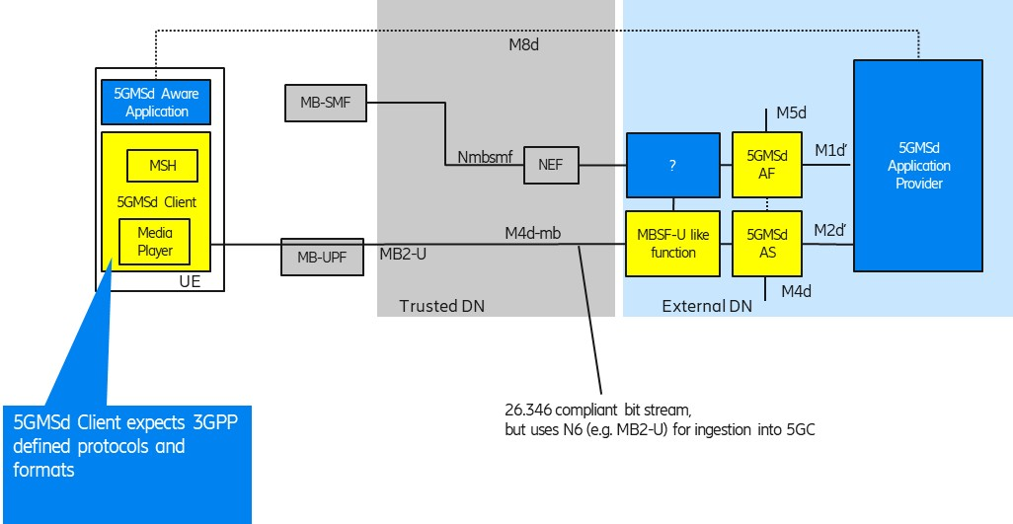
Figure 5: Collaboration C: All media functions in external DN
One could wonder, “why 3GPP should consider this deployment option?”. The consideration here is that a 5GMS Client (including a new 5MBS Client) in the UE can still be leveraged as receiver, supporting reception of 3GPP-defined “DASH over 5MBS”, generic file delivery and RTP streaming. An MBSF-U-like function in an External DN generates a bit stream compliant with TS 26.346. An Application Function (AF) may use Nmbsmf (via NEF) to activate Transport-Only delivery into the MB-UPF (according to Configuration 1 in Figure A.3.2-2 of TR 23.757).
Collaboration D depicts a deployment similar to Collaboration #4 In TS 26.501. Here, the media plane does not follow 3GPP specifications. An Application Function (AF) may use Nmbsmf (via NEF) to activate Transport-Only delivery into the MB-UPF (according to Configuration 1 in Figure A.3.2-2 of TR 23.757). Still, a 3GPP-defined Media Session Handler is interacting with a 3GPP-defined 5GMSd AF.
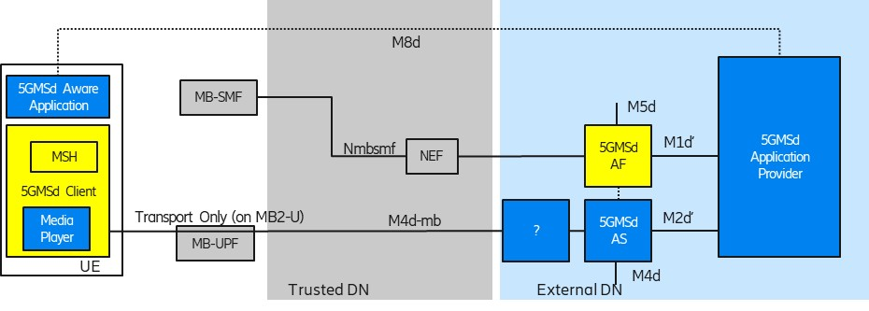
Figure 6: Collaboration D: Usage of Transport only with not 3GPP defined M4d-mb protocols.

4 Related 5G multicast and broadcast work in 3GPP
The BM-SC contains a number of MBMS related functions which may need to be separated between MBSF and 5GMSd functions.
Figure 4: BM-SC sub-functional structure (TS 26.346)
It is obvious that the “MBMS Download and Streaming Delivery Function” from the BM-SC “MBMS Session and Transmission Function” (i.e. FLUTE or RTP sender) are provided by an MBSF-U function.
The MBMS Group Communication Delivery Function also needs to be ported to MBSF-U. When AL-FEC is needed, the GCS AS should inject the MB2-U traffic into the MBSF-U. If no AL-FEC is needed, a GCS AS can directly inject the MB2-U traffic into the MB-UPF. In the case of eMBMS, the BM-SC also supports RoHC header compression (part of PDCP, see TS 29.061, Figure 16k). It is not clear whether the gNB provides PDCP support for 5MBS.
The BM-SC contains the “Associated Delivery Functions” including File Repair, Reception Reporting and Consumption Reporting (respectively for unicast fallback, service continuity and multicast operation on demand, MooD). Some of these functions are already offered by the 5GMSd AF and 5GMSd AS.
The BM-SC also contains the separate “User Service Discovery/Announcement” function, which can use either HTTP (“Interactive Announcement Functions”) or the “MBMS Download and Streaming Delivery Function”. The relation/merging of MBMS Service Announcement with the “Service Access Information” (provided by the 5GMSd AF) should be further studied. One perspective could be that a 5GMSd AF adds 5MBS-related information into the Service Access Information for a 5MBS Provisioning Session, and the 5GMSd AF may use a 5MBS bearer for distribution (i.e. a SACH file).
xMB includes a feature for unicast content delivery, e.g. using an HTTP CDN. Unicast Delivery is important for unicast fallback and service continuity, i.e. when a service should also be offered outside a MBMS coverage area. This delivery option is not clearly depicted in the BM-SC sub-functional structure. It may be beneficial to provide such unicast delivery for service continuity from the 5GMSd AS.

5 Proposal
It is proposed to consider the different deployment options (Clause 3) as Key issue for “identifying important collaboration and deployment scenarios” into TR 26.802. A pCR will be created, when there is principle agreement.
It is further proposed to study the separation of existing BM-SC MBMS User Service functions to MBSF and 5GMSd functions, as described in Clause 4 and include Section 4 into TR 26.802.
Note, interworking with existing LTE Based broadcast systems (i.e. interworking with a BM-SC) needs to be studied further.

