3GPP TSG-SA WG3-LI Meeting #32 SA3LI09_014
Dublin, Ireland, 10-12 Feb. 2009

ETSI TC LI#20 ETSI TC LI (2009) 20litd021

3rd- 5th February 2009, Levi - Finland

Source: | BT Group
Title: | Dynamic Triggering Discussion
Spec: | -
Notice:  One box to be ticked!! | The author of this document declares that the document may be stored in the public TC LI docbox. | X
 | The author of this document declares that the document may only be stored in the protected LI_AM docbox.

Document for: | Decision: | X
 | Discussion: | X
 | Information: | XC

Contact details: | Alex[dot] Leadbeater [at] bt [dot] com

Introduction
At the last TC LI, the topic of dynamic triggering and CCTF standardisation was briefly discussed. This paper concerns the creation of a standardised triggering interface which can be used to activate real-time interception in the transport domain from call control events in the service domain (eg IMS), on a session by session basis rather than based on traditional access network registration binding of target identities to IP addresses.
Note:- This contribution is adapted from BT Group contribution S3LI08_054 in SA3_LI.

Discussion
Figure 1 on the next page illustrates the general CC Dynamic triggering scenarios. While this example is based on the 3GPP IMS domain, these scenarios apply to any general service architectures where there isn’t a specific binding between the access network and the user service.
For the purpose of this contribution, two scenarios are specifically considered in figure1:-
- In this scenario CSP2 is the IMS provider and CSP1 is simply providing network access to their subscriber and the subscriber is then using CSP2's IMS service. This scenario also covers scenarios where a user connects to CSP2’s IMS over the internet or other arbitrary network access means, where the CSP2 has no knowledge of the access network.
In this scenario CSP2 owns both an IMS SIP network and an underlying core transport network but not the access network.
- In this scenario CSP2 only owns the IMS SIP network and Application Servers. Both the access and core transport network are provided by CSP1 or a number of other CSPs.

In scenario 1, we will assume the obligation for LI falls on CSP2 and in scenario 2 we will assume that CSP2 has a direct obligation for intercepting SIP signalling at their CSCFs and a responsibility to assist CSP1 or other ISPs in interception the CC associated with the IMS IRI. To further complicate the scenarios the media streams may be encrypted between the application server / media plane function and the User equipment so that CSP1 cannot intercept in the clear and it is unlikely that CSP2 would have stored any session keys).

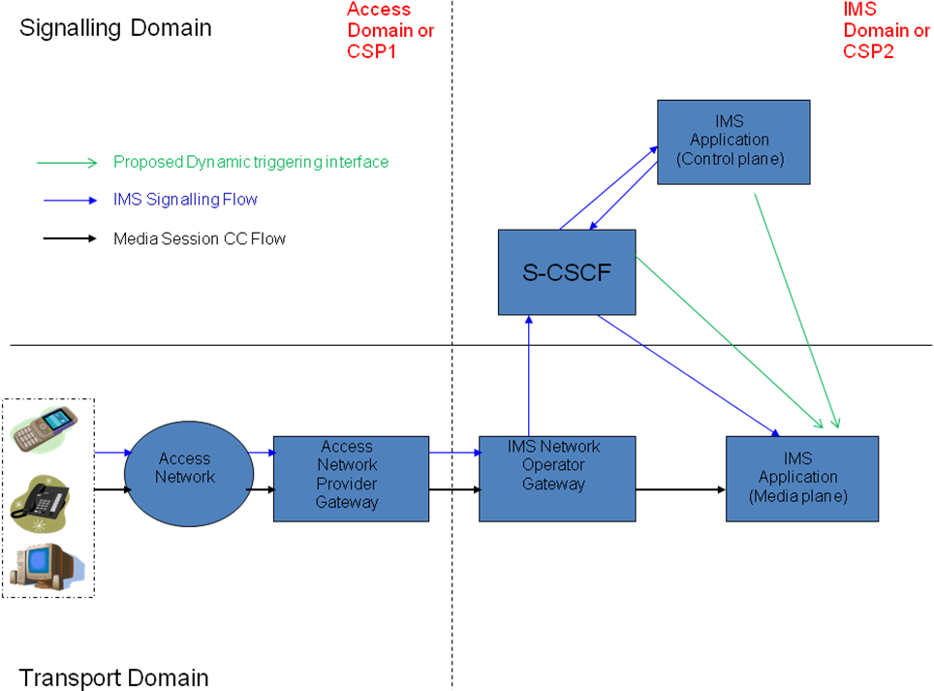
Figure 1:- Generalised IMS CC Dynamic Triggering Scenario

In a common IMS architecture the CSCF does not know/care if the operator offers services to 3G terminals or fixed line NGN terminals or anything else. While the scenarios in figure 1 have a large overlap with TISPAN requirements, these scenarios are not specifically TISPAN, 3GPP or other IMS access provider, they are generic across all operators where the access is decoupled from the IMS core network. A specific mobile scenario could be a Virtual Mobile operator (VMO) which does not own an access network (or does not trust the access network in some roaming scenarios) is obliged to intercept an IMS service/session. Alternatively consider a mobile operator who wishes to offer IMS services over a fixed operator’s broadband network.

Furthermore, under Local Loop Unbundling (LLU) and other freedom of competition regulations/obligations in Europe, subscribers will become increasing able to buy their services from different service providers. This further erodes that traditional link between the mobile or fixed access provider and the provider of the communication service which the subscriber wishes to use. When end to end encryption type scenarios are taken into account traditional approaches of performing interception in the access domain specifically link to access network registration becomes far more difficult.

With regard to figure 1, now assume that the UE initiates a media session using the application server services of CSP2. From the perspective of CSP2, we have a target list programmed into the CSCF so IRI interception is possible. However, because the UE is not registered in the transport domain of CSP2 prior to the media session initiation, the media plane functions in CSP2 cannot match the target identities to an IP address in order to intercept the CC. (Traditionally the HSS provides this linking via the GPRS PS domain registration prior to the IMS session establishment in 3GPP basis scenarios).

So in order for the media plane functions in CSP2 to intercept the CC they need additional triggering information from the CSCF or IMS application server on a per session basis.

This should hopefully summarise what WI is trying to find a standardised solution for. There are obviously more complicated scenarios where the service signalling and Transport domains of CSP2 are split into different operators but the simpler scenario here should illustrate the ideas.

While the scenario in figure 1 is focussed on the use of Common IMS CSCFs, this approach may be equally appropriate for inclusion within an Application Server (AS). Providing the information transferred over a dynamic CC triggering interface is standardised, then it can be left to manufacturers or CSPs to decide whether CSCF or AS based support for the triggering interface is more appropriate.

Existing Approaches
There are a limited number of existing standardised and proprietary ways in which these scenarios are already supported by networks. This section analyses the existing techniques and considers their applicability to the scenario described in this document.

RFC 3603 P-DCS LAES/ Packet Cable 2.0
RFC 3603 provides an optional SIP extension for LI in the form of the P-DCS-LAES header. This approach is used by packet cable to provide some of the similar functionality to that proposed in this contribution.

However the P-DCS-LAES mechanisms essentially insert a SIP extension header into existing SIP messages travelling between SIP signalling nodes (eg CSCF and AS) and SIP messages sent to the transport domain media controllers/routing functions. This means that any SIP node may be able see the LI target information in the SIP messages and generally any person with access to the call setup signalling flows could potentially monitor or capture the LI related information. Using this mechanism also requires the network to ensure that legitimate users or attackers cannot insert or delete this header and consequently effect the operation of the network’s LI capability. However the RFC does include some security mechanisms that can be used to reduce the risks.
[Note these risks are much reduced in the processed triggering approach in this contribution as the triggering would be provided over dedicated LI interfaces].

In the case of packet cable 2.0 it was developed for the cable environment where the cable operator usually provides all parts of the network, generally including the user equipment (cable box). Therefore the CSP split scenarios and the security models are considerably different.

While it might be possible to use RFC3603 over the proposed Dynamic Triggering interface (with additional security), instead of using the RFC over the existing general call setup signalling paths, the approach taken by packet cable is not considered appropriate for Dynamic Triggering.

It should be noted that while Dynamic Triggering needs to be supported by SIP based network elements there is no specific requirement for dynamic triggering to be based on SIP, although SIP is one of several of several industry standard protocols on which an interface could be based.

Call / Session Re-direction or proprietary triggering
Most existing networks provide limited support for dynamic triggering for single CSP non-network split scenario services. These approaches have a number of limitations.

In some cases these solutions require all network elements to be supplied by a single supplier or are restrictive when it comes to launching new product and services out of the box without significant changes to existing LI functionality. In effect you end up with specific linkages between the IMS signalling and Transport domain (not inline with IMS bearer independence goals). These solutions are also generally proprietary.

In other cases, network solutions may force all media streams or calls to take specific or redirected paths through the network (eg via a Session Border Gateway). This is restrictive in terms of call routing and in the case of re-direction could potentially (although unlikely) be detected by the target in the form of routing changes or additional call setup/end to end delay.

TISPAN CCTF
ETSI TISPAN already has a concept for dynamic triggering in terms of the CCTF (Content of Communications Triggering Function). Figure 2 shows the TISPAN LI architecture including the CCTF. The CCTF is one of a number of architectural approaches which could be used for Dynamic triggering. As discussed in 19litd040 and 19litd025, TISPAN already see the need to standardise the CCTF.

While it would be necessary to carefully consider how to secure the CCTF interfaces and what information needs to be transferred across the INI1b, CCTI and CCCI interfaces, the CCTF does represent a viable approach which could be readily adopted by TC LI as the basis for work on dynamic triggering.

Figure 2: Reference Model for Lawful Interception from TR 102 528(Figure 1)

Open Issues
There are a number of initial open issues which need to be addressed in standardisation of a dynamic CC Triggering interface. This list is not exhaustive and it is anticipated that others will be identified during the study.

Issue | Comment/Status
Specifically what information needs to be transferred across the interface? | As a minimum the following is required:-  User Identities / IP Addresses / Media stream Ids.  Correlation Number.
What security mechanisms are required to ensure the IMS domain security is not comprised by this proposed interface.? | Dynamic Triggering interfaces must provide message / end point authentication, integrity protection and encryption.  In addition the triggering interface must not break the IMS security model. SA3 may need to be consulted on these issues.
What security mechanisms are required to ensure the triggering interface cannot be misused. (eg authentication and integrity protection of messages on the interface)? | Dynamic Triggering interfaces must provide message / end point authentication, integrity protection and encryption..  In addition the triggering interface must not break the IMS security model. SA3 may need to be consulted on these issues.
Where should this function be supported (eg CSCF or AS)? | The interface should be generic such that it could be included in any SIP or non SIP or transport bearer (CC) nodes where LI needs to be triggered.
Should the interface be included internally with in the CSCF/AS or supported externally via CCTF interface. | Triggering interface should use an LI triggering specific interface, either as a direct logical connection or via a CCTF / regulatory authorisation function.  In theory it is also possible provide triggering via the X2/HI2 interface. However this may introduce delays which result in media stream call start being missed.
Are there any existing IETF or other standardisation body triggering protocols /functions which could be reused? | Manufacturer specific, basic stream rerouting and RFC 3603 provide some triggering capabilities. However these approaches have significant drawbacks and therefore development of a new interface is considered to be the best solution.  [Note:- It may be possible to reuse parts of existing triggering approaches when developing a new triggering interface].  TISPAN CCTF does offer the potential to form the basis of TC LI dynamic triggering solution
Is there a requirement to support cross-network triggering where the IMS provider and the transport domain function handling the media session (eg MGW or MRFP etc) are in different networks? – Requirement may come from operators who have outsourced some network elements or from LEAs to support cross network LI, but in either case will have knock on effect to the security requirements. | It is considered that this is a real requirement and therefore this requirement will be taken into account when developing a dynamic triggering interface.
How does the SIP IMS IRI LI function (eg AS or CSCF), identify which CC LI function should be triggered, if multiple CC LI functions exist in the network. | TBC in future contributions

Proposal & Conclusion
It is proposed that information in this contribution is taken into account when progressing the work item on dynamic triggering in TC LI.

