3GPP TSG SA WG3 LI Meeting #25 SA3LI0y_0yyry
25-27 April 2007
Riga, Latvia
CR-Form-v9.3
CHANGE REQUEST
 | 33.107 | CR | CRNum |  rev | - |  Current version: | 7.5.0 | 
For HELP on using this form look at the pop-up text over the  symbols. Comprehensive instructions on how to use this form can be found at http://www.3gpp.org/specs/CR.htm.

Proposed change affects:  | UICC apps |  | ME |  | Radio Access Network |  | Core Network | X

Title:  | Add a method to realize IMS interception
Source to WG:  | SA3-LI(ZTE Corporation)
Source to TSG: 
Work item code:  | SEC-LI |  |  |  |  |  |  | Date:  |  | April, 2007
Category:  | B |  |  |  |  |  |  | Release:  |  | 7
 | Use one of the following categories:  F (correction)  A (corresponds to a correction in an earlier release)  B (addition of feature),  C (functional modification of feature)  D (editorial modification)  Detailed explanations of the above categories can  be found in 3GPP TR 21.900. |  |  |  |  |  |  |  | Use one of the following releases:  R97 (Release 1997)  R98 (Release 1998)  R99 (Release 1999)  Rel-4 (Release 4)  Rel-5 (Release 5)  Rel-6 (Release 6)  Rel-7 (Release 7)  Rel-8 (Release 8)
Reason for change:  |  | IRI Interception at a CSCF and CC Interception at a GSN are defined in the TS 33.107.  However, CSCF and GSN locate in the control layer and transport layer seperately, it will be a complicated thing to set the target at every GSN statically in order to get the CC.  Combined way of IRI Interception and CC interception should be defined in IMS interception.  Here supplys a realization method based on the dynamic activation of the CC filter in GGSN.
Summary of change:  |  | Addition of new section for the realization of IMS interception
Consequences if   not approved: |  | No complete solution for IMS interception
Clauses affected:  |  | Annex C (add annex C.7)
 |  | Y | N
Other specs  |  |  | X | Other core specifications 
affected: |  |  | X | Test specifications
 |  |  | X | O&M Specifications
Other comments: 

********** Modification ************

C.7 IMS interception based on dynamic activation

C.7.1 Configuration
In this configuration shown in Figure 1, the initial provision is set on the CSCF for the IRI, however this activation and invocation does not produce the content of communications. When the interception in CSCF is triggered, a dynamic activation through INI1b interface on the certain GGSN should be executed without time delay for the content of communications.
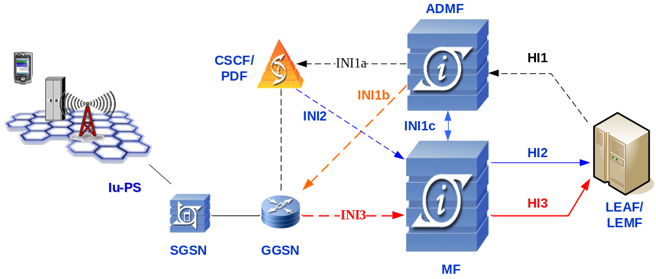
Figure 1 IMS interception configuration

C.7.2 Operation flows
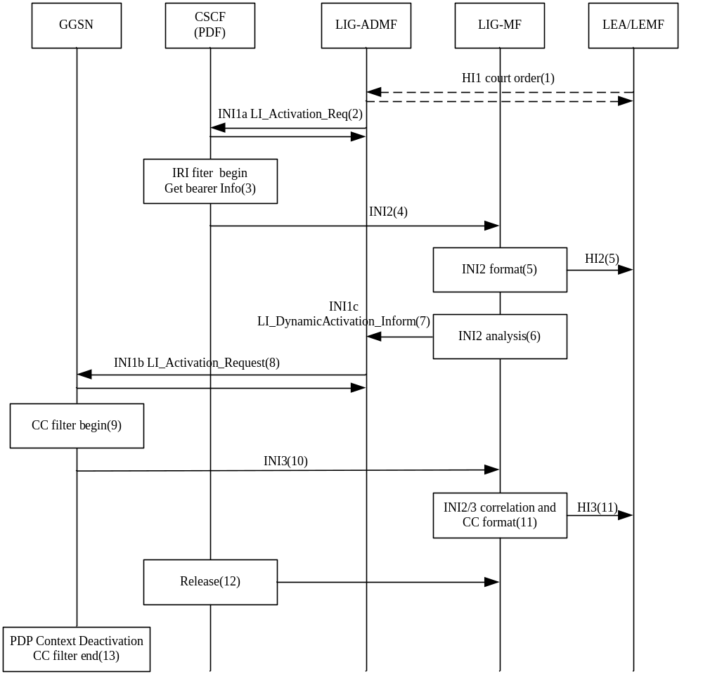
Figure 2 Operation flow
The following describes the sequence of the operation shown in Figure 2:
- The LEA delivers a court order to the network administrator who operates the LI Administration Function.
- The ADMF sends an INI1a LI_Activation_Request to provision the CSCF with the SIP_URI or TEL_URI target identifier.
- When the target has a communication activity, the interception in CSCF will be triggered. The bearer information including the GGSN address and the correlation number which contains the GGSN ID and GSN charging-ID could be achieved by CSCF through PDF. The GSN charging-ID is assigned for each PDP context activation on GGSN.
- The SIP messages related to the target and the bearer information are sent to the MF from CSCF through INI2.
- In the MF, the INI2 message is forwarded to the LEMF in the standard HI2 format.
- In the MF, the Target Endpoint IP address and UDP port is got from the SDP of SIP message.
- The Target Endpoint IP address and UDP port and the Correlation Number identifying the PDP context will be taken as the CC filter. The MF sends an INI1c LI_DynamicActivation_Inform to ADMF to activate the interception on the certain GGSN dynamically with the CC filter.
- ADMF sends an INI1b LI_Activation_Request to the GGSN with the target CC filter and a dynamic_activation_number which identifys this dynamic activation. This step should be done on a automatic method so as to avoid the time delay.
- GGSN starts a CC filter process.
- The RTP packets meet the target CC filter are intercepted and sent to the MF throuth INI3 by the GGSN.
- INI3 is correlated with the INI2. CIN and sequence number is assigned when the interface is based on TS 102 232. The HI3 message is forwarded to the LEMF.
- The communication session is released.
- When GGSN detects the PDP Context is deactivated, CC filter is stopped automatically.

********** End of Modifications ************

