Invitation and General information
on 3GPP RAN1#98-Bis/ RAN2#107-Bis/ RAN3#105-Bis
/RAN4#92-bis/SA3-Ad-Hoc meetings

from Monday 14 to Friday 18 of October 2019 in Chongqing, China

Beijing, 16 July 2019

Dear Delegate,

The Chinese Friends of 3GPP (CF3) has the pleasure of inviting you to the 3GPP RAN1#98-Bis, RAN2#107-Bis, RAN3#105-Bis, RAN4#92-bis, SA3-Ad-Hoc meetings in Chongqing, China.

- RAN1#98-Bis Meeting （14th-20th Oct. 2019）will be held in Radisson Blu Plaza Chongqing.

- RAN2 #107-Bis Meeting and RAN3#105-Bis Meeting will be held in Le Meridien Chongqing Nan'an.

- RAN4#92-Bis Meeting and SA3-Ad-Hoc Meeting will be held in DOUBLETREE BY HILTON CHONGQING – NAN’AN.

We look forward to seeing you all in Chongqing.

Yours sincerely,
the Chinese Friends of 3GPP

Accommodation
CF3 is not responsible for reservation confirmations, cancelled or changed reservations or no-shows. Please contact the hotel directly to make the reservation.

Meeting Venue for 3GPP RAN1#98-Bis
Radisson Blu Plaza Chongqing
22 Nan Bin Road, Nan’an District, Chongqing China
Tel: +86-23-8866 8888
Group Rates:
- Superior Cityview Room / Deluxe Riverview Room (King Bed / Double Beds): CNY 580 net per room per night with one or two daily breakfasts
- Superior Cityview Room / Deluxe Riverview Room (King Bed / Double Beds): CNY 700 net per room per night with one or two daily breakfasts and ONE buffet lunch at the next day
- Superior Cityview Room / Deluxe Riverview Room (King Bed / Double Beds): CNY 820 net per room per night with one or two daily breakfasts and TWO buffet lunches at the next day

* The above rate includes Service Charge and government taxes. Broadband Internet access is complimentary in guest rooms.
* Cancellation Policy:
- RESERVATION IF CANCELLED LESS THAN 3 DAYS PRIOR TO ARRIVAL WILL BE SUBJECTED TO WHOLE CHARGE.
Hotel cut-off date, 12 September 2019
Hotel booking
Meeting Registration
Please register for the meetings online at:
on-line registration

Meeting Venue for 3GPP RAN2#107-Bis and RAN3#105-Bis
Le Meridien Chongqing Nan’an Hotel
No. 10, Jiang Nan Avenue, Nan’An District,Chongqing, China
Tel: +86-23-8638 8888

Group Rates:
- Deluxe King Room: CNY 680 net per room per night with one or two daily breakfast
- Deluxe Twin Room: CNY680 net per room per night with one or two daily breakfasts
* The above rate includes Service Charge and Estimated government taxes and fees. Broadband Internet access is complimentary in guest rooms.
* Cancellation Policy:
- RESERVATION IF CANCELLED LESS THAN 48 HOURS PRIOR TO ARRIVAL WILL BE SUBJECTED TO A ONE-NIGHT CHARGE.
Hotel cut-off date: 09 October 2019

Hotel Booking

Meeting Registration

Please register for the meetings online at:
on-line registration

Meeting Venue for 3GPP RAN4#92-Bis and SA3-Ad-Hoc
Double Tree By Hilton Chongqing Nan’an
No.36 Nanping West Road, Chongqing
Tel: +86-23-6230 8888
Group Rates:
- King Room: CNY 620 net per room per night with one or two daily breakfasts
- Twin Room: CNY 620 net per room per night with one or two daily breakfasts

* Group Code: GCCSA
* The above rates include Service Charge & VAT. Broadband Internet access is complimentary in guest rooms.
* Cancellation Policy:
- The reservation requires a credit card deposit which will be charged to your card.
- RESERVATION IF CANCELLED ON AND AFTER 16 SEPTEMBER, 2019 WILL BE SUBJECT TO A WHOLE CHARGE.
Hotel cut-off date: 15 September 2019
Hotel Booking

Meeting Registration
Please register for the meetings online at:
on-line registration

Other hotels nearby:

Chongqing Marriott Hotel (No.9 Yanyu Road, Nanan District, Chongqing, 400060 P.R.C)
(3.1km to Radisson Blu Plaza Chongqing; 3.2km to Le Meridien Chongqing Nan'an; 3.6km to DOUBLETREE BY HILTON CHONGQING – NAN’AN)

Deluxe Mountain King or Twin Bed room: CNY800net with 1 or 2 breakfasts ;
Deluxe River king or twin bed room: CNY1,000net with 1 or 2 breakfasts

Last Day to Book: Thursday, October 10, 2019
Cancellation Policy: Group rate, Non-refundable, if cancel or no show will be charge first night room fee and service charge.

Hotel Booking
(The hotel will release the rooms in batches. Please contact the host contact if there are no rooms available)

Hilton Chongqing (139 ZhongShan SAN Lu, YuZhong District, Chongqing, China)

Transpotation
Hilton Chongqing----- Radisson Blu Plaza Chongqing
6KM 46Min Bus No. 819: Nan Qu Park Road Station-------- Convention and Exhibition Center Station

Hilton Chongqing----- Le Meridien Chongqing Nan’an Hotel
7KM 25Min Subway Line 3: Liang Lu Kou Station--------Nan Ping Station

Hilton Chongqing----- Double Tree By Hilton Chongqing Nan’an
7KM 26Min Subway Line 3: Liang Lu Kou Station--------Gong Mao Station

Jiang Bei International Airpot----- Hilton Chongqing
25KM 70Min Subway Line 3: Jiang Bei Airpot Station-------- Liang Lu Kou Station

Visa letter
If you need an invitation letter for applying a VISA, complete the provided request form and send it to the person below no later than 10 September, 2019 (Beijing time, GMT+8). Late submission will not be accepted. It is recommended for each company to designate one delegate from your company to collect all the information of your delegates who need the invitation letter and to send one request e-mail by the designated person. Please contact the Chinese Embassy at your country for further information.

Contact person for invitation letter:
Mr. Xu Qi (CCSA)
E-mail: ccsavisa@163.com
Tel: +86-10-6230-4200

Time Zone
GMT +8 hours

Voltage
Commercial power in China is 220V. Please be sure you have the correct adapter. Voltage converters will not be provided at the meeting.
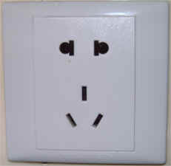

City Profile/ Area Attractions
https://www.ichongqing.info/

Host Contact
For any questions about anything relating to the meeting please contact:
Mr. Xu QI
Tel.: +86-10-6230 4200
E-mail: qixu@ccsa.org.cn

Ms. Hongyan JIA
Tel.: +86-10-6230 2735
E-mail: jiahy@ccsa.org.cn

Mr. Shizhuo ZHAO
Tel.: +86-10-6230 2645
E-mail: zhaosz@ccsa.org.cn

Attachment 1: Invitation letter request form for VISA
Attachment 2: Transport Information about the meeting venue
Attachment 1: Invitation letter request form for VISA

INVITATION LETTER REQUEST FORM

To enter China for the meetings indicated above, you may need a letter of invitation from the Chinese host, which you will need to present to the Chinese Embassy/Consulate in your area in order to obtain your visa. In order to obtain the invitation letter, please:

- fill out the form below
- Send it to (please reference “Invitation letter request for 3GPP RAN X/SA3 meeting” as the subject):

Mr. Xu Qi

China Communications Standards Association (CCSA)

ccsavisa@163.com
(It’s recommended to scan your passport page and email to us so that it’s discernible and can be used.)
Fax number: +86-10-6230 1849-4200 (if your passport page is photocopied and enlarged)
Company
Applicant Information | [ Click and Type in your full name ] |  |  | Mr Ms Mrs
Applicant Information | [ Nationality ] |  |  | [ Passport No.]
Applicant Information | Date of birth : |  |  | [ Job Title ]
Applicant Information | Is this your first visit to China? |  |  | __ Yes ___ No
Applicant Information | If the country in which you'll obtain your visa is different from your nationality, please indicate it here:  [ Country to obtain your visa]
Applicant Information | The name and the address of the Chinese Embassy/Consulate, which you are going to apply your visa.  Name:  Address:
Your Address
Place to visit after entry | In this case, it is Chongqing by default.
Date of arrival at China |  |  | Date of departure from China
End of form
(Please do not forget to attach a copy of your passport photograph page before sending.)
Your information should be sent out before 10 September, 2019.

Attachment 2: Transport Information about Meeting Venue

Transportation from Chongqing Jiang Bei International Airport (https://www.cqa.cn/)
Radisson Blu Plaza Chongqing is about 26 km and 30 mins by car from Chongqing Jiangbei International Airport.

Taxi (30 mins)
The fare for taxi from the Airport to the hotel is around CNY 100 per way. (Please take the taxi which can provide the invoice for your trip)

In case of taking a taxi, please print the following note which shows taxi driver the address of Radisson Blu Plaza Chongqing in both English and Chinese.

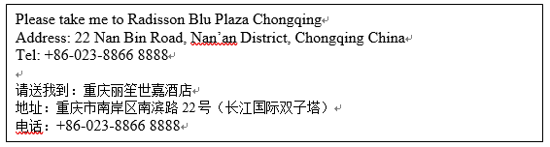

Le Meridien Chongqing Nan’an Hotel is about 30 km and 38 mints by car from Chongqing Jiangbei International Airport.

Taxi (38 mins)
The fare for taxi from the Airport to the hotel is around CNY 70 per way. (Please take the taxi which can provide the invoice for your trip)

In case of taking a taxi, please print the following note which shows taxi driver the address of Le Meridien Chongqing Nan’an Hotel in both English and Chinese.

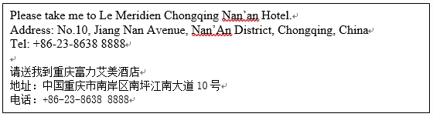

Double Tree by Hilton Chongqing Nan'An is 28km away from the Chongqing Jiangbei International Airport.

Taxi (40 mins)
The fare for taxi from the Airport to the hotel is around CNY 70 per way. (Please take the taxi which can provide the invoice for your trip)

In case of taking a taxi, please print the following note which shows taxi driver the address of Doubletree by Hilton Chongqing Nan an in both English and Chinese.

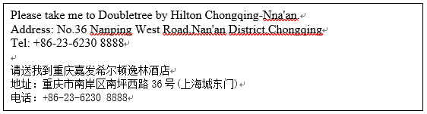

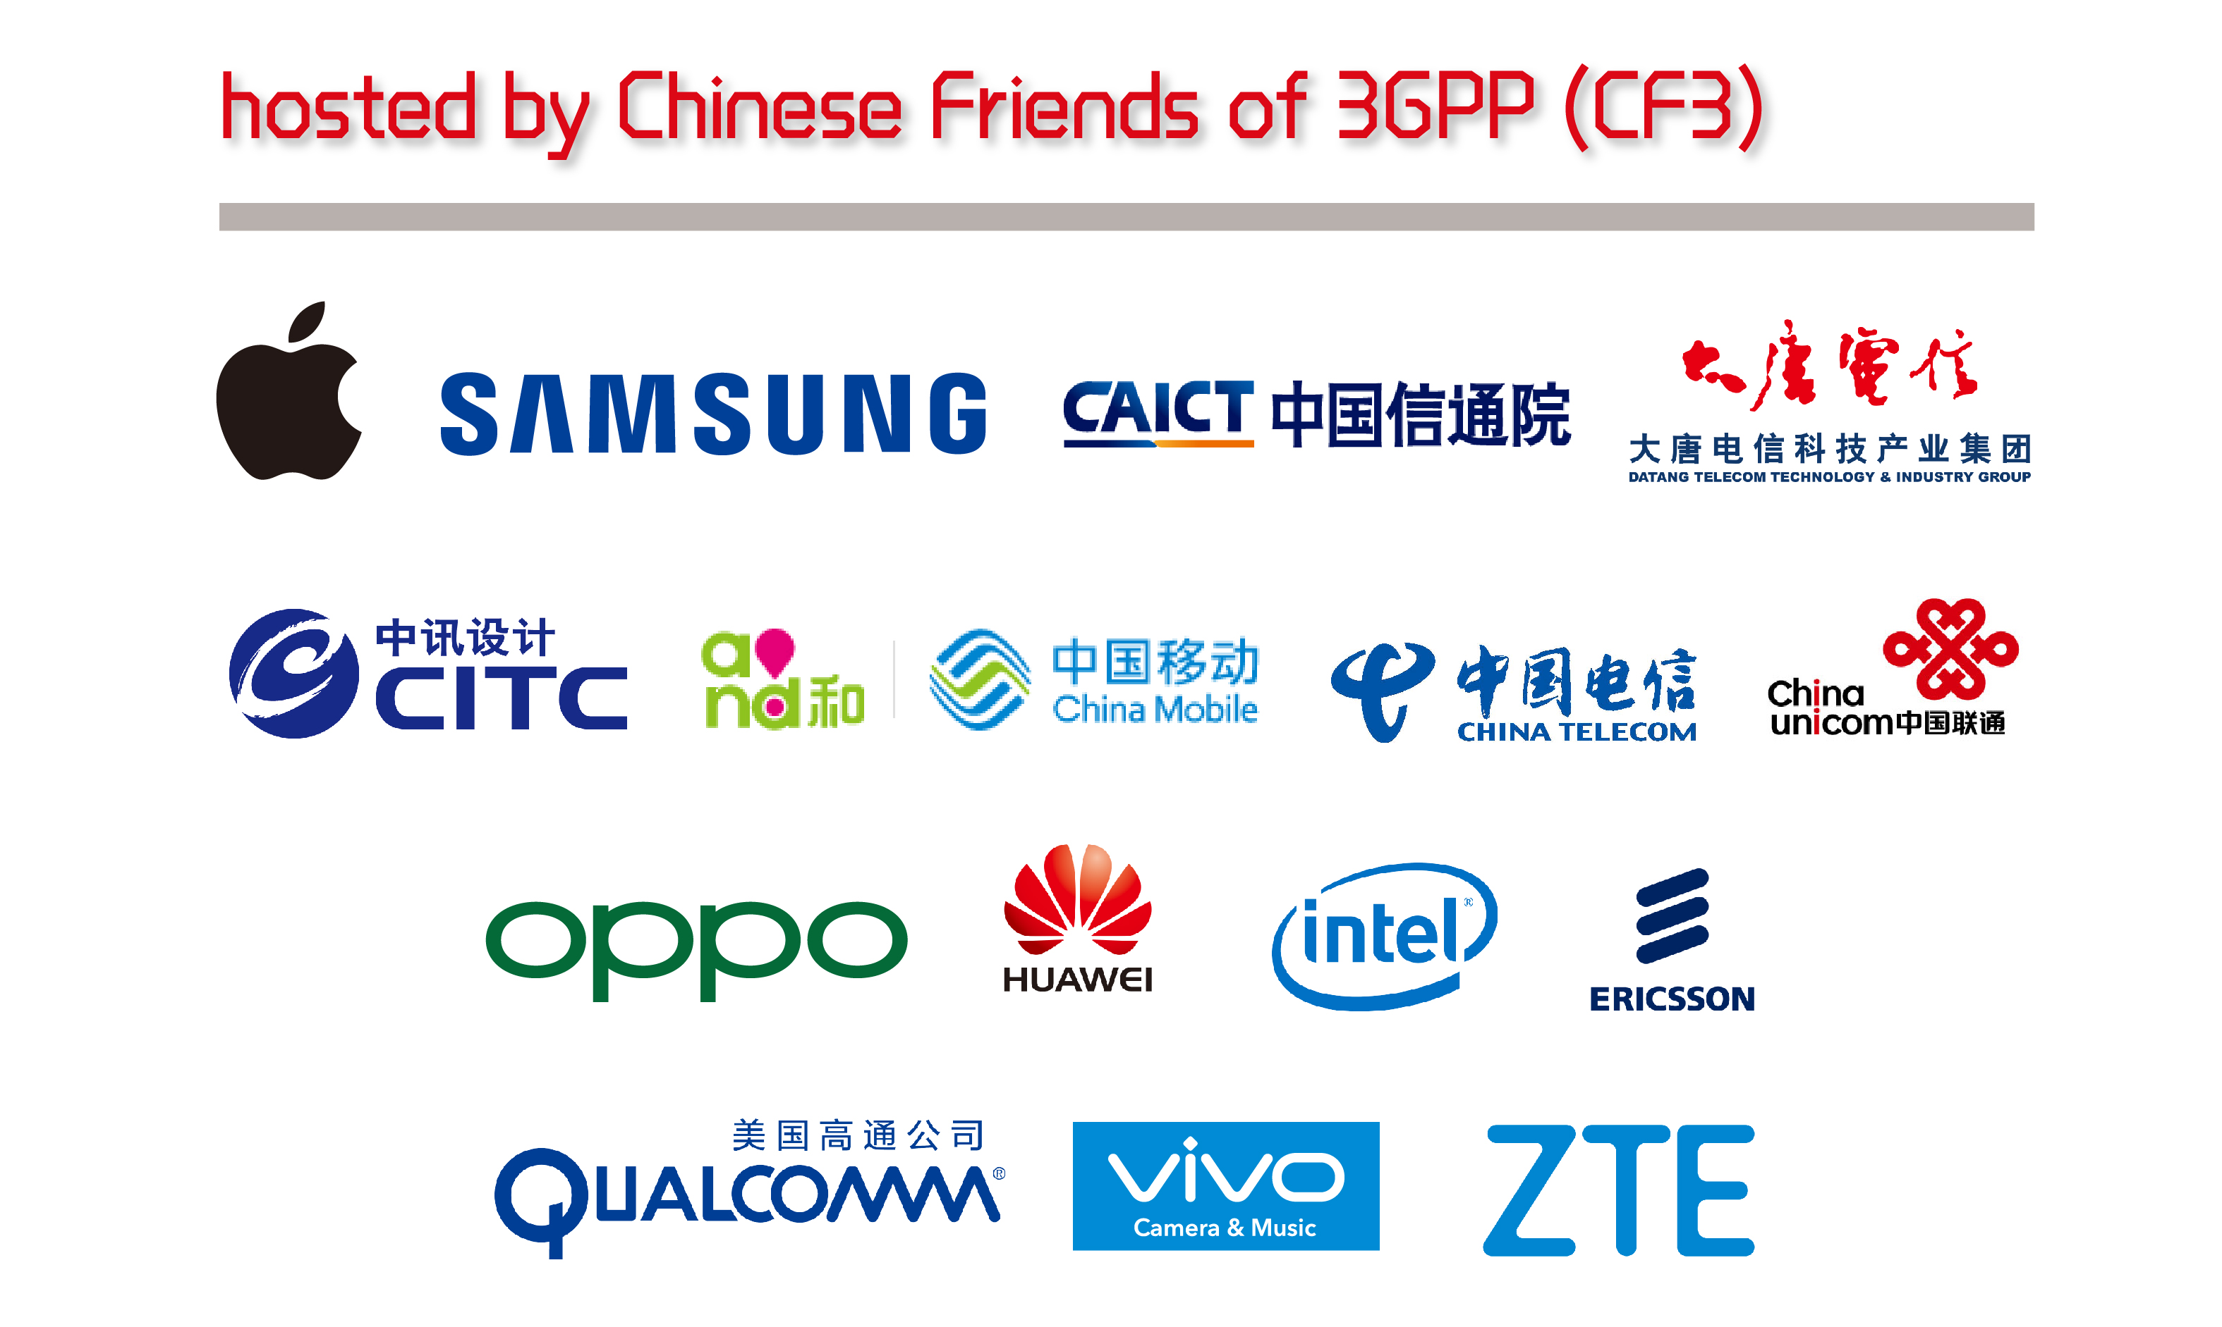

- Apple Computer Trading Co., Ltd.
- BEIJING SAMSUNG TELECOM R&D CENTER
- China Academy of Information and Communications Technology
- China Academy of Telecommunication Technology
- China Information Technology Design & Consulting Institute Co., Ltd.
- China Mobile Communications Corporation
- China Telecommunications Corporation
- China Unicom
- Guangdong OPPO Mobile Telecommunications Corp., Ltd.
- Huawei Technologies Co.,Ltd.
- Intel China Ltd.
- Nanjing Ericsson Panda Com Ltd.
- Qualcomm Wireless Communication Technologies (China) Limited.
- vivo Mobile Communication Co., Ltd.
- ZTE Corporation

Have a successful meeting and enjoy your stay in Chongqing!

