

Invitation to the 3GPP TSG SA1#65, SA2#101 and SA3#74 Meetings
20-24 January, 2014
Taipei, Taiwan.

Dear Delegates,

On behalf of ITRI and sponsors Chunghwa Telecom, Arcadyan, MediaTek, and Institute for Information Industry, I am pleased to invite you to 3GPP TSG SA meetings in Taipei, Taiwan.

The meeting will be held at Howard Taipei Hotel. A block of rooms has been reserved at the hotel under the group code 3GPP (use if you make reservations by phone). The reduced room rate is NT$ 4,800 (~160 USD incl. tax) and the cut-off date for the hotel is 17th December, 2013. Complimentary guest room internet and one buffet breakfast are included. Please read the reservations section of the invitation for more information regarding booking your room.

Please be sure to book your room with the group code 3GPP to insure that the hotel knows that you are with our group. This is very important for the meeting hosts, who graciously offered to set aside and guarantee a certain number of rooms at reduced rates for the attendees of this meeting.

In addition to making your hotel reservation, it is also very important to register for the meeting on the 3GPP website as well. This provides the MCC and meeting planners with important planning information. Please visit http://webapp.etsi.org/3GPPRegistration/fMain.asp?mid=28494 to register on line. Those who do not register for the meeting in a timely fashion will not have a name badge at the registration desk.

Meeting directions and general information are provided in the following pages.

We look forward to seeing you in Taipei, Taiwan.
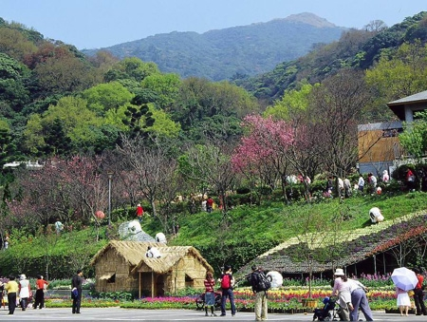
Yours sincerely,

Dr. Ching-Tarng Hsieh
ITRI
email: chsieh@itri.org.tw

General Meeting Information

Meetings
3GPP TSG SA1#65,
3GPP TSG SA2#101,
3GPP TSG SA3#74

Locations:
Taipei, Taiwan

Hotel Address and Contact Information:
Howard Taipei Hotel. (台北福華大飯店)
No. 160, Section 3, Rén'ài Rd, Daan District
Taipei City, Taiwan 106
Phone: (886) 2 2700 2323
臺北市仁愛路三段160號 (Chinese address)
http://taipei.howard-hotels.com/CT_Taipei2.php
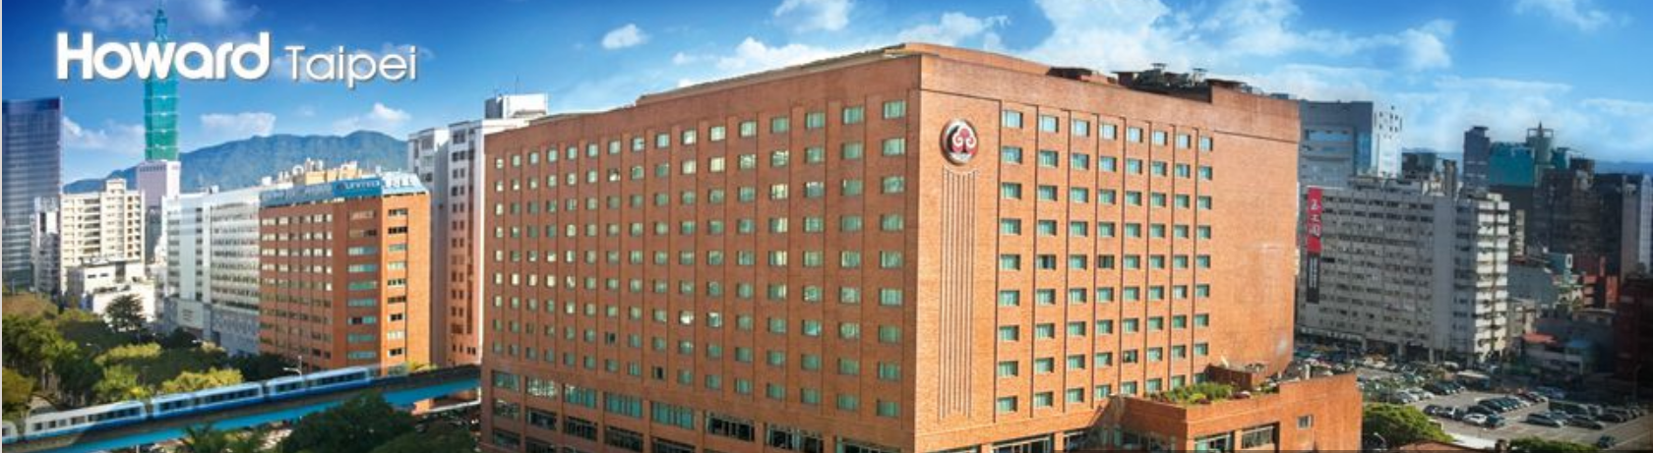

Room Rate:
NT$ 4800 – Superior Single
NT$ 5100 – Deluxe Single
(Inclusive of one International Buffet Breakfast and usage of internet access in guest room)

Cut-off Date:
17th December 2013.
Please be sure to make your reservations before the cut off date to insure the lower group rate. Rates may be significantly higher after the cut-off date.

Check-in/Check-out Times:
Check in – 15:00 pm
Check out – 12:00 pm

Internet Reservations:
Please use the following link to make your reservation on line:
https://www.howard-hotels.com.tw/html/3GPP_TSG.htm

Cancellations:
Reservations must be cancelled 72 hours prior to arrival in order to avoid a penalty of one night’s room and tax.

Airport:
Taiwan Taoyuan International Airport

Time Zone:
Taipei is on CST (China Standard Time), GMT +8 year-round.

Transportation Information
From Taiwan Taoyuan International Airport:

By Taxi – NT$ 1200 ~ $ 40 USD (one way) and will take 40~50 minutes (depending on traffic). Please note: This was the price at the time of distribution. This price is subject to change.

By Shuttle & Metro - Airport Bus - Howard Plaza Hotel, NT$ 145 one way (about 50 minutes)
Limousine transfer NT$ 1890 one-way

By High-Speed Rail and MRT - Bannan Line: Zhongxiao-Fuxing Station, Exit 2
Wenshan-Neihu Line: Daan Station

Directions and Map:
http://taipei.howard-hotels.com/CT_Taipei2.php?Psn=6107

VISA Information

- For visa information, please see the website below:
http://www.boca.gov.tw/np.asp?ctNode=776&mp=2

- For those participants who are holding PRC passports and need an entry VISA, please contact Julia Chiu (邱苑慈, Tel : +886-2-25432538 Ext. 134, Email : julia@itri.org.tw) for application forms and detailed information. It takes about 2 months to process the visa application. You are advised to submit your visa application as early as possible. There will be a NTD 600 fee associated with the application.

- Invitation Letter

To obtain an invitation letter for VISA application, please contact Ms. Julia Chiu via email at julia@itri.org.tw , should you require a personal letter of invitation for a visa application. Your email must include the following information in order for it to be processed:

PLEASE NOTE: LETTERS MAY TAKE 14 DAYS TO BE PROCESSED.
LETTERS WILL BE SENT VIA EMAIL ONLY

Date:

- Family name (last name):
- Forename (first name):
- Birth date (month/date/year):
- Passport number and issuing country:
- Gender:
- Company name:
- Occupation/Position:
- Company/mailing address:
- Postal Code:
- Country:
- Telephone number:
- Fax number:
- Name of meeting:
- Location of meeting:
15: Howard Taipei Hotel Confirmation Number:

Dear ,

On behalf of the ITRI and event sponsors, I am pleased to invite you to the 3GPP working group meetings in Taipei, Taiwan. This technical standardization meeting of the 3GPP will take place on January 20 – 24, 2014. This meeting will further the technical work of developing specifications for wireless communications. Your technical expertise is necessary for ensuring good progress and will help to further this work and as your company is a member of 3GPP, you are specifically invited to participate.

The meetings will be held at the Howard Taipei Hotel. A block of rooms has been reserved at the hotel at a special rate under the name 3GPP.

Please allow adequate travel time to reach the meeting. Your company is responsible for all your expenses while in Taiwan.

Please feel free to contact me should you have any questions.

Sincerely,

Dr. Ching-Tarng Hsieh

PLEASE VERIFY THAT ALL INFORMATION IS ACCURATE AND WILL BE VALID AT THE TIME OF THE MEETING.

General Information for Stay in Taipei

Currency
The national currency of Taiwan is New Taiwan Dollar (NTD). The exchange rate to one US dollar is about NTD 30. Airlines, department stores, hotels and most restaurants accept international credit cards including VISA, American Express, Diners Club, JCB, and Master Card, etc.

Electric Supply
Taiwan’s electricity is supplied at 110V 60Hz, the same as in the U.S. Most electrical outlets are two-pronged, with small prongs and no earth. Appliances from Europe, Australia or South-East Asia will need an adapter and/or transformer.

Weather
In January, the temperature ranges between 12℃ and 28℃, and the average temperature is about 18℃.

Sightseeing
Please visit the following link to get tourist information.
http://eng.taiwan.net.tw/

Please direct any questions regarding the logistical arrangements of this meeting to the 3GPP Meeting Coordinator:

Dr. Ching-Tarng Hsieh, ITRI
email: chsieh@itri.org.tw
Have a great meeting and enjoy your stay in Taipei!

