Have the pleasure of inviting you to
3GPP SA3#63 in Chengdu, China

Apr 2011
TITLE | TYPE | DATES | LOCATION | CTRY
3GPPSA3#63 | OR | 11 - 15 Apr 2011 | China | China

Dear Delegates,
On behalf of China mobile and CATT we have the pleasure to invite you to attend the 3GPP SA3 #63 in Chengdu P.R.China from Apr. 11th – 15th, 2011. Registration will start on the first day of the meeting at 8:30 am.


The meeting will take place at Shangri-la Hotel Chengdu. Please use the enclosed registration form for hotel reservations As Soon As Possible！The hotel has a block booking on the “first come first served”-basis. Deadline for the block booking is Feb. 18th, 2011. Room availability and discount rates cannot be guaranteed if you can not meet the deadline. Besides, April is a very hot season for tourism in Chengdu, so please consider this in your schedule.
We are looking forward to meeting you in Chengdu.

General Meeting Information

Meetings and Dates:
3GPP SA3#63 April 11-15, 2011

Location:

Chengdu, China

Contact from the host:

Yejing Jing
Tel: +861058832758
Fax: +861058832784
Email: jingyejing@datangmobile.cn

Hui Xu
Tel: +861058833105
Fax: +861058832784
Email: xuhui1@datangmobile.cn

Judy Zhu
Tel: +8613911806522
Email: zhuhongru@chinamobile.com

Hotel Information:
The Shangri-la Hotel in Chengdu locates in the center of Chengdu.
Add: No.9 Binjiang Dong Road, Chengdu, P.R.China.
Postcode: 610021
General line :（+86-28）8888 9999
Fax number:（+86-28）8888 6666
Website: http://www.shangri-la.com

WLAN: There will be a wireless LAN.

Accommodation

China Mobile and CATT are not responsible for reservation confirmations, cancelled or changed reservations or no-shows. Please contact the hotel directly to make any changes. Please make your own booking filling in the hotel registration form. If you need to cancel your room, on a reasonable basis, please contact xuhui1@datangmobile.cn.

Voltage:
220 Volts. Please be sure you have the correct adapter. Voltage converters or adapters will not be provided at the meeting.


Hotel Reservation information

Room Rate per night:
Room style | Price
Superior King | ¥1000
Superior Twin | ¥1000

Note:
- This price includes tax, breakfast and internet access.

Cut-off Date:
Feb 18th, 2011
Please make your reservation before the cut-off date to insure the group rate. Reservation beyond this point may be considerably more expensive and subject to unavailability.

Check-in/Check-out Time:
Check in after 2 p.m. on arrival date;
Check out until 12 a.m. on departure date.

Cancellation Policy:

All bookings need to guaranteed by a credit card

Any cancellation after March 18th 2011 will be subjected to one night’s room Rate.

Contact for hotel reservation：

FAX：+86-28-84097330

E-mail：reservations.slcd@shangri-la.com

Transportation information

General：
The Shangri-la Hotel, Chengdu is situated in the city centre of Chengdu, The hotel is 15 minutes by taxi from the city's premier shopping, tourist and business destinations.

Shangri-La Hotel, Chengdu is approximately 30 minutes by taxi from Shuangliu International Airport, which opened in 1983. Taxis and city shuttle buses can be found on the ground floor of the domestic and international arrival halls.

Airport:

Shuangliu International Airport
It takes about 30 minutes from Shuangliu International Airport to the hotel by taxi. It costs about ￥60 CNY.

Directions to Hotel:
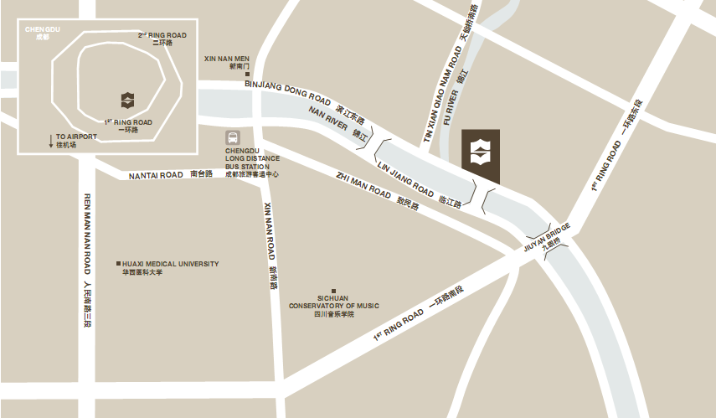

Taxi Information:
It is usually not necessary to tip taxi drivers in Chengdu unless they render extra assistance with bags, etc. However, most taxi drivers do not speak English, so make sure you have the name of your hotel or address printed or written in Chinese.
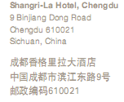

Visa Information:
In case you need a personal invitation for your visa application to China, please fill out the invitation letter request form in Appendix A and email to the contact person.
Invitation letters will be sent via fax. If you need an original letter, please send a request to the contact person Your request will be processed within 10 working days from receiving. If you do not receive your invitation letter within certain days or have any changes after receiving your letter, please inform the contact person.

Please send the request form before March 11th, 2011

Contact for invitation letter：

Name | Tel | Fax | E-mail
Yejing Jing | +861058832758 | +861058832784 | jingyejing@datangmobile.cn

Appendix A

INVITATION LETTER REQUEST FORM
Please ensure the INVITATION LETTER REQUEST FORM is faxed, or e-mailed to the:
Meeting coordinator: Yejing Jing
Tel:+861058832758
Fax:+861058832784
E-mail: jingyejing@datangmobile.cn

Family name

Fore name

Gender

Birth date (dd/mm/yy)

Passport number

Passport expired date

Nationality

Profession

Entry date

Visiting place

Reason of visit

Single entry/multi entry

Duration of staying

Company/Employer

Company/Employer’s Address

Telephone number

E-mail address

Fax number
In which way would you like  the invitation to be sent | Fax only Fax and EMS

Note:

If you have been in China before, please list here all the places you have visited. Otherwise, just fill in ‘No’.

If the country in which you'll obtain your visa is different from your nationality, please indicate it here


Appendix B

Reservation Format

Tel: +86-28- 88889999 ext 6388 • Fax: +86-28-84097330
Block code: 3GPP
E-mail: reservations.slcd@shangri-la.com

□ New Reservation □ Change Reservation □ Cancellation

( ) Mr. ( ) Ms. ( ) Dr. Family Name:…………………………… Given Name:…………………………………
Company Name:…………………………………………………………
Tel:………………………………. Fax: ……………………Email:…………………………………………
(*: Please be sure to include your country code.)

HOTEL ACCOMMODATION
Check In Date : / / Check Out Date : / / ( Nights)
M D Y M D Y
(Check in 2:00 p.m / Check out 12:00 noon)
Room Type
□ Superior King (Single Room)
□ Superior Twin (Double Room)
Name of accompanying person (if any): □Mr. □Ms. …………………………………………
Special Requests: Smoking Non-Smoking

Hotel Room Type | 3GPP Rate
Superior King | ¥1000
Superior Twin | ¥1000
- Above mentioned rates are per room and per night, including 15% service charge per night, breakfast and internet access.
Cancellation Policy:

Any cancellation after March 18th, 2011 will be subjected to one night’s room rate.

CREDIT CARD INFORMATION FOR YOUR RESERVATION
I guarantee my reservation by credit card (required):

Credit card information: VISA MasterCard American Express DC JCB
Card number ____________________________________
Name on card ____________________________________
Expiration date ____________________________________
Signature ____________________________________

Note: Please send back this Accommodation Form to the Shangri-la Hotel until latest 18th February 2011. Room availability and discount rates cannot be guaranteed if you can not meet the deadline.
Transfer Arrangement provided by hotel
Please advise if transfer service is required
[ ] Arrival transfer Chengdu ShuangLiu Intl Airport - RMB 450 per trip per way.
[ ] Arrival transfer Chengdu Railway Station - RMB 450 per trip per way.
[ ] Departure transfer Chengdu Shuangliu Intl Airport - RMB 450 per trip per way.
[ ] Departure transfer Chengdu Railway Station - RMB 450 per trip per way.
----- For other pick up locations,price will be quoted separately.

