3GPP TSG-SA3 Meeting #109bis_e draft_S3-230125r1

Online Meeting, 16 - 20 January, 2023

Source: OPPO

Title: Security of ranging using assistant UE

Document for: Approval
Agenda Item: 5.19

1 Decision/action requested
New KI on security of ranging using assistant UE

2 References
[1] TR 33.893 v0.4.0

3 Rationale
This contribution proposes a new KI on security of ranging with assistant UE:
When two UEs (UE1 and UE2) are not able to perform ranging directly or more ranging precision is required, the use of an assistant UE is needed. In this case, assistant UE performs ranging with UE1 and with UE2 respectively. After the ranging operation with UE2, assistant UE provides ranging results to UE1. UE1 combines the ranging results from its ranging with assistant UE and the ranging result between assistant UE and UE2 that was sent by assistant UE.
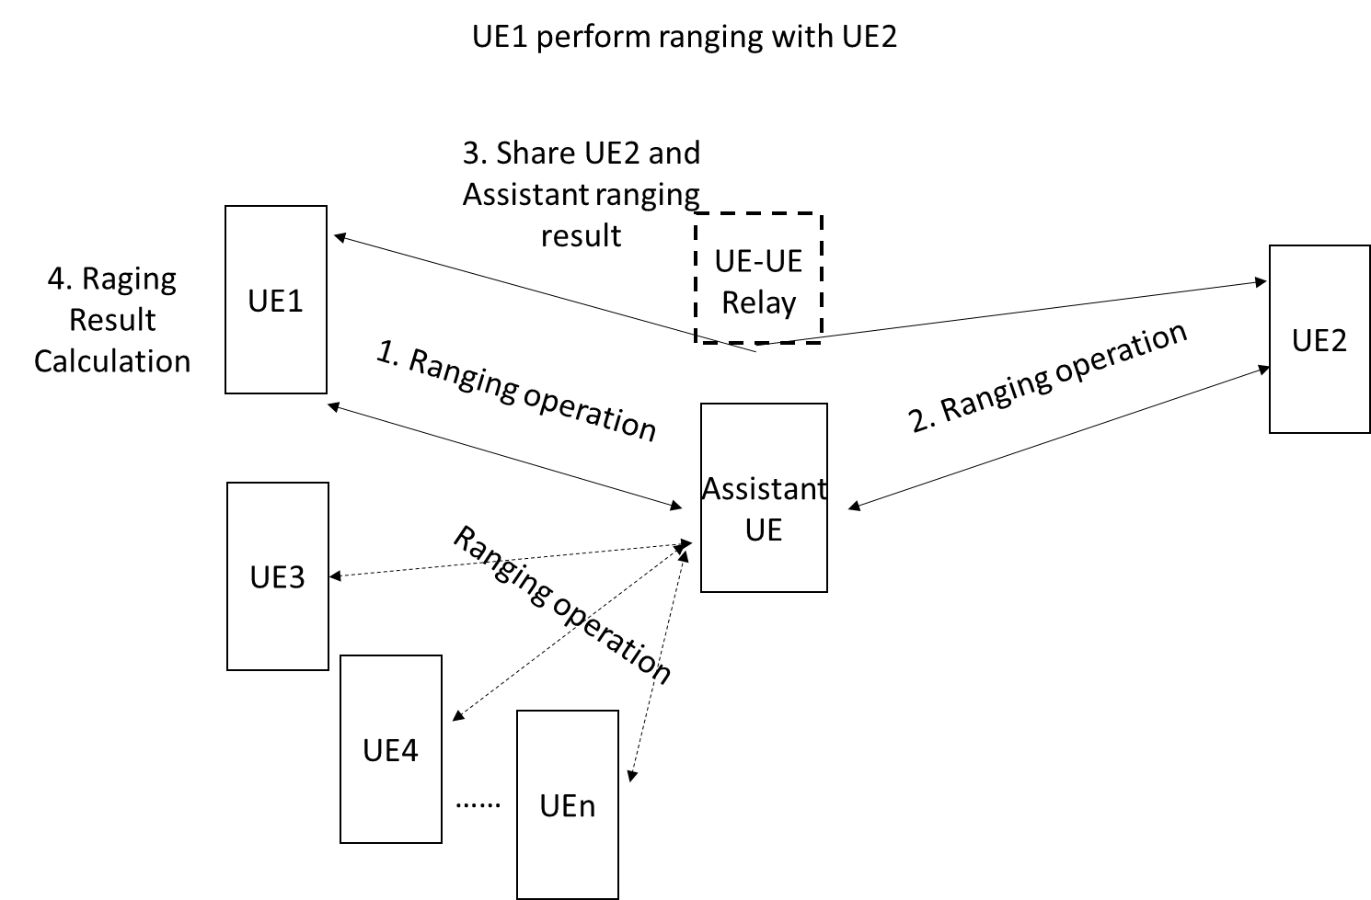
However, since an assistant UE may have concurrent ranging operations with more than one UE. For example, assistant UE may be performing ranging with UE3, UE4, etc and holds ranging results performed with those UEs respectively. If the ranging result sent to the initiating UE does not correspond to the ranging result between the assistant UE and the target UE (i.e., UE2), the UE that initiated ranging (i.e., UE1) may end up with incorrect ranging result, or the ranging information between assistant UE and another UE (e.g., UE3, UE4…) may be illegally disclosed, resulting in disclosure of privacy or tracking of the unintended target.

4 Detailed proposal
It is proposed to include the below pCR in the TR [1].
***** START OF CHANGES *****

5.X Key Issue #x: security of ranging with assistant UE

5.X.1 Key Issue Details
When two UEs (UE1 and UE2) are not able to perform ranging directly or the ranging requires finer precision, the use of an assistant UE is needed. In this case, assistant UE performs ranging with UE1 and with UE2 respectively. After the ranging operation with UE2, assistant UE provides ranging results to UE1. UE1 combines the ranging results from its ranging with assistant UE and the ranging result between assistant UE and UE2 that was sent by assistant UE.
However, an assistant UE may have concurrent ranging operations with more than one UE. For example, assistant UE may be performing ranging with UE3, UE4, etc and holds ranging results performed with those UEs respectively. If the ranging result sent to the initiating UE does not correspond to the ranging result between the assistant UE and the target UE, the UE that initiated ranging may end up with incorrect ranging result, or the ranging information between assistant UE and another UE may be illegally disclosed, resulting in disclosure of privacy or tracking of the unintended target.
Editor’s Note: Inclusion of this KI needs to aligned with SA2 decision whether the use of Assistane UE procedure to be in Rel-18 or not.

5.X.2 Security threats
If the interim ranging result shared with initiating UE does not correspond to the ranging between assistant UE and the target UE, the ranging result may be result of ranging between the assistant UE and another UE that is not the target. This will result in the unintended UE’s Ranging information (e.g. distance measurement, direction measurement, or both, or assistant data) and/or the associated UE’s identity are disclosed leading to the UE’s whereabouts and/or movements will become trackable or traceable.

5.X.3 Potential security requirements
The 5G ranging system shall provide a means to mitigate trackability of unintended UE during ranging.
The 5G ranging system shall provide a means to associate ranging operations between initiating and target UEs when an assistant UE is used.
Editor’s Note: Whether these security requirements can be met by system architecture design is FFS.

***** END OF CHANGES *****

