3GPP TSG-SA3 Meeting #109AdHoc-e S3-230314-r1

Electronic meeting, 16 - 20 January 2023

Source: Ericsson

Title: New Solution to KI #11 based on O&M Provisioning NRF with NFc Profile

Document for: Approval
Agenda Item: 5.24

1 Decision/action requested
Approve the pCR to TR 33.875 [1] below.

2 References
[1] 3GPP TR 33.875: "Study on enhanced security aspects of the 5G Service Based Architecture (SBA)"

3 Rationale
Key Issue #11 (NRF validation of NFc for access token requests) identifies various underspecifications in the mechanism used by the NRF to authorize an NF. One important missing detail is how an NF consumer (NFc) can securely register necessary NF profile at the NRF, i.e., Problem 1a (Clause 5.11.1.1) in TR 33.875 [1]. This document provides a direction towards detailing this underspecification. After receiving the necessary profile data, the NRF is ready to authorize the NF consumer’s request. Other underspecifications regarding Problem 1b and Problem 2 are not addressed in this solution. These other problems can be solved by other solution proposals in parallel.

4 Detailed proposal
*** 1st CHANGE ***

6.A Solution #A: O&M Registering NFc profile to NRF

6.A.1 Introduction
This solution addresses Problem 1a of KI #11. It proposes a mechanism for the O&M to register the NF consumers to the NRF, and mandate all the NF consumers to register to the NRF using at least one of the mechanisms available, e.g., using the existing Nnrf_NFManagement service or using the O&M-based mechanism proposed in this solution.

6.A.2 Solution Details
Current Rel-17 specification 33.501 [3], clause 13.4.1.1.1, "OAuth 2.0 roles" states: "The NF Service registration procedure, as defined in clause 4.17.1 of TS 23.502 [8], may be used to register the OAuth 2.0 client (NF Service Consumer) with the OAuth 2.0 Authorization server (NRF), as described in clause 2.0 of RFC 6749 [43]."

This solution proposes to change the requirement to require that all NF consumers shall be registered to the NRF by using at least one of the mechanisms available, e.g., using the existing Nnrf_NFManagement service or using the O&M-based mechanism proposed in this solution. In the O&M-based mechanism, the O&M registers the NF consumer to the NRF.

Figure 6.A.2-1 depicts a high-level presentation of the solution.

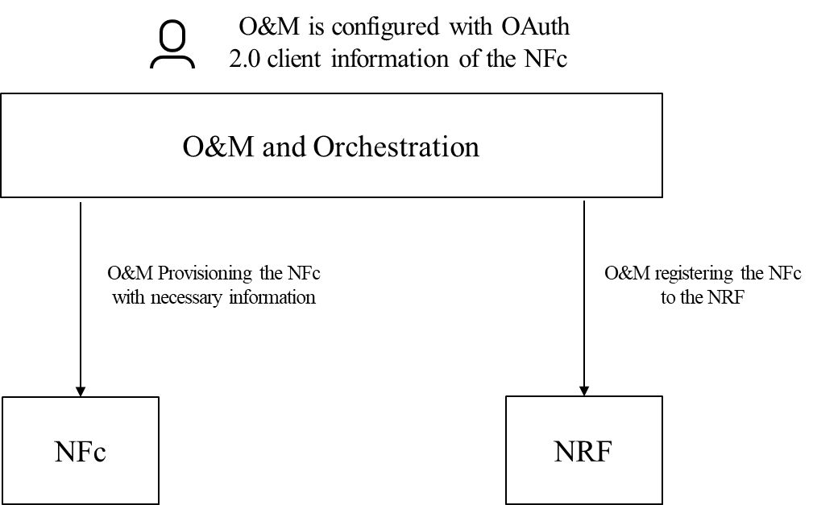

Figure 6.A.2-1: O&M registering the NFc to the NRF

Editor' Note: This solution does not address all the problems mentioned in the KI. It addresses only problem 1a.
Editor’s Note: This solution does not yet address the case of using service mesh to register an NF cosumer to an NRF
Editor’s Note: This solution does not yet address the context of using hierarchial NRFs

6.A.3 Evaluation
This solution addresses one of the problems (1a) mentioned in KI #11.
This solution leaves the secure registration of the NF consumer to the security system between the O&M and NRF, which is out of 3GPP’s scope.
The solution requires modification in the existing implementations of NF consumers, NRF, and O&M.
This solution is meant to be supported in Rlease-18 and onwards.
Further evaluation is FFS.

*** END OF CHANGES ***

