3GPP TSG-SA3 Meeting #103-e S3-211739

e-meeting, 17 - 28 May 2021 Revision of S3-20xxxx

Source: Lenovo, Motorola Mobility

Title: Update to Solution #7

Document for: Approval
Agenda Item: 5.17

1 Decision/action requested
This pCR provides an update to solution #7 in TR 33.864.

2 References
[1] 3GPP TR 33.864 ‘Study on the security of Access and Mobility Management Function (AMF) re-allocation’.

3 Rationale
The pCR adds an example for clarification in solution #7 and provides few editorial corrections.

4 Detailed proposal
SA3 is kindly requested to agree the pCR below to TR 33.864.

*****Start of Change*****

6.7 Solution #7: Solution to enable Reallocated AMF to serve the UE

6.7.1 Introduction
The solution addresses Key issue #1 on Security of AMF re-allocation procedure.
The solution is based on the principle of allowing the initial AMF to decide when a SUPI is available, if a 'AMF reallocation with reroute via RAN' is required or not based on the critical factors (i.e., SUPI, subscription information, slice selection and AMF local policy etc.,), defined in TS 23.502 Clause 4.2.2.2.3.

6.7.2 Solution details
The solution is based on the principle of enabling the initial AMF to verify the UE's slice subscription data soon after response verification during the primary authentication to determine if an AMF is capable to serve a UE or not, before the UE's security context can be provisioned to the initial AMF to prevent system availability issues described in Key Issue#1 of this document. The Figure 6.7.2-1 describes the UE slice subscription data-based AMF serving capability verification and UE Security handling/provisioning to AMF/SEAF during primary authentication as follows. The essential adaptations required over initiation of primary authentication and authentication procedure is described here in Figure 6.7.2-1 and the rest follows similar to Clause 6.1.2 and clause 6.1.3 of TS 33.501.

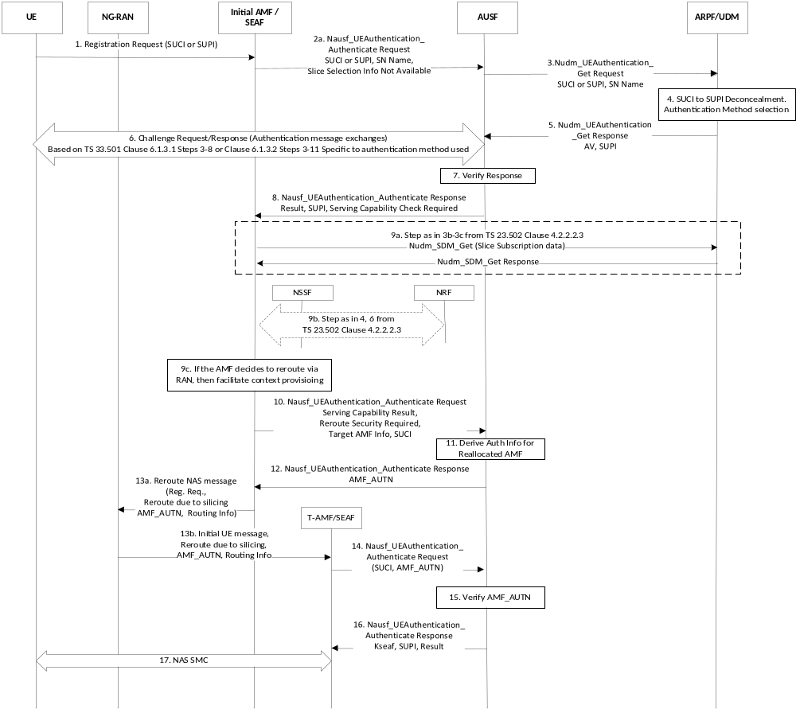
Figure 6.7.2-1: AMF Serving Capability based Security Context handling during primary authentication
The solution uses the existing service operations for the adaptations required.
Step 1. The UE sends the Registration Request with SUCI or 5G-GUTI to the initial AMF.
Step 2a-b. The initial AMF sends authentication request to the SEAF by including the Slice Selection Information Not Available indication (if the AMF received a Registration Request with SUCI/ 5G-GUTI (i.e., during initial registration with SUCI /when the UE and old AMF could not be identified with 5G-GUTI). The SEAF further sends a Nausf_UEAuthentication_Authenticate Request message to the AUSF. The Slice Selection Information Not Available can indicate that the initial AMF has no available information which can enable the network to select the appropriate slice.
Step 3. The AUSF on receiving the Slice Selection Information Not Available Indication determines that the network (ie., AMF) needs further information to verify the serving capability for the corresponding UE. The AUSF sends to the UDM a Nudm_UEAuthentication_Get Request containing, SUCI, and SNN.
Step 4. The UDM/UDR performs SUCI de-concealment and authentication method selection as in TS 33.501 Clause 6.1.2.
Step 5. The UDM sends a Nudm_UEAuthentication_Get Response to the AUSF, which contains an AV (i.e., EAP-AKA' AV/5G HE AV as in 33.501 based on authentication method), and SUPI.
Step 6. The AUSF performs method specific message exchange with the UE to perform primary authentication (i.e., as in TS 33.501 Clause 6.1.3 steps 3-8/9 for EAP-AKA' or 3-11 for 5G AKA). The solution proposes no changes to the challenge request/response message exchanges involved in the primary authentication.
Step 7. The AUSF if finds that the RES* verification (if 5G AKA) or Authentication challenge verification (EAP-AKA') is successful, then the network considers the primary authentication as successful. If a Slice Selection Information Not Available was received in step 2a from AMF/SEAF, then the AUSF determines to hold the UE security context temporarily until the AMF/SEAF informs the AUSF about its serving capability.
Step 8. The AUSF can send to the AMF/SEAF, the authentication result as success, SUPI, and AMF serving Capability Check Required indication.
Step 9a-9b. The initial AMF on receiving the SUPI along with AMF serving Capability Check Required indication, determines to check if a reroute is required or not based on TS 23.502 as shown in step 9a-b.
Step 9c. If the AMF decides to perform an indirect AMF reroute, then it determines to facilitate the UE security context provisioning to the newly selected target AMF.
If the AMF determines to perform indirect AMF reroute via RAN, then sets the AMF service capability result as '0'.
Else, if the AMF determines to perform direct AMF reroute/ if it is capable to serve the UE based on the UE subscription information/slice subscription data, then sets the AMF service capability result as '1'.
Step 10. The AMF/SEAF sends to AUSF, the SUPI, AMF Reroute Security Required Indication, AMF service capability result, Target AMF Information, and optionally SUCI. As an alternative, in addition the AMF/SEAF can also send the ABBA to AUSF in this step.
Alternatively, if No Reroute via RAN is determined, then AMF/SEAF sends to AUSF the SUPI, AMF service capability result set to '1'.
Step 11. The AUSF on receiving a AMF service capability result set as '0', and Reroute Security Required Indication, it determines to store the UE security context to facilitate the security provisioning to the Target AMF at a later point of time when required (i.e., after reallocation). The AUSF derives an authentication information AMF_AUTN from the UE context available in the AUSF (for the Target AMF using the hash of AUSF, SUPI, RAND, SNN and the target AMF information).
Alternatively, for no Reroute via RAN case, the AUSF on receiving from AMF/SEAF, AMF service capability result with '1', provides the Anchor key, SUPI and authentication result to the initial AMF and the initial AMF can setup NAS Security similar to the existing system.
Step 12. The AUSF sends to the AMF/SEAF, the SUPI, AMF_AUTN, AUSF locally stores the AMF_AUTN along with the SUPI with SUCI, Kausf, ABBA (if received), Kseaf and corresponding SNN. The SEAF forwards the received SUPI, authentication result as success, SUPI, AMF_AUTN, to the initial AMF.
Step 13a. The AMF sends a reroute NAS message to the NG-RAN with initial UE message, reroute due slicing, Routing Information (to indicate the AUSF holding the context) and AMF_AUTN. As an alternative, in addition the initial AMF can send the ngKSI in the Reroute NAS message.
Step 13b. The NG-RAN forwards the received Reroute NAS message to the Target AMF with initial UE message, reroute due slicing, Routing Information, ngKSI (if received) and AMF_AUTN.
Step 14. The Target AMF on receiving the Reroute NAS message with reroute due slicing, Routing Information and AMF_AUTN will attempt to contact the right AUSF based on the Routing Information. The Target AMF sends to appropriate AUSF, the Nausf_UEAuthentication_Authenticate Request containing the SUCI, SNN, and the received AMF_AUTN (to authenticate itself with AUSF to fetch the UE security context). The target AMF if received a ngKSI, then that ngKSI can be used to identify the partial native security context created after the successful primary authentication.
Step 15. The AUSF verifies the received AMF_AUTN and SNN based on the UE authentication information locally stored. If the Target AMF provided AMF_AUTN matches with the locally stored AMF_AUTN for a SUCI and/or SUPI, then the AUSF considers the AMF_AUTN verification as successful.
Step 16. The AUSF sends to SEAF of the Target AMF, the authentication result, SUPI and Kseaf (the anchor key) as in the existing system and the rest follows similar to the existing procedures. Further the SEAF sends the ABBA parameters, authentication result as success, and Kamf key to the Target AMF. As an alternative, if the AUSF inaddition received ABBA in step 10, the AUSF sends the ABBA received to SEAF and the SEAF is required to use the received ABBA.
NOTE 1: The ABBA parameter usage should be same as in the existing system. TS 33.501 specified the ABBA parameter value as ‘0x0000’. The UE shall use the ABBA parameter provided by the SEAF in the calculation of KAMF as specified in TS 33.501 Clause A.7.1 ABBA parameter values.
NOTE 2: For EAP-AKA', perform step 11 as specified in TS 33.501 clause 6.1.3.1. For 5G AKA, perform step 12 as specified in TS 33.501 clause 6.1.3.2.0.

Step 17. The Target AMF on receiving the Kamf and authentication result can trigger the NAS Security mode command (NAS SMC) procedure with UE when required to activate the UE NAS security context as in TS 33.501.
Adaptations for Registration Mobility Update:
This section describes the simple adaptations required to address security handling in AMF-reallocation during registration mobility update procedure as shown in Figure 6.7.2-2.

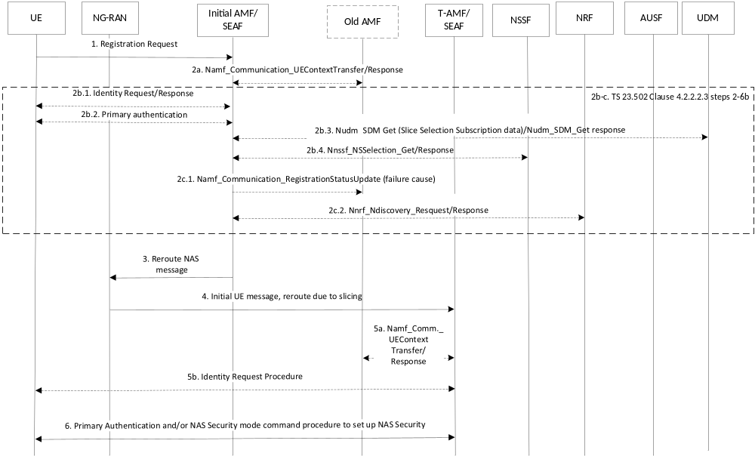
Figure 6.7.2-2: Security context handling during registration mobility update
NOTE 1: According to TS 33.501 Clause 6.9.3 for the case where source/old AMF sends new 5G security context to Initial AMF, it states, 'The source AMF subsequently deletes the 5G security context which it holds.'
Step 1. If the Registration Request contains 5G-GUTI (pointing to an old AMF), the initial AMF performs the following accordingly for various scenarios mentioned in Clause 4.3 'Architecture and security assumptions', of this TR,
Case 1-2.a.i) N14 interface exists only between Initial AMF and Old AMF:
Step 2a-b. The Initial AMF based on TS 33.501 Clause 6.9.3, fetches SUPI and security context from the old AMF by providing the 5G-GUTI and the registration request. Further SUPI and subscription information (fetched from UDM as shown in 2b.3) can be used to decide whether to reroute the Registration Request according to TS 23.502 Clause 4.2.2.2.3 step 2. If a reroute is required, the initial AMF, if fetched the UE context (as in TS 23.502 Clause 5.2.2.2.2) from the old AMF, it can use the slice information to perform (2b.4) Nnssf_NSSelection service operation based on 23.502 4.2.2.2.3 step 4a-b. Also, for the case, where the current 5G security context is fetched, the AMF may decipher the NAS container with the same security context, and get the initial NAS message and so if there is any Requested NSSAI provided by UE, it can also be used in Nnssf_NSSelection service operation (even thought it is an optional IE according to TS 23.502 Clause 5.2.16.2.1). If an indirect AMF allocation and reroute via RAN is required, the initial AMF does not send any NAS message to the UE (i.e., it does not use current/new 5G security context fetched from old AMF), inturn can perform reroute via RAN.
Step 2c.1. If another AMF is selected, the initial AMF sends a reject indication to the old AMF and the old AMF continues as if the Namf_Communication_UEContextTransfer had never been received.
Step 2c.2. Target AMF discovery can be based on 23.502 clause 4.2.2.2.3 steps 6a-b.
Step 3-4. The initial AMF perfoms reroute via RAN as in 23.502 Clause 4.2.2.2.3 step 7B.
Step 5a-b. The Target AMF on receiving the initial NAS message with 5G-GUTI finds that it is not able to identify the related old AMF and considers that it cannot identify the UE with 5G-GUTI and so initiates identity request procedure with UE and get SUCI.
Step 6. The target AMF initiates primary authentication by sending authentication request with SUCI (without Slice Selection Information Not Available Indication, because the target AMF is aware that this is reroute due to slicing as received in Reroute NAS message as in TS 23.502 Clause 4.2.2.2.3 step 7B).
The target AMF will not include any Slice Selection Information Not Available Indication, so the AUSF soon after successful response verification will provide Anchor key to the AMF/SEAF as in existing system.
Case 2-2.a.ii) No N14 exists between Initial AMF and old AMF and also no N14 exists between target AMF and old AMF: As the initial AMF lack N14 with old AMF, the UE cannot be identified by means of a temporary identity (5G-GUTI) and so the initial AMF performs Subscription identification procedure (as shown in step 2b.1) with UE and continues with primary authentication (as shown in step 2b.2) with the adaptations described in Figure 6.6.2-1 steps 2a-17 as applicable.
Case 3-2.b.i) N14 exists between Initial AMF and old AMF and also between target AMF and old AMF: The initial AMF having N14 with old AMF will act similar to Case 2-2.a.i steps 1-4.
Step 5-6. The Target AMF on receiving the initial NAS message with 5G-GUTI finds it can contact the corresponding old AMF. Based on local policy and reroute due to slicing indication received in reroute NAS message, the target AMF may fetch security context from old AMF (or) determines not to fetch security context from old AMF and perform Identity request/response procedure and primary authentication accordingly (as in case 2.a.i).
If the target AMF fetches security context from old AMF, either based on local policy the target AMF may use current/new security context fetched from old AMF or the target may determine to perform primary authentication with SUPI (as in case 2.a.i, but SUPI is used instead of SUCI).
NOTE 2: Further the case 2.b.i may not be feasible according to the vertical slice isolation requirement and it may need to be aligned with the Clause 4.3.
Case 4-2.b.ii) N14 exists only between target AMF and old AMF: As the initial AMF lack N14 with old AMF, the UE cannot be identified by means of a temporary identity (5G-GUTI) and so the AMF performs Subscription identification procedure (as shown in 2b.1) with UE and continues with primary authentication (as shown in 2b.2) based on the adaptations described in Figure 6.6.2-1 steps 2a-13. The target AMF on receiving the reroute NAS message (i.e., Registration Request with 5G-GUTI), based on local policy, received authentication information (AMF_AUTN) and reroute due to slicing indication, determine to fetch and use security context related to an authentication information received in the reroute NAS message from the AUSF and if required can fetch UE context from the old AMF.
*****End of Change*****

