3GPP TSG-SA3 Meeting #103-e S3-211714r2

e-meeting, 17-28 May 2021

Source: Apple

Title: New solution on key distribution

Document for: Approval
Agenda Item: 5.11

1 Decision/action requested
It is proposed to add a new solution in MBS TR 33.850.

2 References
[1] 3GPP TR 33.850: " Study on security aspects of enhancements for 5G Multicast-Broadcast Services (MBS)"

3 Rationale
This pCR proposes a new solution on the key delivery in service layer.

4 Detailed proposal
****START OF CHANGES ***

6.X Solution #X: Secure key delivery in service layer

6.x.1 Solution overview
This solution addresses Key Issue #3: Security protection of key distribution, which includes the security requirement as “The distribution of the keys for protection of MBS traffic between the key generator and the UE shall be confidentiality, integrity and anti-replay protected.”
As the NAS confidentiality protection between AMF and UE is not mandatory and it is not always enabled. Whenever there is no NAS confidentiality protection, K_{MBS} will be sent in the clear, which is a huge damage for MBS service. That’s the motivation to design this solution. For the case when the NAS confidentiality protection is enabled, the protection in this solution is optional but also no harm to enable.
This solution proposes a method to protect the K_{MBS} used for MBS traffic protection based on K_{MBS-UE} which is derived based on K_{AUSF}. With this solution, K_{MBS} delivery from MB-SMF to UE can be confidentially protected.

6.x.2 Solution details

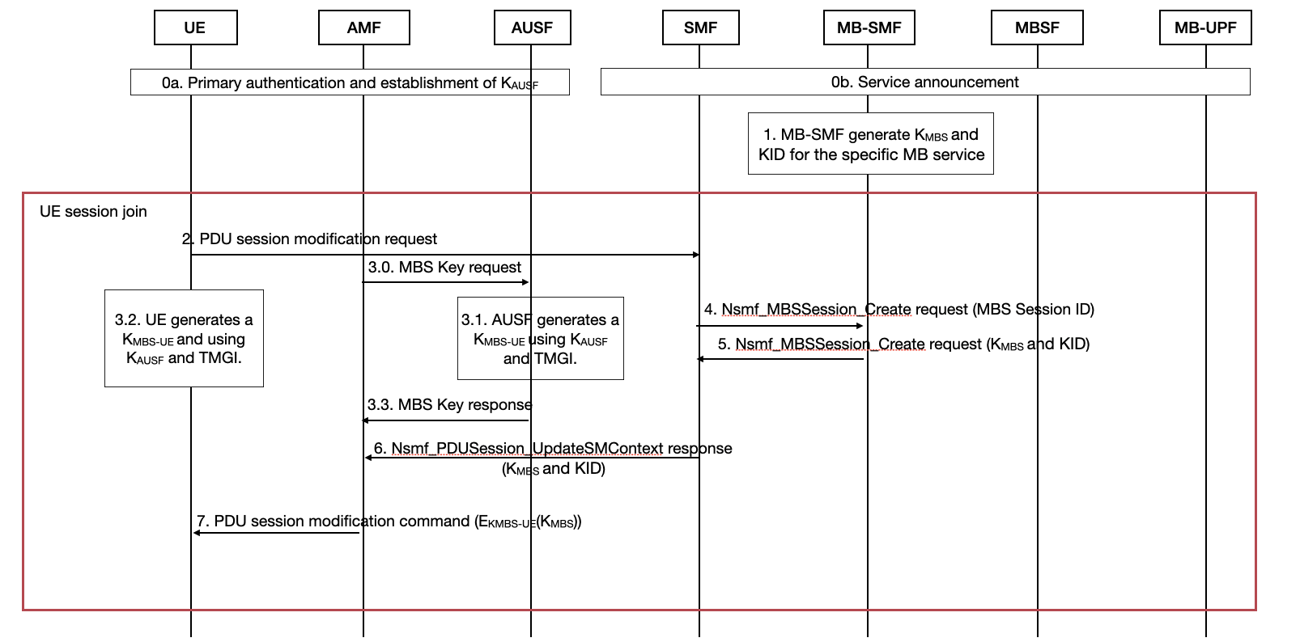

Figure 6.x.2-1. The procedure of key delivery of K_{MBS}
The procedure is described as follows:
Step 0a: UE initiates the Primary Authentication and establishes the K_{AUSF} with AUSF in HPLMN.
Step 0b: Service announcement procedure, following the current Clause 7.1.1 in TS 23.247.
Step 1. MB-SMF generates K_{MBS} and KID for the specific MB service.
Step 2. To join the multicast group, the UE sends the PDU Session Modification Request (MBS Session ID). MBS Session ID indicates the multicast group that UE wants to join.
Step 3.0. AMF sends MBS Key Request to AUSF to ask for the encryption key.
Step 3.1. AUSF generates a K_{MBS-UE} using K_{AUSF} and TMGI.
Editor’s Note: it's FFS how AUSF knows TMGI
Step 3.2. UE generates a K_{MBS-UE} and using K_{AUSF} and TMGI.
Step 3.3. AUSF send the K_{MBS-UE} to AMF.
Step 4. By using Nsmf_MBSSession_Create request (MBS Session ID), SMF interacts with MB SMF to retrieve multicast QoS flow information of the indicated MBS session.
Step 5. MB-SMF sends the K_{MBS} and KID to SMF using Nsmf_MBSSession_Create response.
Step 6. SMF responds to AMF through Nsmf_PDUSession_UpdateSMContext response(N2 SM information (PDU Session ID, MBS Session ID, MB-SMF ID, multicast QoS flow information, updated PDU Session information, mapping between unicast QoS flow and multicast QoS flow information), N1 SM container (PDU Session Modification Command, KMBS and KID)
Step 7. AMF send the PDU session modification command (E_{KMBS-UE}(K_{MBS})) to UE, including the encrypted K_{MBS} and KID.
Step 8. UE decrypt the E_{KMBS-UE}(K_{MBS}) and gets the K_{MBS}
K_{MBS} is used for the future protection of the MBS traffic.
Editor’s Note: It is FFS whether the K_{MBS} will be used as the root key or the session key.
NOTE: The UE leaving group procedure will be handled separately.
Editor’s Note: Whether other keys (e.g Kamf) can be used is FFS.
Editor’s Note: What algorithms should be used is FFS.

6.x.3 Solution evaluation
TBD

****END OF CHANGES ***

