3GPP TSG-SA3 Meeting #101e draft_S3-203333-r1

e-meeting, 9 - 20 November 2020 Revision of S3-203333

Source: Nokia, Nokia Shanghai Bell

Title: SQNms protection by concealment

Document for: Approval
Agenda Item: 5.5

1 Decision/action requested

Solution update for SQNms protection by concealment to address MCC editorial comments in TR 33.846.

2 References

[1] 3GPP TR 21.905: "Vocabulary for 3GPP Specifications".
[2] 3GPP TS 33.501: "Security architecture and procedures for 5G system".
[3] 3GPP TS 33.102: "Security architecture".
[4] Ravishankar Borgaonkar (published online: July 2019), “New Privacy Threat on 3G, 4G, and Upcoming 5G AKA Protocols”, https://eprint.iacr.org/2018/1175.pdf
[5] 3GPP TS 29.503: "5G System; Unified Data Management Services".
[6] 3GPP TS 23.501 : System architecture for the 5G System (5GS)

3 Rationale
After SA3#100bis-e, a few editorial corrections were suggested by MCC:
- Clause 6.4.3.2: Figure and title have the wrong styles.
- Same clause: TS 23.003 [A] ??
- Clause 6.4.3.3: missing references to TS 33.501
- Step 1 in the same clause: TS 33.501 (missing reference) and “section 6.1.3.2.0”. We have no sections in 3GPP, we have “clauses”.
- Same clause: blue text in steps 8 and 11.
- Clause 6.4.3.5: missing reference to TS 23.003 and the word “section”.

This contribution addresses these editorials.

4 Detailed proposal

***** START OF CHANGES

References

[1] 3GPP TR 21.905: "Vocabulary for 3GPP Specifications".
[2] 3GPP TS 33.501: "Security architecture and procedures for 5G system".
[3] 3GPP TS 33.102: "Security architecture".
[4] Ravishankar Borgaonkar (published online: July 2019), “New Privacy Threat on 3G, 4G, and Upcoming 5G AKA Protocols”, https://eprint.iacr.org/2018/1175.pdf
[5] 3GPP TS 29.503: "5G System; Unified Data Management Services".
[6] 3GPP TS 23.501 : System architecture for the 5G System (5GS)
[X] 3GPP TS 23.003: Numbering, addressing and identification.

***** NEXT CHANGE

6.4.3 Solution #4.3: SQN protection by concealment with SUPI

6.4.3.1 Introduction
This solution addresses the key issue #4.1 Protection of SQN during AKA re-synchronisations.

6.4.3.2 Solution details
Current usage of ECIES for concealment of SUPI can be expanded to accommodate SQNMS and SUPI. Maximum allowed size of cipher text from concealment of protection scheme output is 3000 digits. SUPI utilizes only few bytes of those maximum allowed digits and still can adapt SQNMS.

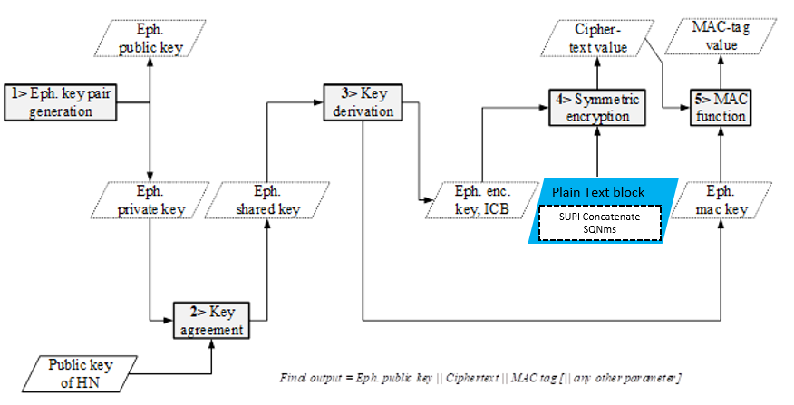
Figure 6.4.3.2-1 Encryption based on ECIES at UE

Figure 6.4.3.2-1 shows the encryption based on ECIES at UE side, where SUPI is concatenated with SQNMS and taken as one plain text block for symmetric encryption. In case of SUPI type as IMSI, then MSIN (9 to 10 digits) and SQN_{MS} (48 bits: 6 bytes) is concatenated in UE.

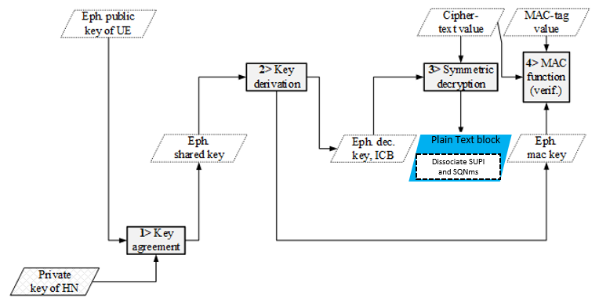
Figure 6.4.3.2-2 Decryption based on ECIES at home network

Figure 6.4.3.2-2 shows the decryption based on ECIES at home network, where SUPI and SQNMS is dissociated after the symmetric decryption.

Figure 6.4.3.2-3: Structure of SUCI
Figure 6.4.3.2-3 shows the structure of SUCI with SUPI Type, which consists values in the range 0 to 7 as specified in clause 2.2B of TS 23.003 [X]. SUPI Type identifies the type of the SUPI concealed in the SUCI.
For this solution, the encoding of SUCI for ‘SUPI plus SQN_{MS'} will be represented by a new SUPI Type value, e.g. value 4.
- 0: IMSI
- 1: Network Specific Identifier
- 2: Global Line Identifier (GLI)
- 3: Global Cable Identifier (GCI)
- 4: SUPI plus SQNMS
- 5 to 7: spare values for future use.

6.4.3.3 Adaptation of authentication procedures

6.4.3.3.0 General
The following sequence charts illustrates the text already specified in 3GPP TS 33.501[2], clause 6.1.2, for the case of initiation of authentication and selection of authentication method. Changes are marked in bold.

6.4.3.3.1 Initiation of authentication and selection of authentication method

2. <N1 message>
(SUCI containing SQNMS )
UE
3. Nausf_UEAuthentication_ Authenticate Request
(SUCI containing SQNMS or SUPI, SN-Name)
4. Nudm_UEAuthentication_ Get Request (SUCI containing SQNMS or SUPI, SN-Name)
UDM/ARPF
AMF/
SEAF
AUSF
1. Conceal SUPI and SQNMS
5. [SUCI to SUPI, SQNMS de-concealment].
Authentication Method selection.

Figure 6.4.3.3.1-1: Illustration of UE and HE is sharing SQN_{MS} along with SUCI

- During the primary authentication procedure, USIM concatenates SUPI and SQNMS. The concatenated plain text block is encrypted using ECIES method. New value is introduced for “SUPI Type”, for e.g. Value 4 represents SUCI encoded with SUPI plus SQNMS.
- UE uses SUCI containing SQNMS in Registration request message, which is sent to AMF/SEAF.
- AMF/SEAF invokes the Nausf_UEAuthentication service by sending a Nausf_UEAuthentication_Authenticate Request message to the AUSF whenever the AMF/SEAF wishes to initiate an authentication.
The Nausf_UEAuthentication_Authenticate Request message contains either:
- SUCI containing SQN_{MS}, as defined in the current specification, or
- SUPI, as defined in 3GPP TS 23.501 [6].
The AMF/SEAF includes the SUPI in the Nausf_UEAuthentication_Authenticate Request message in case the AMF/SEAF has a valid 5G-GUTI and re-authenticates the UE. Otherwise the SUCI containing SQNMS is included in Nausf_UEAuthentication_Authenticate Request. SUPI/SUCI structure is part of stage 3 protocol design.
The Nausf_UEAuthentication_Authenticate Request furthermore contains:
- the serving network name, as defined in sub-clause 6.1.1.4 of 3GPP TS 33.501 [2].
- Upon receiving the Nausf_UEAuthentication_Authenticate Request message, the AUSF checks that the requesting AMF/SEAF in the serving network is entitled to use the serving network name in the Nausf_UEAuthentication_Authenticate Request by comparing the serving network name with the expected serving network name. The AUSF stores the received serving network name temporarily. If the serving network is not authorized to use the serving network name, the AUSF responds with "serving network not authorized" in the Nausf_UEAuthentication_Authenticate Response.
The Nudm_UEAuthentication_Get Request sent from AUSF to UDM includes the following information:
- SUCI containing SQN_{MS} or SUPI;
- the serving network name;
- Upon reception of the Nudm_UEAuthentication_Get Request, the UDM invokes SIDF if a SUPI type is SUPI plus SQN_{MS}, then SIDF de-conceals SUCI to gain SUPI and SQN_{MS} before UDM can process the request.
Based on SUPI, the UDM/ARPF chooses the authentication method. SQN_{MS} is stored in UDM for future use. At UDM, Authentication vector is generated with existing SQN_{HE}. The solution is restricted to 5G.

NOTE 1: The Nudm_UEAuthentication_Get Response in reply to the Nudm_UEAuthentication_Get Request and the Nausf_UEAuthentication_Authenticate Response message in reply to the Nausf_UEAuthentication_Authenticate Request message are described as part of the authentication procedures in 3GPP TS.33.501 [2], clause 6.1.3.
NOTE 2: SQNMS is not considered for Authentication vector generation on purpose.

6.4.3.3.2 Successful Authentication case
In success case the Authentication procedure (considering example of 5G AKA) is the same as 3GPP TS.33.501[2], clause 6.1.3.2.0. The solution does not impact the existing call flow.

6.4.3.3.3 Authentication failure case
Figure6.4.3.3.3-1: Authentication procedure for 5G AKA (Failure case)

Figure 6.4.3.3.3-1 shows the failure case of Authentication procedure (considering example of 5G AKA). Changes are shown in blue.

1. For each Nudm_Authenticate_Get Request, the UDM/ARPF creates a 5G HE AV. The UDM/ARPF does this by generating an AV with the Authentication Management Field (AMF) separation bit set to "1" as defined in TS 33.102 [3]. The UDM/ARPF then derives K_{AUSF} (as per Annex A.2) and calculate XRES* (as per Annex A.4). Finally, the UDM/ARPF creates a 5G HE AV from RAND, AUTN, XRES*, and K_{AUSF}.
2. The UDM then returns the 5G HE AV to the AUSF together with an indication that the 5G HE AV is to be used for 5G-AKA in a Nudm_UEAuthentication_Get Response. In case SUCI was included in the Nudm_UEAuthentication_Get Request, UDM will include the SUPI in the Nudm_UEAuthentication_Get Response.
3. The AUSF stores the XRES* temporarily together with the received SUCI or SUPI.
4. The AUSF then generates the 5G AV from the 5G HE AV received from the UDM/ARPF by computing the HXRES* from XRES* (according to 3GPP TS 33.501 [2] Annex A.5) and K_{SEAF} from K_{AUSF} (according to 3GPP TS 33.501 [2] Annex A.6), and replacing the XRES* with the HXRES* and K_{AUSF} with K_{SEAF} in the 5G HE AV.
5. The AUSF then removes the K_{SEAF} return the 5G SE AV (RAND, AUTN, HXRES*) to the SEAF in a Nausf_UEAuthentication_Authenticate Response.
6. The SEAF sends RAND, AUTN to the UE in a NAS message Authentication -Request. This message also includes the ngKSI that will be used by the UE and AMF to identify the K_{AMF} and the partial native security context that is created if the authentication is successful. This message also includes the ABBA parameter. The SEAF sets the ABBA paremeter as defined in Annex A.7.1. The ME forwards the RAND and AUTN received in NAS message Authentication Request to the USIM.
7. At receipt of the RAND and AUTN, the USIM verifies the freshness of the 5G AV by checking whether AUTN can be accepted as described in 3GPP TS 33.102 [3]. If the verification of the AUTN fails, then the USIM indicates to the ME the reason for failure.
8. The ME responds with NAS message Authentication Failure only with a CAUSE value indicating the reason for failure (as SQN failure/mismatch). AUTS is not calculated by the UE and not shared to network.
9. Upon receiving an authentication failure message from the UE, the SEAF sends an Nausf_UEAuthentication_Authenticate Request message to the AUSF.
10. AUSF sends an Nudm_UEAuthentication_Get Request message to the UDM/ARPF.
11. When the UDM/ARPF receives an Nudm_UEAuthentication_Get Request message it acts as described in 3GPP TS 33.102 [3], clause 6.3.5, where ARPF is mapped to HE/AuC. The UDM/ARPF sends an Nudm_UEAuthentication_Get Response message with a new authentication vector by considering the SQNMS from database (i.e. SQNMS received in Nudm_UEAuthentication_ Get Request). The AUSF runs a new authentication procedure with the UE according to clauses 6.1.3.1 or 6.1.3.2 of 3GPP TS 33.501 [2] depending on the authentication method applicable for the user.

6.4.3.4 Solution summary
The solution adds a new SUPI type in 3GPP TS 23.003 [X], clause 2.2B.
Encryption and decryption on ECIES consider plain text block as “SUPI and SQNms” at UE and UDM / ARPF in 3GPP TS 33.501 [2].
Registration request is sent with SUPI plus SQN_{MS}.
Sync failure during AKA challenge sends only failure cause and no AUTS is sent to the network.
Editor’s Note: It is ffs if this solution works for synchronization failure when AMF receives 5G-GUTI and decides to initiate authentication.
Editor’s Note: Backward compatibility analysis is FFS.

6.4.3.5 Evaluation
The solution only protects the sequence number in 5GS.
The solution requires changes on the USIM and the UDM.
At USIM, during ECIES procedure of primary authentication, New SUPI type is added, SQNMS is concatenated with SUPI (plain text block).
At UDM, when the SUPI indicates ‘SUPI plus SQN_{MS'} the de-concealment needs to disassociate SUPI and SQN_{MS}. UDM stores SQN_{MS} temporarily until the success or failure of the authentication is known.
There is no change to any entities if the authentication succeeds.
If there is authentication failure at the UE, UE sends only Authentication failure message to the HE with SQN failure cause code (new value), without AUTS.
At the UDM, if an authentication failure message with cause code (SQN failure) is received, the stored value of SQN_{MS} received at the very first step is processed. UDM synchronizes its value of SQN, i.e SQN_{HE} = SQN_{MS}. Sequence number management profiles detailed in Annex C in 3GPP TS 33.102 [3] is kept intact.

***** END OF CHANGES

