3GPP TSG SA WG3 Meeting #101e draft_S3-203026-r2

E-meeting, 09-20 November 2020 revision S3-20abcd

Source: Huawei, HiSilicon

Title: Solution on key management in UE-to-network relay based on primary authentication

Document for: Approval
Agenda Item: 5.9

Decision/action requested
This contribution proposes a solution on key management in UE-to-network relay

References
[1] 3GPP TR 33.847 "Study on Security Aspects of Enhancement for Proximity Based Services in 5GS".

Rational
This contribution proposes a new solution for key management for UE-to-Network Relays and Remote UE’s.

Detailed proposal
*************** Start of 1st Change ****************

6.Y Solution #Y: Key management in UE-to-Network Relay based on primary authentication

6.Y.1 Introduction
This solution addresses the KI #3, KI#4 and KI#9. This solution provides a mechanism setup a PC5 link security between a remote UE and UE-to-network relay based on primary authentication.
Editor’s note: whether this solution supporting out of coverage being FFS.

6.Y.2 Solution details
The procedure for key management in UE-to-Network relay using primary authentication is depicted in Figure 6.Y.2-1.
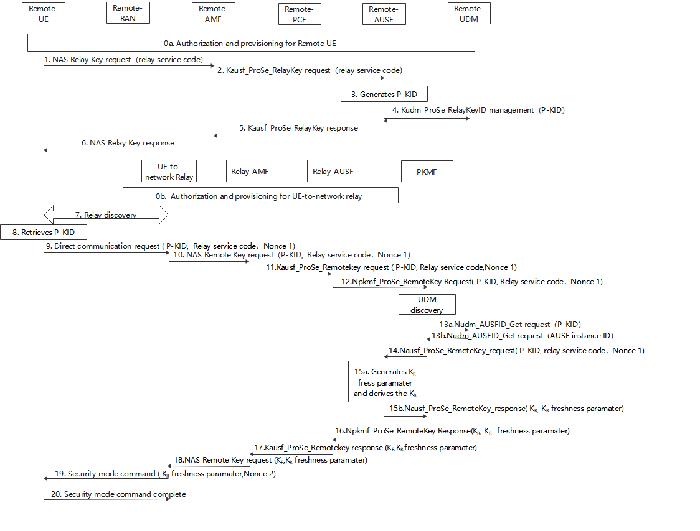
Figure 6.Y.2-1: Procedures for key management in ProSe UE-to-Network Relay based on primary authentication
0. During Registration procedure, authorization and provisioning is performed for the Remote UE (0a) and ProSe UE-to-NW relay (0b).
1. The Remote UE sends a NAS relay Key request message with relay service code for PC5 communication with a UE-to-network relay.
2. After receiving the NAS relay key request from UE, the Remote AMF that serves the remote UE first checks whether the UE is authorized to be as a remote UE. If it is authorized, the Remote AMF further sends Nausf_ProSe_RelayKey request with relay service code.
3. The Remote AUSF that serves the remote UE generates P-KID for the relay service code in the Nausf_ProSe_RelayKey request.
Editor’s note: The generation of the P-KID in AUSF is FFS.
4. The Remote AUSF further stores P-KID in UDM via Kudm_ProSe_RelayKey service.
5. The Remote AUSF sends Nausf_ProSe_RelayKey response to the AMF.
6. The Remote AMF sends NAS relay Key response to the UE.
Editor’s note: how the procedure (i.e step 1~6 ) works in Kausf change (e.g., due to reauthentication) is FFS.
7. The Remote UE discovers the UE-to-network Relay using either model A or model B discovery.
8. The Remote UE retrieves P-KID based on the relay service code the Remote UE would like to access.
Editor’s note: The retrieval of the P-KID in UE is FFS.
9. The Remote UE sends a Direct Communication Request. The Direct Communication Request contains the Relay Service Code, P-KID and Nonce1.
Editor’s note: It’s FFS whether P-KID or other user ID e.g. SUCI should be used in PC5.
10. The UE-to-Network relay triggers the PC5 root key (i.e PC5 root key for communicating with the remote UE) retrieval procedure. The Relay sends NAS remote Key request with P-KID, Relay service code, Nonce 1.
11. The relay AMF that serves the relay UE first check whether the relay UE is authorized to be a relay. If authorized, the relay AMF sends Nausf_ProSe_RemoteKey request with P-KID, Relay service code, Nonce 1.
Editor’s note: The role of relay-AUSF is unclear. I.e. step11 could be invoked directly towards home NF, e.g. remote AUSF.
12. The relay AUSF discovers the PKMF and sends Npkmf_ProSe_RemoteKey request with P-KID, Relay service code, Nonce 1.
Editor’s note: The role of the PKMF is unclear. If AUSF of Remote UE is responsible for generating the key, then what is the role of PKMF.
13. The PKMF discovers the UDM based on the P-KID, and sends Nudm_AUSFID_Get request with P-KID. The UDM response to PKMF via Nudm_AUSFID_Get with AUSF instance ID of the AUSF serving remote UE.
Editor’s note: Whether PKMF can interface with the Remote UDM or Remote AUSF, in particular in the roaming case, is FFS.
14. PKMF further sends the remote AUSF Nausf_ProSe_RemoteKey request with P-KID, Relay service code, Nonce 1.
15. The remote AUSF generates K_{R} freshness parameter and derives K_{R} using at least Kausf, relay service code,K_{R} freshness parameter and Nonce 1 as input.
Editor’s note: The generation of the K_{R} key is FFS.
16. The PKMF sends Npkmf_ProSe_RemoteKey response with K_{R}, K_{R} freshness parameter to AUSF.
17. The relay AUSF sends Nausf_ProSe_RemoteKey response with K_{R}, K_{R} freshness parameter to the relay AMF.
18. The relay AMF sends NAS remote Key response K_{R}, K_{R} freshness parameter to the UE-to-network relay.
19. The UE-to-network relay sends a Direct Security Mode Command message to the Remote UE, K_{R} freshness parameter and Nonce 2 are included in the message.
Editor’s note: The parameters included in Direct Security Mode Command message are FFS.
20. The Remote UE derives K_{R} key in the same way as the remote AUSF in step 15.
Editor’s note: how the DSMC messages are being protected is FFS.

6.Y.3 Evaluation
TBD.

*************** End of 1st Change ****************

