3GPP TSG-SA3 Meeting #101-e draft_S3-202920-r1

e-meeting, 9 – 20 November 2020

Source: ZTE

Title: New solution for key issue#1 in TR 33.850

Document for: Approval
Agenda Item: 5.11

1 Decision/action requested
This contribution proposes a new solution for key issue#1 .

2 References
(Reference - in list form - should be made to previous related SA3/3GPP/etc. documents.)
[1] 3GPP TR 33.850 “ Study on security aspects of enhancements for 5G Multicast-Broadcast Services (MBS)”.

3 Rationale
This contribution proposes a new solution for key issue#1.

4 Detailed proposal
**** START OF CHANGES ****

6.X Solution #X: Authentication and authorization for multicast communication service based on AKMA

6.X.1 Solution overview
This solution, which is based on AKMA, addresses the key issue #1 Security of authentication and authorization for multicast communication service.

X.2 Solution details

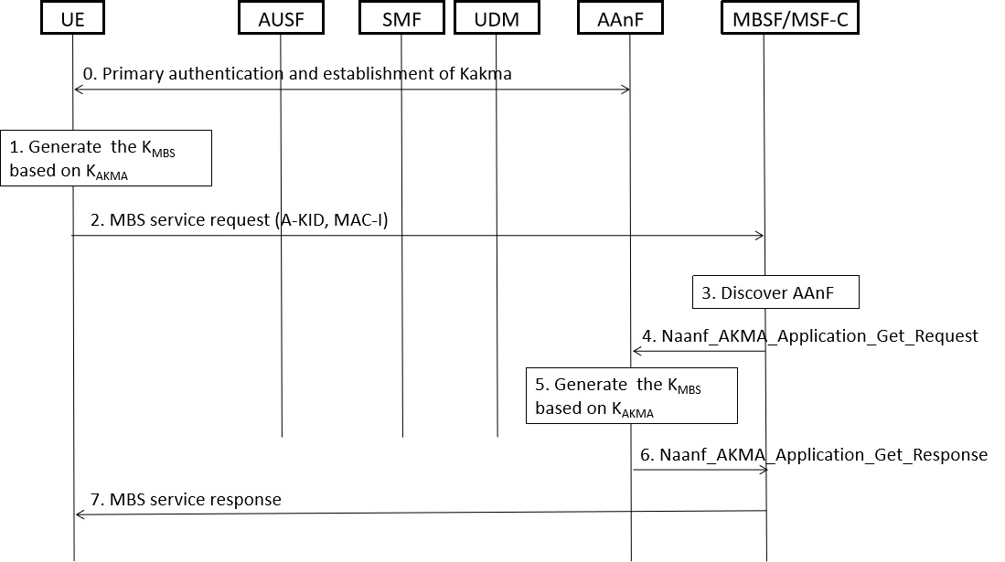
Figure 6.x.2-1 Authentication between the MBSF/MSF-C and UE based AKMA
- UE shall generate the AKMA Anchor Key (K_{AKMA}) and the A-KID from the K_{AUSF} before initiating communication with an AKMA Application Function, i.e MBSF/MSF-C, as specified in TS 33.535[x].
- UE derive a key K_{MBS} for authentication with the MBSF/MSF-C .
- When UE try to join the multicast service, UE computes MAC-I and then UE sends a MBS service request to MBSF/MSF-C. The service request include A-KID and MAC-I.
Editor’s Note: How to derive the MAC-I is FFS.
3-6. Upon receiving the request, the MBSF/MSF-U discovers the AAnF, then AAnF generates K_{MBS} and sends the K_{MBS} to MBSF/MSF-C.
Editor’s Note: It is FFS how to discover the correct AAnF.
Editor’s Note: How MBSF/MSF-C obtains authorization information is FFS.
Editor’s Note: It is ffs whether primary authentication is sufficient to authenticate the UE towards the MBSF.
7. The MBSF/MSF-C verifies the MAC-I using the K_{MBS}, when the verification is succeed, and if the UE is authorized to perform the operation,Then the MBSF/MSF-C sends a service response to the UE.

6.X.3 Solution evaluation
TBD
**** END OF CHANGES ****
**** START OF CHANGES ****

2 References
The following documents contain provisions which, through reference in this text, constitute provisions of the present document.
- References are either specific (identified by date of publication, edition number, version number, etc.) or non-specific.
- For a specific reference, subsequent revisions do not apply.
- For a non-specific reference, the latest version applies. In the case of a reference to a 3GPP document (including a GSM document), a non-specific reference implicitly refers to the latest version of that document in the same Release as the present document.
[1] 3GPP TR 21.905: "Vocabulary for 3GPP Specifications".
[2] 3GPP TR 23.757: " Study on architectural enhancements for 5G multicast-broadcast services ".
[3] 3GPP TS 33.246: " Security of Multimedia Broadcast/Multicast Service (MBMS) ".
[4] 3GPP TS 23.246: "Multimedia Broadcast/Multicast Service (MBMS); Architecture and functional description".
[x] 3GPP TS 33.535: "Authentication and Key Management for Applications (AKMA) based on 3GPP credentials in the 5G System (5GS)".
**** END OF CHANGES ****

