Invitation and General information
on 3GPP RAN1#116-bis/RAN2#125-Bis/RAN3#123-Bis/RAN4#110-Bis/SA2#162/SA5#154/SA6#60/CT1#148/CT3#134/CT4#122 meetings

from Monday 15 to Friday 19 of April 2024 in Changsha, China

Beijing, 23 February 2024

Dear Delegate,

The Chinese Friends of 3GPP (CF3) has the pleasure of inviting you to the 3GPP RAN1#116-bis, RAN2#125-Bis, RAN3#123-Bis, RAN4#110-Bis, SA2#162, SA5#154, SA6#60, CT1#148, CT3#134 and CT4#122 meetings in Changsha, China.

RAN1#116-bis Meeting will be held in Wanda Vista Changsha.

RAN2#125-Bis Meeting will be held in Wyndham Grand Plaza Royale Furongguo Changsha.

RAN3#123-Bis Meeting will be held in Sheraton Changsha Hotel.

RAN4#110-Bis Meeting will be held in Hilton Changsha Riverside.

SA2#162, SA5#154 and SA6#60 meetings will be held in Kempinski Hotel Changsha.

CT1#148, CT3#134 and CT4#122 meetings will be held in JW Marriott Hotel Changsha.

The locations of the hotels are shown in the following map.
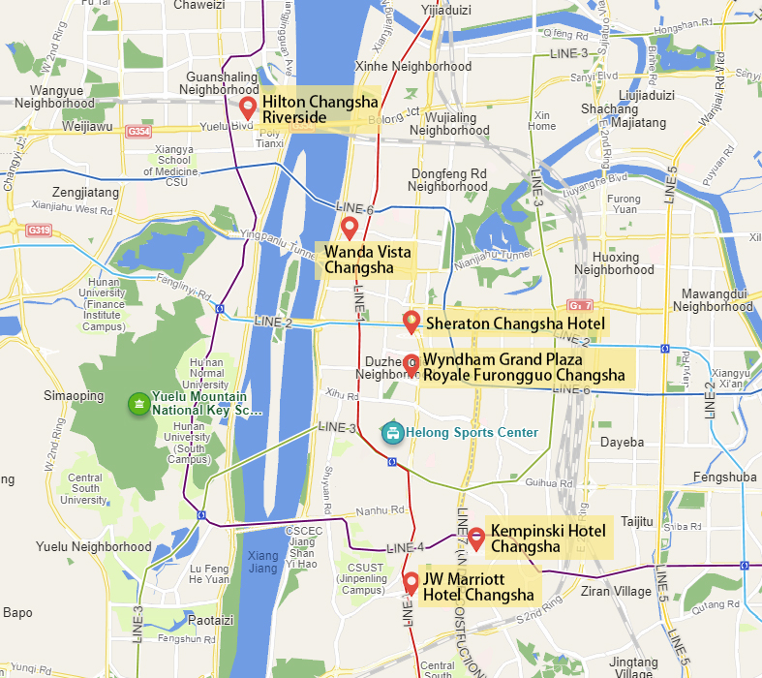

We look forward to seeing you all in Changsha, China.

Yours sincerely,
the Chinese Friends of 3GPP

Accommodation
CF3 is not responsible for reservation confirmations, cancelled or changed reservations or no-shows. Please contact the hotel directly to make the reservation.

Meeting Venue for 3GPP RAN1#116-bis
Wanda Vista Changsha
NO.308 Xiangjiang Middle Road, Section 1, Kaifu District, Changsha,Hunan China
Tel: +86 731 8800 8888
Group Rates:
- Deluxe Room (King Bed/ 2 Double Beds): CNY 780 net per room per night with one daily breakfasts
- Executive Room (King Bed/ 2 Double Beds): CNY980 net per room per night with one daily breakfasts
- Grand Deluxe River View Room (King Bed):CNY1280 net per room per night with one daily breakfasts
* The above rate includes Service Charge and Estimated government taxes and fees. Broadband Internet access is complimentary in guest rooms.
* Cancellation Policy: Free cancellation before 6 pm the previous day of check-in, or the first night will be charged from your credit card
Hotel cut-off date, 31 March2024
Hotel booking

Meeting Registration
Please register for the meetings online at:
on-line registration

Meeting Venue for 3GPP RAN2#125-Bis
Wyndham Grand Plaza Royale Furongguo Changsha
No. 106, Section 2, Furong Middle Road, Furong District, Changsha, Hunan province, China.
Tel: +86 731 8868 8888
Group Rates:
- Deluxe King Room Smoking (0KS) (King Bed): CNY 650 net per room per night with one daily breakfast
- Deluxe King Room Non Smoking (0KN) (King Bed): CNY 650 net per room per night with one daily breakfast
- Deluxe Twin Room Smoking (0vs) (Twin Bed): CNY 700 net per room per night with one or two daily breakfasts（Based on the number of people checking in）
- Deluxe Twin Room Non Smoking (0vs) (Twin Bed): CNY 700 net per room per night with one or two daily breakfasts（Based on the number of people checking in）
- Commercial King Room Smoking (1KS) (King Bed): CNY 750 net per room per night with one daily breakfast
- Commercial King Room Non Smoking (1KN) (King Bed): CNY 750 net per room per night with one daily breakfast
- Commercial Twin Room Smoking (1vs) (Twin Bed): CNY 700 net per room per night with one or two daily breakfasts（Based on the number of people checking in）
- Commercial Twin Room Non Smoking (1VN) (Twin Bed): CNY 700 net per room per night with one or two daily breakfasts（Based on the number of people checking in）
- Club King Room Smoking (2KS) (King Bed): CNY 950 net per room per night with one daily breakfast
- Club King Room Non Smoking (2KN) (King Bed): CNY 950 net per room per night with one daily breakfast
* The above rate includes Service Charge and Estimated government taxes and fees. Broadband Internet access is complimentary in guest rooms.

* Cancellation Policy: (72H12) Cancel 72 hours prior to 12am day of arrival to avoid penalty.

Hotel cut-off date, 31 March2024
Hotel booking

Meeting Registration
Please register for the meetings online at:
on-line registration

Meeting Venue for 3GPP RAN3#123-Bis
Sheraton Changsha Hotel
No. 478, Section 1, Furong Zhong Road Changsha, Hunan, China
Tel: +86 731 8488 8999
Group Rates:
- Guest room, 1 King: CNY 700 net per room per night with one daily breakfasts
- Guest room, 2 Twins: CNY 750 net per room per night with two daily breakfasts
- Guest room, 1 King High floor: CNY 750 net per room per night with one daily breakfasts
- Guest room, 2 Twins High floor: CNY 800 net per room per night with two daily breakfasts
- Club lounge access, Guest room,1 King High floor: CNY 900 net per room per night with one daily breakfasts
- Club lounge access, Guest room, 2 Twins High floor: CNY 950 net per room per night with two daily breakfasts
- 1 Bedroom Suite,1 King: CNY 1450 net per room per night with one daily breakfasts

- * The above rate includes Service Charge and Estimated government taxes and fees. Broadband Internet access is complimentary in guest rooms.

* Cancellation Policy: If no-show & cancellation for the guaranteed reservation, one night will be charged. If you need to cancel or modify the order after booking, please contact the booking department.TEL: +86 731 8488 8999; E-mail: reservation.changsha@marriott.com
Hotel cut-off date, 31 March2024
Hotel booking

Meeting Registration
Please register for the meetings online at:
on-line registration

Meeting Venue for 3GPP RAN4#110-Bis
Hilton Changsha Riverside
No. 1100 Section Three, Xiaoxiang North Road, Yuelu District, Changsha Hunan 410013, China
Tel: +86 731 8830 8888
Group Rates:
- DELUXE ROOM (King Bed/ 2 Double Beds): CNY 800 net per room per night with one or two daily breakfasts
- DELUXE ROOM RIVER VIEW (King Bed/ 2 Double Beds): CNY 900 net per room per night with one or two daily breakfasts
- SUPERIOR ROOM RIVER VIEW (King Bed/ 2 Double Beds): CNY 950 net per room per night with one or two daily breakfasts
- EXECUTIVE ROOM( King Bed) ): CNY 1060 net per room per night with one or two daily breakfasts

* The above rate includes Service Charge and Estimated government taxes and fees. Broadband Internet access is complimentary in guest rooms.
* Cancellation Policy:There is a credit card required for this reservation. Free cancellation before 14 days prior to arrival.

Hotel cut-off date, 31 March2024
Hotel booking
Meeting Registration
Please register for the meetings online at:
on-line registration

Meeting Venue for 3GPP SA2#162, SA5#154 and SA6#60
Kempinski Hotel Changsha
NO.419 Shaoshan Middle Road Yuhua District,410007
Tel: +86 731 8463 3333

Group Rates:
- SUPERIOR ROOM (King Bed/ 2 Double Beds): CNY 750 net per room per night with one or two daily breakfasts
- EXECUTIVE ROOMS (King Bed/ 2 Double Beds): CNY 900 net per room per night with one or two daily breakfasts
- GRAND DELUXE SUITE(King Bed): CNY 1460 net per room per night with one or two daily breakfasts
* The above rate includes Service Charge and Estimated government taxes and fees. Broadband Internet access is complimentary in guest rooms.

* Cancellation Policy:
Cancel up to 7 days prior to arrival to avoid a penalty of first night.

* Deposit/guarantee Policy
A valid credit card is required to guarantee the booking.

Hotel cut-off date, 31 March2024
Hotel booking

Meeting Registration
Please register for the meetings online at:
on-line registration

Meeting Venue for 3GPP CT1#148, CT3#134 and CT4#122
JW Marriott Hotel Changsha
No.567, Furong Middle Road, Yuhua District, Changsha, 410021 P. R. China
T: +86 731 8329 9999
Group Rates:
- Deluxe King Bed Room (King Bed: CNY RMB:800 net per room per night with one or two daily breakfasts
- Deluxe Double Bed Room (2 Double Beds): CNY RMB:800 net per room per night with one or two daily breakfasts
- Executive King Bed Room (King Bed: CNY RMB:988 net per room per night with one or two daily breakfasts
* The above rate includes Service Charge and Estimated government taxes and fees. Broadband Internet access is complimentary in guest rooms.
* Cancellation Policy: You may email to the hotel reservations: mhrs.csxjc.reservation@marriotthotels.com to cancel reservation for no charge before April 02 & change before April 02, 2024. Please note that your reservation will be hold till 18 PM on your arrival day, if your arrival time is after 18 PM please DO remark it upon reserving, otherwise your reservation will be cancelled at that time of 18 PM on arrival day local time.

Hotel cut-off date, 31 March2024
Hotel booking
Meeting Registration
Please register for the meetings online at:
on-line registration

Visa letter
If you need an invitation letter for applying a VISA, complete the provided request form and send it to the person below no later than 22 March, 2024 (Beijing time, GMT+8). Late submission will not be accepted. It is recommended for each company to designate one delegate from your company to collect all the information of your delegates who need the invitation letter and to send one request e-mail by the designated person. Please contact the Chinese Embassy at your country for further information.

Contact person for invitation letter:
Mr. Ruixiao BAI (CCSA)
E-mail: ccsavisa@163.com
Tel: +86-15501150226

Time Zone
GMT +8 hours

Voltage
Commercial power in China is 220V. Please be sure you have the correct adapter. Voltage converters will not be provided at the meeting.
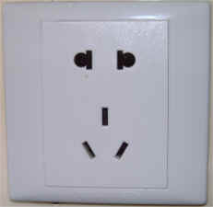

City Profile/ Area Attractions
Changsha Tours
Host Contact
For any questions about anything relating to the meeting please contact:

Mr. Ruixiao BAI Mr. Xu QI
Tel.: +86- 15501150226 Tel.: +86-10-6230 4200
E-mail: bairuixiao@ccsa.org.cn E-mail: qixu@ccsa.org.cn

Mr. Shizhuo ZHAO
Tel.: +86-10-6230 2645
E-mail: zhaosz@ccsa.org.cn

Attachment 1: Invitation letter request form for VISA
Attachment 2: Transport Information about the meeting venue
Attachment 3: Special offer for 3GPP in Changsha

Attachment 1: Invitation letter request form for VISA

INVITATION LETTER REQUEST FORM

To enter China for the meetings indicated above, you may need a letter of invitation from the Chinese host, which you will need to present to the Chinese Embassy/Consulate in your area in order to obtain your visa. In order to obtain the invitation letter, please:

- fill out the form below
- Send it to (please reference “Invitation letter request for 3GPP RAN X/SA X/CT X meeting” as the subject):

Mr. Ruixiao BAIChina Communications Standards Association (CCSA)

ccsavisa@163.com
(It’s recommended to scan your passport page and email to us so that it’s discernible and can be used.)
Fax number: +86-10-6230 1849-4200 (if your passport page is photocopied and enlarged)
Company
Applicant Information |  |  |  | Mr Ms Mrs
 | Date of birth :
 | Is this your first visit to China? |  |  | __ Yes ___ No
 | If the country in which you'll obtain your visa is different from your nationality, please indicate it here:
The name and the address of the Chinese Embassy/Consulate, which you are going to apply your visa.
Name:
Address:
Your Address
Place to visit after entry | In this case, it is Changsha by default.
Date of arrival at China |  |  | Date of departure from China
End of form
(Please do not forget to attach a copy of your passport photograph page before sending.)
Your information should be sent out before 22 March, 2024.

Attachment 2: Transport Information about Meeting Venue

Wanda Vista Changsha Hotel is about 30 km and 50 mins by car from Changsha Huanghua International Airport.
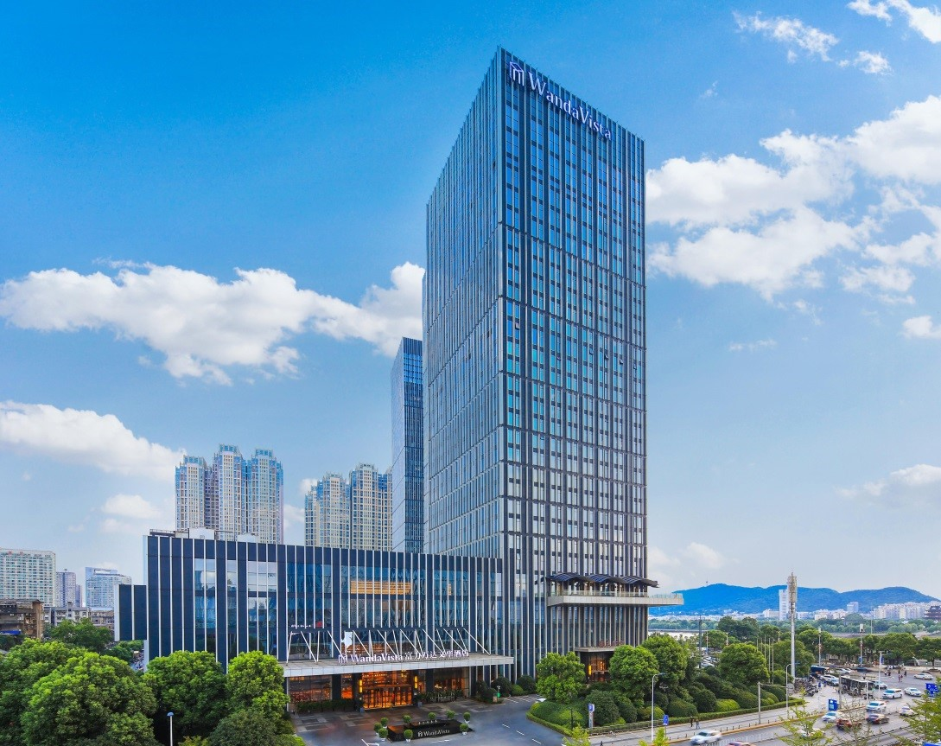
Taxi (50 mins)
The fare for taxi from the Airport to the hotel is around CNY 80 per way. (Please take the taxi which can provide the invoice for your trip)

In case of taking a taxi, please print the following note which shows taxi driver the address of Wanda Vista Changsha Hotel in both English and Chinese.

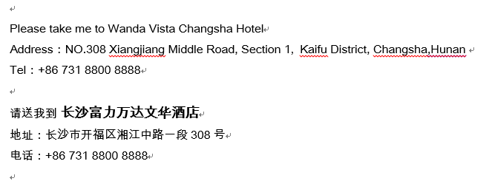
Wyndham Grand Plaza Royale Furongguo Changsha, is about 25 km and 50 mins by car from Huang Hua International Airport
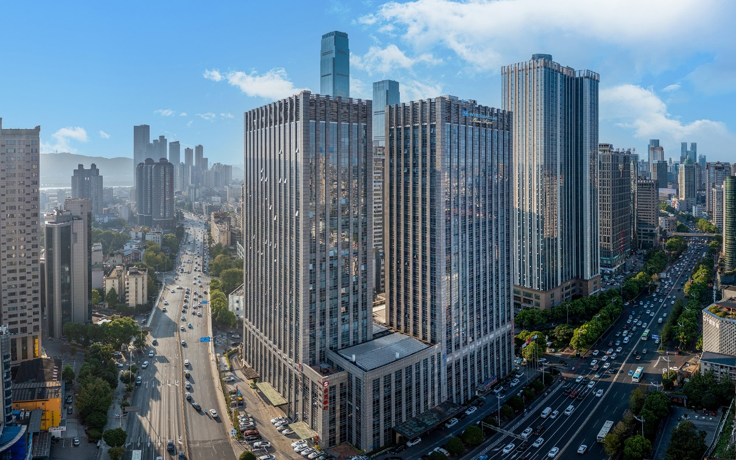
Taxi (50 mins)
The fare for taxi from the Airport to the hotel is around CNY 60-100 per way. (Please take the taxi which can provide the invoice for your trip)

In case of taking a taxi, please print the following note which shows taxi driver the address of . Wyndham Grand Plaza Royale Furongguo Changsha in both English and Chinese.

Please take me to Wyndham Grand Plaza Royale Furongguo Changsha
Address: No. 106, Section 2, Furong Middle Road, Furong District, Changsha, Hunan province, China.

TEL：+86 731 8868 8888

请送我到长沙芙蓉国温德姆至尊豪廷大酒店

地址: 中国湖南省长沙市芙蓉区芙蓉中路2段106号

电话: +86 731 8868 8888

Please take me to Shangri-La Hotel, Xi’an.
Address: 38B Keji Road, Xi’an, China
Tel: +86-29-8875 8888

请送我到西安香格里拉大酒店
地址：中国西安市科技路38号乙
电话：+86-29-8875 8888
Please take me to Shangri-La Hotel, Xi’an.
Address: 38B Keji Road, Xi’an, China
Tel: +86-29-8875 8888

请送我到西安香格里拉大酒店
地址：中国西安市科技路38号乙
电话：+86-29-8875 8888
Please take me to Shangri-La Hotel, Xi’an.
Address: 38B Keji Road, Xi’an, China
Tel: +86-29-8875 8888

请送我到西安香格里拉大酒店
地址：中国西安市科技路38号乙
电话：+86-29-8875 8888
Please take me to Shangri-La Hotel, Xi’an.
Address: 38B Keji Road, Xi’an, China
Tel: +86-29-8875 8888

请送我到西安香格里拉大酒店
地址：中国西安市科技路38号乙
电话：+86-29-8875 8888
Sheraton Changsha Hotel is about 27 km and 55 mins by car from Changsha Huanghua International Airport
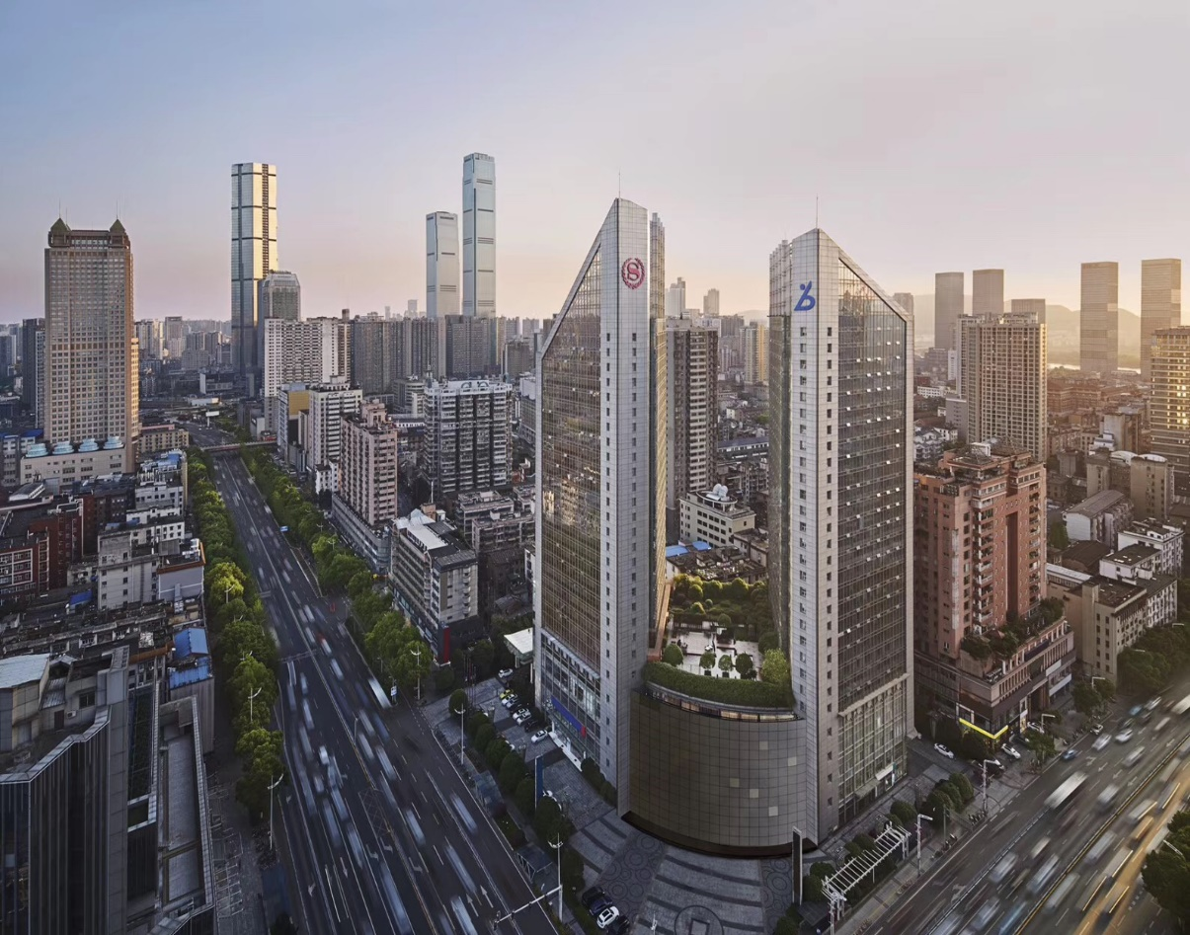

Taxi (55 mins)
The fare for taxi from the Airport to the hotel is around CNY 100 per way. (Please take the taxi which can provide the invoice for your trip)

In case of taking a taxi, please print the following note which shows taxi driver the address of Sheraton Changsha Hotel in both English and Chinese.

Please take me to Sheraton Changsha Hotel
Address: No. 478, Section 1, Furong Zhong Road Changsha, Hunan, China

TEL：+86 731 8488 8888

请送我到长沙运达喜来登酒店

地址: 中国湖南省长沙市开福区芙蓉中路一段478号运达国际广场

电话: +86 731 8488 8888

Hilton Changsha Riverside is about 32km and 60mins by car from Changsha Huanghua International Airport
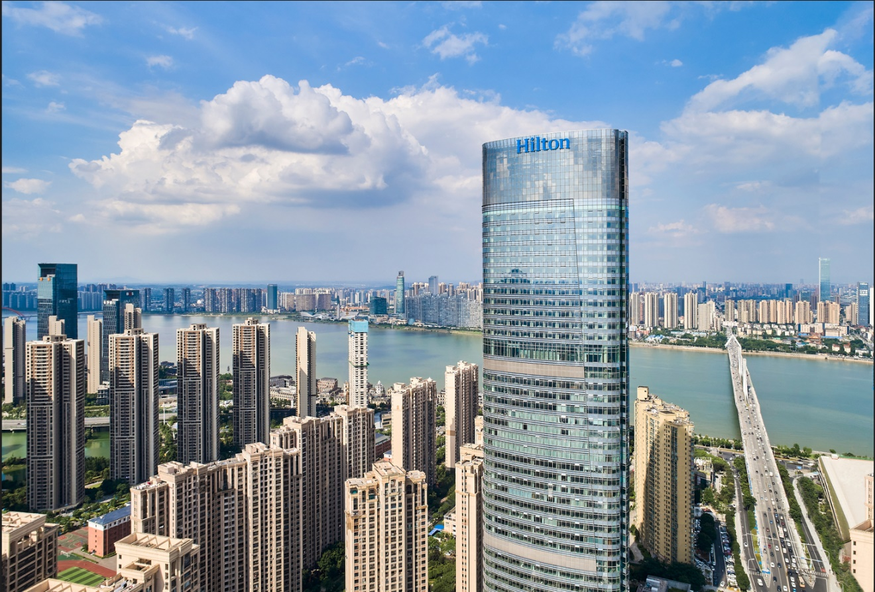

Taxi (60mins)
The fare for taxi from the Airport to the hotel is around CNY 120 per way. (Please take the taxi which can provide the invoice for your trip)

In case of taking a taxi, please print the following note, which shows taxi driver the address of Hilton Changsha Riverside in both English and Chinese.

Please take me to Hilton Changsha Riverside
Address: No.1100 Section Three, Xiaoxiang North Road, Yuelu District, Changsha，Hunan
T: +86 731 8830 8888
请送我到 长沙世茂希尔顿酒店
地址：长沙市岳麓区潇湘北路三段1100号
电话： +86 731 8830 88888

Kempinski Hotel Changsha, is about 25km and 30mins by car from Huanghua International Airport.
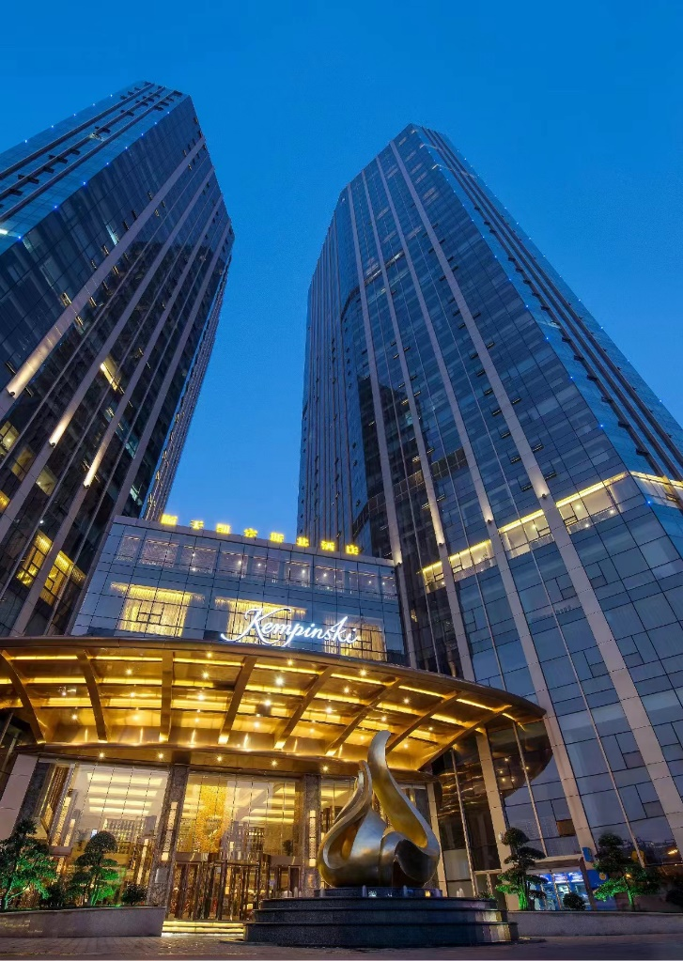

Taxi (30 mins)
The fare for taxi from the Airport to the hotel is around CNY65- 100 per way. (Please take the taxi which can provide the invoice for your trip)

In case of taking a taxi, please print the following note which shows taxi driver the address of Kempinski Hotel Changsha in both English and Chinese.

Please take me to Kempinski Hotel Changsha
Address:NO.419 Shaoshan Middle Road Yuhua District,Changsha
Tel: +86 731 8463 3333
请送我到 长沙顺天凯宾斯基酒店
地址：长沙市雨花区韶山中路419号
电话： +86 731 8463 3333

JW Marriott Hotel Changsha is about 25 km and 35 mins by car from Changsha Huanghua International Airport
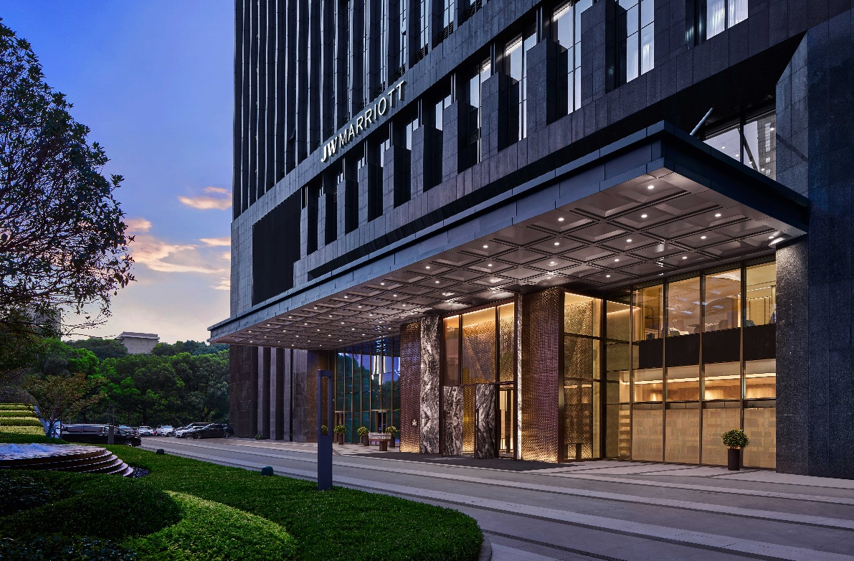

Taxi (35 mins)
The fare for taxi from the Airport to the hotel is around CNY 80 per way. (Please take the taxi which can provide the invoice for your trip)

In case of taking a taxi, please print the following note which shows taxi driver the address of JW Marriott Hotel Changsha, in both English and Chinese.

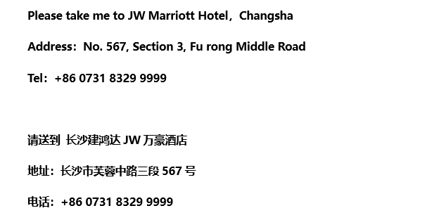

Attachment 3: Special offer for 3GPP in Changsha

Air China (one of Star Alliance members) would like to offer special Conferences & Meetings Programs for the 3GPP meetings in Changsha, China. Please refer the details on how to take advantage of the discount offerings:

- Visit Air China’s website (http://www.airchina.com.cn/en/index.shtml) , from the list of “WorldWide sites” (right-up corner of the page) select the country where you are from.

- Select Promotions / Corporate and Conference / Conference offers.

- Input“Conference ID ”as: X9CVA00HJ.

The negotiated discounted fares are valid between Apr 5 and Apr 29,2024.

Air China Hotline: 95583

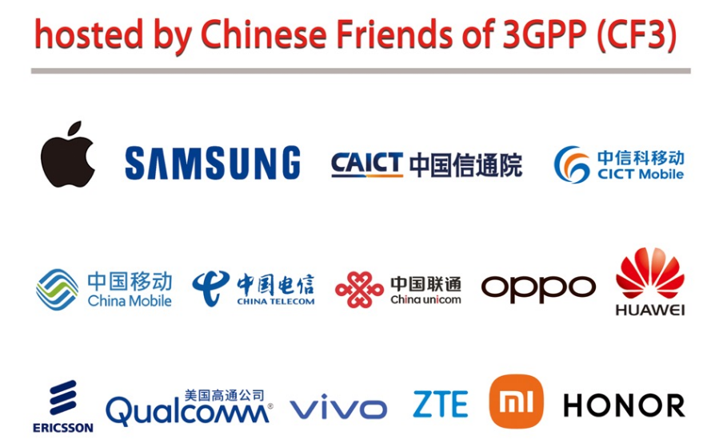

Have a successful meeting and enjoy your stay in Changsha!

