Short Chicago Guide

Important: Deep dish pizza can take between 40 minutes to an hour to prepare, so I wouldn’t recommend it for a quick lunch, but if you enjoy excessive cheese, please try it :p

A map with convenience stores, grocery stores, pharmacies, restaurants (that I like), and tourist attractions can be found here. I may add more things to the map. The area the hotel is in is called South Loop, and just north of that is the Loop, where all the metro lines converge in a loop. The meeting hotels are right next to Millennium and Grant Park, where you can find Buckingham Fountain, the Cloud Gate (or the Bean), and plenty of running paths. Surrounding the Loop are the Riverwalk and the Lakefront Trail, (blue path) which are also great for running.
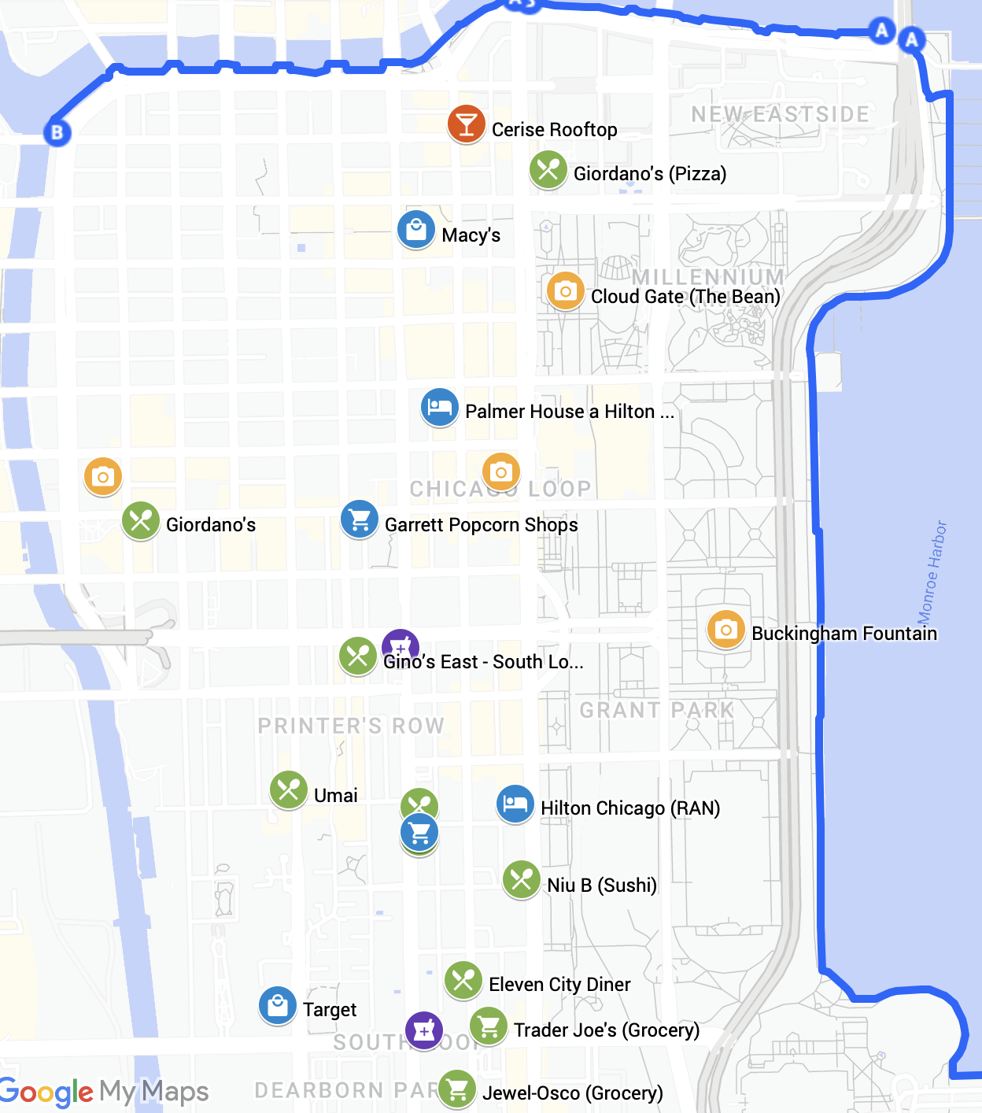
Just north of the Loop and the Chicago River is a neighborhood known for excellent restaurants, called River North. On the map below, you can see a concentration of restaurants that I’ve enjoyed, but there are plenty more to explore there. The Navy pier on the east side of Streeterville is also a nice place to get a view of the city and there are plenty of restaurants and souvenir shops as well. The Magnificent Mile, or North Michigan Ave., is where you can find all the big name-brand shops as well as more restaurants and a 4-story Starbucks with a bar at the top – this gets quite busy, though.

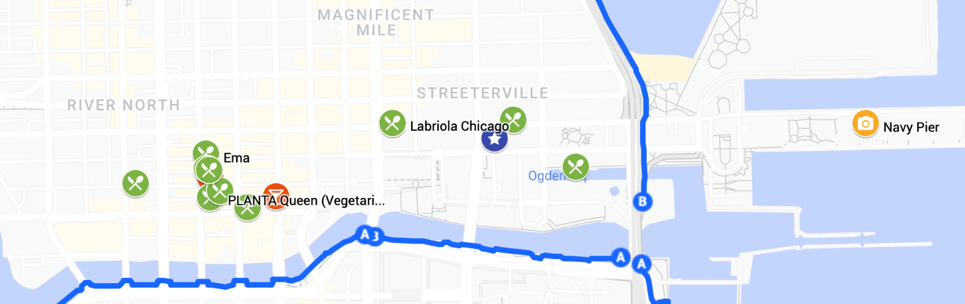

General Tips
- The drivers are a bit reckless, so be careful crossing the street.
- The city is quite safe, especially during the daytime. I would recommend against venturing too far south of the loop at night, but crime is rarely targeted at tourists in my experience, aside from the normal scams found in big cities.
Transportation
- To use the metro, called the “L”, use the Ventra App, or tap your credit card. But, if you tap your credit card, it will cost $5 instead of $2.50. Transfers between buses and metro trains are complimentary. Note that the commuter train is called “metra” so don’t confuse that with the “L”. The minimum amount to load on the app is $10.
  - Both Google Maps and Apple Maps are good for planning routes, but the Ventra app will have the most up to date status of the “L” trains.
  - It is possible to take the blue line from O’Hare Airport to Jackson and walk 13 minutes to the hotel. Depending on time of day, the “L”, and a taxi might take the same amount of time because of traffic.
- At the airport, Uber, and Lyft (rideshare) leave from Terminal 2, so if you are arriving internationally, you will have to take the airport train to Terminal 2. Alternatively, taxis are available outside of Terminal 5 where you will arrive.
- The number for the police and emergency services is 911.
- For taxis, we mostly use the following:
  - Uber
  - Lyft
- And if you’re adventurous, you can rent a bike. These are picked up and returned at stations around the city. A map is available in the app to show availability and available return locations.
  - Divvy
Convenience stores
- 7-11
- CVS (also a pharmacy)
- Walgreens (also a pharmacy)
Restaurant Booking and Search
- www.resy.com – Some fancier restaurants list on this app, but its selection is smaller.
- www.opentable.com – Restaurants are most commonly listed here.
Food Delivery and Pickup (with App)
- Grubhub App
- Uber Eats App – This one is quite easy if you already use Uber
- DoorDash App
Tourist Attractions
- If you have time for museums, shows, or other things to do, I recommend this site: https://www.timeout.com/chicago. Specific details on museums can be found here: https://www.timeout.com/chicago/attractions/10-best-chicago-museums-top-institutions-to-visit-in-chicago.
- To get a quick, but comprehensive tour of Chicago, I recommend the Chicago Architectural Boat Tour from Wendella: https://www.wendellaboats.com. It may be windy and/or cold, but in either 45 minutes you can see the main branch of the river, or in 90 minutes, you see the main branch and the north and south branches of the Chicago River. There is also a bar on board if you want to relax a bit.

