3GPP WG SA2 Meeting #160AHE S2-2400708r01
22 - 29 January, 2024, Electronic
Source: NEC
Title: KI #1, New Sol: Regenerative architecture.
Document for: Approval
Agenda Item: 19.1
Work Item / Release: FS_5GSAT_ARCH_Ph3 / Rel-19
Abstract of the contribution: The contribution proposes a solution to Key Issue #1: KI#1: Support of Regenerative-based satellite access.
1. Introduction
This contribution proposes a solution to Key Issue #1: KI#1: Support of Regenerative-based satellite access.

.1 Key Issue #1: Support of Regenerative-based satellite access

5.1.1 Description
The deployment of an eNB or an gNB on a satellite for regenerative based satellite access for LEO/MEO deployment is to be studied. The aspects to be studied include:
- Identify and study whether there is any impact on 5GS and EPS to support an gNB/eNB embedded on a satellite:
- any impact of RAN nodes changing for any given 5GC/EPC and for a given area in the case of RAN nodes moving.
2. Discussion
WT#1 proposes to integrate eNB or gNB in a LEO/MEOsatellite and study the impact on the EPS or 5GS.
One of the impacts will be when a gNB or eNB is put in the LEO/MEO satellite, the NG interface in 5GS and S1 intreface in the EPS system needs to be tear down and setup everytime the satellite comes to a particular location. This will create a lot of signaling at an NG interface or at an S1 interface.
To solve the above issue, it is proposed the gNB sends its availability time (Feeder link available tine) to the AMF during the NG interface setup procedure. The gNB and the AMF maintain the NG interface and the AMF transmits any NGAP message to the gNB during the gNB availability time and the AMF doesn’t send any message to the gNB outside the gNB availability window. In this way the gNB and the AMF maintain NG interface without tearing down and set up the NG interface every time when gNB moves away and come back to the place respectively.

3. Proposal
It is proposed to agree the following solution to 3GPP TR 23.700-66.

* * * Start of change * * * *

6.x Solution #X: Support of Regenerative-based satellite access

6.x.1 Key Issue mapping

This solution addresses the scenarios mentioned in the KI#1.

6.x.2 Functional Description

This solution follows following basic principles and assumptions:
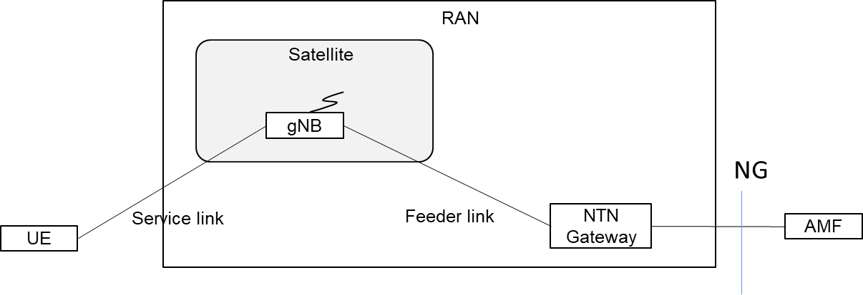
1. The gNB is in the payload of the satellite.
2. When the feeder link becomes available, the gNB sends NG SETUP REQUEST message including feeder link available time i.e. gNB available time to the AMF.
3. The AMF stores the feeder link available time for this gNB. The gNB and the AMF communicate the NGAP messages over the NG interface during the feeder link available time.
4. When the gNB moves away at the location and the feeder link becomes not available, the gNB and the AMF suspends the NG connection i.e the gNB and the AMF do not communicate any NGAP message at this interface.
5. When the feederlink availability time indicates that the feeder link is available the gNB and the AMF resumes the NG connection.
The same principle is applied to the EPS at the S1 interface between eNB and MME.
EN: It is FFS how to manage the heart beat management procedure of SCTP protocol in step 4 and 5,
NOTE: Adverse weather condition might impact the feeder link establishment procedure.

6.x.4 Impacts on existing services, entities and interfaces
gNB,and AMF needs to implement the suspend and resume \NG connection.
eNB and MME. needs to implement the suspend and resume S1 connection.

* * * End of change * * * *

