SA WG2 Meeting SA2#160-Ad Hoc-e S2-2400111

22-29 January, 2024, Electronic

Source: OPPO
Title: KI #1, New Sol: Energy Brokerage Function for energy related information processing
Document for: Approval
Agenda Item: 19.4
Work Item / Release: FS_EnergySys / Rel-19
Abstract of the contribution: This contribution proposes a new solution for KI#1

Introduction
A new solution is proposed in this contribution for inclusion in TR 23.700-66. This solution outlines the specifics of using Energy Brokerage Function for energy related information acquisition and processing.

2 Proposal
It is proposed to capture the following solution in TR 23.700-66.
Start of Changes

6.x Solution #X: Energy Brokerage Function for energy related information acquisition and processing

6.x.1 Key Issue mapping

In KI#1, to support network energy related information exposure, the following aspects are to be studied:
- How the network energy related information is exposed.
- How and what network energy related information from the Network entities (i.e. RAN nodes, 5GC NFs) can be obtained in order to support network energy related information exposure.

6.x.2 Functional Description

Based on the requirements and use cases in TS 22.261 [X], it is proposed to specify an Energy Brokerage Function (EBF) in 5GC to act as an intermediary between the network and authorized third parties to acquire energy related information, process the information to generate energy consumption and energy efficiency KPI, and expose energy consumption and efficiency-related data to authorized third parties.
The functionalities of EBF shall include:
- Collects relevant counters from OAM and uses them to generate energy efficiency related KPIs.
- Calculate energy efficiency, carbon emissions, ratio of renewable energy, etc. based on requirements.
- Enables periodic reporting to authorized third parties based on their agreement (e.g., monthly, or yearly).
- Notifies when the energy consumption reaches the energy credit limit.
- With user consent, exposes energy efficiency information based on a subscriber's data volume and other metrics.
- Exposes energy related information to NFs and AFs, e.g., as data source to expose energy related information to NWDAF or MDAF for them to generate energy related analytics.
Editor’s note: whether there is a need for a new 5GC NF or whether proposed functionality can be provided by existing NFs will be evaluated and concluded on during the evaluation and conclusion phase.
Editor’s note: Details for energy consumption information and details for energy efficiency information sent to AF are FFS.

6.x.3 Procedures

The EBF could collect relevant counters from OAM and use them to generate energy efficiency related KPIs. The interactions between EBF and OAM for data collection are illustrated in Fig. 1. The type of performance measurements data to be collected depends on the use cases. This figure is an abstraction of the OAM performance data file report management service that is defined in TS 28.532 [11]. The actual OAM services and reporting mechanisms that EBF may use are specified in TS 28.532, TS 28.550 [10] or TS 28.545 [12].
The flow below assumes that EBF is configured on how to subscribe to the relevant OAM services. OAM shall setup the required mechanisms to guarantee the continuous data collection requested by EBF.
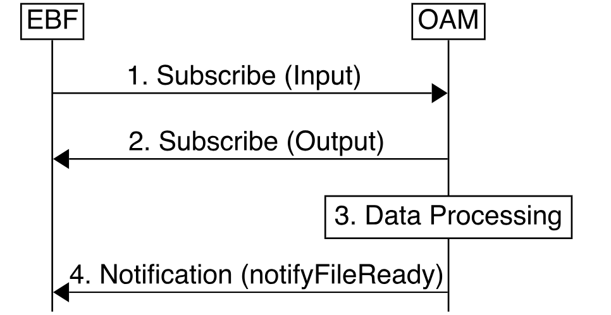
Figure 1: Data collection from OAM performance data file report management service
1. Subscribe (Input): EBF subscribes to the notification(s) related to the services provided by the management service producer.
2. Subscribe (Output): management service producer responses to EBF if the subscription is success or not.
3. Data processing: management service producer prepares the data.
4. Notification (notifyFileReady): management service producer notifies the data file is ready.
As the final step, EBF fetches data by using file transfer protocols as defined in clause 11.6.2 of TS 28.532.
In terms of network slice, based on the Network Slice information, the EBF could identify the Network Slice managed object relating to the S-NSSAI and NSI ID and consumes the management services to collect the management data of the corresponding Network Slice managed object (including the NRF serving the network slice, the NFs associated to the network slice, the NG RAN or 5GC performance measurements defined in TS 28.552, or the 5G end to end KPIs defined in TS 28.554) provided by OAM.
A high-level procedure is depicted in Fig. 2 to show how EBF, as defined in clause 6.x.2, could use data collected from OAM various NFs to determine energy related information based on energy consumption KPI based on the formula in TS 28.554.

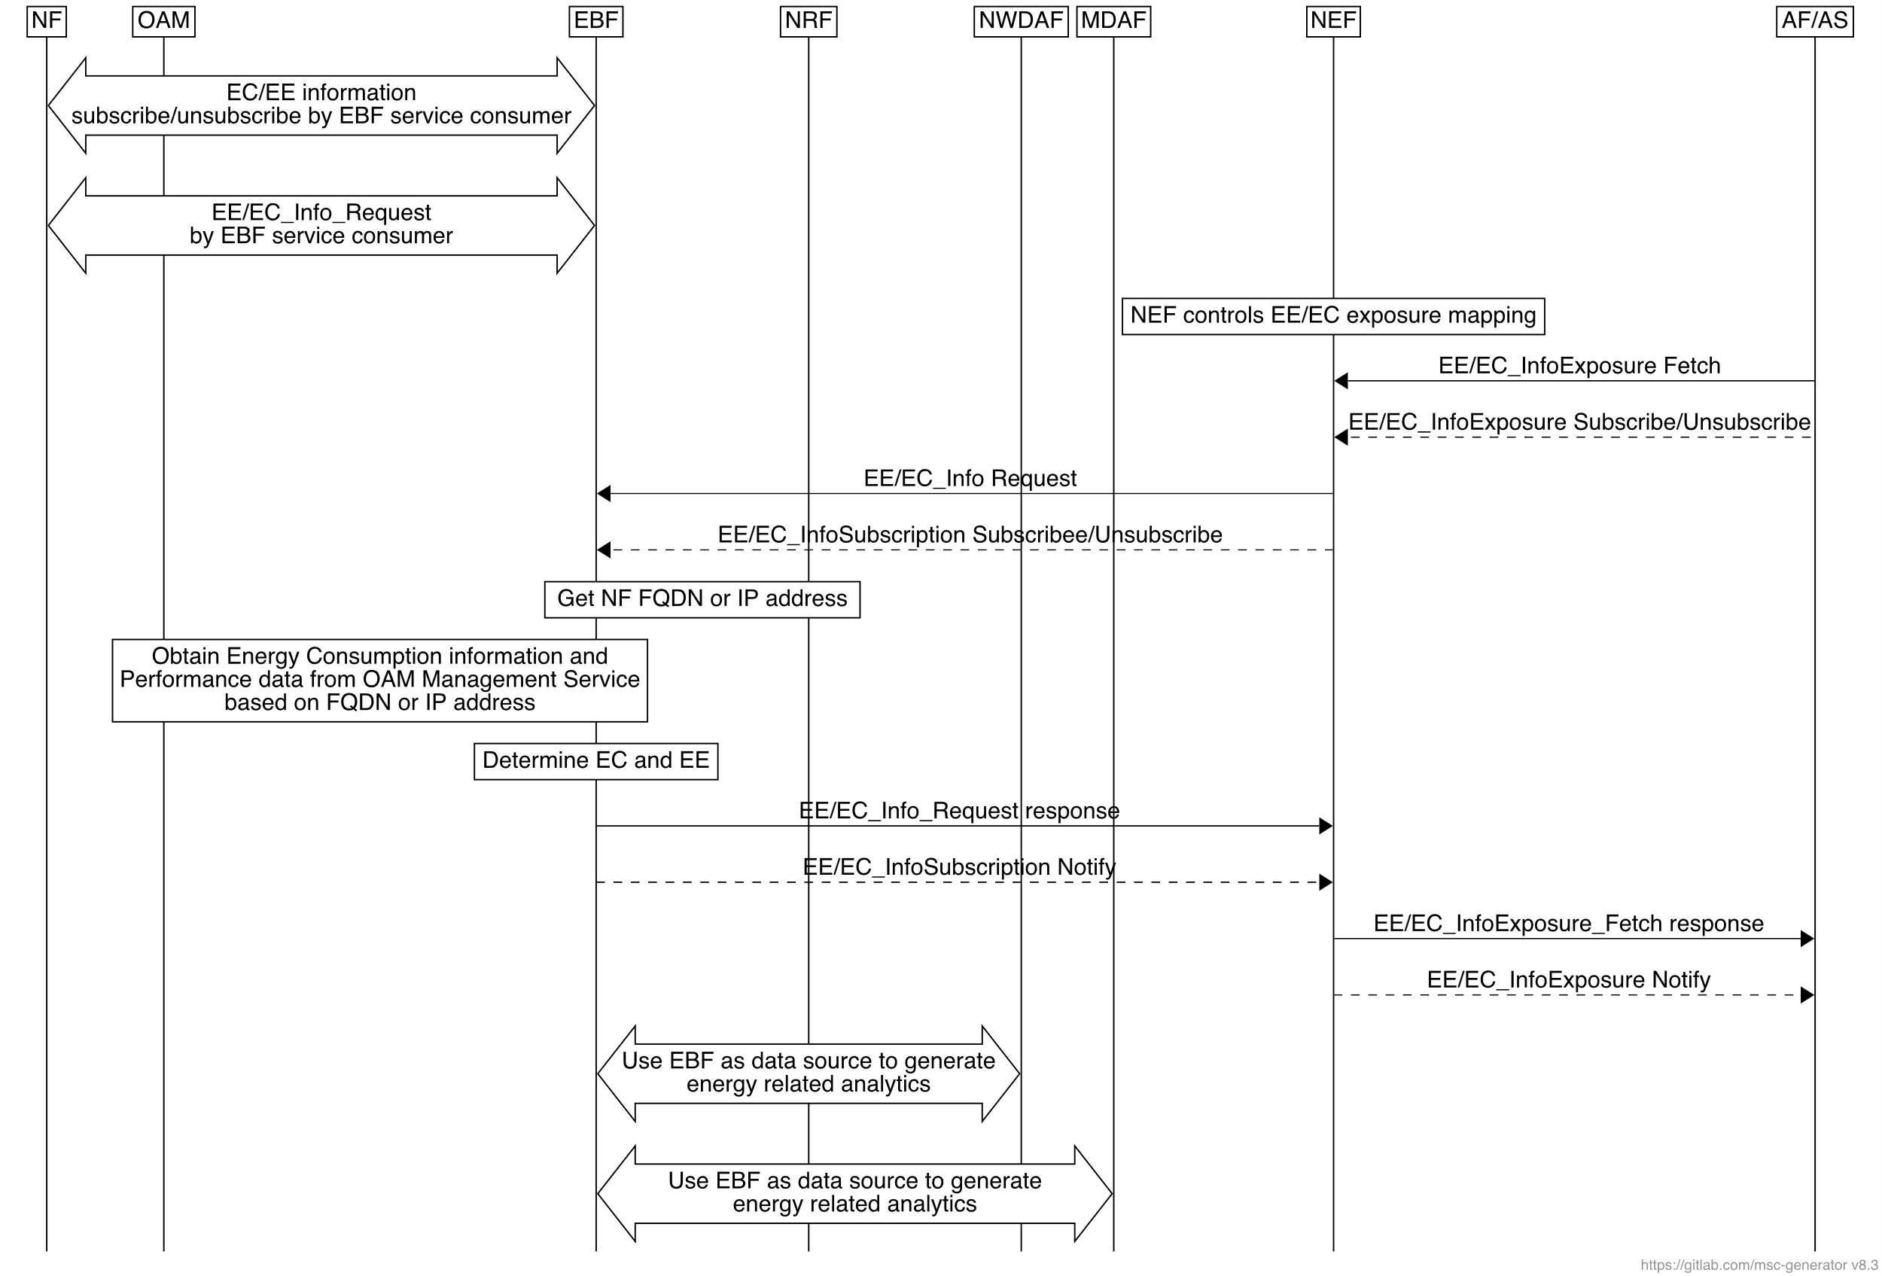

Fig.2 High Level Procedures for Energy-related information acquisition and processing
Three sets of procedures are depicted in this figure.
In one set of procedures, the EBF service consumer (e.g. including NFs/OAM) could subscribe/unsubscribe at EBF to be notified on EE/EC information. The EE/EC information exposure to AF/AS may be performed via NEF by using EE/EC information subscription to EBF.
In the other set of procedures, The EE/EC information could be requested and get by EBF service consumer (e.g. including NFs/OAM). And the EE/EC information exposure to AF/AS may be performed via NEF by using EE/EC request to EBF.
In the third set of procedures, the EBF could be the data source for NWDAF or MDAF to generate energy related analytics.
Editor Note: That detailed procedures for EBF entity are FFS.

6.x.4 Impacts on existing services, entities and interfaces

The EBF can be deployed as a standalone function or as a sub-function in Network Data Analytics Function (NWDAF) of the 5G core.
NOTE: EBF as a sub-function of MDAF requires coordination with SA5.
The EBF interacts with other Network Functions:
- EBF can fetch data from OAM or NMS (Network Management System) regarding e.g. network measurements (e.g. Packet loss, delay, failed events, etc.), energy sources, and other pertinent energy-related metrics.
- Collects relevant counters from OAM and uses them to generate energy efficiency related KPIs.
- Enables periodic reporting to authorized third parties based on their agreement (e.g., monthly, or yearly).
- With user consent, exposes energy efficiency information based on a subscriber's data volume and other metrics.
- Exposes energy related information to NFs and AFs, e.g., as data source to expose energy related information to NWDAF or MDAF for them to generate energy related analytics.

Editor’s Note: EBF interfaces are FFS.
Editor’s Note: The details of the information provided to NFs and AFs are FFS.
Editor’s Note: The granularity of the reporting is FFS.

Second Change

2 References
The following documents contain provisions which, through reference in this text, constitute provisions of the present document.
- References are either specific (identified by date of publication, edition number, version number, etc.) or non-specific.
- For a specific reference, subsequent revisions do not apply.
- For a non-specific reference, the latest version applies. In the case of a reference to a 3GPP document (including a GSM document), a non-specific reference implicitly refers to the latest version of that document in the same Release as the present document.
[1] 3GPP TR 21.905: "Vocabulary for 3GPP Specifications".
[2] 3GPP TS 23.501: "System Architecture for the 5G System; Stage 2".
[3] 3GPP TS 23.502: "Procedures for the 5G system, Stage 2".
[4] 3GPP TS 23.503: "Policy and Charging Control Framework for the 5G System".
[5] 3GPP TR 22.882: "Study on Energy Efficiency as service criteria".
[6] 3GPP TS 28.554 "5G end to end Key Performance Indicators (KPI)".
[7] 3GPP TS 28.310 "Management and orchestration; Energy efficiency of 5G".
[8] 3GPP TS 22.261 "Service requirements for the 5G system".
[9] 3GPP TS 28.552 "Management and orchestration; 5G performance measurements".
[10] 3GPP TS 28.550 "Management and orchestration; Performance assurance".
[11] 3GPP TS 28.532 "Management and orchestration; Generic management services".
[12] 3GPP TS 28.545 "Management and orchestration; Fault Supervision (FS)".

End of Changes

