**3GPP TSG-WG SA2 Meeting #154 *S2-220xxxx***

**Toulouse, France, November 14 – 18, 2022 (revision of S2-220xxxx)**

**Source: Huawei, HiSilicon**

**Title: KI#4: Updates of conclusions**

**Document for: Approval**

**Agenda Item: 9.9**

**Work Item / Release: FS_VMR / Rel-18**

*Abstract: Updates of conclusions for KI#4.*

# 1. Discussion

### 1.1 Analysis of MBSR roaming

When the MBSR moves out of coverage of the HPLMN and into VPLMN in connected mode, there are two steps for MBSR roaming into VPLMN:

**Step 1 IAB-UE roaming:** IAB-UE initiates a registration procedure or performs handover procedure into VPLMN. SA2 has studied the IAB authorization based on PLMN/TAI restriction in case of roaming.

**Step 2 IAB-DU roaming:** After the Registration or handover of MBSR is accepted, the IAB-DU can setup F1 connection with IAB donor-CU using either 1) IAB-node integration procedure, or 2) inter-IAB-donor gNB mobility procedure.

**1) IAB-node integration of roaming**

When IAB-UE roams to the VPLMN, the IAB-DU releases the F1 connection with the IAB-CU of HPLMN. The MBSR stops the IAB operation for the HPLMN and changes to serve VPLMN until the F1 setup with IAB-CU of VPLMN and VPLMN cell activation.

The procedure of IAB-node integration is defined in TS 38.401. There are several issues need to be considered or confirmed, and they might be also RAN-related, e.g., does IAB-CU need to identify the IAB-DU is roaming, whether additional enhancements are needed during F1 setup?

**2) Inter-donor migration**

Rel-18 full migration uses two logical IAB-DUs in an IAB node. The two cells reside on the same physical IAB-node (i.e., MBSR) but on different logical IAB-DUs (e.g. IAB-DU1 and IAB-DU2), which each have a separate F1 connection to IAB-donor-CU1 and IAB-donor-CU2, respectively.

When IAB-UE (i.e., MBSR) roams to the VPLMN, IAB-DU1 and IAB-DU2 are controlled by different CUs from different PLMNs (Figure 1). Since the connected UEs are still camped on the IAB-DU1, for supporting Inter-donor migration, several issues shall be addressed and they are under the remit of RAN WGs:

* Whether the IAB-DU1 is still broadcasting the cell information of HPLMN after the IAB-UE (i.e., IAB-MT) roaming;
* Whether and how the F1 connection to the HPLMN IAB-CU1 is maintained;
* There is no Xn inferface between CUs in case of inter-PLMN mobility. How to negotiate the QoS parameters needed for the traffic routing from DU1 to CU1?
* Will the UE detect two different cells of different PLMNs?

These open issues affect the UE’s behaviour and service continuity in case MBSR roaming, and further inputs from RAN WGs are needed.

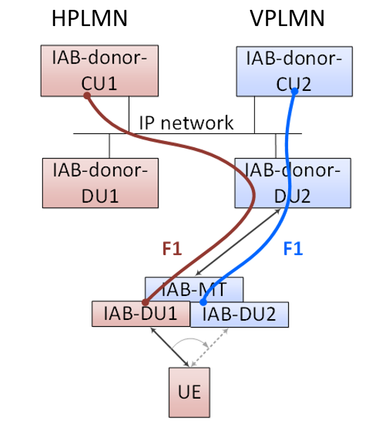

**Figure 1: Inter-donor migration of roaming**

MBSR roaming consists of IAB-UE roaming and IAB-DU roaming. There is no doubt that it is SA2’s scope to discuss the IAB authorization for roaming. However, the support of IAB-UE roaming is incomplete to realize the MBSR roaming feature since IAB-DU roaming requires further involvement of RAN WGs.

**[Observation 1]:** SA2 needs RAN WGs to provide feasibility analysis on the integration/inter-donor-migration procedures used for IAB-node roaming.

According to the Reply LS on FS_VMR solutions review (R3-226048, R2-2211062) from RAN, it is clear that IAB-node roaming is out-of-scope in Rel-18 RAN study. Due to the scope limitation, RAN WGs cannot confirm the solution feasibility of integration/inter-donor-migration procedures.

|  |
| --- |
| **SA2 point #4:** With regard to Key Issue#4 (as defined in clause 5.4), SA2 would like to understand if IAB-node integration procedure or inter-IAB-donor gNB mobility procedure, or both, can be used for MBSR to integrate into the VPLMN.  **RAN2’s feedback on point #4:**This topic is not in RAN2 scope.  **RAN3’s feedback on point #4:** IAB-node roaming was not discussed in Rel-16/17, and it is out-of-scope in Rel-18. RAN3 can therefore neither confirm nor deny whether the integration/inter-donor-migration procedures will work in a VPLMN. |

**[Proposal 1]:** As analysed above, it is not clear whether the MBSR roaming, especially IAB-DU roaming is feasible.

1.3 FFS about how to notify the MBSR in case IAB-UE authorization failure

There is an FFS about how to notify the MBSR when the IAB-UE is not authorized. In the last meeting, there are different views that whether IAB-UE is still allowed to register to the network even though the IAB operation is not authorized.

|  |
| --- |
| NOTE 1: Which NAS message(s) (registration accept, registration reject or/and deregistration request) is used by the AMF of the MBSR for indicating to the MBSR that it is not allowed to act as MBSR will be FFS. |

According to the TS 23.501, for the IAB-UE operation, the existing UE authentication methods as defined in TS 33.501 applies. Therefore, the handling of authentication failure for IAB-UE should follow the same logic as the existing UE, i.e., the AMF shall reject IAB-UE’s registration if the IAB operation is not authorized.

Moreover, it is noted that in Rel-17 the IAB-node is not a normal UE since 1) it needs to indicate its IAB role in the RRC message, and 2) it acts as UE only for IAB-related operation as mentioned in TS 23.501:

|  |
| --- |
| The IAB-UE function behaves as a UE, and reuses UE procedures to connect to:  - the gNB-DU on a parent IAB-node or IAB-donor for access and backhauling;  - the gNB-CU on the IAB-donor via RRC for control of the access and backhaul link;  - 5GC, e.g. AMF, via NAS;  - OAM system via a PDU session or PDN connection (based on implementation). |

Therefore, it is still unclear whether there is such a need to keep the MBSR registered as a UE if it is not allowed to act as an MBSR.

**[Proposal 2]:** The MBSR is not allowed to register to the network if it is not allowed to act as an MBSR in the network.

# 2. Text Proposal

It is proposed to capture the following changes into TR 23.700-05 V1.1.0.

* * * * First change * * * *

## 8.4 Conclusions for KI#4

Editor's note: The interim conclusion is subject to feedback of RAN WGs and will be revisited as per the feedback.

For KI#4, the interim conclusions are as follows:

Editor's note: How MBSR is made available with information related to its roaming operation in a VPLMN is FFS.

- Depends on RAN WG confirmation, MBSR (IAB-DU) can use IAB-node integration procedure or inter-IAB-donor gNB mobility procedure to integrate into VPLMN to provide service.

- It is assumed that some roaming agreement for MBSR operation in VPLMN is in place in HPLMN, and the 5GC can make use of it for authorization of MBSR in VPLMN based on subscription information.

- The MBSR(IAB-UE) is assumed to be configured with preferred PLMN lists and forbidden PLMNs by the HPLMN.

- If the MBSR (IAB-UE) performs initial registration with the PLMN and accepted by the network acting as MBSR based on subscription information, and the information on how to obtain configuration information is available at MBSR. If the MBSR has no information for configuration in the serving PLMN and is not allowed to operate in the serving PLMN, it records the serving PLMN as not supporting operation as MBSR.

- The AMF of the MBSR can indicate to the MBSR that it is not allowed to act as an IAB node in the RA as part of registration procedure via registration reject. Even after the MBSR is authorized as an IAB node in the initial registration, the AMF of MBSR supports location based restriction of MBSR operation and shall de-reregister the MBSR. The MBSR should store the corresponding RA TAIs and avoid attempts to access these PLMNs/TAIs.

NOTE 1: The mechanism applies to both roaming and non-roaming MBSR operations.

* * * * End of changes * * * *