SA WG2 Meeting #150E S2-2204668
6 - 12 April 2022, Elbonia
Source: Nokia, Nokia Shanghai Bell
Title: KI#1, Sol#7: Updates to remove EN
Document for: Approval
Agenda Item: 9.23
Work Item / Release: FS_eNA_Ph3 / Rel-18
Abstract of the contribution: This paper proposes improvements to resolve the EN in TR 23.700-81 clause 6.7 Solution #7: Enhancements to NWDAF analytics services

1 Discussion
During SA2#150E for FS_eNA_Ph3, S2-2203360 was approved, which provides solution#7 TR 23.700-81. This paper adds the “impacts” subclause and improves the solution description and procedure to resolve the EN.

2 Proposal
It is proposed to improve the solution#7 in FS_eNA_ph3 TR 23.700-81 as described below.
*** Start of Changes ***
*** Change 1 ***

6.7 Solution #7: Enhancements to NWDAF analytics services

6.7.1 Description
In general, the ability for a service consumer to use a performance score to select an NWDAF Analytics and/or ML model may help such service consumer to obtain the desired level of correctness. This solution proposes to associate a score attribute to NWDAF Analytics and ML models, which, similarly to what happens with popular recommendation systems, can be used in the selection of NWDAF Analytics and/or ML models.
In particular, the solution allows a service consumer to rate ML models and/or NWDAF analytics from different providers (or by the same provider offering multiple ML models for the same NWDAF analytics). Also, the solution allows a service consumer to retrieve the score associated to the NWDAF Analytics and/or ML models.
An analytics consumer is allowed to rate an analytics service (i.e., Analytics ID) from an NWDAF (see procedure in clause 6.7.2.1), whereas an NWDAF containing AnLF is enabled to rate an ML model provided by an NWDAF containing MTLF (see procedure in clause 6.7.2.2). In this solution, a consumer from the same vendor of the analytics service or model provisioning service is allowed to rate the analytics service or the used ML model, while the entity producing/exposing the analytics service or ML model is not allowed to self-rate it. For example, an analytics consumer from the same vendor as the NWDAF containing AnLF producer can rate the analytics service, while self-ratings from the NWDAF containing AnLF are not accepted. The rating is based on a metric associated to the Analytics ID and the corresponding ML model. Such metric is stored in the NF profile at the NRF.
The solution leverages on the introduction of:
- A Trusted Rating Logical Function (TRLF) that manages the rating provided by the service consumers. Furthermore, it ensures that only verified consumers (i.e., consumers that really have had access to the ML model and/or Analytics services) can rate the ML model and/or the Analytic service. For example, it prevents rating (of its own) by the producer of the ML model and/or analytics service while an analytics consumer from the same vendor is still able to rate the analytics service. For example, NWDAF(MTLF) that has produced the ML model is forbidden to rate such ML model, while NWDAF(AnLF) from the same vendor could rate the ML model if it has used the ML model.
- A rating format that includes key information regarding the usage of the Analytics service provided or not by using an ML model and that can be exploited by other consumers as well as by other producers/vendors.

6.7.2 Procedures

6.7.2.1 Analytics consumer rating an NWDAF analytics provided by an NWDAF containing AnLF
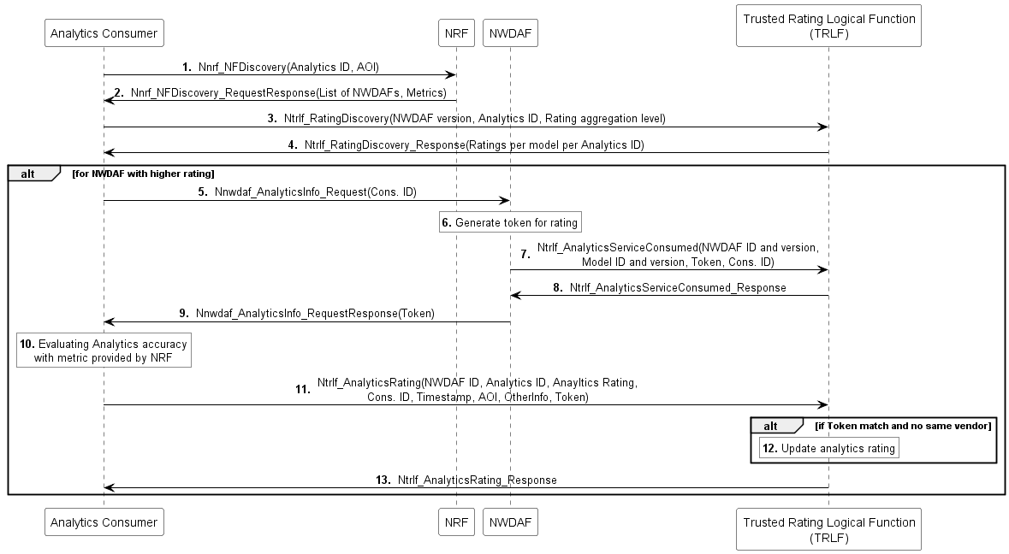
Figure 6.7.2.1-1. Procedure for analytics consumer rating an NWDAF analytics provided by an NWDAF containing AnLF
Pre-condition: NF profile of the NWDAF in NRF contains a metric that should be utilized to rate the analytics service. A metric is associated to each analytics service (i.e., Analytics ID).
1. An Analytics Consumer sends a discovery request to NRF looking for NWDAFs providing the Analytics ID(s) and other input parameters as specified in clause 6.1.3 of TS 23.288 [5].
2. The NRF returns to the Analytics consumer the list of available NWDAFs matching the filter parameters along with the metrics to rate the analytics.
3. The Analytics Consumer requests, for the discovered NWDAFs, the ratings of the Analytics ID from the Trusted Rating Logical Function (TRLF) through a Ntrlf_RatingDiscovery service. In the request, the Analytics Consumer specifies the NWDAF(s) and the Analytics ID(s). The Analytics Consumer sets the "rating aggregation level" request parameter according to its preferred value: "Global Average" to receive an aggregated model rating (i.e. a single value), "average per vendor" to receive a single average value for each vendor which issued a rating, or "detailed" in case it is interested to receive the rating from each service consumer which casted a rating.
The aggregated rating is a value, e.g. between 0 (very bad performance) to 5 (very good performance) derived by the TRLF by an average over all ratings. Along with the aggregated rating, the Analytics Consumer receives also the total number of ratings submitted, so that the consumer can derive the accuracy of the rating.
The Analytics consumer may also implement a local cache for such ratings, in order to avoid the need to query TRLF for each NWDAF discovery request. In this case, steps 2 and 3 may be skipped for future requests.
4. The TRLF returns to the Analytics Consumer the requested ratings according to the specified "rating aggregation level". Based on the "average per vendor" or "detailed" model rating, the analytics consumer can identify how ratings were casted by each vendor.
5. The Analytics consumer selects the NWDAF providing the best performance for the specific use case and scenario. The Analytics consumer requests the analytics service to the selected NWDAF specifying also its Consumer ID comprising the NF (instance or Set) ID and Vendor ID.
6. The NWDAF generates a token that can be used by the Analytics consumer to rate the analytics service.
NOTE: The normative aspects about token generation, and how it is used for verification and communicated to other NFs should be carried out in coordination with SA3.
7. The NWDAF sends through the Ntrlf_AnalyticsServiceConsumed service to the TRLF information about the Consumer ID, Analytics ID, information on the ML model used for producing the analytics (if any), its own NWDAF (instance or Set) ID and the token generated for the Analytics consumer. In this way, the TRLF can associate the rating from the Consumer to the analytics service provided by the NWDAF and, implicitly, to the ML model used to generate it in case the analytics service is based on an ML model.
8. The TRLF sends an acknowledgement to the NWDAF.
9. The NWDAF sends the analytics response to the Analytics consumer along with the token generated for allowing only verified consumers (i.e. only the ones that really have consumed the service) to evaluate the analytics service.
In case the analytics consumer subscribed to the analytics service, the token is valid for the entire subscription duration and the consumer may update its rating by sending another Ntrlf_AnalyticsRating request. Once the subscription is terminated, the NWDAF shall inform the TRLF about it, such that only a final rating can be provided by the consumer after which the token is revoked.
10. The analytics consumer evaluates the performance of the analytics service utilizing the metric obtained by NRF during the discovery procedure.
11. The analytics consumer through the Ntrlf_AnalyticsRating service sends its rating to the TRLF. The request also includes the Consumer ID of the analytics consumer and the received token.
12. The TRLF, in case the token matches and the analytics consumer is not the model producer, accepts and updates the rating. The TRLF stores the rating per Analytics ID and for each Consumer ID.
13. The TRLF sends to the analytics consumer a confirmation regarding the update of the rating.

6.7.2.2 NWDAF containing AnLF rating an ML model provided by an NWDAF containing MTLF
This procedure, depicted in Figure 6.7.2.2-1, enables an NWDAF containing AnLF to rate an ML model received by NWDAF containing MTLF.
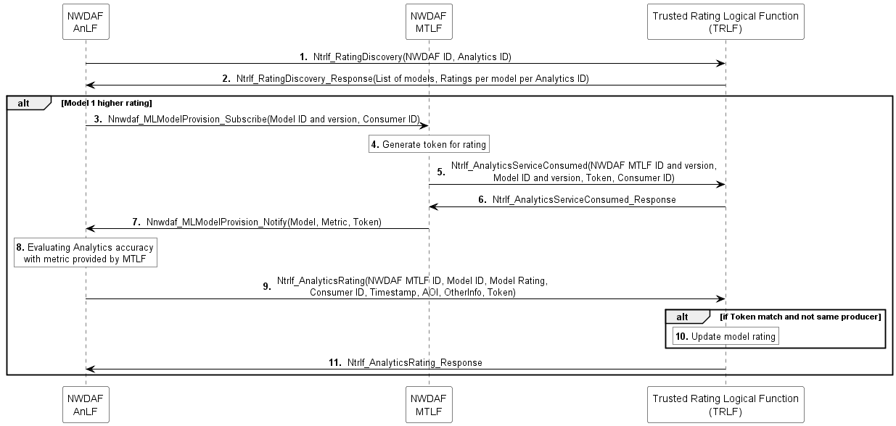
Figure 6.7.2.2-1. Procedure for NWDAF containing AnLF rating an NWDAF analytics provided by an NWDAF containing MTLF
1. The NWDAF containing AnLF requests, for the NWDAFs that support the Analytics ID for the desired AOI) the rating(s) of the employed ML model(s) from the Trusted Rating Logical Function (TRLF) through a Ntrlf_RatingDiscovery service. In the request, the NWDAF containing AnLF specifies the NWDAF(s) and the Analytics ID(s). The NWDAF containing AnLF sets the "rating aggregation level" request parameter according to its preferred value: "Global Average" to receive an aggregated model rating (i.e. a single value), "average per vendor" to receive a single average value for each vendor which issued a rating, or "detailed" in case it is interested to receive the rating from each service consumer which casted a rating.
2. The TRLF returns to the NWDAF containing AnLF the requested ratings per model ID and per analytics ID, according to the specified "rating aggregation level". Based on the "average per vendor" or "detailed" model rating, the analytics consumer can identify how ratings were casted by each vendor.
3. The NWDAF containing AnLF selects the NWDAF containing MTLF providing the required performance of the ML model for the specific use case and scenario. The NWDAF containing AnLF subscribes to ML model provisioning service to the selected NWDAF specifying also its Consumer ID comprising the NF (instance or Set) ID and Vendor ID.
4. The NWDAF containing MTLF generates a token that can be used by the NWDAF containing AnLF to rate the ML model.
5. The NWDAF sends through the Ntrlf_AnalyticsServiceConsumed service to the TRLF information about the Consumer ID, Model ID and version used for producing the analytics, its NWDAF ID and version and the token generated for the NWDAF containing AnLF.
6. The TRLF sends an acknowledgement to the NWDAF containing MTLF.
7. The NWDAF containing MTLF sends the subscription notification to the NWDAF containing AnLF along with the token generated.
8. The NWDAF containing AnLF evaluates the performance of the ML model utilizing the metric obtained by NRF during the discovery procedure.
9. The NWDAF containing AnLF through the Ntrlf_AnalyticsRating service sends its rating to the TRLF. The request also includes the Consumer ID of the NWDAF containing AnLF and the received token.
10. The TRLF, in case the token matches and the NWDAF containing AnLF is not the model producer, accepts and updates the rating. The TRLF stores the rating per Analytics ID and for each Consumer ID.
11. The TRLF sends to the NWDAF containing AnLF a confirmation regarding the update of the rating.

*** Change 2 – all new text ***

6.7.3 Impacts on services, entities and interfaces
This solution introduces the Trusted Rating Logical Function (TRLF), which exposes the following services:
- Ntrlf_RatingDiscovery service
- Ntrlf_AnalyticsServiceConsumed service
- Ntrlf_AnalyticsRating service
NRF
- Support for the metric parameter associated to the Analytics IDs and ML models in the Nnrf_discovery service
*** End of Changes ***

