3GPP TR 23.700-85 V0.2.0 (2022-04)
Technical Report

3rd Generation Partnership Project;
Technical Specification Group Services and System Aspects;
Study on enhancement of 5G User Equipment (UE) policy
(Release 18)
 | 
The present document has been developed within the 3rd Generation Partnership Project (3GPP TM) and may be further elaborated for the purposes of 3GPP.
The present document has not been subject to any approval process by the 3GPP Organizational Partners and shall not be implemented.
This Specification is provided for future development work within 3GPP only. The Organizational Partners accept no liability for any use of this Specification.
Specifications and Reports for implementation of the 3GPP TM system should be obtained via the 3GPP Organizational Partners' Publications Offices.

3GPP
Postal address

3GPP support office address
650 Route des Lucioles - Sophia Antipolis
Valbonne - FRANCE
Tel.: +33 4 92 94 42 00 Fax: +33 4 93 65 47 16
Internet
http://www.3gpp.org

Copyright Notification
No part may be reproduced except as authorized by written permission.
The copyright and the foregoing restriction extend to reproduction in all media.

© 2019, 3GPP Organizational Partners (ARIB, ATIS, CCSA, ETSI, TSDSI, TTA, TTC).
All rights reserved.

UMTS™ is a Trade Mark of ETSI registered for the benefit of its members
3GPP™ is a Trade Mark of ETSI registered for the benefit of its Members and of the 3GPP Organizational Partners
LTE™ is a Trade Mark of ETSI registered for the benefit of its Members and of the 3GPP Organizational Partners
GSM® and the GSM logo are registered and owned by the GSM Association

Contents
Foreword 6
1 Scope 8
2 References 8
3 Definitions of terms and abbreviations 9
3.1 Terms 9
3.2 Abbreviations 9
4 Architectural Assumptions and Principles 9
5 Key Issues 9
5.1 Key Issue #1: URSP in VPLMN 9
5.1.1 Description 9
5.2 Key Issue #2: 5GC awareness of URSP enforcement 9
5.2.1 Description 9
5.3 Key Issue #3: Provision consistent URSP to UE across 5GS and EPS 10
5.3.1 Description 10
5.4 Key Issue #4: Support standardized and operator-specific traffic categories in URSP 10
5.4.1 Description 10
5.X Key Issue #X: <Key Issue Title> 10
5.X.1 Description 10
6 Solutions 11
6.0 Mapping of Solutions to Key Issues 11
6.1 Solution #1: Usage of application guidance for URSP rules determination mechanisms 11
6.1.1 Description 11
6.1.2 Procedures 12
6.1.3 Impacts on Existing Nodes and Functionality 12
6.2 Solution #2: VPLMN influencing URSP rules in an HPLMN 12
6.2.1 Description 12
6.2.2 Procedures 13
6.2.2.1 VPLMN AF guidance for URSP rule creation at an HPLMN. 13
6.2.2.2 UE behaviour on applying a URSP rule with a PLMN validity condition in route selection descriptor 14
6.2.3 Impacts on services, entities and interfaces 15
6.3 Solution #3: URSP provisioning and updating in roaming 15
6.3.1 Description 15
6.3.2 UE Policy Association Establishment with VPLMN assistant information 15
6.3.3 UE Policy Association modification with VPLMN assistant information 16
6.3.4 Support routing of the same application traffic with different URSP rules in different PLMNs 17
6.3.5 Impacts on Existing Nodes and Functionality 17
6.4 Solution #4: URSP decision with V-PCF involvement 17
6.4.1 Description 17
6.4.2 Procedure 18
6.4.3 Impacts on services, entities and interfaces 18
6.5 Solution #5: URSP determination based on service parameter obtained from VPLMN 19
6.5.1 Description 19
6.5.2 Procedures 19
6.5.2.1 Procedure for URSP determination based on service parameter obtained from VPLMN 19
6.5.3 Impacts on services, entities and interfaces 21
6.6 Solution #6: Solution for URSP in VPLMN with PLMN domain indication 21
6.6.1 General 21
6.6.2 Functional descriptions 22
6.6.3 Procedures 22
6.6.4 Impacts on services, entities, and interfaces 22
6.7 Solution #7: URSP Compliance Verification 22
6.7.1 Description 22
6.7.2 Procedures 24
6.7.2.1 Provisioning of URSP Compliance Verification in Registration procedure 24
6.7.2.2 URSP Compliance Verification in PDU Session Establishment procedure 24
6.7.3 Impacts on services, entities and interfaces 26
6.8 Solution #8: PSI reporting for awareness of URSP enforcement 27
6.8.1 Description 27
6.8.2 Procedures 27
6.8.3 Impacts on services, entities and interfaces 28
6.9 Solution #9: Per-PDU session awareness of URSP enforcement 28
6.9.1 Description 28
6.9.2 Procedures 28
6.9.3 Impacts on services, entities and interfaces 30
6.11 Solution #11: 5GC awareness of URSP recognition by UE 32
6.11.1 Description 32
6.11.2 Procedures 33
6.11.3 Impacts on services, entities and interfaces 33
6.12 Solution #12: URSP rule enforcement validation via gating control 33
6.12.1 Description 33
6.12.2 Procedure 34
6.12.3 Impacts on existing Functions 35
6.13 Solution #13: URSP enforcement via PDU Session authorization/authentication when UE associating with application 36
6.13.1 Description 36
6.13.2 Procedures 37
6.13.3 Impacts on services, entities and interfaces 38
6.14 Solution #14: 5GC awareness of URSP rule evaluation and verification of network slice usage 38
6.14.1 Description 38
6.14.2 Procedures 39
6.14.3 Impacts on services, entities and interfaces 39
6.15.3 Impacts on services, entities and interfaces 41
6.16 Solution #16: URSPs into PCO for EPC 41
6.16.1 Description 41
6.16.1.1 Use cases and scenarios 41
6.16.1.2 Background: URSP provisioning to a UE in 5GS 42
6.16.1.3 How to provision URSP to a UE in EPC 42
6.16.2 Procedures 43
6.16.2.1 Initial Attach procedure in EPC 43
6.16.2.2 URSP update initiated by PCF 44
6.16.3 Impacts 45
6.17 Solution #17: Indication of applicability of URSP to UE in EPS 46
6.17.1 Description 46
6.17.2 Procedures 46
6.17.2.1 URSP provisioning with EPS applicability indication 46
6.17.2.2 Evaluation of URSP rules with EPS applicability indication 47
6.17.3 Impacts on services, entities and interfaces 47
6.18 Solution #18: Provisioning consistent URSP to UE across 5GS and EPS for Collocated PCF Deployment 48
6.18.1 Description 48
6.18.2 Procedures 48
6.18.2.1 UE triggered UE Policy provisioning procedure in EPS 48
6.18.2.2 PCF triggered UE Policy provisioning procedure in EPS 49
6.18.3 Impacts on services, entities and interfaces 49
6.19 Solution #19: Provision of URSP to UE when the UE attaches in the EPS 49
6.19.1 Introduction 49
6.19.2 Procedures 50
6.20 Solution #20: URSP delivery for the UE in EPS 51
6.20.1 Description 51
6.20.2 Procedures 53
6.20.2.1 UE Policy delivery procedure initiated by the UE in EPS 53
6.20.2.2 UE Policy delivery procedure initiated by the PCF 54
6.20.3 Impacts on services, entities and interfaces 54
6.21 Solution #21: Traffic Category with existing mechanism 55
6.21.1 Description 55
6.21.2 Procedures 56
6.21.3 Impacts on services, entities and interfaces 56
6.22 Solution #22: UE provisioned/configured with a mapping of application traffic to traffic categories 56
6.22.1 Description 56
6.22.2 Procedures 57
6.22.2.1 Association of application traffic to a Traffic Category 57
6.22.2.2 Enhancing URSP rule with a Traffic Category Traffic Descriptor 59
6.22.3 Impacts on services, entities and interfaces 60
6.23 Solution #23: Support standardized and operator-specific traffic categories in URSP 60
6.23.1 Description 60
6.23.2 Procedures 61
6.23.3 Impacts on services, entities and interfaces 61
6.25 Solution #25: Support standardized and operator-specific traffic categories in URSP 63
6.25.1 Description 63
6.25.2 Procedures 64
6.25.3 Impacts on Existing Nodes and Functionality 64
6.26 Solution #26: Traffic categories based on 5G QoS characteristics 64
6.26.1 Description 64
6.26.1.1 Traffic categories based on service type 64
6.26.1.2 Traffic categories based on Traffic characteristics 65
6.26.2 Procedures 66
6.26.3 Impacts on services, entities and interfaces 66
6.X Solution #X: <Solution Title> 66
6.X.1 Description 66
6.X.2 Procedures 66
6.X.3 Impacts on services, entities and interfaces 66
7 Overall Evaluation 66
8 Conclusions 67
Annex A: Change history 67

Foreword
This Technical Report has been produced by the 3rd Generation Partnership Project (3GPP).
The contents of the present document are subject to continuing work within the TSG and may change following formal TSG approval. Should the TSG modify the contents of the present document, it will be re-released by the TSG with an identifying change of release date and an increase in version number as follows:
Version x.y.z
where:
x the first digit:
1 presented to TSG for information;
2 presented to TSG for approval;
3 or greater indicates TSG approved document under change control.
y the second digit is incremented for all changes of substance, i.e. technical enhancements, corrections, updates, etc.
z the third digit is incremented when editorial only changes have been incorporated in the document.
In the present document, certain modal verbs have the following meanings:
shall indicates a mandatory requirement to do something
shall not indicates an interdiction (prohibition) to do something
NOTE 1: The constructions "shall" and "shall not" are confined to the context of normative provisions, and do not appear in Technical Reports.
NOTE 2: The constructions "must" and "must not" are not used as substitutes for "shall" and "shall not". Their use is avoided insofar as possible, and they are not used in a normative context except in a direct citation from an external, referenced, non-3GPP document, or so as to maintain continuity of style when extending or modifying the provisions of such a referenced document.
should indicates a recommendation to do something
should not indicates a recommendation not to do something
may indicates permission to do something
need not indicates permission not to do something
NOTE 3: The construction "may not" is ambiguous and is not used in normative elements. The unambiguous constructions "might not" or "shall not" are used instead, depending upon the meaning intended.
can indicates that something is possible
cannot indicates that something is impossible
NOTE 4: The constructions "can" and "cannot" shall not to be used as substitutes for "may" and "need not".
will indicates that something is certain or expected to happen as a result of action taken by an agency the behaviour of which is outside the scope of the present document
will not indicates that something is certain or expected not to happen as a result of action taken by an agency the behaviour of which is outside the scope of the present document
might indicates a likelihood that something will happen as a result of action taken by some agency the behaviour of which is outside the scope of the present document
might not indicates a likelihood that something will not happen as a result of action taken by some agency the behaviour of which is outside the scope of the present document
In addition:
is (or any other verb in the indicative mood) indicates a statement of fact
is not (or any other negative verb in the indicative mood) indicates a statement of fact
NOTE 5: The constructions "is" and "is not" do not indicate requirements.

1 Scope

This study focuses on key issue description, solution and conclusion on the enhancement of 5G UE Policy aspect by covering following objectives:
- URSP rule provisioning and updating procedures for home-routed and LBO roaming scenario, while keeping the existing framework of policy control based on HPLMN;
- Investigate whether and how the network can be made aware when the UE enforces URSP rule and investigate whether and what actions the 5G network can perform.
- Investigate if enhancements are needed for provisioning UE with consistent URSP across 5GC and EPC, and study the mechanism if needed.
- Investigate how to support standardized and operator-specific traffic categories in the traffic descriptor of URSP.

2 References
The following documents contain provisions which, through reference in this text, constitute provisions of the present document.
- References are either specific (identified by date of publication, edition number, version number, etc.) or non-specific.
- For a specific reference, subsequent revisions do not apply.
- For a non-specific reference, the latest version applies. In the case of a reference to a 3GPP document (including a GSM document), a non-specific reference implicitly refers to the latest version of that document in the same Release as the present document.
[1] 3GPP TR 21.905: "Vocabulary for 3GPP Specifications".
[2] 3GPP TS 23.501: "System Architecture for the 5G System; Stage 2".
[3] 3GPP TS 23.502: "Procedures for the 5G System (5GS); Stage 2".
[4] 3GPP TS 23.503: "Policy and charging control framework for the 5G System (5GS); Stage 2".
[5] 3GPP TS 23.548: "5G System Enhancements for Edge Computing; Stage 2".
[6] 3GPP TS 23.434: "Service Enabler Architecture Layer for Verticals (SEAL); Functional architecture and information flows".
[7] 3GPP TS 24.501: "Non-Access-Stratum (NAS) protocol for 5G System (5GS); Stage 3".
[8] 3GPP TS 23.401: "General Packet Radio Service (GPRS) enhancements for Evolved Universal Terrestrial Radio Access Network (E-UTRAN) access".
[9] 3GPP TS 29.525: "5G System; UE Policy Control Service; Stage 3".
[10] 3GPP TS 24.526: "User Equipment (UE) policies for 5G System (5GS); Stage 3".

3 Definitions of terms and abbreviations

3.1 Terms
For the purposes of the present document, the terms given in 3GPP TR 21.905 [1] and the following apply. A term defined in the present document takes precedence over the definition of the same term, if any, in 3GPP TR 21.905 [1].

3.2 Abbreviations
For the purposes of the present document, the abbreviations given in 3GPP TR 21.905 [1] and the following apply. An abbreviation defined in the present document takes precedence over the definition of the same abbreviation, if any, in 3GPP TR 21.905 [1].

4 Architectural Assumptions and Principles
Editor’s Note: This clause will document any architectural assumptions and principles.
Rel-15, Rel-16 and Rel-17 specified UE Policy mechanism in 23.501[2], 23.502[3] and 23.503[4] will be used as baseline for this study.
No new interface in EPC will be defined to solve the issue of consistent URSP provisioning.

5 Key Issues

5.1 Key Issue #1: URSP in VPLMN

5.1.1 Description
This Key Issue will study URSP rule provisioning and updating procedures in roaming scenario, while keeping backward compatibility with the existing framework of policy control based on HPLMN. In particular,
- Whether the HPLMN needs any information from the VPLMN to generate URSP Rules in roaming. If so, which information and how to provide it.
- How to provide URSP Rules in roaming to the UE. In particular, how the HPLMN and VPLMN are involved in such procedure.
- Whether and how to support URSP enhancements to support routing of the application traffic with different URSP rules in different PLMNs

5.2 Key Issue #2: 5GC awareness of URSP enforcement

5.2.1 Description
This key issue address WT#4: whether and how the network can be made aware when the UE enforces URSP rule for a traffic and investigate whether and what actions the 5G network can perform.
The following aspects will be studied:
- Whether and how the 5GC can be made aware whether or when the UE enforces a URSP rule to route an application traffic to a PDU Session based on the URSP rule provisioned by 5GC.
- Whether there are any actions the 5GS can take after 5GC is aware whether the UE enforces a URSP rule for specific application traffic or not. If any, what action 5GC should take?
NOTE: User privacy needs to be considered when defining solution (e.g. 5GC will know if a user started/stopped “any” application).

5.3 Key Issue #3: Provision consistent URSP to UE across 5GS and EPS

5.3.1 Description
The UE may use the route selection component (e.g., DNN) in a URSP rule in EPS, but when the URSP rule is updated at network side, there is no way to provision the URSP rule to UE in EPS based on current design. The different scenarios of provisioning the UE with URSP in EPS will be defined, according to the existing Rel-17 23.501 [2], 23.502 [3] and 23.503 [4] TSs and considered in order to configure the UE with consistent URSP across EPS and 5GS. This key issue is to study how to support provisioning of URSP to a UE that is consistent across 5GC and EPC, including:
- Identify the use cases and scenarios where the UE may need URSP that is consistent across 5GC and EPC.
- Study whether there are any issues and gaps in the existing URSP mapping mechanism described in TS 23.501 [2] clause 5.17.1.2, if so, identify them and propose solutions.
- Whether, when and how to provision the URSP to UE when served by the EPC and ANDSF is not deployed in the network. For the Rel-15 UEs not supporting the URSP mapping in EPS, whether the URSP updating/provisioning to such UEs in EPS should be supported.
NOTE: No new interface will be defined in EPC to solve this key issue.

5.4 Key Issue #4: Support standardized and operator-specific traffic categories in URSP

5.4.1 Description
Based on GSMA requirement (LS in S2-2105356), SA2 will investigate how to support traffic categories in the traffic descriptor of URSP. Following aspects will be considered:
- Definition of Traffic Category use cases and how to support both standardized traffic categories and MNO-specific traffic categories. If standardized values for traffic categories are defined, what are the various traffic categories that need to be standardized.
- Whether the existing URSP design can be used to support the traffic category. If not, how to support traffic category in the traffic descriptor of a URSP rule.
NOTE 1: Traffic categories should support mechanisms that enable the UE to uniquely identify and categorize the traffic generated by any active application in a consistent manner across UE implementations.
NOTE 2: 3GPP will coordinate with GSMA for the definition of traffic category, its use cases and the traffic categories GSMA may want to standardize.

5.X Key Issue #X: <Key Issue Title>

5.X.1 Description
Editor’s note: This clause provides a description of the key issue.

6 Solutions

6.0 Mapping of Solutions to Key Issues
Table 6.0-1: Mapping of Solutions to Key Issues
 | Key Issues
Solutions | 1 | 2 | 3 | 4
1 | X
2 | X
3 | X
4 | X
5 | X
6 | X
7 |  | X
8 |  | X
9 |  | X
10 |  | X
11 |  | X
12 |  | X
13 |  | X
14 |  | X
15 |  | X
16 |  |  | X
17 |  |  | X
18 |  |  | X
19 |  |  | X
20 |  |  | X
21 |  |  |  | X
22 |  |  |  | X
23 |  |  |  | X
24 |  |  |  | X
25 |  |  |  | X
26 |  |  |  | X

6.1 Solution #1: Usage of application guidance for URSP rules determination mechanisms

6.1.1 Description
Currently when a UE is served by a network other than its home operator (i.e. VPLMN) the serving network cannot influence the determination of URSP. It would be useful for the serving network to be able to influence the determination of URSP for example in LBO case where the VPLMN may support dedicated DNN(s) for Edge applications.
A solution is to leverage TS 23.548 [5] clause 6.6 "Support of AF Guidance to PCF Determination of Proper URSP Rules" and clause 4.15.6.10 of TS 23.502 [3] "Application guidance for URSP rules determination mechanisms" as defined for R17.
An AF from the VPLMN provides the VPLMN specific URSP information (e.g. DNN and S-NSSAI to be used for an application traffic etc.) (per 23.548 [5] § Support of AF Guidance to PCF Determination of Proper URSP Rules and clause 4.15.6.10 of TS 23.502 [3]"application guidance for URSP rules determination mechanisms"); this indication can be leveraged by the PCF of the HPLMN to (if authorized by HPLMN) provide dedicated URSP rules applicable to relevant users of the HPLMN when they are roaming in that VPLMN. These URSP may have a validity condition corresponding to the VPLMN. As part of the location validity condition the AF from VPLMN may provide the list of TA(s) or Cell Id(s) of the VPLMN.
The H-PCF may, based on local policies, determine whether to always send the URSP rules immediately to the UE or to send these rules only when the UE is served by the corresponding serving PLMN, e.g. waiting to be triggered from a V-PCF of that PLMN in step 3 of TS 23.502 [3] Clause 4.6.11.
Editor's Note: It is FFS whether a PLMN validity condition should be included in the URSP rule (e.g. in the RSD) or should the PLMN ID indication at the PSI level be used to identify for which PLMN the rule apply.
The PCF of the HPLMN when it sends such URSP update to a UE, needs, as for R17, to ensure that the DNN, S-NSSAI provided in the URSP rules sent to the UE is allowed in UDM subscription even when the UE is roaming in that VPLMN.
NOTE 1: This solution could also apply in FS_EDGE_Ph2.
NOTE 2: This solution is applicable only when HPLMN supports dynamic PCC and application guidance for URSP rules determination mechanisms.

6.1.2 Procedures
The solution reuses existing procedures.

6.1.3 Impacts on Existing Nodes and Functionality
- The VPLMN and the HPLMN as part of the roaming agreement need to ensure that the VPLMN AF can reach the NEF of the HPLMN to use the API defined in clause 4.15.6.10 of TS 23.502 [3] "Application guidance for URSP rules determination mechanisms"
- UDM to include the DNN, S-NSSAI of the VPLMN in the list of Subscribed S-NSSAIs and to allow the DNN, S-NSSAI to work in LBO mode in the user subscription.

6.2 Solution #2: VPLMN influencing URSP rules in an HPLMN

6.2.1 Description
Editor's note: This clause will describe the solution principles and architecture assumptions for corresponding key issue(s) which should be explicitly stated. Clause(s) may be added to capture details.
To support the objectives of KI#1 it is proposed to re-use the procedure defined in Release-17 on application guidance for URSP rule creation with the additional enhancement on allowing an Application Function in a VPLMN to influence URSP rules creation at an HPLMN. The AF in the visited PLMN provides the service information re-using the service specific information provisioning procedure described in 3GPP TS 23.502 [3] with the following addition:
- The AF includes an indication to apply this rule only when UEs register to a specific PLMN.
The trigger for the AF request could be due to:
- AF service provider of a VPLMN wishes to use specific DNN/S-NSSAI handling for roaming UEs
- A trigger by the Network Slices Capability Enablement Server defined in 3GPP TS 23.434 [6]. The NSCE server may be located in an AF. The NSCE server may receive from an NSCE client (located in a UE) a network/slice notification remapping for an application based on configuration provided by the NSCE server to the NSCE client in the UE.
The NEF stores the AF request information in the UDR in the “Application Data” field within the Service Specific Information Data Subset together with the assigned Transaction Reference ID (provided by the AF).
When the PCF receives the updated subscription information from the UDR the PCF derives updated URSP rules for a UE (or any UE) including in the URSP rule information indicating to the UEs to apply this URSP rules only when routing traffic via a specific PLMN. This is supported by enhancing the Route Selection Descriptor of the URSP rule including a PLMN identity. There are several options on how the RSD component can be enhanced:
- Option 1: New validation criteria in RSD
- Option 2: Use existing validation criteria i.e. the location criteria, where the location could be set to e.g. 3GPP location"={PLMN,location}
- Option 3: Include a new RSD parameter (i.e. not validation criteria) to identify the PLMN
If the UE determines an applicable URSP rule for detected application traffic then the UE considers the Route Selection Descriptor valid if the PLMN identity of the validity condition matches the PLMN identity of the registered PLMN. The new RSD component that include PLMN identity are set by the PCF as higher priority so that the UE evaluates the first.

6.2.2 Procedures
Editor's note: This clause describes high-level procedures and information flows for the solution.

6.2.2.1 VPLMN AF guidance for URSP rule creation at an HPLMN.
A call flow of the procedure is shown below.
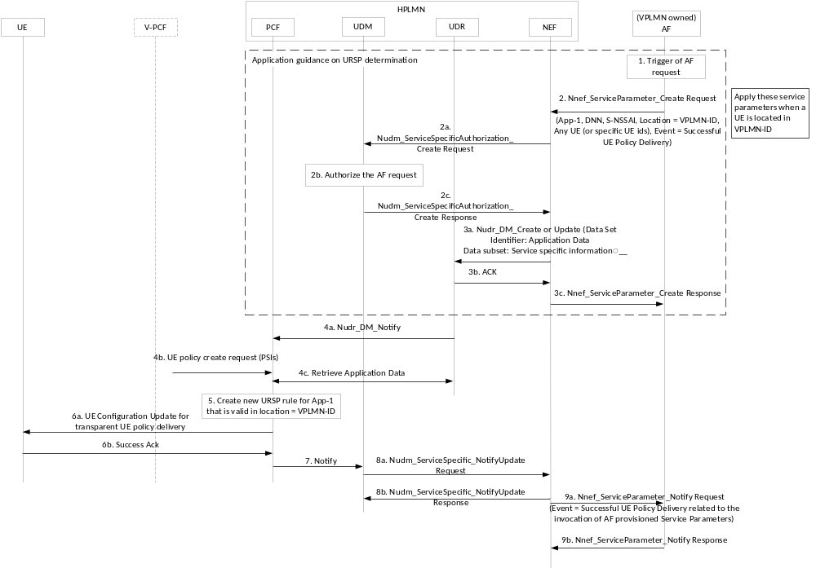
Figure 6.2.2.1-1: Procedure to influence URSP rules for a different PLMN
Steps are as follows:

1. AF in VPLMN is triggered to request to the home PLMN of a UE a specific handling of routing traffic to the VPLMN
2. The AF invokes a service operation with the NEF including in the request updated service information as described in 3GPP TS 23.502 [3] clause 4.15.6.10. The updated information includes a validity conditions to apply a URSP rule in a specific PLMN (or a list of PLMN). The request is applicable for any UE or the AF may include external identifiers of the UE.
Editor's Note: Since the allowed S-NSSAI in one PLMN can also apply to the equivalent PLMNs indicated in a TAI list in registration accept. When UE moves from one PLMN to another equivalent PLMN, the allowed S-NSSAI still need to be used. How to guarantee it in this solution is FFS.
2a-2c The NEF may authorize the request with the UDM as per 3GPP TS 23.502 [3]
3a When the authorization is successful the NEF updates the data in the UDR including within Application Data the updated service information. The NEF invokes an Nudr_DM_Create (or Update) service request requested the UDR to store the service information in the “Application Data” Data Set within the Service Specific Information Data Subset identifier. The NEF may also include a Data Key the target UEs or Group of UEs.
3b. The UDR acknowledges the NEF request.
3c. The NEF acknowledges the AF request
4a. If the PCF has subscribed to Service Specific Information the UDR notifies the PCF of the updated service information
4b. When a UE registers to the H-PLMN (or VPLMN) the UE includes a list of PSIs. The AMF (in HPLMN) or V-PCF (in VPLMN) initiates a UE Policy Association Create request with the PCF including in the request the list of PSIs associated to the HPLMN.
4c. The PCF may retrieve Application Data subscription information from the UDR
5. The PCF creates updated URSP rules including URSP rules with validity conditions on per PLMN basis according to the information stored in the UDR.
6. The PCF provides updated URSP rules to the UE by initiating a UE Configuration Update for transparent policy delivery (via the V-PCF if the UE is roaming) to deliver updated URSP rule to a UE.
6b. The UE acknowledges successful installation of rules
7. If the AF has subscribed to notification of successful policy delivery the PCF notifies the UDR
8a-8b The UDR informes the NEF of successful policy delivery
9a-9b. The NEF informs the AF of successful policy delivery

6.2.2.2 UE behaviour on applying a URSP rule with a PLMN validity condition in route selection descriptor
The UE upon reception of URSP rules including a PLMN validity conditions within Route Selection Descriptors enforces the URSP rules as follows:
- When the UE finds that application traffic matches traffic descriptor of a URSP rules the UE checks the list of Route Selection Descriptors of the matched URSP rule
- If an RSD in the list of RSDs contains PLMN validity conditions the UE checks if the PLMN identity within the validity conditions matches the PLMN identity of the registered PLMN or an equivalent PLMN of the registered PLMN.
- If there is match the UE considers the RSD valid and and routes the application traffic according to the contents of the route selection descriptor
- If there is no match the UE considers the RSD as invalid and continues to process a second RSD in the list of RSD of the matched URSP rules if available.

6.2.3 Impacts on services, entities and interfaces
Editor's note: This clause captures impacts on existing 3GPP nodes and functional elements.
- URSP rule is enhanced with a PLMN identity validity condition within Route Selection Descriptors

6.3 Solution #3: URSP provisioning and updating in roaming

6.3.1 Description
This is a solution related to the Key Issue #1 URSP in VPLMN.
Flexible scenarios deployed in VPLMN, e.g. flexible LADN deployment or MEC deployment, requires the URSP generation and updating to have the consideration of the policy information (including LADN DNN or AF located in VPLMN) in VPLMN dynamically. Furthermore, as it needs to keep the backward compatibility with the existing framework of policy control based on HPLMN, the aforementioned policy information in VPLMN needs to be provided to the HPLMN by VPLMN for UPSP generation and updating in roaming case. In this solution, it is proposed that the V-PCF provides the UE policy assistant information of VPLMN to the H-PCF and take the UE Policy Association Establishment/modification procedure as specified in clause 4.16.11 of TS23.502 [3] as basis for URSP provisioning and updating.

6.3.2 UE Policy Association Establishment with VPLMN assistant information
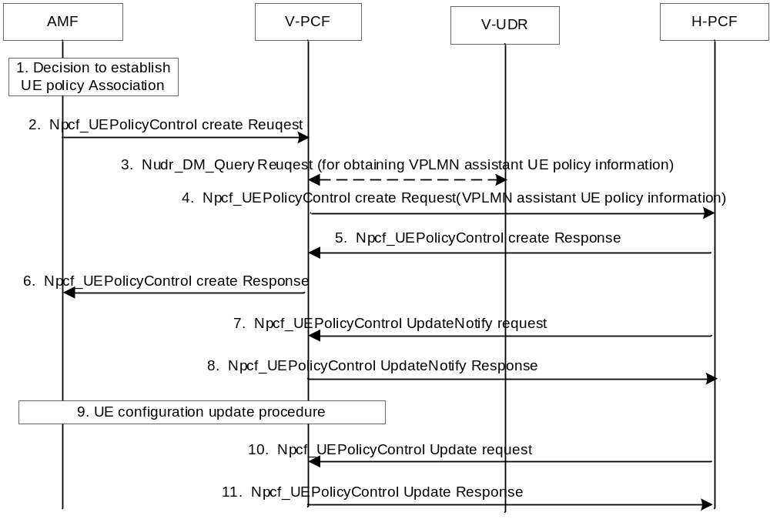
Figure 6.3.2-1: UE Policy Association Establishment with VPLMN assistant information
This procedure takes the UE Policy Association Establishment procedure in roaming case as specified in clause 4.16.11 of TS23.502 [3] as basis.
1. The AMF establishes UE Policy Association with the V-PCF same as step 1 in clause 4.16.11 of TS23.502 [3].
2. The AMF sends a Npcf_UEPolicyControl Create Request to V-PCF same as step 2 in clause 4.16.11 of TS23.502 [3].
3. After receiving the Npcf_UEPolicyControl Create Request from the AMF, the V-PCF gets the VPLMN assistant UE policy information based on local policy or get it from the V-UDR by using the Nudr_DM_Query service. The VPLMN assistant UE policy information is used for HPLMN to generate the UE policy taking the VPLMN requirement into account.
4. The V-PCF forwards the information received from AMF in step 2 and the VPLMN assistant UE policy information got in step 3 to the H-PCF. The VPLMN assistant UE policy information may include the following information:
- The mapping from traffic descriptor to DNN, NSSAI, SSC mode, PLMN ID, etc., in VPLMN.
5~6.Step5~6 same as step 4~5 are performed.
7. Similar to step 6 in clause 4.16.11 of TS 23.502 [3], the H-PCF gets policy subscription related information and the latest list of PSIs from the UDR using Nudr_DM_Query service operation. The H-PCF creates the UE policy based on the policy information from UDR and the VPLMN assistant UE policy information if any in step4, then provides the UE policy container in the Npcf_UEPolicyControl UpdateNotify Request to V-PCF.
8~11. The steps 8~11 are same as the step 7~10.

6.3.3 UE Policy Association modification with VPLMN assistant information
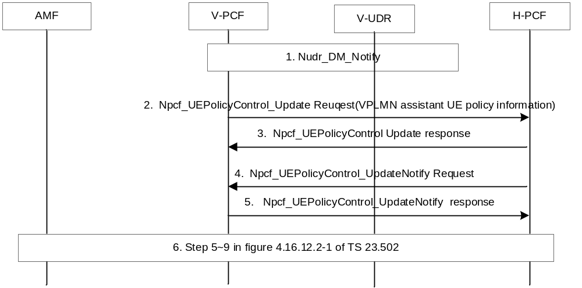
Figure 6.3.3-1: UE Policy Association modification with VPLMN assistant information
This procedure takes the UE Policy Association Modification initiated by the PCF procedure in roaming case as specified in clause 4.16.12.2 of TS23.502 [3] as basis.
1. If (V-)PCF subscribed to notification of VPLMN assistant information change and a change is detected, the V-UDR notifies V-PCF of that the VPLMN assistant information has been changed. Before performing this step, the V-PCF needs to subscribe the notification of VPLMN assistant information change from the V-UDR.
2. If the VPLMN assistant information changed according the step1 or based on local policy in V-PCF, the V-PCF forwards the VPLMN assistant information to the H-PCF via the Npcf_UEPolicyControl_Update request.
3. H-PCF responds to V-PCF.
4. The H-PCF may update the UE policy based on the VPLMN assistant UE policy information from V-PCF in step4, and send it to the V-PCF via the Npcf_UEpolicyControl_UpdateNotify request similar to the step3 of figure 4.16.12.2-1 of TS23.502 [3].
5. The V-PCF sends a response to H-PCF using Npcf_UEPolicyControl UpdateNotify Response.
6. The step6 is same to the step 5~9 of figure 4.16.12.2-1 of TS23.502 [3].

6.3.4 Support routing of the same application traffic with different URSP rules in different PLMNs
For support routing of the same application traffic with different URSP rules in different PLMNs, a potential way is to enhance the existing structure of URSP as specified in clause 6.6.2 of TS23.503 [4]. The Traffic descriptor in URSP can be enhanced to include:
- a new component "PLMN ID"
When to perform the URSP evaluation, for every newly detected application, the UE additionally enter a PLMN ID with the application data. This means that PLMN ID is also involved in URSP evaluation. The PLMN ID is the PLMN ID of its serving PLMN.

6.3.5 Impacts on Existing Nodes and Functionality
The solution has impacts on the following entities:
V-PCF:
- is able to request the VPLMN assistant UE policy information from the V-UDR.
- support the subscription of VPLMN assistant UE policy information change notification from the V-UDR.
UDR:
- support the notification of VPLMN assistant UE policy information change.
- support to provide the VPLMN assistant UE policy information to V-PVF.
H-PCF:
- support to create/update the UE policy combined with the VPLMN assistant UE policy information from the V-PCF.

6.4 Solution #4: URSP decision with V-PCF involvement

6.4.1 Description
The Solution addresses Key Issue #1 on URSP in VPLMN. This solution assumes the following:
- It is assumed that there are some applications which may be deployed in both VPLMN and HPLMN, or VPLMN only. In either scenario, the VPLMN may request to transport the corresponding application traffic with some specific DNN(s) and/or S-NSSAI(s).
- During the lifetime of UE Policy Association, the V-PCF is capable of generating URSP rules from VPLMN perspective, based on operator configuration or input from the AF. For example, the AF (e.g. gyms, museums) in VPLMN may request to distribute URSP rules to the UEs within a specific area, including the roaming UEs, thus the application traffic can be routed with corresponding DNN and/or S-NSSAI in the URSP rules.
- To avoid breaking the current framework of URSP decision by HPLMN, the V-PCF provides the generated URSP rules to the H-PCF for final decision, which contains the Route Selection Descriptor and Validation Criteria which indicates that the RSD is only applicable in the current VPLMN and its equivalent PLMN(s).
The enhancement is to add a new criteria as Applicable PLMN to the Route Selection Validation Criteria in the Route Selection Descriptor, as defined in the Table 6.6.2.1-3 of the TS 23.503 [4]:
Applicable PLMN | Indicates the applicable PLMN(s) in which the RSD can be adopted for URSP association. | Optional | Yes | UE context

6.4.2 Procedure
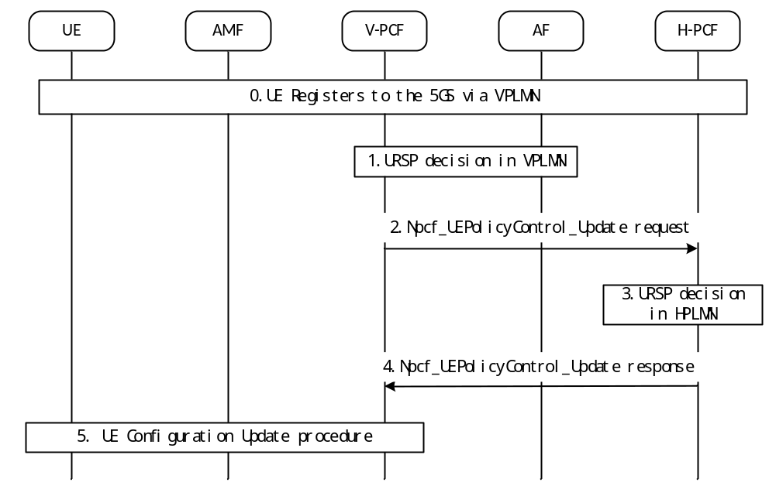
Figure 6.4.2-1 URSP decision with V-PCF involvement
- UE registers to the 5GC via the VPLMN.
- The V-PCF determines to generate URSP rules applicable to the UE based on local policies and/or AF/V-UDR interaction, to allow the UE access to the application using the values indicated by specific DNN, and/or S-NSSAI. Besides, the Route Selection Validation Criteria of the RSD contains the PLMN(s) in which the RSD is applicable, e.g. the VPLMN, the PLMN(s) equivalent to the VPLMN.
NOTE X: The S-NSSAI within the NSSP provided by the V-PCF is for the HPLMN, which is determined by the V-PCF based on local configuration or based on the mapping of VPLMN S-NSSAIs to HPLMN S-NSSAIs received from the AMF.
NOTE Y: The equivalent PLMN(s) of the VPLMN can be configured in the V-PCF or received from the AMF.
- The V-PCF provides the generated URSP rule(s) to the H-PCF for final decision via Npcf_UEPolicyControl_Update request message.
- Based on the subscription data and/or local policies, the H-PCF checks whether the received URSP rule(s) can be authorized for the UE, e.g. whether the S-NSSAI in the NSSP is allowed by the subscription NSSAI.
NOTE Z: It is up to the H-PCF implementation to determine the precedence of the URSP rules originated by the V-PCF.
- The H-PCF provides the authorized URSP rules to the V-PCF via Npcf_UEPolicyControl Update response message.
- The V-PCF triggers the UE policy delivery via UE configuration Update procedure.
After this procedure, the UE can associate the corresponding application to appropriate PDU Session based on the received URSP rules.

6.4.3 Impacts on services, entities and interfaces
The solution has impacts in the following entities:
UE:
- Needs to support the validation of Applicable PLMN list in RSD Validation Criteria.
V-PCF:
- Needs to support the generation of URSP rules applicable to VPLMN only and further provide the generated URSP rules to H-PCF for final decision.
H-PCF:
- Needs to perform final decision taking the generated URSP rules from V-PCF into account.

6.5 Solution #5: URSP determination based on service parameter obtained from VPLMN

6.5.1 Description
This is a solution for key issue #1 "URSP in VPLMN".
Currently, URSP is only controlled and determined by HPLMN. Therefore, to give influence on URSP determination, e.g., application guidance for URSP determination specified in clause 4.15.6.10 of TS 23.502 [3], the AF needs to provide inputs to HPLMN. The application guidance for URSP determination may be for Edge services or for location-based services which means there may be the case that the URSP rules determined based on the application guidance can be applied and valid only when the UEs are in any specific VPLMN in roaming case. Anyhow, in this case, the AF may need to provide application guidance for URSP determination to all PLMNs whose subscribers will be probably roaming into the VPLMN. In addition, if the AF includes a geographical area as spatial validity condition in the application guidance for URSP determination, the NEF may need to transform this information into 3GPP identifiers (e.g. TAI(s)). For this, the NEF needs to have knowledge on VPLMN's 3GPP identifiers (e.g. TAI(s)).
In this solution, the AF provides application guidance for URSP determination to the PLMN (i.e. to UDR via NEF of this PLMN) where the related services are provided or the related traffic is routed. H-PCF of the roaming UE obtains the application guidance for URSP determination from VPLMN by requesting V-PCF to subscribe to V-UDR to be notified about the data creation/modification for the UE. V-PCF subscribes to V-UDR on behalf of H-PCF. If the AF provides inputs to V-UDR via V-NEF, V-PCF provides the data notified by V-UDR to H-PCF.

6.5.2 Procedures

6.5.2.1 Procedure for URSP determination based on service parameter obtained from VPLMN
Figure 6.Y.2.1-1 shows the procedure for URSP determination based on service parameter obtained from VPLMN.
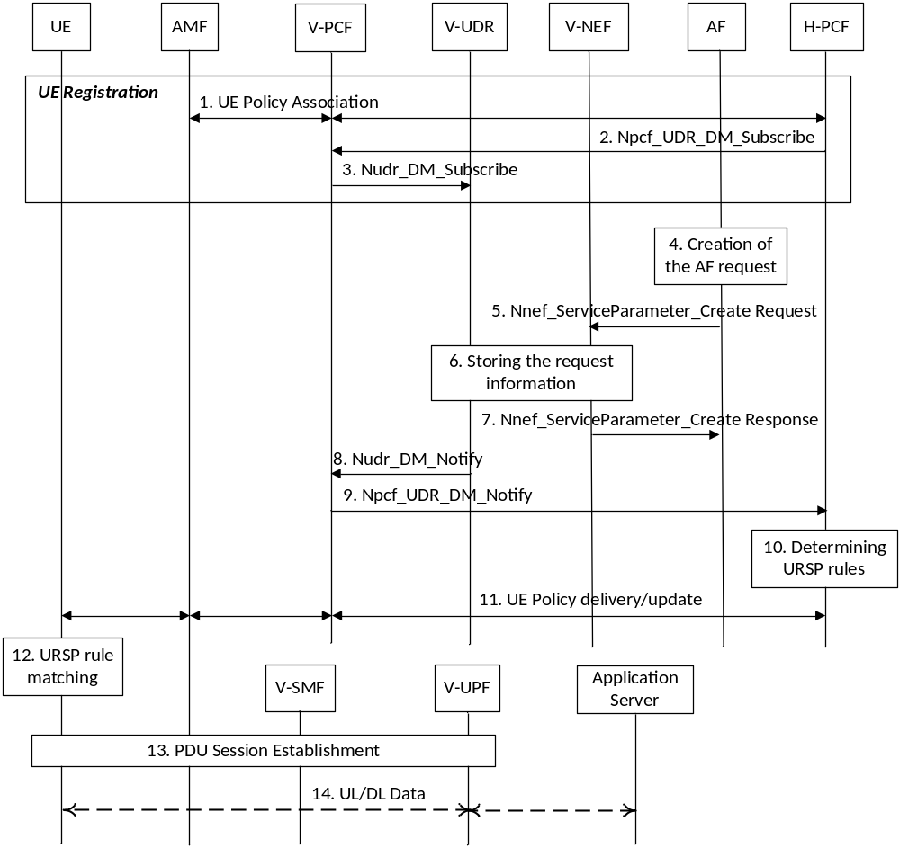
Figure 6.5.2.1-1: Procedure for URSP determination based on service parameter obtained from VPLMN
1. The UE is registered to 5GC and the UE Policy Association is performed between the AMF and the H-PCF via V-PCF.
2. The H-PCF requests V-PCF to subscribe to the V-UDR to be notified about the data creation/modification for the UE, i.e. service specific information by invoking Npcf_UDR_DM_Subscribe. The request includes DNN and S-NSSAI of the HPLMN.
3. Based on the request from the H-PCF, the V-PCF subscribes to the V-UDR to be notified about the data creation/modification for the UE by invoking Nudr_DM_Subscribe. The V-PCF includes VPLMN DNN and S-NSSAI mapped to the DNN and S-NSSAI of the HPLMN in the subscription request.
4. To provide Application guidance for URSP determination as specified in clause 4.15.6.10 of TS 23.502 [3], the AF creates a new request.
5-7. As specified in steps 2 to 4 in clause 4.15.6.7 of TS 23.502 [3], the AF sends its request to the NEF, and the NEF stores the AF request information in the UDR and responds to the AF. In this figure, the NEF is V-NEF and the UDR is V-UDR.
The AF request is targeting any UE (all UEs). Therefore, the V-NEF authorizes the request based on local policy (e.g. based on AF Id) without requesting for any service specific authorization from UDM as specified in clause 4.15.6.10 of TS 23.502 [3].
NOTE 1: The AF request targeting a specific UE or a group of UE(s) does not apply to this solution because Service Specific Authorization for an individual UE or group of UEs by NEF to UDM has to be performed for the AF request as specified in clause 4.15.6.10 of TS 23.502 [3].
8. The V-PCF receives a Nudr_DM_Notify notification of data change from the V-UDR.
The V-PCF replaces the DNN and S-NSSAI in the notification with the DNN and S-NSSAI of the HPLMN.
9. The V-PCF sends the notification of data change from the V-UDR to the H-PCF by invoking Npcf_UDR_DM_Notify.
NOTE 2: New PCF service operations, Npcf_UDR_DM_Subscribe/Npcf_UDR_DM_Notify are introduced in this proposal.
10. The H-PCF determines the URSP rules based on the data received from V-UDR via V-PCF.
That is, the H-PCF replaces any URSP rules related to Route Selection Descriptor(s) including the DNN and S-NSSAI.
Editor's note: It is FFS how the H-PCF provides the URSP rules of the HPLMN (i.e. the original one) to the UE when the UE comes back and registers to the HPLMN.
11. The H-PCF provisions the URSP rules to the UE via the V-PCF by using the UE Configuration Update procedure for transparent UE Policy delivery as specified in clause 4.2.4.3 of TS 23.502 [3].
12. The UE needs to send traffic, e.g. destined to an Edge service. Therefore, the UE determines a URSP rule applicable for the traffic.
13. If there is no PDU Session that matches all components in the selected RSD within the URSP rule, the UE establishes a PDU Session.
14. The UE communicates with the Application Server, e.g. Edge Application Server.

6.5.3 Impacts on services, entities and interfaces
H-PCF:
- requests V-PCF to subscribe to V-UDR to be notified about the data creation/modification for roaming UE.
- determines URSP rules based on the data provided by AF and received via V-UDR and V-PCF.
V-PCF:
- subscribe to V-UDR to be notified about the data creation/modification for roaming UE on behalf of H-PCF.
- provides the data notified by V-UDR to H-PCF.

6.6 Solution #6: Solution for URSP in VPLMN with PLMN domain indication

6.6.1 General
As specified in TS 23.503 [4], the URSP is only to be provided by the HPLMN. However, there are cases where different VPLMNs have different preference on the PDU session parameters for the same application. To support such differentiated URSP handling in different PLMNs, following enhancements are required:
- Enhance the URSP provision so that the URSP rules of a Policy Sections are provided with PLMN ID(s) associated.
Editor's Note: it is FFS how the PLMN IDs are signaled with the Policy Sections.
- Allowing the UE to utilize the URSP rules associated with the serving PLMN fist, and if no match is found, utilize the URSP of the HPLMN.

6.6.2 Functional descriptions
The VPLMN provides the URSP applicable to the UE to HPLMN. This may be triggered by the UE's registration in the VPLMN or happen before UE roam into the VPLMN. AF in VPLMN may use the service specific parameter procedure to influence HPLMN generating the URSP for VPLMN.
The HPLMN constructs the URSP for the UE, with different Policy Sections associated with the different PLMN IDs, e.g. Policy Section 1 associated with VPLMN-1, Policy Section 2 associated with VPLMN-2, and Policy Section 3 associated with HPLMN. The HPLMN ensures that the URSP rules associated with the VPLMN IDs only apply to the PDU session that supports LBO.
The UE is provisioned with the URSP rules following the existing procedure as defined in TS 24.501 [7]. The UE stores the URSP Policy Section associated with PLMN IDs.
When UE registered in the VPLMN, it locates the URSP Policy Sections associated with the VPLMN-ID and the Policy Sections associated with HPLMN-ID.
UE applies the URSP rules associated with the VPLMN ID first, if any. If there is a match, the UE follows the URSP rule to establish the PDU session.
If the UE could not find a match using the URSP rules associated with the VPLMN ID, it uses the URSP rules associated with the HPLMN ID.
The UE cannot use other URSP rules than those associated with the VPLMN ID or HPLMN IDs.
Editor's Note: It is FFS whether the HPLMN can provide PSIs applicable in the VPLMN and if so whether the VPLMN needs to authorize it.

6.6.3 Procedures
The existing procedures as defined in TS 24.501 [7] for UE Policy provisioning can be reused, besides the above enhancements.

6.6.4 Impacts on services, entities, and interfaces
Impacts on existing entities
UE needs to utilize URSP rules associated with the VPLMN before applying URSP rules associated with HPLMN.
Functions required at new entities
None.

6.7 Solution #7: URSP Compliance Verification

6.7.1 Description
This solution addresses the following technical issues of the KI#1:
- Whether and how the 5GC can be made aware whether or when the UE enforces a URSP rule to route an application traffic to a PDU Session based on the URSP rule provisioned by 5GC.
- Whether there are any actions the 5GS can take after 5GC is aware whether the UE enforces a URSP rule for specific application traffic or not. If any, what action 5GC should take?
In the current 5GC, there is no way to check whether the application traffic from the UE is compliant with the URSP.
The URSP is composed of Traffic Descriptor and Route Selection Component. The UE can associate application with the existing PDU Session or request a new PDU Session if no PDU Session matches the URSP rules when the application is detected. In this solution, we focus on the case when the UE requests a new PDU Session and discuss how the 5GC can know whether the requested PDU Session is compliant with the URSP.
In order to check whether the PDU Session Establishment request is compliant with URSP rule, the 5GC needs to identify the request is caused by which URSP rule. The PDU Session Establishment request can include RSC of the URSP rules, however, there is no information which URSP rule (i.e. Traffic Descriptor) matches.
Therefore, we introduce an identifier for the URSP Rule so that the PCF can identify which URSP rule causes the request of the PDU Session. If the UE includes the matched URSP Rule Identifier in the PDU Session Establishment request, the 5GC can be aware of the association between the URSP rules and the PDU Session so that 5GC can verify whether the UE is compliant with the URSP rules.
1. When constructing a URSP rule, URSP Rule Identifier (URID) is added to identify the URSP rule.
2. UE reports the URSP Rule Identifier associated with URSP rules causing a new PDU Session Establishment request by including the URID in the same request based on the PCF demand.
When the SMF is reported for the associated URID, it should be reported to the PCF responsible for the URSP (i.e. UE-PCF). Since the multiple SM-PCFs can be used for one UE, we assume UE-PCF and SM-PCF may not be the same and the UE-PCF is responsible for URSP compliance verification.
Since SMF may not have a direct interface to the UE-PCF, we use the reporting path from the SMF to the UE-PCF via SM-PCF in order for the SMF to report the URID and its received PDU Session Parameters (PSP).
If the 5GC identifies that the UE is not compliant to the URSP rule, the 5GC does not allow the UE to establish a new PDU Session based on its policy.
The abstract of this solution is depicted in the Figure 6.X.1-1.
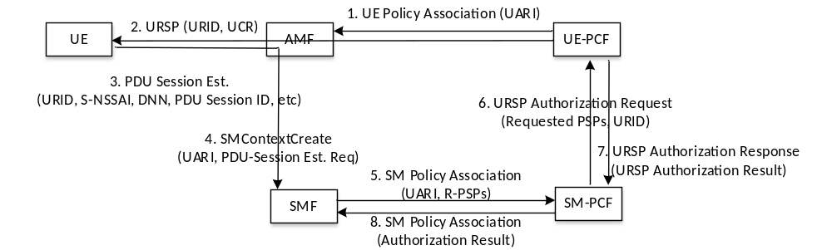
Figure 6.7.1-1. Authorization of URSP verified PDU Session using the UE reported URSP rule identifier
The UE-PCF is responsible for URSP compliance verification. The UE-PCF sends URSP Authorization Request Indication (UARI) to the AMF when the UE Policy Association is established or notified with the update.
If AMF receives UARI and PCF binding info, it stores the information and sends them to the SMF during the PDU Session Establishment procedure.
NOTE: This solution uses the existing feature that the AMF stores the PCF ID so that the SM-PCF can use it to contact the UE-PCF.
When the SMF establishes the SM Policy Association, the SMF forwards the UARI and Received PDU Session Parameters (R-PSPs) to the SM-PCF. If the SM-PCF receives the UARI request, it performs the URSP Authorization procedure with UE-PCF with the R-PSPs received from the SMF through SM-PCF and URID received from the UE.
The UE-PCF can request the UE to assist the URSP compliance by sending URSP Compliance Request (UCR) together with URSP rules with the UE Policy Container. The UCR indicates the UE to report the URSP Rule Identifier (URID) associated URSP rule that causes the establishment of the PDU Session. If the UE receives the UCR, the UE includes the URID in the PDU Session Establishment request when initiating a PDU Session caused by the URSP rule.
When the SMF is requested for UARI and receives the PDU Session Establishment Request, the SMF requests the authorization of the PDU Session from the UE-PCF through SM-PCF. The UE-PCF checks the R-PSP requested by the UE and the URID to verify whether the PDU Session Establishment request is compliant with the URSP rule.

6.7.2 Procedures

6.7.2.1 Provisioning of URSP Compliance Verification in Registration procedure
This procedure describes the provisioning of URSP Compliance Verification procedure during the UE registration procedure. With this procedure, the UE-PCF performs the following
- UE-PCF indicates the UE to report the URSP Rule Identifier associated with URSP rules causing a new PDU Session Establishment request by including the URID in the same request.
- UE-PCF provides PDU Session Parameter Reporting (PSPR) or URSP Authorization Request Indication (UARI) with PCF binding information to the AMF so that the AMF sends them to the SMF during the PDU Session Establishment procedure.
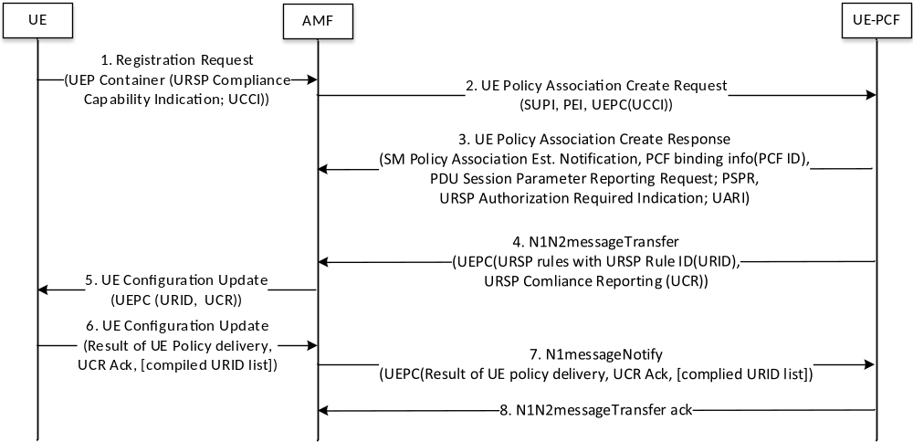
Figure 6.7.2-1: Provisioning of URSP Compliance Verification during Registration procedure
Step 1. The UE, that is compliant with URSP and supports the reporting URSP identifier, sends URSP Compliance Capability Indicator (UCCI) within the UE Policy Container during the registration procedure.
Step 2. The UE-PCF determines whether to perform the URSP compliance verification procedure (e.g. URSP compliant PDU Session Authorization or PDU Session Parameter Reporting).
Step 3. The UE-PCF sends PSPR (PDU Session Parameter Reporting Request) or URSP Authorization Required Indication (UARI) to the AMF. The AMF records the PCF binding info (PCF ID)
Step 4-5. The UE-PCF provides the URSP Compliance Reporting (UCR) and the URSP rules in UE Policy Container. When the UE-PCF constructing a URSP rule, URSP Rule Identifier (URID) is added to identify the URSP rule. The UE-PCF provides the URSP rules within which each URSP rule is identified by the URSP identifier.
Step 5. When the UE receives the UE Policy Container, the UE stores the URSP rules with URID and UCR.
Step 6. The UE sends the acknowledgement of UCR with the URID that the UE is compliant with them.
Step 7. The UE-PCF receives the UCR acknowledgement.

6.7.2.2 URSP Compliance Verification in PDU Session Establishment procedure
This procedure describes the URSP Compliance Verification during the PDU Session Establishment procedure
- Authorization of URSP compliant PDU Session Establishment with (or without) UE reporting URSP rule identifier. (UARI)
- Reporting of PDU Session Parameters with (or without UE) UE reporting URSP rule identifier (PSPR)
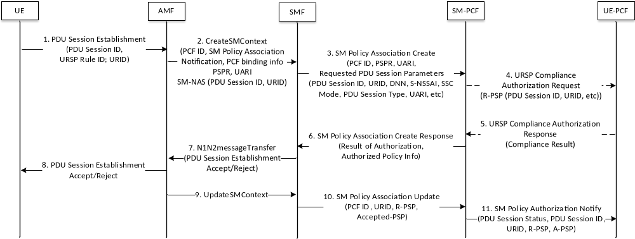
Figure 6.7.2.2-1. URSP Compliance Verification during PDU Session Establishment
Step 1. After the UE evaluates URSP rules, the UE detects an application that matches the URSP rule and determines to establishment a new PDU Session based on the URSP. If the UE receives the URSP Compliance Request (UCR) in the provisioning of URSP compliance verification during registration procedure (see the step 5 of Figure 6.X.2.1), the UE sends the PDU Session Establishment request including the URSP Rule Identifier (URID) associated with URSP rule causing the establishment of this PDU session.
Editor's note: User consent is needed for URID reporting and the detailed descriptions and procedures of user consent is FFS.
Step 2. The AMF forwards the PDU Session Establishment to the SMF. If the PSPR or UARI is requested from the UE-PCF, the AMF forwards the request to the SMF together with PCF binding info.
Step 3. UARI mode: The SMF sends Requested PDU Session Parameters (R-PSPs)
Editor’s Note: it is FFS whether the PDU Session Parameters included in the existing SM Policy Association is enough for the UE-PCF to verify the RSD. For example, the DNN, S-NSSAI are already included, but SSC mode is not included.
Step 4. If the UE-PCF has requested UARI (as in the step x of Figure 6.X.2.1), the SM-PCF sends the URSP Compliance Authorization Request to the UE-PCF.
Step 5. The UE-PCF verify whether the UE is compliant with the URSP rules by checking the requested PDU Session parameters with the URSP rules (RSDs) and authorises the UE requested PDU Session. The UE-PCF is able to reject the PDU Session if the UE-PCF determines that the request is not compliant with URSP rules.
Step 5. Once the UE-PCF authorises the URSP compliance, the UE-PCF sends URSP Compliance Authorization Response including the URSP compliance result.
Step 6. If URSP compliance result is successful, the SM-PCF sends the authorized policy information to the SMF. The SMF forwards the URSP compliance result.
Step 7. If the SMF is requested with UARI and the URSP Compliance Authorization Result is not successful, the SMF reject the PDU Session Establishment.
Step 8. The AMF forwards the PDU Session Establishment Accept/Reject to the UE
Step 9. The AMF updates the SM context.
Step 10. After the successful establishment of the PDU Session, if the SMF is indicated with the PSPR, the SMF reports the A-PSPs to the SM-PCF.
NOTE: The UE-PCF can stores the established PDU Session Parameters and later it can use them to verify whether the UE is compliant with selecting the PDU Session for the corresponding application or application traffic by using application detection feature.
Step 11. If the SM-PCF is requested with PSPR to the UE-PCF, the SM-PCF notifies the UE-PCF of the PDU Session Status, PDU Session ID and URID, A-PSP. The UE-PCF records A-PSP, PDU Session ID associated with the URSP Rule Identifier for verification of the URSP compliance.

6.7.3 Impacts on services, entities and interfaces
UE:
- The UE should understand the URSP Rule Identifier referring URSP Rules and be able to identify the URSP rule when initiating a PDU Session.
- The UE should be able to report the URSP Rule Identifier in the PDU Session Establishment Request.
- The UE should be able to report the complied URSP Rule Identifiers back to the UE-PCF
NOTE: Due to UE design philosophy, some of UE implementation may not support some of Traffic Descriptors in the URSP Rule. For those URSP rules, the UE may reply to the UE-PCF with sending the compiled URSP Rule Identifiers with UE policy delivery result.
AMF:
- The AMF should be able to receive the request (i.e. either URSP Compliance Authorization or PDU Session Parameter Reporting) and its related parameters from the UE-PCF during UE Policy Association procedure.
- When receiving PDU Session Establishment request from the UE, the AMF should forward the request from the UE-PCF to the SMF.
SMF:
- For URSP Compliance Authorization, the SMF should authorize the UE requested PDU Session based on the response from the SM-PCF after the UE-PCF authorizes the request via SM-PCF.
- For PDU Session Parameter Reporting, the SMF should report the requested and accepted PDU Session Parameters to the SM-PCF so that SM-PCF can report those to the UE-PCF.
SM-PCF:
- For USSP Compliance Authorization, during the SM Policy Association procedure caused by the PDU Session Establishment, the SM-PCF performs the URSP compliance authorization with UE-PCF.
- For PDU Session Parameter Reporting, after the PDU Session Establishment procedure, the SM-PCF reports the UE requested and accepted PDU Session Parameters to the UE-PCF.
UE-PCF:
- The UE-PCF is responsible for URSP compliance verification. The UE-PCF should be able to support 1) URSP Compliance Reporting 2) URSP Compliance Authorization 3) PDU Session Parameter Reporting.
- For URSP Compliance Reporting (UCR request) to the UE, the UE-PCF generates the URSP rules with URSP Rule Identifier and request the UE to report the URSP Rule Identifier.
- For URSP Compliance Authorization (UARI), the UE-PCF should be able to authorize the UE-requested PDU Session by checking whether the PDU Session Parameters of the request is compliant to the RSD’s of URSP rules.
For PDU Session Parameter Reporting (PSPR), the UE-PCF should be able to request the SMF to report the PDU Session Parameters of the request.

6.8 Solution #8: PSI reporting for awareness of URSP enforcement

6.8.1 Description
This solution aims to address the Key Issue#2: 5GC awareness of URSP enforcement.
The URSP rules sent to the UE are contained in a Policy Section identified by a PSI (Policy Section Identifier), and each Policy Section may include multiple URSP rules. For 5GC awareness of URSP enforcement, this solution proposes to use the parameter of Rule Precedence to identify a specific URSP rule within a Policy Section.
Editor's note: User consent is needed for URSP enforcement reporting and the detailed descriptions and procedures of user consent is FFS.
The UE can indicate to the network the URSP rule it is trying to enforce by reporting the combination of PSI + Rule Precedence. When an existing PDU session matches the RSD of selected URSP, or when the UE tries to establish a new PDU Session using the values specified by the selected RSD, the URSP enforcement reporting process can be done during a session management procedures such as PDU Session Establishment procedure or PDU Session Modification procedure.

6.8.2 Procedures
As described in TS 23.503 [4], for every newly detected application the UE evaluates the URSP rules in the order of Rule Precedence and determines if the application is matching the Traffic descriptor of any URSP rule. When a valid Route Selection Descriptor is found, the UE determines if there is an existing PDU Session that matches all components in the selected Route Selection Descriptor.
If one or more matching PDU Session(s) exist(s), the UE associates the application to one existing PDU Session and initiates PDU Session Modification procedure for URSP enforcement reporting as described in clause 4.3.3.2 TS 23.502 [3]. Following impacts are applicable:
- Step 1a: The UE includes UE Policy Container (the combination of PSI + Rule Precedence corresponding to the URSP rule enforced by the UE, and the operating system identifier) in PDU Session Modification Request message. The AMF transfers the message transparently to the SMF via Nsmf_PDUSession_UpdateSMContext message.
- After receiving UE Policy Container in the PDU Session Modification Request message, the SMF notifies the PCF the combination of PSI + Rule Precedence reported by the UE.
Editor's note: Whether existing Npcf services (e.g. Npcf_UEPolicyControl service or Npcf_SMPolicyControl service) can be reused for URSP enforcement reporting is FFS.
NOTE 1: It is assumed that same PCF is selected by the SMF and the AMF.
Editor's note: What further actions will be taken by the network after URSP enforcement reporting is FFS.
If none of the existing PDU Sessions matches the selected Route Selection Descriptor, the UE tries to establish a new PDU Session as described in clause 4.3.2.2.1 TS 23.502 [3] using the values specified by the selected RSD. Following impacts are applicable for URSP enforcement reporting:
- Step 1: The UE includes UE Policy Container (the combination of PSI + Rule Precedence corresponding to the URSP enforced by the UE, and the operating system identifier) in PDU Session Establishment Request message.
- Step 3: The AMF transfers the PDU Session Establishment Request (UE Policy Container (the combination of PSI + Rule Precedence corresponding to the URSP rule enforced by the UE, and the operating system identifier)) to the SMF by Nsmf_PDUSession_CreateSMContext Request message.
- After receiving UE Policy Container in the PDU Session Establishment Request message, the SMF notifies the PCF the combination of PSI + Rule Precedence reported by the UE.
Editor's note: Whether existing Npcf services (e.g. Npcf_UEPolicyControl service or Npcf_SMPolicyControl service) can be reused for URSP enforcement reporting is FFS.
Editor's note: What further actions will be taken by the network after URSP enforcement reporting is FFS.

6.8.3 Impacts on services, entities and interfaces
UE:
- Initiates PDU Session Modification procedure when matching PDU Session is found for a URSP rule, and includes UE Policy Container (the combination of PSI + Rule Precedence corresponding to the URSP enforced by the UE, and the operating system identifier) in PDU Session Modification Request message.
- During the new PDU Session Establishment procedure when none of the existing PDU Sessions matches the selected Route Selection Descriptor, includes UE Policy Container (the combination of PSI + Rule Precedence corresponding to the URSP enforced by the UE, and the operating system identifier) in PDU Session Establishment Request message.
SMF:
- Forwards the combination of PSI + Rule Precedence reported by the UE to the PCF.

6.9 Solution #9: Per-PDU session awareness of URSP enforcement

6.9.1 Description
Editor's note: This clause will describe the solution principles and architecture assumptions for corresponding key issue(s) which should be explicitly stated. Clause(s) may be added to capture details.
The solution relies on the PCF to identify if a UE routes traffic correctly when the UE establishes a PDU session for an S-NSSAI/DNN/RAT type that matches a Route Selection Descriptor of a URSP rule that was provisioned to the UE.
The PCF determines to identify if the UE routes traffic correctly to the UE requested PDU session based on local configuration or based on information provided by the UDR. In such scenario, the PCF determines the applicable URSP rule that triggered the UE to request establishment of a PDU session to a specific S-NSSAI/DNN by obtaining the list of PSIs containing the provisioned URSP rules to the UE from the UDR. The PCF then identifies the traffic allowed to the requested S-NSSAI/DNN by identifying URSP rule(s) that have within a Route Selection Descriptor, components that matches the requested S-NSSAI/DNN and then evaluating the Traffic Descriptor of such URSP rule(s). For example, if the Traffic Descriptor includes a Destination Address IP 3 tuple then the PCF considers allowed traffic any traffic sent to or received via the Destination Address.
Editor's Note: Futher parameters provided by the UE to assist the PCF to determine the URSP rule are FFS
Editor's Note: Whether this solution is applicable when a UE establishes a PDU session based on a match-all rule is FFS
When the PCF is triggered to identify if the UE routes traffic to an S-NSSAI/DNN according to a provisoned URSP rule the PCF provides rules to the SMF to report traffic that is not intended to be routed via the PDU session.Further details are provided below.

6.9.2 Procedures
Editor's note: This clause describes high-level procedures and information flows for the solution.
The procedure is shown below:

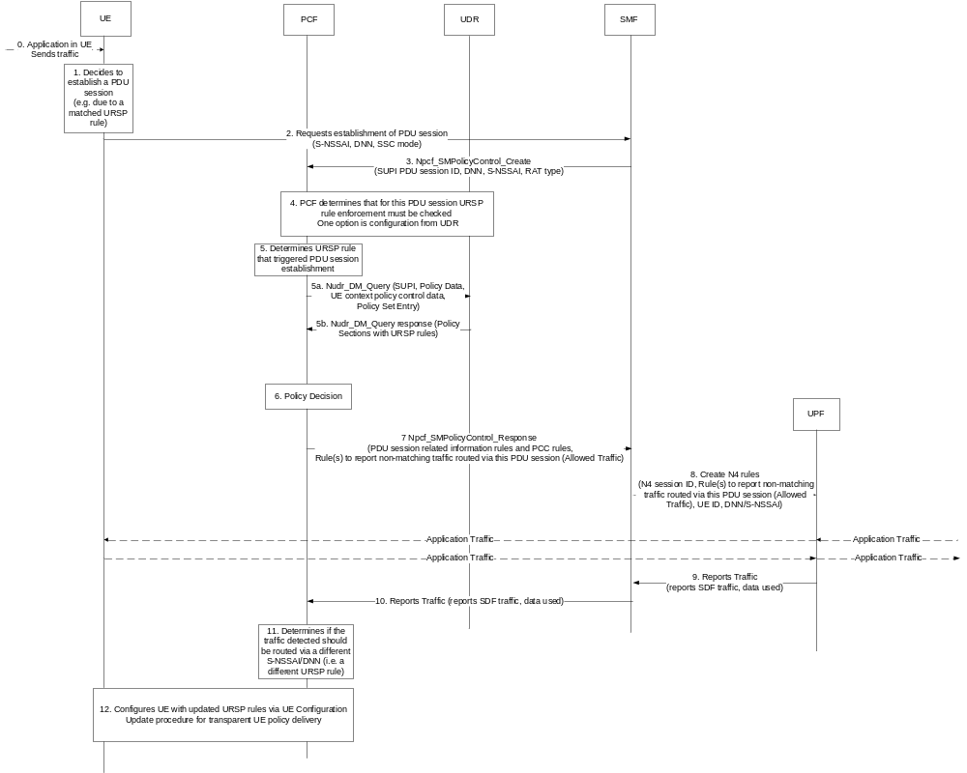
Figure 6.9.2-1: PCF requests to identify from UPF if UE enforces URSP rules correctly
The procedure is as follows:
0. An application in the UE sends traffic or request a network connection
1. The UE detects new application traffic and determines that application traffic needs to be routed via a PDU session of a specific DNN, S-NSSAI, RAT type. The determination may be based due to a configured URSP rule, local configuration or application request.
2. The UE requests establishment of a PDU session using specific S-NSSAI, DNN, SSC mode.
3. The SMF selects a PCF and requests policies by establishing an SM Policy Association. The SMF sends an Npcf_SM_PolicyControl_Create including the SUPI, PDU session ID, DNN, S-NSSAI requested and RAT type of the access that the UE requested establishment of a PDU session.
4. The PCF determines to check for the UE requested PDU session if the UE routes traffic according to a provisioned URSP rule
5. The PCF determines the potential URSP rule and the corresponding Traffic Descriptor of the URSP rule that triggered the UE to request establishment of a PDU session to a specific S-NSSAI/DNN
5a. The PCF obtains the URSP rule by interfacing with the UDR to obtain the policy sections of URSP rules provisioned to the UE.
5b. The UDR provides the policy sections of the URSP rule
6. The PCF makes policy decisions according to UE subscription
7. The PCF provides PDU session related information rules and PCC rules in an Npcf_SMPolicyCreate_Response. The PCF also includes rules to the SMF to report non-matching traffic (i.e. traffic different to the allowed traffic) via the S-NSSAI, DNN. The PCF includes the Allowed Traffic that can be routed via the PDU session
NOTE: The PCF may provide rule at a later stage by invoking an Npcf_SMPolicyModication request.
8. SMF based on the PCC rules installs N4 rules at the UPF. SMF includes rules to the UPF to report non-matching traffic via the S-NSSAI, DNN and includes also the allowed traffic
9. When the UPF detects non-matching traffic the UPF reports the traffic to the SMF. The UPF includes the service data flow information of the non-matching traffic detected.
10. The SMF reports the detected information to the PCF
11. The PCF determines if the traffic reported should be sent via a different S-NSSAI or whether traffic should be blocked. The PCF may install rules to the SMF to block such traffic or determine new URSP rules to route traffic via a different S-NSSAI
12. The PCF provides updated URSP rules to the UE using the UE Configuration Update for transparent policy delivery.

6.9.3 Impacts on services, entities and interfaces
Editor's note: This clause captures impacts on existing 3GPP nodes and functional elements.
- UPF report SDFs that do not match to allowed traffic

6.10 Solution #10: Network based URSP rules enforcement feedback

6.10.1 Description
The UE uses URSP rules to apply the application traffic to PDU sessions in UE. But, for some of the situation, the 5GC wants to aware of the enforcement of URSP rules in UE.
One of the solutions is, according to the URSP rules, the UPF sets the PDR in specific UE’s PDU session. If the specific application packets are detected by PDR, it means the application traffic is applied to this PDU session, and the parameters of this PDU session can be used to reverse to determine the RSD. Which RSDs contains the PDU session parameters, is the real URSP rules that used in UE for this application traffic.
If PCF wants to monitor some of the enforcement of the RSD in specific Traffic Descriptor, the PCF provides the Traffic Descriptor which describes the traffic feature to SMF to construct the PDR.
In PDR, the packet filter set is the main parameters for UPF to detect. And in the Traffic Descriptor in URSP rules, the IP descriptor can be directly used for the construction of PDR, that the IP descriptor describes the destination IP address. But for other kinds of Traffic Descriptor, for example, the Application Descriptor, DNN, Domain Descriptor or Connection Capabilities, that these parameters can’t be directly used for construction of PDR.
Although some of the Traffic Descriptor in URSP rules doesn’t provide the 5-IP-tuple, but finally, the application traffic should be routed to a specific application server which is represented as IP address and port number. So, it means the Traffic Descriptor in UE only has the function of applying application traffic to specific PDU session, but there still has a mapping table between Traffic Descriptor and destination IP address.
So, after applying the application traffic to a PDU session, the SMF should set the destination IP address of this application traffic in UPF. The SMF should maintain a mapping table between non-IP related Traffic Descriptor and 3-IP-tuple.
For example:
- If the application traffic is applied to a PDU session by Traffic Descriptor = ABC.com (FQDN), the SMF should have a mapping table between ABC.com and the destination IP address of this application traffic, for example, ABC.com (FQDN) is equal to 100.1.1.1;
- If the application traffic is applied to a PDU session by Traffic Descriptor = APP1 (Application Descriptor), the SMF should have a mapping table between APP1 and the destination IP address of this application traffic, for example, APP1 is equal to 192.168.1.1

6.10.2 Procedure
The details of the procedure of network based URSP rules enforcement feedback is in Figure 6.X.2-1.
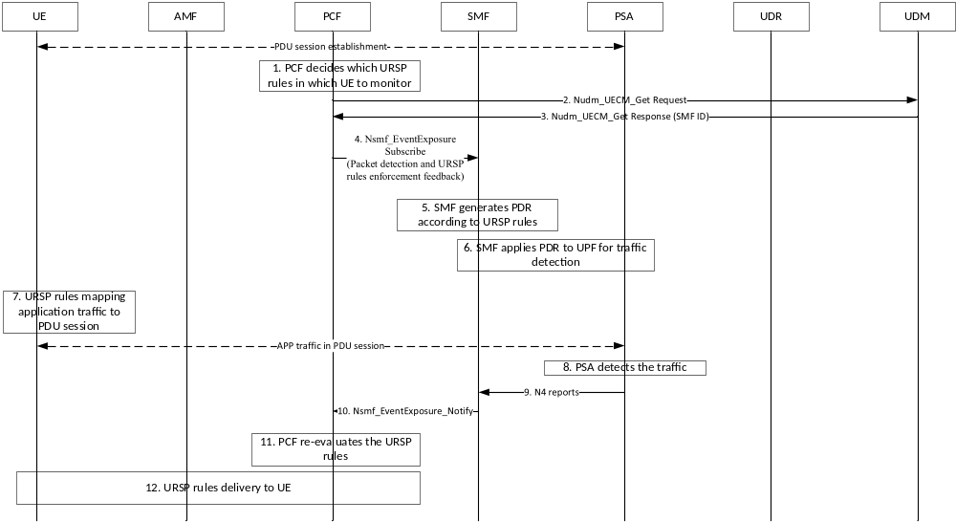
Figure 6.10.2-1: Network based URSP rules enforcement feedback
1. The PCF determines to monitor the URSP rules enforcement in UE.
2. The PCF finds the SMF serving the UE for this SUPI using Nudm_UECM_Get_Request including SUPI, type of requested information set to SMF Registration Info and the S-NSSAI and DNN, as defined in clause 5.3.2.5.7 in TS 29.503 [4].
3. The UDM provides the SMF id and the corresponding PDU Session id, S-NSSAI, DNN using
4. The PCF subscribes the service in SMF for packet detection. The PCF provides the monitored Traffic Descriptor to SMF via Nsmf_EventExposure_Subscribe. The PCF will be notified with the PDU session parameters that the application traffic applied to.
5. The SMF receives the parameters of Traffic Descriptor from PCF and generate the PDR. And the SMF should derive the IP descriptor which the Traffic Descriptor corresponds to.
And in the Traffic Descriptor, the IP descriptor can be directly used for the construction of PDR, that the IP descriptor describes the destination IP address. If for other kinds of Traffic Descriptor, for example, the Application Descriptor, DNN, Domain Descriptor or Connection Capabilities, the SMF derives the 3-IP-tuple which the Application Descriptor, DNN, Domain Descriptor or Connection Capabilities corresponds to by the maintained mapping table between non-IP related Traffic Descriptor and 3-IP-tuple.
6. The SMF applies the PDR to the UPF that serves the UE via N4 session procedure.
7. In UE, an application traffic is mapped to a PDU session by the monitored URSP rules.
8. The UPF detects the application traffic by PDR in a PDU session.
9. The UPF reports the PDU session information, which the application traffic applied to, to SMF, including the PDU session information, including PDU session id, SSC mode, DNN, access type, S-NSSAI and etc, by N4 reporting procedure. The PDU session information is used to verify the which RSDs are enforced in the Traffic Descriptor in URSP rules.
10. The SMF reports the PDU session information, which the application traffic applied to, to PCF, including the PDU session id, SSC mode, DNN, access type, S-NSSAI and etc by Nsmf_EventExposure_Notify.
11. The PCF verify which RSDs are enforced in the Traffic Descriptor in URSP rules according to PDU session information. And PCF determines the enforcement of UE’s URSP rules at this step. If no RSDs are matched to the PDU session information, it means the UE doesn’t use the URSP rules correctly.
The PCF should re-evaluate the URSP rules to this UE and update the URSP rules in UE, if the URSP rules are not enforced correctly. For example, adjust the precedence of Traffic Descriptor or RSD, update the RSDs in Traffic Descriptor, add or remove the Traffic Descriptor and RSDs and etc.
12. The PCF updates the re-evaluated URSP rules to UE, according to the step from step 5 to step 9 described in section 4.16.12.2 of TS 23.502 [3].

6.10.5 Impacts on services, entities and interfaces
Editor's note: This clause lists impacts to services and interfaces.
PCF:
- Decides the monitored URSP rules, and provides the parameters in Traffic Descriptor to SMF to generate PDR.
- Subscribe the packet detection results from SMF to verify the URSP rules enforcement in UE.
- Re-evaluates the URSP rules to the UE and update the URSP rules in UE, if the URSP rules are not enforced correctly according to the notification from SMF.
SMF:
- Transition of the Application Descriptor, DNN, Domain Descriptor or Connection Capabilities in Traffic Descriptor to IP descriptor to construct 3-IP-tuple in PDR.
- Receives the monitored Traffic Descriptor which is included in the monitored URSP rules from PCF .
- Provide the traffic detection results to PCF.

6.11 Solution #11: 5GC awareness of URSP recognition by UE

6.11.1 Description
Currently the UCU procedure is used to provision UE policy (including URSP policy) to UE. However, the result in the UCU Response message only indicates whether the UE supports the type of UE policy per Policy Section.
Meanwhile, if UE supports URSP but not support a URSP rule (e.g. due to not recognize the TD parameter in a URSP rule), the UE will ignore(skip) the URSP rule without any notification to network side. This implicit ignoring will incur the 5GC is unable to realize whether the specific Application traffic will be associated to the expected slice as described in an RSD of a URSP rule.
Therefore, it is proposed to use the result in UCU response to indicate if and which URSP rule is not recognized/supported by UE.

6.11.2 Procedures
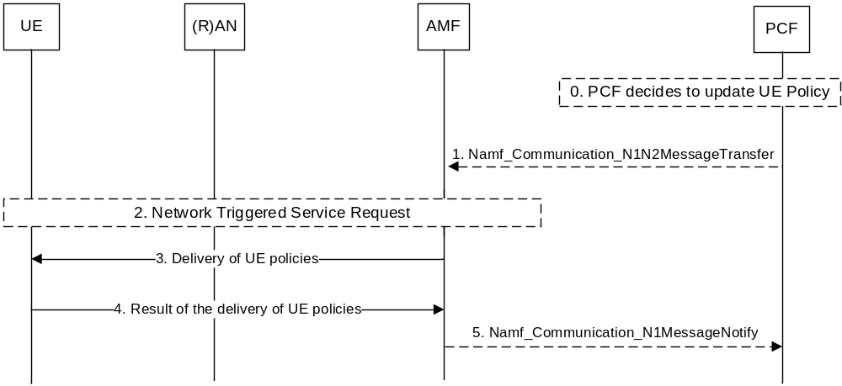
Figure 6.11.2-1 Result of the delivery of UE policies indicate if and which URSP rule is supported by UE

The procedure above is the same as the UCU procedure in clause 4.2.4.3 in TS 23.502 [3], with the extension that
- When receiving the UE policies in step-3, the UE will evaluate the each URSP rule in the URSP, and identify which URSP rule is not recognized (not supported) by UE.
- The UE indicate the additional information in the result in step-4: whether and which URSP rule is not recognized (not supported) by the UE
NOTE: the Traffic Descriptor can be used to indicate a specific URSP rule
Based on the feedback from UE, the PCF may update the parameters (e.g. if some parameters in TD are wrongly configured) and provision the updated URSP to UE again. But whether and how to determine the URSP based on the feedback is per implementation specific.

6.11.3 Impacts on services, entities and interfaces
UE:
- Check the URSP rules when it is provisioned in “Delivery of UE policies” message; and
- Provide feedback about which URSP Rule/RSD cannot be recognized in the UE policy container conveyed in “Result of the delivery of UE policies” message

6.12 Solution #12: URSP rule enforcement validation via gating control

6.12.1 Description
This solution addresses Key Issue #2 on validation of URSP rule enforcement.
For newly detected application, the UE is required to evaluate the URSP rules and associate the application to a specific PDU Session, by initiating PDU Session Establishment procedure or PDU Session Modification procedure, depending on whether existing PDU session can be reused or not.
While, the core network is not aware of which URSP rule is matched in the UE, not to mention what the detected application is. As the URSP rule is only known to the core network at PSI granularity.
To resolve the validation of URSP rule enforcement, URSP rule ID is introduced to uniquely identify the URSP rule sent to a UE. When the PCF provides URSP rules to the UE, a rule ID is allocated for each URSP rule and sent to the UE together with the URSP rules, apart from the PSI. When the UE initiates a PDU Session Establishment/Modification request, the UE indicates the URSP rule ID it uses for the request to the network, the network is able to know which URSP rule is enforced by the UE for the request. Further the PCF for the PDU Session when receiving the URSP rule ID transferred by the SMF can retrieve the content of the URSP rule identified by the rule ID from the PCF for the UE or the UDR, and then check if the requested S-NSSAI and DNN requested by the UE matches with the components of the Route Selection Descriptors of the URSP rule, and generate the policy for the session management e.g. allow the application traffic identified by the corresponding Traffic descriptor of the URSP rule, to be transferred via the PDU Session.
The enhancement is to add a Rule Identifier to URSP rule as defined in the Table 6.6.2.1-2 of the TS 23.503 [4]:
Rule Identifier | Uniquely identifies the URSP rule, within the UE.  It is used between PCF and UE for referencing URSP rules. | Conditional | Yes | UE Context

When detecting there is an unmatched application in the PDU Session, the PCF for the PDU Session may notify the PCF for the UE and the PCF for the UE may decide to update the URSP in the UE.
NOTE X: The UE may use wrong URSP since the URSP in UE is not updated in time.
Editor’s note: it is FFS whether the URSP rule identifier is mandatory.
Editor's note: User consent is needed for URSP rule ID reporting and the detailed descriptions and procedures of user consent is FFS.

6.12.2 Procedure
When the UE triggers the PDU Session Establishment procedure or PDU Session Modification Procedure, the rule identifier of the matched URSP rule will be provided to the SMF, and then further provided by the SMF to the PCF for validation of the enforcement of the corresponding URSP rule and generate corresponding policy for the session management.
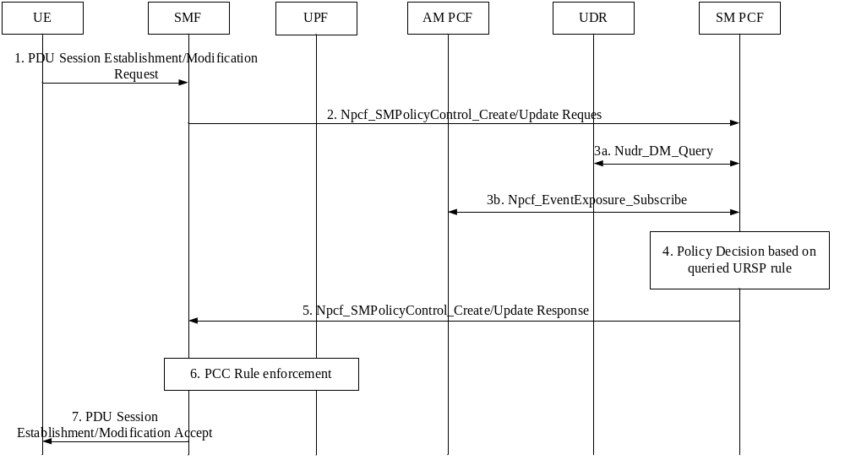
Figure 6.12.2-1: PDU Session Establishment/Modification Procedure for URSP enforcement validation
- During the PDU Session Establishment/Modification procedure, the URSP rule ID related to the application which triggers the procedure is contained within the SM NAS request message by the UE.
- The SMF sends Npcf_SMPolicyControl_Create/Update request message to the PCF, which includes the URSP rule ID received from the UE.
- Upon receiving the URSP rule ID, the PCF for the PDU Session can retrieve the content of the corresponding URSP rule by either interacting with PCF for the UE via Npcf_EventExposure_Subscribe serice operation or with the UDR via Nudr_DM_Query service operation (e.g. Policy Set Entry).
- Based on the received URSP rule, the PCF for the PDU Session first checks whether the PDU Session is associated correctly, e.g. whether the DNN/S-NSSAI or the SSC mode matches with the components of the RSD(s) of the URSP rule. If the PDU Session is associated correctly, the PCF can make policy decision by generating PCC rule(s) corresponding to the application traffic identified by the Traffic descriptor. If the PDU Session is associated incorrectly, the PCF may reject the request message from the SMF.
- The PCF provides the generated PCC rule(s) based on the URSP received in step 3 to the SMF. In addition, the PCF may set “unmatched application” PCR trigger to the SMF, and the SMF shall report to the PCF for the PDU Session when it determines the application transferred in the PDU Session does not match the URSP rule.
- The SMF enforces the received PCC rule(s) by providing corresponding N4 rule(s) to the UPF, thus the application traffic of the Traffic descriptor can be transferred via this PDU Session.
- The SMF responds to the UE with PDU Session Establishment/Modification Accept message, which may contain QoS rule(s) corresponding to the received PCC rule(s).
After this procedure, upon receiving the service packets, if the UPF determines that the service packets are not aligned with the instruction in N4 rules received from SMF, the UPF will drop the packet and report the unmatched application event (i.e. there is an unmatched packet) to the SMF, then the SMF notifies the PCF for the PDU Session. The PCF for the UE updates the URSP in the UE when receiving the event notification of unmatched application from the PCF for the PDU Session.

6.12.3 Impacts on existing Functions
The solution has impacts on the following entities:
UE:
- Supports the reporting of URSP rule ID in PDU Session establishment/modification request.
SMF:
- Supports procedures for transferring of URSP rule ID to the PCF.
- Reports to the PCF about whether there is an unmatched application event.
UPF:
- Reports to the SMF about whether there is an unmatched application event.
PCF:
- Supports procedures for querying the content of the URSP rule from the PCF for the UE.
- Generates the policy for the session management based on the URSP rule,
- Rejects the transmission of application traffic not matching the Traffic descriptor of the URSP .
- Subscribes to PCF for the PDU Session and SMF for notification about whether there is an unmatched application event.
- triggers URSP update based on the unmatched application event.

6.13 Solution #13: URSP enforcement via PDU Session authorization/authentication when UE associating with application

6.13.1 Description
This solution addresses Key Issue #2 5GC awareness of URSP enforcement.
Currently for every newly detected application, the UE evaluates the URSP rules to select a Route Selection Descriptor. UE determines to reuse an existing PDU Session or establish a new PDU Session to associate the application, depending on whether an existing PDU Session matches all components in the selected Route Selection Descriptor or not.
However, 5GC is not aware of which URSP rule the UE matches, and what application the UE detects. To resolve the key issue, a PDU Session authorization/authentication when UE detecting and associating with application is introduced to verify whether the UE should route the specific application traffic to the PDU session or not.
After UE evaluates the URSP rules to select a Route Selection Descriptor for newly detected application, if UE determines to initiates a PDU Session Establishment, the UE indicates the Rule Precedence of URSP rulePSI (Policy Section Identifier) it uses for the request to the network, and the application identity.
Editor's note: User consent is needed for application identity reporting and the detailed descriptions and procedures of user consent is FFS.
The SMF may trigger a PDU Session eEstablishment authentication/authorization procedure with the DN-AAA Server without involving the UPF if the DN-AAA Server is located in the 5GC and reachable directly. If UE determines to reuse the existing PDU Session for the newly detected application, UE shall initiate a PDU Session EstablishmentModification rRequest and includes the Rule Precedence of URSP rulePSI and application identity. The SMF may trigger the PDU Session establishment authentication/authorization procedure with the DN-AAA Server. DN-AAA Server confirms the successful authentication/authorization of the PDU Session for the specific application. The SMF shall reuse the existing PDU Session and accept the PDU Session Establishment, without establish a new PDU session.
NOTE1: Application identity is the subscription identity of Network Slice Customer (NSC), and able to map to the DN-AAA server.
Further, the PCF for SM policy control, when receiving the PSIRule Precedence of URSP rule transferred by the SMF, can retrieve the content of the URSP rule identified by the PSIRule Precedence from the PCF for AM policy control, and then check if the requested S-NSSAI and DNN requested by the UE matches with the components of the Route Selection Descriptors of the URSP rule, and generate the policy for the session management e.g. allow the application traffic identified by the corresponding Traffic descriptor of the URSP rule.

6.13.2 Procedures
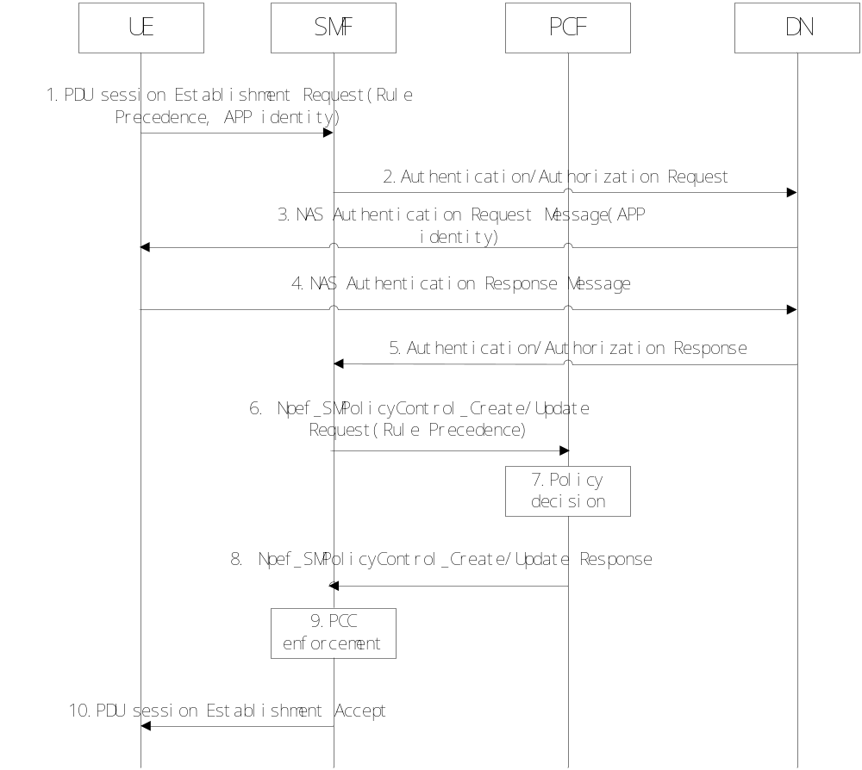
Figure 6.13.2-1: PDU Session Establishment/Modification Procedure for URSP enforcement
- During the PDU Session Establishment/Modification procedure, UE includes PSIRule Precedence of URSP rule and application identity in SM NAS request message.
- SMF may trigger the PDU Session establishment/modification authentication/authorization directly with DN-AAA Server.
- DN-AAA Server sends an Authentication/Authorization message towards UE including application identity.
- Transfer of DN Request Container information received from UE towards the DN-AAA.
- The DN-AAA Server confirms the successful authentication/authorization of the PDU Session associating with the application.
- Within the Npcf_SMPolicyControl_Create/Update request message, SMF provide the PSIRule Precedence to the PCF.
- Upon receiving the PSIRule Precedence of URSP rule, the PCF can retrieve the content of the corresponding URSP rule directly or from the UDR. Based on the received URSP rule, the PCF checks whether the UE associated the correct PDU Session according to the Route Selection Descriptior of the URSP rule. If the PDU Session is associated correctly, the PCF can make policy decision by generating PCC rule(s). If the PDU Session is associated incorrectly, the PCF may reject the request message from SMF.
- The PCF provides the generated PCC rule(s) to the SMF.
- The SMF enforces the received PCC rule(s) by providing corresponding N4 rule(s) to the UPF, thus the traffic can be transferred via this PDU Session.
- The SMF responds to the UE with PDU Session Establishment/Modification Accept message, which may contain QoS rule(s) corresponding to the received PCC rule(s).

6.13.3 Impacts on services, entities and interfaces
The solution has impacts in the following entities:
UE:
- Needs to support the reporting of PSIRule Precedence and application identity in PDU Session eEstablishment/modification request.
- Needs to support secondary Authentication/Authorization based on the application identity.
- Needs to support to initiate a PDU session EstablishmentModification request if UE determines to reuse the existing PDU Session for the newly detected application after UE evaluates the URSP rules to select a Route Selection Descriptor.
SMF:
- Needs to support procedures for transferring of PSIRule Precedence to the PCF.
- Needs to support procedures for transferring of application identity to the DN-AAA Server in Authentication/Authorization Request. in PDU session establishment procedure.
PCF:
- Needs to support procedures for querying the content of the URSP rule based on received PSIRule Precedence of URSP rule.
- Needs to generate the policy for the session management based on the URSP rule, and reject the transmission of application traffic if not matching with the Traffic descriptor of the URSP.

6.14 Solution #14: 5GC awareness of URSP rule evaluation and verification of network slice usage

6.14.1 Description
This solution addresses Key Issue #2: "5GC awareness of URSP enforcement".
This solution is intended to be used when a specific network slice has been deployed for the exclusive usage of an application service provider. Business agreements between the MNO and the application service provider guarantee that the network slice only carries traffic from the applications of the application service provider.
When the evaluation of URSP rules triggers the establishment of a new PDU Session, the UE includes in the PDU Session Establishment Request the Traffic Descriptor of the matched URSP rule, and the application identity. The SMF may verify that the indicated application identity is trusted and that the S-NSSAI is allowed for this application according to operator policy. If this verification fails, the SMF rejects the PDU Session Establishment Request with a proper cause value.
Editor’s note: User privacy consideration is FFS. User consent is needed for application identity reporting and the detailed descriptions and procedures of user consent is FFS.
Editor’s note: Details on the application identity and its verification are FFS.
Editor’s note: The case where the evaluation of URSP rules does not trigger the establishment of a new PDU Session is FFS.

6.14.2 Procedures
Editor's note: This clause describes high-level procedures and information flows for the solution.

6.14.3 Impacts on services, entities and interfaces
Editor's note: This clause captures impacts on existing 3GPP nodes and functional elements.

6.15 Solution #15: UE URSP enforcement validation by the network

6.15.1 Description
Editor's note: This clause will describe the solution principles and architecture assumptions for corresponding
This solution addresses the bellow requirements from Key Issue #2: 5GC awareness of URSP enforcement.
- Whether and how the 5GC can be made aware whether or when the UE enforces a URSP rule to route an application traffic to a PDU Session based on the URSP rule provisioned by 5GC.
- Whether there are any actions the 5GS can take after 5GC is aware whether the UE enforces a URSP rule for specific application traffic or not. If any, what action 5GC should take?
The solution allows for UE enforcement to follow correctly the URSP rules for traffic matching. It introduces Application identity parameter provisioned to the PCF by the UE during PDU Session Establishment procedure. The PCF performs URSP validity check in order to validate whether the UE correctly enforces the traffic matching rules in the URSP for the Application requiring the service. If the PCF finds out that the URSP rules are not correctly followed by the UE, the PDU Session is rejected with a new cause to indicate that the URSP rules in general or a specific URSP rules are not followed. Also, the PCF may optionally trigger UE Policy Update procedure to refresh the URSP rules in the UE with the latest version of the URSP rules.

6.15.2 Procedures
Editor's note: This clause describes high-level procedures and information flows for the solution.
UE
AMF
PCF
9.
PDU Session Establishment
R
eject (reject cause = URSP rules not followed)
SMF
1.
PDU Session Establishment Request (
PDU_Session_
ID
,
DNN, S
-
NSSAI,
App_ID
)
3.
Nsmf_PDUSession_CreateSMContext
Request (UE_ID, PDU_Session_ID , DNN, S
-
NSSAI,
User location,
App_ID
)
8.
Nsmf_PDUSession_CreateSMContext_Response
(
reject cause = URSP rules not followed)
5
.
Npcf_SMPpolicy_Control_Create
(UE_ID, PDU_Session_ID, DNN, S
-
NSSAI,
App_ID
,
UE_location
)
7
.
Npcf_SMPolicy_Control_Create
Response
(Failure,
reject cause = URSP rules not followed
)
6. UE URSP rules validity check fails
4. PDU Session Establishment procedure as per TS23.502, clause 4.3.2.2.1, steps 4 to 7a
2. SMF selection
11. UE Policy update as per TS23.502, clause 4.2.4.3
10. URSP rules in the UE update trigger
Figure 6.15.2-1: UE’s URSP enforcement validation by the network
- An Application in the UE requires service. The UE initiates PDU Session Establishment Request message in which the UE includes the UE_ID, the PDU_Session_ID, the S-NSSAI and the DNN. The UE selects the S-NSSAI and the DNN based on the URSP rules applicable for the Application requiring service. The UE also includes the App_ID of the Application in the PDU Session Establishment Request message.
Editor’s Note: User consent is needed for App_ID reporting and the detailed descriptions and procedures of user consent is FFSIt is FFS to clarify the Application Identity and any user privacy issues related to its provision to the network
Note: The App_ID does not reveal user sensitive privacy information. The App_ID is a network slice service subscription identity which is assigned by the service vendor and the network Operator would not know the real Application it is related to. The App_ID is used to relate the S-NSSAI selection criteria within the URSP rules in the UE to the one within the URSP rules in the PCF.
2. SMF selection by the AMF.
3. The AMF invokes either Nsmf_PDUSession_CreateSMContext_Request message to the SMF if there is no association with it or Nsmf_PDUSession_UpdateSMContext_Request message if the AMF is already associated with a SMF. Along with the UE_ID, the S-NSSAI, the DNN and the User location parameters, the AMF also forwards to the SMF the App_ID received by the UE.
4. Continue with PDU Session Establishment procedure as per TS23.502 [3], clause 4.3.2.2.1, steps 4 to 7a.
5. The SMF initiates the SM Policy Association Establishment procedure and the SMF sends the Npcf_SMPpolicy_Control_Create message to the PCF in which the SMF includes the UE_ID, the S-NSSAI, the DNN, the User location and the App_ID parameters.
6. The PCF performs URSP validity check for the UE. The PCF retrieves the stored latest version of the URSP rules for the UE and the PCF verifies whether the UE is folowing correctly the S-NSSAI selection rules, the DNN selector rules, the Time window criteria and the Location criteria.
7. If the result from the URSP validity check by the PCF is that one or more of the traffic matching rules in the latest version of the URSP are not correctly followed by the UE, the PCF returns Failure parameter in the Npcf_SMPpolicy_Control_Create response to the SMF. The PCF may also include the cause for the failure, e.g. URSP rules not followed or a more specific reject cause identifying the specific URSP rule that is not followed by the UE.
8. The SMF forwards the reject cause to the AMF in the Nsmf_PDUSession_CreateSMContext_Response message.
9. The AMF rejects the PDU Session Establishment Request from the UE and the AMF includes a rejection cause URSP rules not followed or a more specific reject cause pointing to which URSP rules are not followed (e.g. S-NSSAI selection rules not followed or DNN selection rules not followed or Time windows criteria not followed or Location criteria not followed).
10. If at step 6 the URSP validity check by the PCF fails, the PCF may assume the UE may not have the latest URSP rules so, the PCF may trigger UE Policy update procedure as per TS23.502, clause 4.2.4.3 to refresh the UE with the latest URSP rules.
11. UE Policy update as per TS23.502 [3], clause 4.2.4.3
Editor’s Note: It is FFS how the solution works when Application Descriptor is not provided in the TD of the URSP rule, instead other TD parameter like DNN, Connection Capabilities are included in the TD of the URSP rule.

6.15.3 Impacts on services, entities and interfaces
Editor's note: This clause captures impacts on existing 3GPP nodes and functional elements.
UE, AMF, SMF – new App_ID parameter and a new PDU Session Establishment reject cause.
PCF – new App_ID parameter and URSP validity check functionality.

6.16 Solution #16: URSPs into PCO for EPC

6.16.1 Description
The solution address KI#3. In this solution, two different aspects are covered:
- Provide the use case examples and scenarios where the UE may need URSP when in EPS.
- How to provision the URSP to UE when served by the EPS.

6.16.1.1 Use cases and scenarios
When a UE attaches initially in EPC or when the UE handovers from 5GC to EPC, PCF may need to update the URSPs in the UE:
- During Initial attach procedure in EPS due to for example:
  - New AF guidance on URSP request applicable to the UE was sent by an AF while the UE is deregistered and prior to the EPC attach procedure, so the corresponding URSP rules were not delivered yet to the UE.
  - Operator policies configured with time, location or any other condition are met when the UE attaches to EPC, implying new or updated URSP rules apply under those conditions.
  - Operator policies for determining URSPs were updated by the operator while the UE is deregistered and prior to the EPC attach procedure, so the corresponding URSP rules were not delivered yet to the UE.
- At any time a URSP is changed while the UE is registered in EPC (coming from EPC initial attachment or after handover from 5GC) due to for example:
  - New AF guidance on URSP request applicable to the UE is sent by an AF.
  - Due to time, location change or other network condition the PCF determines that an operator policy configured for the operator for URSP determination applies in the new network conditions, implying new or updated URSP rules apply to the UE.

6.16.1.2 Background: URSP provisioning to a UE in 5GS
In 5GC URSP updates are delivered from the PCF to the UEs following the procedure defined in TS 23.503[4] section 6.1.2.2.2 for the distribution of the policies to UE. The distribution of UE policies is based on a protocol defined between the UE and the PCF described in 3GPP TS 24.501[2] and called UPDP protocol (UE Policy Delivery Protocol) and summarized in the figure below. The UPDP messages are then encapsulated into N1 Policy Containers and transferred transparently by the AMF from/to the UEs.
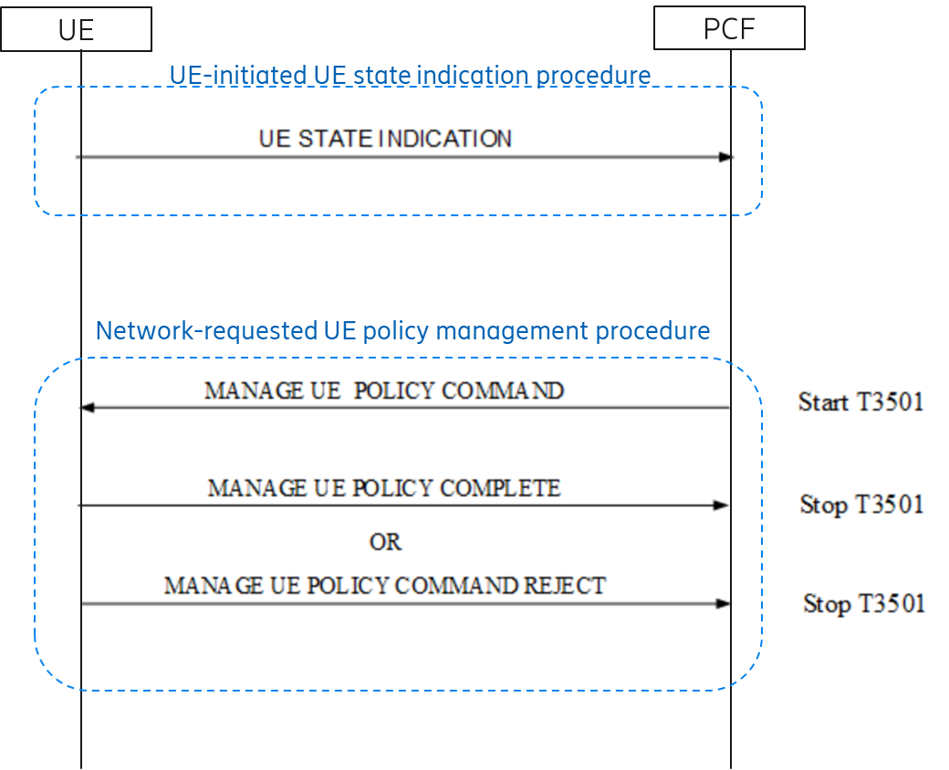
Figure 6.16.1.2-1: URSP provisioning to a UE in 5GS
The operation UE STATE INDICATION is used by the UE to provide to the PCF the list of stored PSIs which identify the Policy Sections stored in the UE.
The Network-requested UE Policy management procedure is used by the PCF to delivery an update of UE Policies to the UE. First the PCF sends the operation MANAGE UE POLICY COMMAND including the update of UE policies to the UE. Then the UE answer to the PCF with MANAGE UE POLICY COMPLETE or MANAGE UE POLICY COMMAND REJECT.

6.16.1.3 How to provision URSP to a UE in EPC
The solution in this paper proposes a mechanism that allows the network to update the URSPs for a UE in EPC, by encapsulating UPDP messages into a new ePCO parameter (from now on UE Policy Container ePCO) and transfer them to the UE via PDN connection.
The solution assumes the same protocol (UPDP protocol) for URSP delivery between the PCF and the UE than in 5GC, although the final decision on this is up to stage 3.
The mechanism reuses the existing capability of the EPC network for sending ePCO from the UE to the SMF+PGW-C (and vice versa) and in addition it proposes a way to transport the UE Policy Container from the SMF+PGW-C to the PCF (and vice versa) based on reusing existing PDU session procedures.
For the delivery of URSPs to UEs in EPC, this solution assumes the standard solution for interworking architecture between EPC and 5GC as described in 3GPP TS 23.501[2].
When the PCF needs to send a UE Policy update towards the UE in EPC, it invokes a SM Policy Association Modification including the corresponding UPDP message into a new IE (UE Policy Container) in the N7 interface. When the SMF+PGW-C receives this new IE the SMF+PGW-C encapsulates it into UE Policy Container ePCO and transfers them to the UE by using existing procedure of PDN GW initiated bearer modification without bearer QoS update as defined in TS 23.401[8] section 5.4.3.
When the UE in EPC needs to send a UPDP message towards the PCF in relation to UE Policy handling the UE first encapsulates the UPDP message into a UE Policy Container ePCO and then transfers it towards the SMF+PGW-C by reusing existing mechanisms. When the SMF+PGW-C receives such UE Policy Container ePCO from the UE, just forwards transparently the UE Policy Container towards the PCF by reusing SMF initiated SM Policy Association procedure (establishment or modification).
The solution also proposes that the UE has to be able to handle the reception of such UPDP messages received over EPC NAS signalling in a similar way than when received over 5GC NAS signalling in 5GC.
In addition, for those events happening in PCF which may trigger the sending of a URSP update for a UE (as described in section 6.X.1.1), the PCF will check if the UE is currently in EPC, and if so will use one of these PDU sessions to trigger the delivery of the URSP updates, by invoking PCF initiated SM Policy Association modification procedure including the proper UE Policy Container.
The PCF refers to a deployment where the PCF serving the UE and the PCF serving each of the PDU Sessions of this UE are the same PCF.
Editor’s Note: It is FFS the analysis of the solution for deployments where the PCF for the UE and the PCF for the PDU Session are different PCFs.

6.16.2 Procedures

6.16.2.1 Initial Attach procedure in EPC
For the initial attachment of a UE in EPC, the procedure follows the one defined in TS 23.401[8] section 5.3.2.1 with the following additions summarized in the figure below for the support of URSP deliveries to the UE:
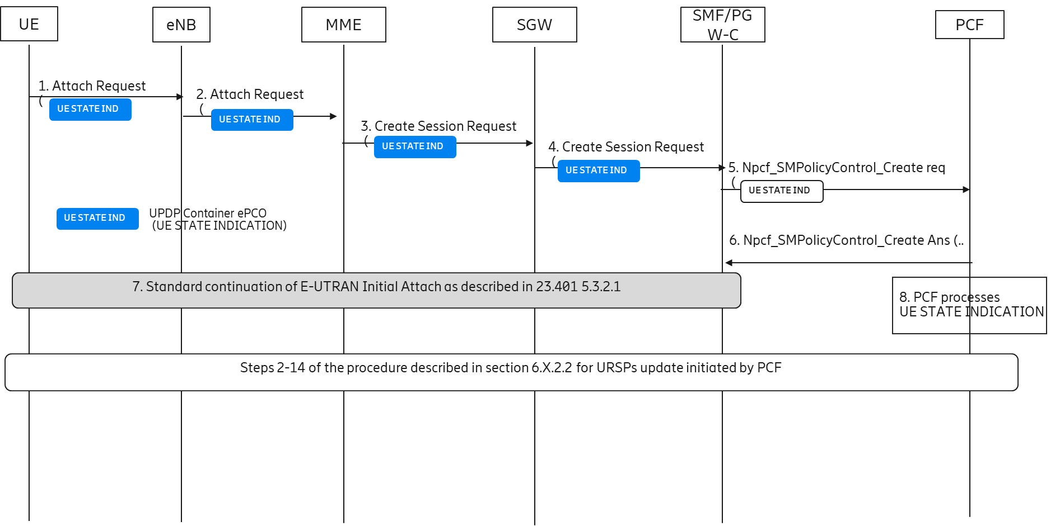
Figure 6.16.2-1: Initial Attach procedure in EPC
- Step 1: The UE generates UE STATE INDICATION UPDP message (including the list of PSIs stored in the UE) in the same way that it is done for the registration in 5GC. Then the UE includes this UE STATE INDICATION UPDP message into UE Policy Container ePCO in PDN Connectivity Request encapsulated in Attach Request.
Note: For those cases where the UE attaches to EPC but doesn’t request the establishment of a default bearer the procedure just follows the steps defined in TS 23.401[8] section 5.3.2.1 and there is no PCF interaction. However, for those cases, the UE will include UE STATE INDICATION within a UE Policy Container ePCO during the first request for PDN connectivity. Then the PCF will be able to update the URSPs to the UE only after the establishment of the first PDU session establishment for the UE.
- Steps 2-4: These steps follow the existing procedure as defined in TS 23.401, so the UE Policy Container ePCO is sent towards the SMF+PGW-C.
- Step 5: the SMF+PGW-C forwards transparently the UE Policy Container ePCO to the PCF as a new IE in the PDU Session Establishment (Npcf_SMPolicyControl_Create Request).
Note: Upon the reception of this UE Policy Container ePCO, the SMF+PGW-C shall establish the corresponding SM Policy Association even in case the network configuration for the APN of the PDN connection does not require PCF involvement.
- Steps 6: The PCF answers to the SMF with Npcf_SMPolicyControl_Create Response.
- Step 7: The procedure for initial attach continues as defined in 23.401[8] section 5.3.2.1.
- Step 8: the PCF gets the content of the UE STATE INDICATION included in new IE and processes it in a similar way than it does when it is received in 5GC during the UE Policy Association establishment, i.e. uses the list of UPSIs included in the UE STATE INDICATION to determine if an update of UE policies is required for this UE. If no update is determined the procedure finishes here. If an update is needed, then the PCF generates the corresponding UPDP message MANAGE UE POLICY COMMAND in a similar way than it is done in 5GC and then includes the message into a UPDP Container ePCO.
Note: The interactions toward UDR in relation with the retrieving and storage of UPSIs into UDR are not shown in the diagram.
- The flow follows the steps 2-14 defined in section 6.X.2.2 for URSP update initiated by PCF.

6.16.2.2 URSP update initiated by PCF
For the procedure for URSP update initiated by the PCF when the UE is in EPC, the procedure follows the steps described in the figure below:
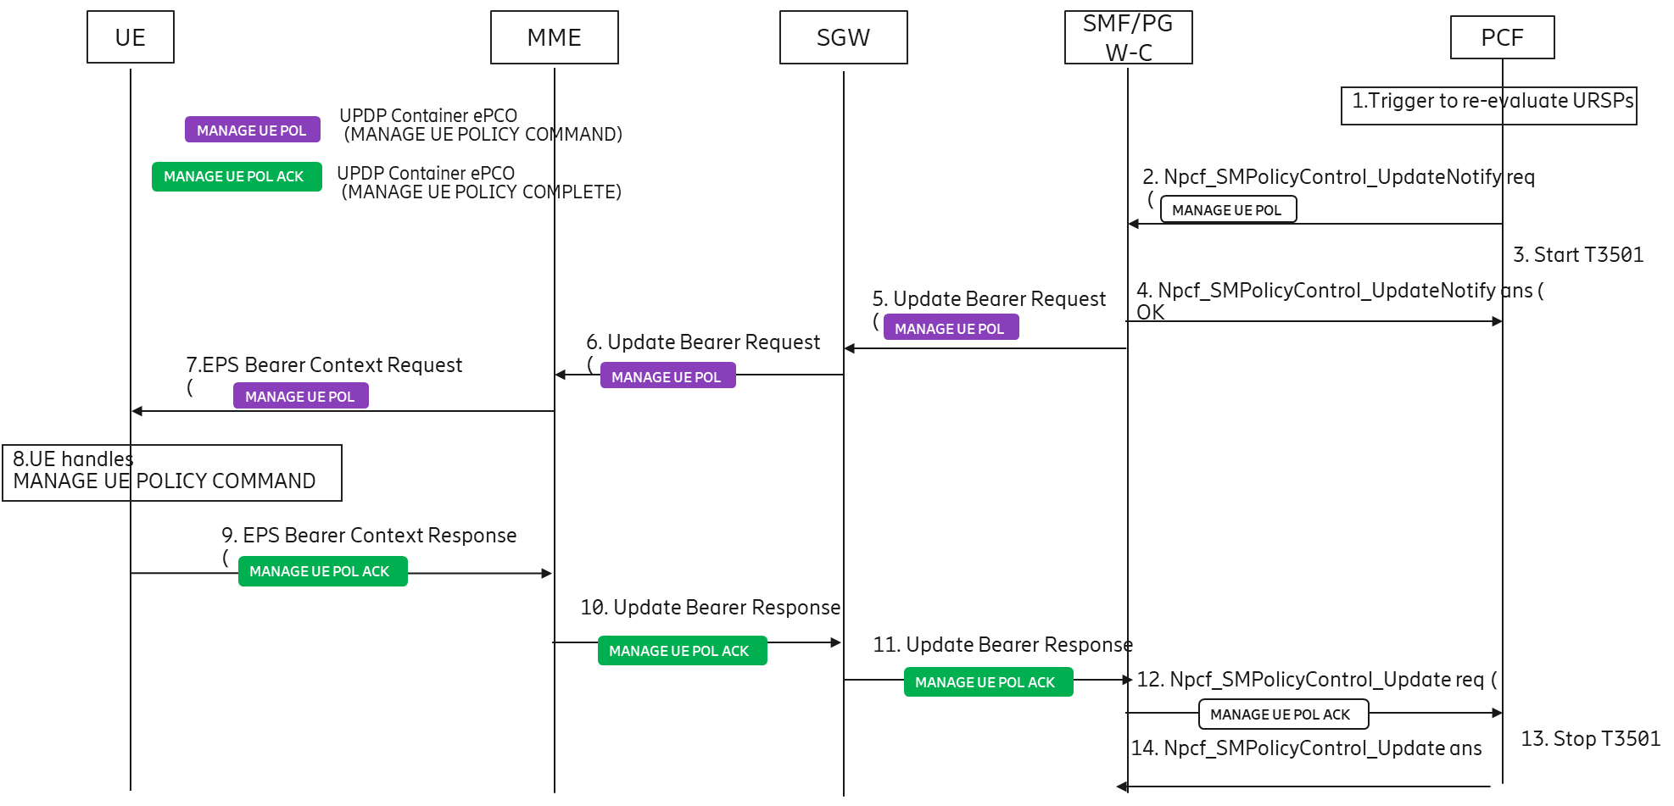
Figure 6.16.2.2-1: PCF initiated URSP update procedure
- Step 1: An event as described in section 6.X.1.1 happens in PCF. The PCF triggers the re-evaluation of applicable URSPs for the UE and determines an update of URSP is needed for the UE. The PCF selects one of the PDN connection/PDU sessions associated to EPC for the delivery of the URSP update. Then the PCF generates the corresponding UPDP message MANAGE UE POLICY COMMAND in a similar way than it is done in 5GC and then includes the message into a new IE for sending it to the SMF over N7.
- Step 2: The UPDP message is then provided to the SMF+PGW-C by invoking Npcf_SMPolicyControl_UpdateNotify request.
- Step 3: The PCF starts timer T3501 to monitor the reception of an answer for UPDP MANAGE UE POLICY COMMAND.
- Step 4: The SMF+PGW-C, upon reception of the new IE with UPDP message, answers the PCF with Npcf_SMPolicyControl_UpdateNotify response and initiates a bearer modification procedure without bearer QoS update (as defined in 23.401[8] section 5.4.3) to provide the UE Policy Container ePCO towards the UE.
- Steps 5-7: These steps follow the existing procedure for bearer modification procedure without bearer QoS
- Step 8: When the UE gets the UE Policy Container ePCO including a MANAGE UE POLICY COMMAND UPDP message, the UE processes that message in a similar way than when it is received in 5GC, i.e. stores the URSP updates, optionally re-evaluates the mapping of applications into PDN connections according to the mapping of URSP values into EPC, and generates UPDP message MANAGE UE POLICY COMMAND COMPLETE with the result to the PCF.
- Step 9: The UE then generates a UE Policy Container UPDP including the MANAGE UE POLICY COMMAND COMPLETE, and include it in the EPS Bearer Context Response sent to the MME.
- Step 10-11: These steps follow the existing procedure defined for Update Bearer Response
- Step 12: Upon reception of UE Policy Container ePCO in Update Bearer Response, the SMF+PGW-C then invokes Npcf_SMPolicyControl_Update Request including the content of the UE Policy Container ePCO.
- Step 13: The PCF processes the MANAGE UE POLICY COMMAND COMPLETE in a similar way than in 5GC as defined in TS 29.525 [9] and stops timer T3501.
- Step 14: The PCF sends Npcf_SMPolicyControl_Update Response.

6.16.3 Impacts
Impact on interface:
N7: Introduce additional IE for the transfer of UE Policy Container between SMF+PGW-C and PCF.
NAS, S11, S5/S8(?): Introduce new parameter UE Policy Container in ePCO.
Impact on PCF:
- Handling of UE Policy Container within SM Policy Association procedures.
- For those cases where PCF initiates the sending of URSP update for a UE in EPC, the triggering of SM Policy Association modification including the new IE with MANAGE UE POLICY COMMAND UPDP message.
Impact on SMF+PGW-C:
- Upon reception of UE Policy Container ePCO in Create Session Request, the SMF+PGW-C forwards the UE Policy Container to the PCF at SM Policy Association establishment. Use the reception of UPDP Container as an additional reason to establish the SM Policy Association, even in case the network configuration for the APN of the PDN connection does not require PCF involvement.
- Upon reception of UE Policy Container from PCF during SM Policy Association initiated by PCF, SMF+PGW-C performs a Bearer Modification Procedure without bearer QoS update including the UE Policy Container ePCO.
- Upon reception of Update Bearer Response from MME including UE Policy Container ePCO, the SMF+PGW-C forwards the received UE Policy Container to PCF.
Impact on UE:
- During initial attach in EPC, the UE includes UE STATE INDICATION UPDP message into UE Policy Container ePCO in PDN Connectivity Request encapsulated in Attach Request
- The UE receives MANAGE UE POLICY COMMAND in UE Policy Container ePCO during EPS Bearer Context Request and process it as in 5GC. The UE generates MANAGE UE POLICY COMPLETE UPDP message and send it to the MME encapsulated into a UE Policy Container ePCO in EPS Bearer Context Response.

6.17 Solution #17: Indication of applicability of URSP to UE in EPS

6.17.1 Description
Support of URSPs in EPS was introduced in 3GPP Rel-16. A Rel-16 UE can use URSPs while in EPS (S1 mode) by translating the various parameters in the Traffic Descriptors and Route Selection Descriptors to corresponding EPS parameters as defined in clause 4.4.2 of TS 24.526 [10]. URSPs are still provisioned via 5GC. Whereas for the Traffic Descriptors (TD) a 1-to-1 mapping can be derived, certain 5GS parameters of a Route Selection Descriptor (RSD) do not have an exact equivalent in EPS e.g. SSC mode selection, Network Slice selection, DNN selection, Time Window, Location criteria etc. For this purpose, a static mapping of 5GS parameters to EPS was specified in the Table 4.4.2.2 of TS 24.526 [10], with certain parameters marked as not applicable in EPS. A UE in EPS currently ignores an RSD if it contains any such parameter that are marked as not applicable in Table 4.4.2.2 of TS 24.526 [10].
Although this static mapping enables the use of certain URSPs in EPS, i.e. the ones that do not contain any of the non-applicable parameters, this static mapping of what is applicable in EPS is very limiting. Essentially, a network operator, to ensure that the UEs in EPS behave as desired, has to design and provision EPS-specific RSDs that avoid any non-applicable parameter. This results to unnecessary signalling, storage and processing overheads at both UE and network sides, and network management overheads.
Additionally, with this static mapping none of those parameters can be used by a UE while in EPS. However, for certain features like edge computing, "Time Window" and "Location Criteria" are spatial and temporal criteria which could be used to determine the validity of URSP rules.
In this solution, it is proposed to introduce a new optional parameter "EPS applicability" in the Route Selection Descriptor component of a URSP rule. The new parameter, if present in the RSD, will provide an indication to the UE, whether the RSD parameter is applicable in EPS.
In order to ensure backwards compatibility and avoid any unnecessary signaling, at registration the UE shall indicate whether it supports this new feature. If the UE includes the "EPS RSD support indication" during registration, the PCF may then include the additional parameter "EPS applicability" in the RSD component to indicate how the UE should use each RSD parameter in EPS. This design ensures that the optional applicability indication can be used only if needed, and supported by both the UE and the network

6.17.2 Procedures

6.17.2.1 URSP provisioning with EPS applicability indication
Figure 6.16.2.1-1 explains the procedure for URSP provisioning with EPS applicability indication.
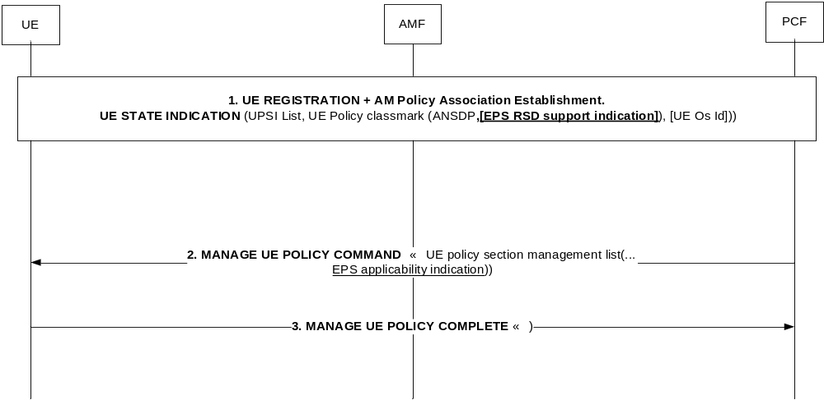
Figure 6.17.2.1-1: URSP provisioning with EPS applicability indication
1. At registration the UE indicates support of the feature by including the "EPS RSD support indication".
2. If the UE has indicated support for "EPS RSD support indication" then the PCF generates the URSP rules including the applicability of certain parameters to EPS. For each Route Selection Descriptor component, the PCF shall include the new optional parameter "EPS applicability".
3. UE indicates the success or failure of update.
The Route Selection Descriptor component is extended as shown in Table 6.17.2.1-1 below to support the "EPS applicability" indication.
Editor's note: It is FFS whether the EPS applicability indication is included to all components or only to the ones for which the handling over the static mapping of "4.4.2 Use of URSP in EPS" of TS 24.526 [10] as per Rel-16 is to be overridden.
Table 6.17.2.1-1: Route Selection Descriptor component
Parameter name | Description | Mandatory/Optional
RSD component type | This indicates the route selection descriptor component type e.g. SSC mode or DNN type etc. as specified in Table 5.2.1 of TS 24.526 [10]. This parameter is transmitted first. | M
RSD component value | This indicates the value corresponding to the route selection descriptor component type. | M
EPS applicability | Indicates how to handle this RSD when in EPS. This parameter may be included only if UE has indicated support. One of the following values can be included:  1) Not applicable (backward compatible handling)  2) To be ignored in EPS  3) Applies to EPS  4) reserved | O

6.17.2.2 Evaluation of URSP rules with EPS applicability indication
When the UE is in S1 mode, during URSP evaluation the UE shall:
- ignore the complete RSD if any RSD component has EPS applicability parameter set to "Not applicable"
- only ignore the specific RSD component (i.e. not the whole RSD) when the EPS applicability parameter is set to "To be ignored in EPS"
- consider the RSD component in EPS also if the EPS applicability parameter in the RSD component is set to "Applicable to EPS"

6.17.3 Impacts on services, entities and interfaces
The solution has the following impacts:
PCF:
- PCF shall support the additional parameter (EPS applicability indication) in RSD component of URSP rule as explained in clause 6.16.2.1.
- PCF shall include the "EPS applicability indication" in RSD component only if UE has provided "EPS RSD support indication" during registration.
UE:
- UE shall include "EPS RSD support indication" during registration.
- UE shall support evaluation of the URSP rules as described in clause 6.16.2.2.

6.18 Solution #18: Provisioning consistent URSP to UE across 5GS and EPS for CollocatedSingle PCF Deployment

6.18.1 Description
This solution addresses KI#3 and assumes a collocatedsingle PCF deployment where the PCF serving the UE and PCF serving each of the PDU Sessions of the UE are the same PCF. The solution aims to solve the issue when ANDSF is not deployed in EPS.
With regard to the scenarios and gaps (first two bullets in the KI#3), if a UE has used the Route Selection component (e.g. DNN) in a URSP rule in EPS and the Route Selection component (e.g. DNN) has been changed when the UE stays in EPS, the updated URSP rule needs to be provisioned to UE in EPS, otherwise the UE in EPS may use outdated DNN to establish PDN connection in EPS. In 5GS the UE may be provisioned with URSP rules for both 5GS and EPS by the PCF of the HPLMN. Only the rules provisioned by the PCF are used by the UE, if both URSP rules provisioned by the PCF and pre-configured URSP rules are present. The URSP rules are provisioned in UE using NAS messages. The AMF transparently transfers the UE Policy container (UE policy information) received from the PCF to the UE (using DL NAS TRANSPORT message). The UE Policy container includes the list of Policy Sections as described in TS 23.503 [4]. Similar mechanism can be used to provision URSP rules in EPS.
This solution aims to solve the issue when ANDSF is not deployed in EPS.
The EPS and 5GS interworking architecture defined in TS 23.501 [xx] is reused, the solution addresses the single PCF deployment scenario where the SM-PCF and UE-PCF are collocated, N7 interface is reused to provision URSP from PCF to PGW-C and no new interface is introduced.
On this aspect in the key issue#3 description:
For the Rel-15 UEs not supporting the URSP mapping in EPS, whether the URSP updating/provisioning to such UEs in EPS should be supported.
Since the URSP usage is not supported by a Rel-15 UE supporting interworking between EPS and 5GS, it’s not necessary useless to provision/update the URSP to such UE, which will cause additional signalling overload. Thus, the EPS needs to be aware whether a 4G interworking UE supports the URSP usage or not.
To realize provisioning ofthe consistent URSP rules in UE, this solution follows the below two principles:
NOTE 1) The same set of URSP is provisioned to UE regardless of UE attaching to EPS or registering to 5GS.
NOTE 2) The UE in EPS uses the components in RSD of a URSP rule according to Rel-16 specification defined in TS 23.501 [2] clause 5.17.1.2.
The EPS and 5GS interworking architecture defined in TS 23.501 [2] is reused, the solution addresses the collocatedsingle PCF deployment scenario where the SM-PCF and UE-PCF are collocated, N7 interface is reused to provision URSP from PCF to PGW-C and no new interface is introduced. Theis solution proposes a mechanism for the network to provision and update the URSP for a UE in EPS by encapsulating UE Policy Container in ePCO via one of the PDN connections. The UE Policy Container is transparently forwarded via SMF+PGW-C. The communication between SMF+PGW-C and PCF reuses the SM Policy Association procedures.

6.18.2 Procedures

6.18.2.1 UE triggered UE Policy provisioning procedure in EPS
1. The UE sendsreports the UE Policy Container including 4G interworking URSP Support indication in EPS which is indicating a whether a 4G interworking UE supports the URSP usage or not in EPS (defined in TS 23.501 [2] clause 5.17.1.2) and the PSIs (Policy Set Identifier) in ePCO (extended PCO) to SMF+PGW-C during Initial Attach procedure (in the Attach Request) as described in clause 5.3.2.1 of TS 23.401[8] and the UE requested PDN connectivity procedure (PDN Connectivity Request) as described in clause 5.10.2 of TS 23.401[8].
2. When tThe SMF+PGW-C receivestransparently forwards the UE Policy Container in ePCO to the PCF as a new IE in the PDU Session Establishment (Npcf_SMPolicyControl_Create Request).
NOTE 1:, In case the PCF involvement for a PDN connection is not required, the SMF+PGW-C should still it establishes SMUE Policy Association with PCF and forwards the UE Policy Container to PCF. If a UE Policy Container is not received from UE, the PGW-C may establish UE Policy Association with PCF based on local configuration.
3. The PCF gets policy subscription related information and the latestupdated list of PSIs from the UDR. The PCF creates the UE policy container including UE policy information as defined in clause 6.6 of TS 23.503[4]. Then it sends the latest UE policy information in the UE Policy Container to SMF+PGW-C.
4. The SMF+PGW-C sends the UE Policy Container in ePCO to UE in Activate Default EPS Bearer Context message which may be encapsulated in Attach Accept or PDN Connectivity Accept message.

5. The UE sends a response to SMF+PGW-C by acknowledging the reception of the UE Policy reusing existing messages (e.g. Attach Complete, Modify Bearer Request) as defined in clause 5.3.2 of TS 23.401[8].
6. The SMF+PGW-C forwards the acknowledgement of UE reception of the UE Policy to PCF using Npcf_SMPolicyControl_Update request.

6.18.2.2 PCF triggered UE Policy provisioning procedure in EPS
1. When the PCF is notified by UDR that the URSP is updated, it triggers the UE Policy update procedure towards the SMF+PGW-C using Npcf_SMPolicyControl_UpdateNotify request. The PCF selects one of the PDN connections/ PDU Sessions for the UE in EPS for the delivery of the updated URSP rules update.
2. The SMF+PGW-C transparently forwardprovides the updated URSP rules to UE in UE Policy Container via ePCO, which can be achieved by using new message or reusing existing messages (e.g. Update Bearer Request, Downlink NAS Transport, EPS Bearer Context Request) as defined in clause 5.4.3 of TS 23.401[8].
3. When the UE receives the updated URSP rules, it enforces the updates the URSP rules and sends a response to SMF+PGW-C byon acknowledging the reception of the UE Policy reusing existing messages (e.g. Uplink NAS Transport, Update Bearer Response, EPS Bearer Context Response) as defined in clause 5.4.3 of TS 23.401[8].
4. Tthe SMF+PGW-C forwards the acknowledgementACK of UE reception of the UE Policy to PCF using Npcf_SMPolicyControl_Update request.

6.18.3 Impacts on services, entities and interfaces
UE:
- Send the UE Policy Container including UE capability to support 4G interworking URSP Support indication in EPS and PSIs to PGW-C via ePCO.
- Receive the URSP rules in the UE Policy Container from PGW-C via ePCO.
- Sends an acknowledgement of UE Policy reception
SMF+PGW-C:
- ReceiveTransparently forward the UE Policy Container from UE viain ePCO and forward to PCF.
- Transparently forwardReceive the UE Policy Container in ePCO from PCF and forward to UE via ePCO.
PCF:
- Receive the UE Policy Container from SMF+PGW-C.
- SendInitiates transfer of URSP rules in UE Policy Container to UE via SMF+PGW-C.
- Subscribe to UDR on URSP change notification.

6.19 Solution #19: Provision of URSP to UE when the UE attaches in the EPS

6.19.1 Introduction
This solution addresses1 key issue#3 ‘Provision consistent URSP to UE across 5GS and EPS’.
When the UE is attaching to the EPS system, the PGW-C+SMF node requests the PCF to provide the URSP information. The PCF provides the URSP information after interacting with the UDR.

6.19.2 Procedures

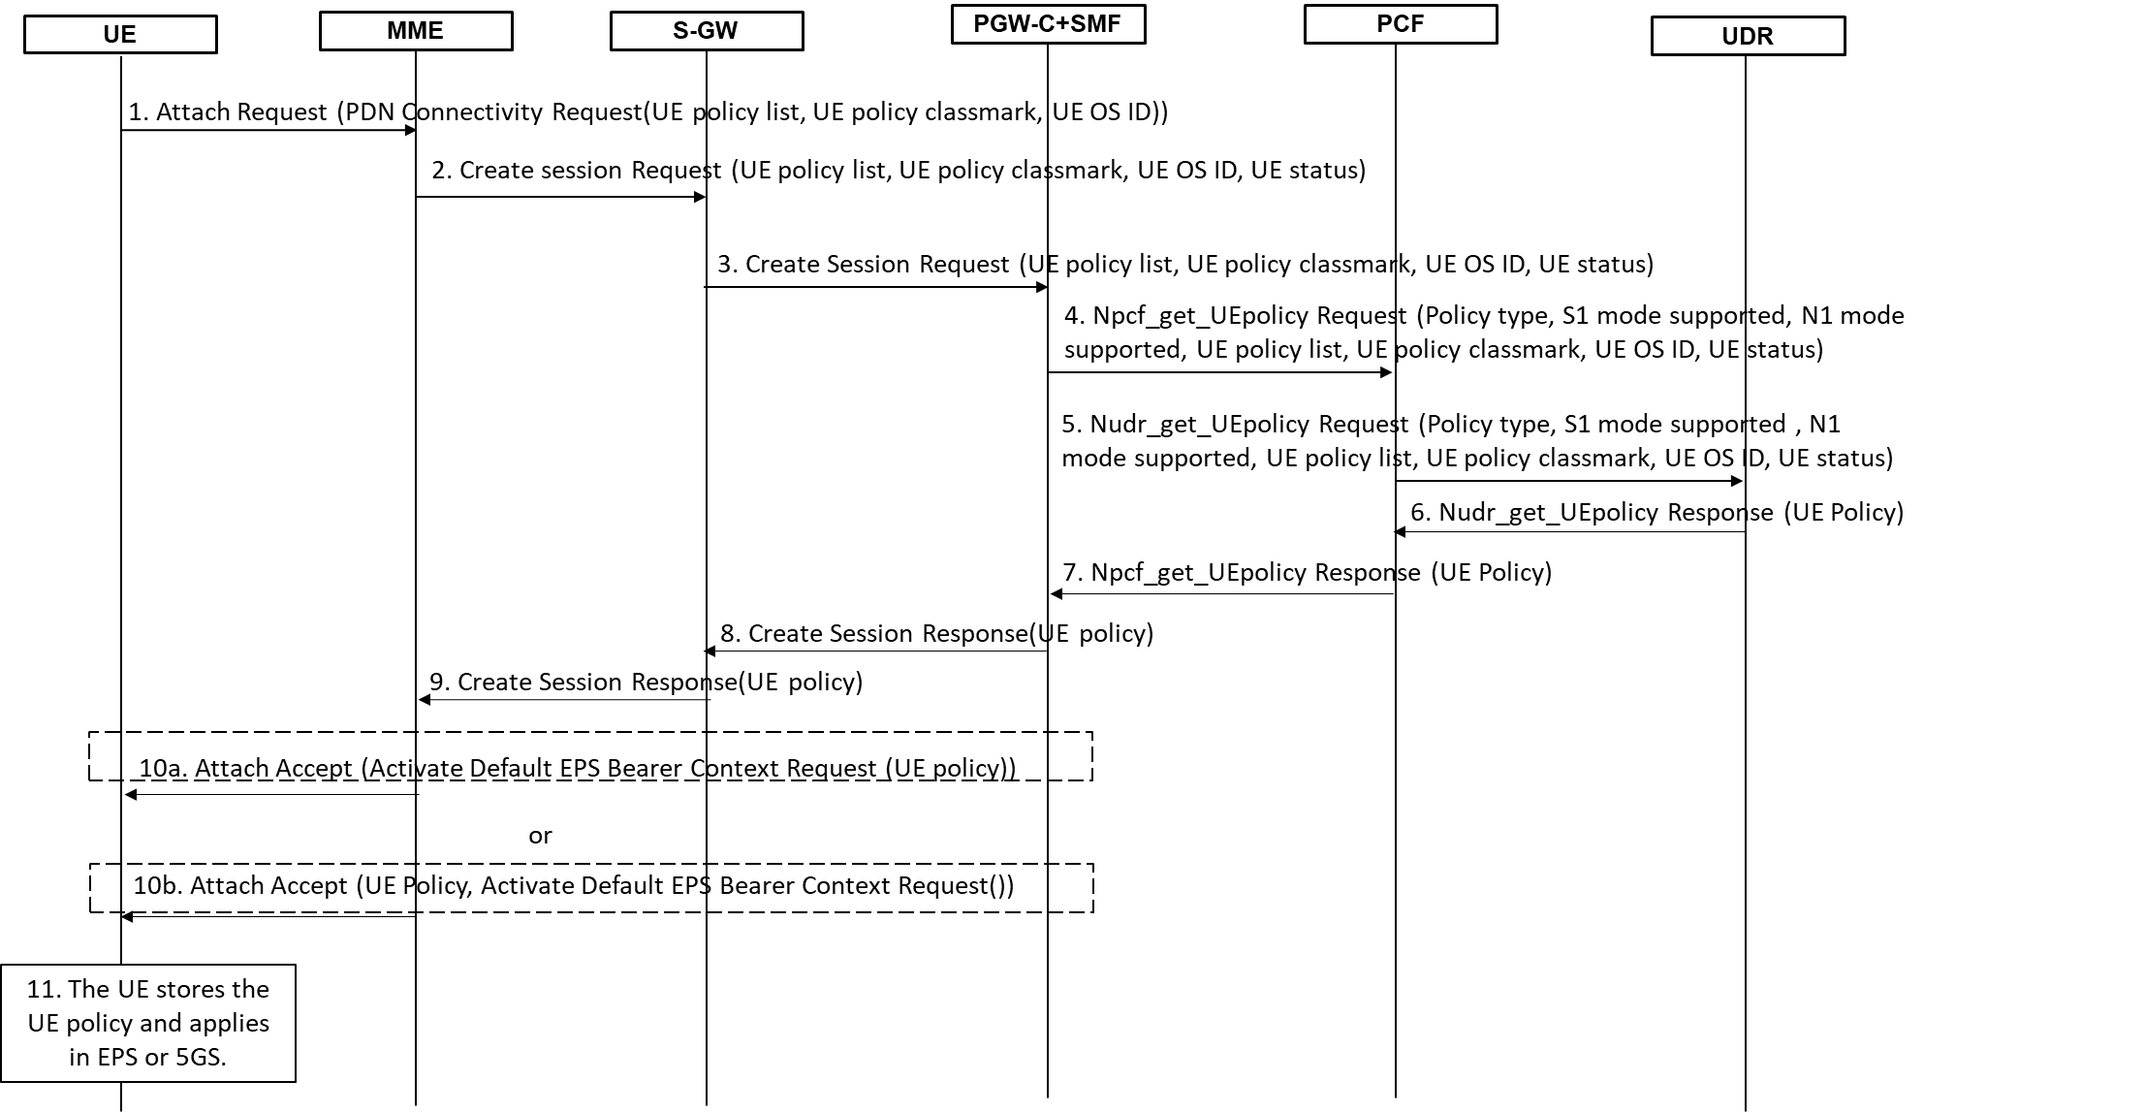

Figure 6.19.2-1: Transfer of URSP procedure when the UE is registering to the EPS system.

The detailed steps of the procedure are defined below:
Step 1: The UE initiates attach procedure to a PLMN by sending an attach request message to the MME. The UE includes the UE policy list, UE policy classmark and UE OS ID Information Element (IE) either in a PDN connectivity request message or in the attach request message. The UE policy list, the UE policy classmark and the UE OS ID Information Element (IE) may be set in the PCO parameter in the attach request message.

NOTE1: UE policy list, the UE policy classmark and the UE OS ID are defined in 3GPP TS 24.501 [2].

Step 2: Upon reception of the attach request message, the MME sends a create session request message containing PCO, UE status and the UE policy list, the UE policy classmark and the UE OS ID Information Element (IE) to the S-GW. The UE status may be added to the create session request message by the MME. The UE status may include following information.
- CN type: It indicates a CN type, core network type, that the UE is being or has attached. E.g., EPC or 5GC.
- Access Type: It indicates an access that the UE is accessing. E.g., 3GPP access or Non-3GPP access.
- RAT type: It indicates a Radio Access Technology that the UE is accessing. E.g., EUTRAN, EUTRAN-NB-IoT, LTE-M, or NR.
- Serving Network (PLMN ID, or PLMN ID and NID).

In this solution, the MME may determine the UE status based on local information regarding the UE in the MME or received information regarding the UE from other network node(s).

Step 3: Upon reception of the create session request message the S-GWsends the create session request message containing the PCO, the UE status and the UE policy list, the UE policy classmark and the UE OS ID Information Element (IE) to the PGW-C+SMF.

Step 4: Upon reception of the create session request message the PGW-C+SMF sends Npcf_get_UEpolicy Request message containing Policy type, S1 mode supported, N1 mode supported, the UE policy list, the UE policy classmark, the UE OS ID IE and the UE status. The Policy type indicates a type of UE policy that the PGW-C+SMF wants to fetch for the UE. If the UE policy list, the UE policy classmark and the UE OS ID Information Element (IE) are encapsulated in the PCO, the PGW-C+SMF extracts the UE policy list, the UE policy classmark and the UE OS ID Information Element (IE) from the PCO.

If policy list is not contained in the create session request message, the PGW-C+SMF includes Policy type information element. In this solution, the PGW-C+SMF may determine the Policy type information element based on the UE policy list. In this solution, the PGW-C+SMF may determine the Policy type information element based on a local configuration in the PGW-C+SMF or stored information regarding policy list of the UE.
The PGW-C+SMF may obtain the “S1 mode supported” and the “N1 mode supported” based on information regarding the UE stored in the PGW-C+SMF or received information regarding the UE from other network node(s).

Step 5: Upon reception of the message from the PGW-C+SMF, the PCF sends Nudr_get_UEpolicy Request message containing the Policy type, the S1 mode supported, the N1 mode supported, the UE policy list, the UE policy classmark, the UE OS ID and the UE status to the UDR.

Step 6: Upon reception of the message from the PCF, the UDR transfers the UE policy to the PCF in the Nudr_get_UEpolicy Response message.

Step 7: Upon reception of the UE policy in the response message from the UDR, the PCF sends Npcf_get_UE policy response message to the PGW-C+SMF.

Step 8: Upon reception of the UE policy in the response message from the PCF, the PGW-C+SMF sends a Create session response message containing the UE policy to the S-GW. The UE policy may be stored in the PCO. The UE policy may be stored in the PCO of the Create session response message.

Step 9: Upon reception of the Create session response message, the S-GW sends a Create session response message containing PCO and the UE policy to the MME.
Upon reception of the Create session response message the MME takes either step 10a or step 10b.

Step 10a: The MME sends an attach accept message containing the PCO and Activate Default EPS Bearer Context Request message which contains the UE policy. If the UE policy is encapsulated in the PCO, the UE extracts the UE policy from the PCO.

Step 10b: The MME sends an attach accept message containing the PCO and the UE policy and an Activate Default EPS Bearer Context Request message.

Step 11: The UE upon reception of the UE policy applies the UE policy when the UE is registered in the EPS or when the UE registers to the 5GS as defined in 3GPP TS 24.526 [10].
Editor’s Note: It is FFS whether PCF for UE and PCF for PDU session are collocated.

6.20 Solution #20: URSP delivery for the UE in EPS

6.20.1 Description
In this solution, as specified in clause 5.2.1 of TS 23.503 [4], the SM-PCF does not support N15 reference point while the UE-PCF does not support N7 reference point. For URSP delivery from UE-PCF in 5GC to the UE in EPS, the SMF+PGW-C needs to receive the updated URSP from the UE-PCF, so that the URSP is transparently delivered to the UE via SGW and MME. This solution proposes the interface between the UE-PCF and the SM-PCF to forward the UE Policy (including the list of PSI, and URSP), and the acknowledgement on UE reception of UE Policy. The architecture is shown in Figure 6.20.1-1.
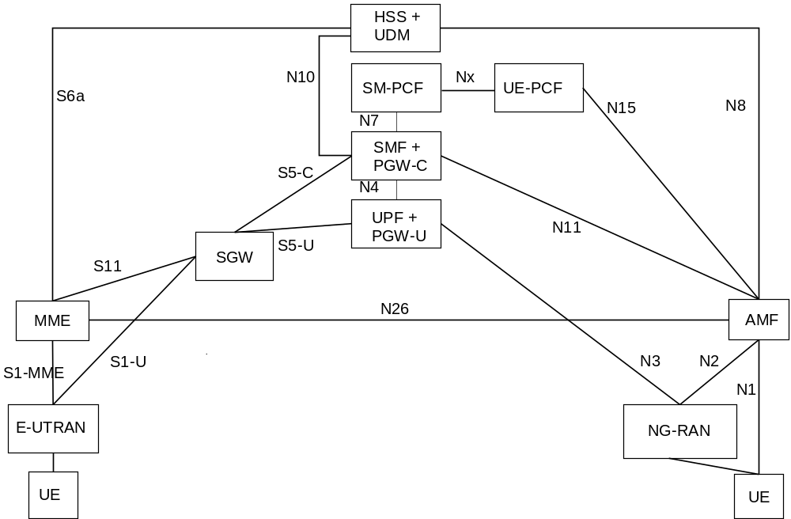
Figure 6.20.1-1 Non-roaming architecture for URSP delivery to the UE in EPS
The key points of the solution are as follows:
- The UE in EPS initiates the UE Policy delivery from the network. When the UE has the list of PSIs, the UE includes the list of PSIs into the UE Policy Container, and includes the UE Policy Container to PCO. The UE sends this PCO to the SMF+PGW-C during the Initial Attach procedure, as described in clause 5.3.2.1 in TS 23.401 [8].
- The SMF+PGW-C invokes Npcf_SMPolicyControl_Update Request to the SM-PCF to transfer the UE Policy Container received from the UE to the UE-PCF, and to retrieve the latest PSIs from the UE-PCF.
- The SM-PCF establishes the UE-PCF Association with the UE-PCF which is identified UE-PCF ID received from the SMF+PGW-C.
Editor's note: It is FFS, how the SMF+PGW-C can know the UE-PCF ID.
- The UE-PCF gets policy subscription related information and the latest list of PSIs from the UDR, and creates the UE policy container including UE policy information as defined in clause 6.6 of TS 23.503 [4]. UE-PCF decides to provide the created UE policy container to the UE.
- When the UE-PCF decides to provide the latest or updated list of PSIs to the UE, the UE-PCF provides to SM-PCF the UE Policy Container, and the SM-PCF forwards it to the SMF+PGW-C.
- The SMF+PGW-C includes the UE Policy Container within the PCO, and delivers to the UE. When the UE Policy delivery is initiated by the UE, the Initial Attach procedure (described in clause 5.3.2.1 in TS 23.401 [8]) is used. When the UE Policy delivery is initiated by the UE-PCF, the PDN GW initiated bearer modification without bearer QoS update procedure (specified in clause 5.4.3 of TS 23.401 [8]) is used.
Editor's note: It is FFS, whether and how to handle the UE Policy Association established in 5GS when the UE moves to EPS. When the established PDU Session is moved to EPS, and if the same UE-PCF needs to be selected (e.g. when the UE-PCF was notified about UE policy information delivery failure in 5GS described in TS 23.503 [4]), whether not to terminate the UE Policy Association and whether/how to receive PCF Selection Assistance Info and UE-PCF ID from the UDM (as described in clause 6.3.7 in TS 23.501 [2]) can be further studied.

6.20.2 Procedures

6.20.2.1 UE Policy delivery procedure initiated by the UE in EPS
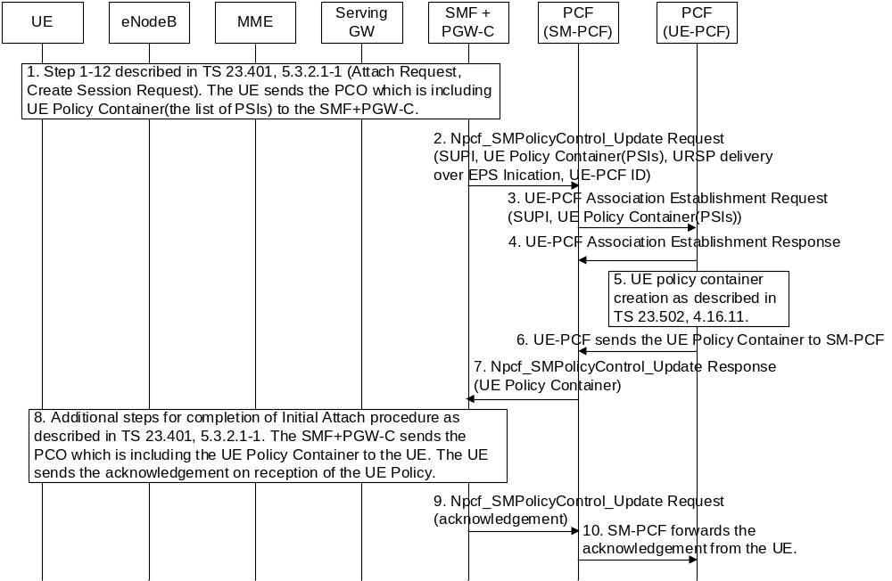
Figure 6.20.2-1: UE Policy delivery procedure initiated by the UE in EPS

- UE sends the PCO which is including UE Policy Container (the list of PSIs stored in the UE is included) to the SMF+PGW-C. The step 1 to 12 described in Figure 5.3.2.1-1 of TS 23.401 [8] is used. The PCO can be included in Attach Request and Create Session Request.
- The SMF+PGW-C invokes Npcf_SMPolicyControl_Update Request to the SM-PCF to forwards the UE Policy Container to the SM-PCF. The SMF+PGW-C provides SUPI, URSP delivery over EPS Indication and UE-PCF ID to the SM-PCF. The SM-PCF can notice that the UE-PCF Association Establishment with UE-PCF is allowed in this network by the presence of URSP delivery over the EPS Indication.
- The SM-PCF establishes the UE-PCF Association with the UE-PCF which is identified UE-PCF ID received from the SMF+PGW-C, and forwards the UE Policy Container to the UE-PCF.
Editor's note: It is FFS, how the SMF+PGW-C can know the UE-PCF ID.
- The UE-PCF sends to SM-PCF the UE-PCF Association Establishment Response with result of UE-PCF Association establishment result.
- The UE-PCF gets policy subscription related information and the latest list of PSIs from the UDR using Nudr_DM_Query service operation. The UE-PCF creates the UE policy container including UE policy information as defined in clause 6.6 of TS 23.503 [4]. (step 6 of Figure 4.16.11-1 of TS 23.502 [3] can be reused)
- When the UE-PCF decides to provide the UE policy to the UE, the UE-PCF sends to SM-PCF the UE Policy Container.
- The SM-PCF forwards the UE Policy Container to the SMF+PGW-C by Npcf_SMPolicyControl_Update Response.
- The Initial Attach procedure is continued as described in Figure 5.3.2.1-1 of TS 23.401 [8]. The SMF+PGW-C sends the PCO which is including the UE Policy Container to the UE. The PCO can be included in Attach Accept. The UE sends the acknowledgement on successful reception of the UE Policy to the SMF+PGW-C, this acknowledgement can be included in the Attach Complete and Modify Bearer Request.
- The SMF+PGW-C forwards the UE’s acknowledgement by invoking Npcf_SMPolicyControl_Update Request to the SM-PCF.
- The SM-PCF forwards the UE’s acknowledgement to the UE-PCF.

6.20.2.2 UE Policy delivery procedure initiated by the PCF
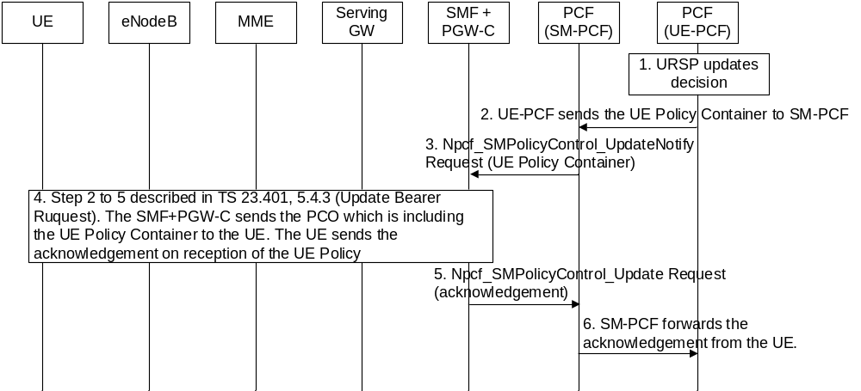
Figure 6.20.2-1: UE Policy delivery procedure initiated by the PCF
- The UE-PCF is notified from the UDR that the URSP is updated.
- The UE-PCF sends to SM-PCF the UE Policy Container which includes the updated URSP.
- The SM-PCF forwards the UE Policy Container to the SMF+PGW-C by Npcf_SMPolicyControl_UpdateNotify Request.
- The SMF+PGW-C sends the PCO which is including the UE Policy Container to the UE. The step 2 to 5 described in Figure 5.4.3-1 of TS 23.401 [8] is used. The PCO can be included in Update Bearer Request, Downlink NAS Transport, and Direct Transfer. The UE sends the acknowledgement on successful reception of the UE Policy to the SMF+PGW-C, this acknowledgement can be included in Direct Transfer, Uplink NAS Transport, and Update Bearer Response.
- The SMF+PGW-C forwards the UE’s acknowledgement by invoking Npcf_SMPolicyControl_Update Request to the SM-PCF.
- The SM-PCF forwards the UE’s acknowledgement to the UE-PCF.

6.20.3 Impacts on services, entities and interfaces
SMF+PGW-C
- Shall be able to include the UE Policy Container received from the PCF into the PCO, and forward to the UE via SGW and MME transparently.
- Shall be able to forward the UE Policy Container from the UE to the UE-PCF.
- Shall be able to provide the UE-PCF ID to SM-PCF.
Editor's note: It is FFS, how the SMF+PGW-C can know the UE-PCF ID.
- Shall be able to forward the acknowledgement of UE reception of the UE Policy to the PCF.
PCF
- Shall be able to create association between the PCF (PCF instance) supporting N7 reference point (i.e. SM-PCF) and the PCF (PCF instance) supporting N15 reference point (i.e. UE-PCF).
- Shall be able to provide to SMF+PGW-C, the UE Policy Container which includes the UE Policy for the UE in EPS.
UE:
- Shall be able to store the URSP received over EPS entities.
- Shall be able to send the acknowledgement of UE reception of the UE Policy to the PCF over EPS entities.
- Shall be able to send the list of PSIs stored in the UE to the PCF by encapsulating in UE Policy Container, and by including the UE Policy Container into PCO over EPS entities.

6.21 Solution #21: Traffic Category with existing mechanism

6.21.1 Description
It is proposed to reuse the current Traffic Descriptor (TD) type to represent Traffic Category.
Option 1:
Introduce new special DNN in the TD to represent Traffic Category. DNN is composed of Network Identifier and optionally Operator Identifier. Network Identifier has a maximum length of 63 octets. It is enough to have standardized traffic categories. If it is an operator specific traffic category, Operator Identifier is involved.
The applications that shares the same traffic category should be mapped to the same DNN in the TD.
It is proposed to have following DNNs considering the requirement from Enterprise, Gaming or Video Streaming Service:
- Enterprise
- Gaming
- Video Streaming
- Enterprise and Gaming
- Enterprise and Video Streaming
NOTE 1: The DNN in corresponding Route Selection (RSD) could be different if the real DNN of the application is not the same as the one in TD as described in clause 6.6.2.1, TS 23.503 [4].
NOTE 2: It is assumed that the operator will allocate proper DNN to an application with considering its traffic category.
NOTE 3: To cover the case that an application may share different traffic categories, DNN could be combination of different categories.
Option 2:
Introduce new standardized Application descriptor. A new OS Id value which means “Traffic Category” Type should be defined. the maximum length of OS App Id is 256 octets. It is enough to have standardized traffic categories and operator specific Traffic Categories.
It is proposed to have following application descriptors considering the requirement from Enterprise, Gaming or Video Streaming Service:
- Enterprise
- Gaming
- Video Streaming
NOTE 4: More than one application descriptors can be provided in TD as described in clause 6.6.2.1, TS 23.503 [4]. Thus no need to introduce new application descriptors as combination of different categories.
Editor’s note: It is FFS whether DNN or OSid could be reused.

6.21.2 Procedures
No new procedure will be introduced. The PCF will transfer the URSP to the UE via UE Configuration Update procedure as defined in clause 4.2.4.3 of TS 23.502 [3]

6.21.3 Impacts on services, entities and interfaces
UE/PCF:
Need to support the new standardized value of DNN/Application Descriptor in the Traffic descriptor.

6.22 Solution #22: UE provisioned/configured with a mapping of application traffic to traffic categories

6.22.1 Description
Editor's note: This clause will describe the solution principles and architecture assumptions for corresponding key issue(s) which should be explicitly stated. Clause(s) may be added to capture details.
A general description of the solution is as follows:
- A UE is provisioned/configured with a mapping of Application Traffic to a Traffic Category (or one or more traffic categories). The UE may be configured with such mapping from an Application Function or from the PCF or based on pre-configuration. If provisioned by the PCF this mapping information is sent outside of a URSP rule, i.e. a new rule within UE policy information (ATC rule).
- When the UE receives such mapping, when the UE detects new Application Traffic the UE associates the application to the corresponding traffic category.
- The existing traffic descriptors defined in URSP rules can be used to map Application Traffic to one or more Traffic Categories. For example
- An application with Application Descriptor (com.android.app1) is mapped to Traffic Category: "Gaming".
- An application sending traffic to a specific destination IP 3 tuple mapped to Traffic Category: "Streaming."
- Domain Descriptors (e.g. FQDN requested) mapped to one or more traffic categories.
- In such case the UE associates the destination IP addresses received in a DNS response to a traffic category
- Non-IP descriptors mapped to one or more traffic categories
- An application requesting DNN "IMS" is mapped to Traffic Category "Voice"
- An Application requesting connection capability for MMS is mapped to Traffic Category "Media".
- The URSP rule is enhanced with a Traffic Category Traffic Descriptor
- When the UE receives URSP rules with Traffic Categories traffic descriptor then the UE uses the configuration received from the AF/PCF to associate detected application traffic to a traffic category and consider the URSP rule matched when the Traffic Category of the URSP rule matches the traffic category of the application.

The solution can support both MNO specific and standardised traffic categories. The encoding of the Traffic Category can be defined in stage 3. For example, standardised traffic category can be encoded as a bit map as follows:
- Bitmap: 00000001 → Gaming (Standardised)
- Bitmap: 00000002 → Voice (Standardised)
- Bitmap: 00000003 → Reserved for operators (MNO specific)

The solution has the advantage that the rules to associate an application (or application traffic) are provided by the MNO and does not rely on the application in the UE or the OS layer in the UE to indicate a traffic category for an application traffic.
The procedures are shown in the next clause.

6.22.2 Procedures
Editor's note: This clause describes high-level procedures and information flows for the solution.

6.22.2.1 Association of application traffic to a Traffic Category
The UE associates application traffic to a traffic category based on "Application to Traffic Category" (ATC) rules received from the AF or the PCF. The rules provide information on how Application Traffic is mapped to a traffic category.
The PCF can provide ATC rules to the UE using the UE configuration update for transparent policy deliver. The ATC rules are sent outside of URSP rule as a new type of rule within UE policies provisioned by the PCF. The UE can include ATC rules within a specific Policy Section identified by a Policy Section Identifier. The PCF may determine the ATC rules the UE requires based on the operating system supported by the UE. The procedure is shown in the figure below.

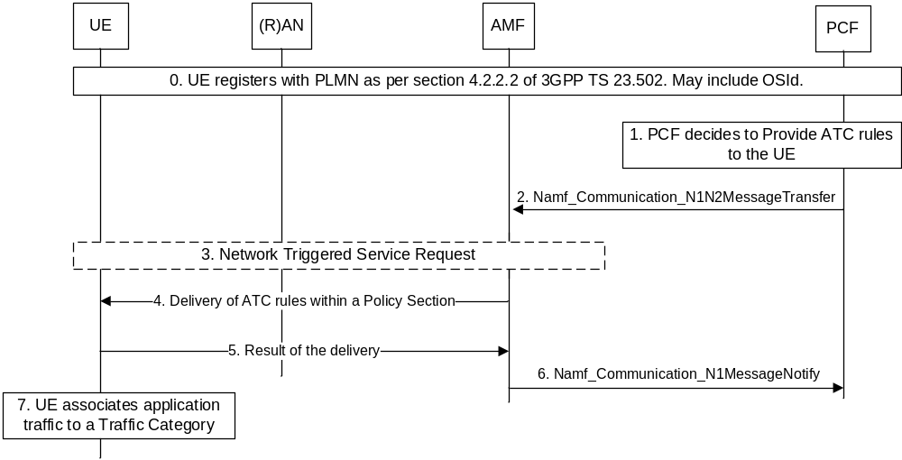
Figure 6.22.2.1-1: PCF provisioning Application to Traffic Categories Rules
0. UE registers to the PLMN as per 3GPP TS 23.502 [3]. The UE may include OSId of its operating system and a list of Policy Sections (identified by a PSI) installed at the UE. During registration the AMF selects a PCF for AM and SM policies.
1. The PCF determines that ATC rules are needed to be provided to the UE. The PCF determines based on:
- A policy section identified by a PSI is not installed at the UE or the policy section identifier provided by the UE that includes ATC rules requires updating.
- A trigger from the UDM/UDR
2. The PCF sends ATC rules to the AMF via an Namf_Communication_N1N2Message transfer service operation based on the UE Configuration Update for transparent policy delivery.
3. The AMF transparently sends the ATC rules to the UE. If the UE is in IDLE the AMF triggers a network triggered service request
4. The ATC rules are sent to the UE via a NAS Downlink transport message
5. The UE installs the rules and provides the result to the AMF via a NAS Uplink transport messasge.
6. The AMF forwards the ack to the PCF.
7. The UE associates applications to a traffic category based on the ATC rules

An Application Function may also provide ATC rules to the UE as shown in the figure below.

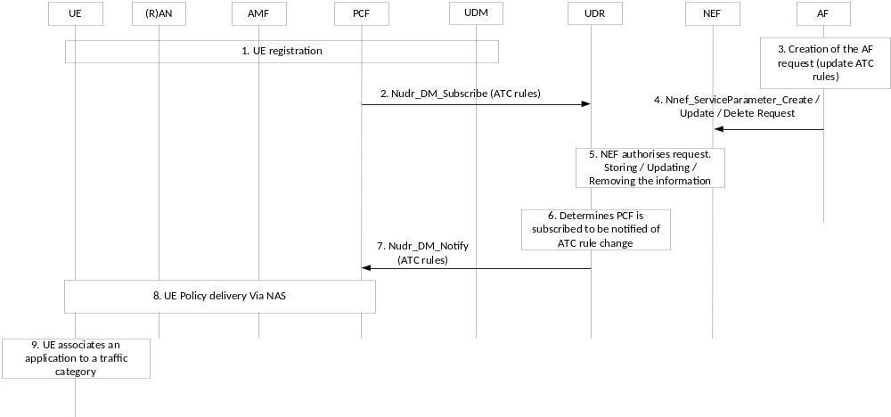
Figure 6.22.2.1-2: AF provisioning ATC rules to a UE
1. The UE registers with the PLMN network as per 3GPP TS 23.502 [3].
2. The PCF subscribes from the UDR to be notified of change/update of ATC rules.
3. The AF decides to update ATC rules for a UE.
4. The AF sends an Nnef_ServiceParameterCreate request including parameters for ATC rules determination.
5. The NEF authorizes the request and stores the ATC rules in the UDR. The NEF stores the AF request information in the UDR as the "Application Data" (Data Subset setting to "Service specific information") together with the assigned Transaction Reference ID.
6. The UDR determines that the PCF needs to be notified.
7. The UDR notifies the PCF in a Nudr_DM_Notify service operation.
8. The PCF sends update ATC rules using the UE Configuration Update procedure for transparent policy delivery (as per steps 2-6 of Figure 2.3).
9. The UE associates application to an application category based on the ATC rules.

6.22.2.2 Enhancing URSP rule with a Traffic Category Traffic Descriptor
The URSP rule is enhanced to include a Traffic Category Traffic Descriptor. How the Traffic Category Traffic Descriptor is encoded is up to stage 3 design.
When the UE is provisioned with a URSP rule containing a Traffic Category traffic descriptor then for every detected application traffic the UE considers this URSP rule applicable when the Traffic Category of the application detected matches the Traffic Category of the Traffic Descriptor in the URSP rule.
If the UE has received URSP rules with Traffic Category traffic descriptors but the UE did not receive ATC rules or cannot identify the traffic category of the application traffic detected (i.e. the ATC rules do not provide any association for the application traffic detected) the UE considers the rule not applicable and moves to the next URSP rule in the order of precedence.
An example implementation is shown in the figure below.
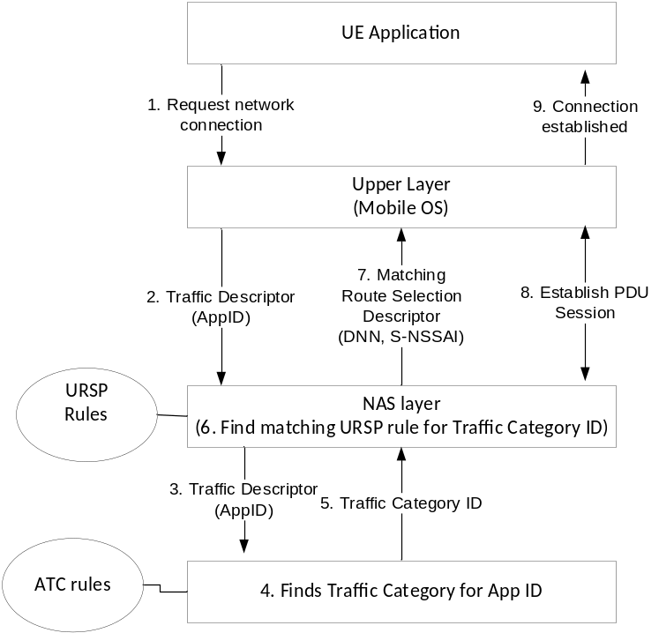
Figure 6.22.2.2-1: Example implementation for Traffic Classification and matching a URSP rule based on Traffic Category
1. An application in a UE requests a network connection from the operating system in the UE
2. The mobile operating system requests a network connection including the AppID of the application
3. The UE determines that URSP rules include Traffic Categories Traffic Descriptor and determines a Traffic Category
4. The UE finds the traffic category based on the ATC rules
5., 6. The UE finds a matching URSP rules based on the Traffic Category ID
7.8. A PDU session is established based on the RSD of the matched URSP rule.
9. The Mobile OS notifies the application that a connection is established.

6.22.3 Impacts on services, entities and interfaces
Editor's note: This clause captures impacts on existing 3GPP nodes and functional elements.
- URSP rule is enhanced with a new Traffic Descriptor for supporting Traffic Category
- New Policy Section is defined to include ATC rules

6.23 Solution #23: Support standardized and operator-specific traffic categories in URSP

6.23.1 Description
As per the LS received from GSMA, the traffic generated by a UE could be grouped into various traffic categories, enabling each traffic category to be handled differently, e.g., mapped to a different slice. Some example traffic categories are as below:
Enterprise: Traffic from one or more applications related to an Enterprise service.
Gaming: Traffic from one or more applications related to Gaming service, e.g., with low latency requirement.
Video Streaming: Traffic from one or more applications related to Video Streaming, e.g., HD video streaming, 4K video streaming.
A new component "traffic category" is introduced in the traffic descriptor part of the URSP rule. The "traffic category" shall support standardized values specified by 3GPP and values that are reserved for operator specific traffic categories. For example, the Traffic category can be encoded as below (this is a stage 3 decision):
Bits
8 7 6 5 4 3 2 1
0 0 0 0 0 0 0 1 Enterprise
0 0 0 0 0 0 1 0 Gaming
0 0 0 0 0 0 1 1 Video Streaming
0 0 0 0 0 1 0 0
to
0 1 1 1 1 1 1 1 Spare for standardized traffic categories
1 0 0 0 0 0 0 0
to
1 1 1 1 1 1 1 1 Reserved for Operator specific traffic categories

Editor's Note: It is FFS whether a new TD component "traffic category" is introduced or to re-use/extend an existing TD component e.g. Connection capabilities to support the new standardized and operator defined traffic categories.
An application can indicate a traffic category in its request which the UE then matches with the traffic category component in the Traffic Descriptor of the URSP rule. Only one traffic category can be included in a single request. However, a single application may indicate different traffic category in different requests, for example, an application may indicate one traffic category in the traffic descriptor for IM or chat session while it may indicate a different traffic category in the traffic descriptor for live video or streaming etc. A given traffic category can be simultaneously used by multiple applications.
An application may request any traffic category from the traffic category values standardized by 3GPP or from the operator specific traffic category values.
Editor's Note: It is FFS whether and how the UE or the Network verifies that an application is requesting for the correct traffic category.

6.23.2 Procedures
When an application starts, or at a later time, it may request for a specific traffic category. The traffic categories are defined by the 3GPP and are independent of the Operating System used in the UE. The traffic category requested by an application may be either a traffic category standardized by the 3GPP or a value that is specified by the MNO. The application requests a traffic category in a way similar to existing traffic descriptors, which is then pushed to the URSP layer transparently through the OS layer. Traffic categories shall be transparent to the OS layer to allow MNOs to define operator-specific traffic categories and still enable the application to request for such traffic categories.
NOTE 1: The implementation details of how the application indicates the requested traffic category are outside the scope of 3GPP.
A UE of a previous release that does not support "Traffic Category" shall ignore the URSP rules with "Traffic Category" as per clause 4.2.3 Unknown or unexpected URSP rules of TS 24.526 [10].
NOTE 2: Based on UE implementation, if the UE does not support "Traffic category" TD request for "Traffic category" by an application can be disabled.

6.23.3 Impacts on services, entities and interfaces
The solution has the following impacts:
PCF:
- PCF shall support the new parameter "traffic category" in traffic descriptor part of the URSP rule.
UE:
- UE shall support receiving "traffic category" from the application and match it with the "traffic category" component in the Traffic Descriptor provided as part of the URSP rule.

6.24 Solution #24: Introduction of Traffic Category into URSP rules

6.24.1 Description
In order to have no impact or further work to application layer, a new mapping rules can be introduced to UE of traffic category.
The application on UE still use the original parameters in Traffic Descriptor to describe the features of application traffic, for example, the FQDN, DNN or IP-5-tuple. And before the UE maps the application traffic to specific PDU session that RSDs corresponds to, the UE should map the application traffic to a specific traffic category.
For example, according to the FQDNs, the UE can identify the traffic category belongs to video or music. Also, according to the destination IP address of application traffic, the UE can identify the traffic category as enterprise because the IP address located in the IP range that the enterprise served.
According to this design, one of the examples of introducing traffic category are listed below:
Table 6.24.1-1: Example of URSP rules contains traffic category
Example URSP rules
Traffic Descriptor |  | Route Selection Descriptor
Traffic Descriptor | Traffic Category
Rule Precedence =1  Traffic Descriptor: Application descriptor=App1 | Traffic Category = video | Route Selection Descriptor Precedence=1  Network Slice Selection: S-NSSAI-a  SSC Mode Selection: SSC Mode 3  DNN Selection: internet  Access Type preference: 3GPP access  Route Selection Descriptor Precedence =2  Network Slice Selection: S-NSSAI-a  Access Type preference: Non-3GPP access
Rule Precedence =2  Traffic Descriptor: Application descriptor=App2 | Traffic Category = video
Rule Precedence =3  Traffic Descriptor: Application descriptor=App2 | None | Route Selection Descriptor Precedence=1  Network Slice Selection: S-NSSAI-a  SSC Mode Selection: SSC Mode 1  DNN Selection: internet  Access Type preference: 3GPP access
Rule Precedence =4  IP Descriptor = 10.1.1.1 | Traffic Category = Enterprise | Route Selection Descriptor Precedence = 1  Non-seamless Offload indication: Permitted (WLAN SSID-a)
Rule Precedence =5  Traffic Descriptor: Application descriptor=App2 | Traffic Category = Enterprise
Rule Precedence =6  Domain Descriptor = ABC.com | Traffic Category = Game | Route Selection Descriptor Precedence=1  Network Slice Selection: S-NSSAI-b  SSC Mode Selection: SSC Mode 2  Route Selection Descriptor Precedence =2  Access Type preference: Non-3GPP access
Rule Precedence =7  DNN = local.DN.1 | Traffic Category = Game

NOTE1: It is up to operator’s configuration that whether the application traffic matched by a Traffic Descriptor directly to the RSD or to the Traffic category. The mapping rules between Traffic Descriptor and Traffic category can be co-existed with the original mapping rules between Traffic Descriptor and RSD.
NOTE2: As the example above, the operators can set the one mapping from Traffic Descriptor to RSD as higher or lower precedence than the mapping from Traffic Descriptor to Traffic category. This depends on the PCF’s designation of URSP rules.
Editor’s note: Whether the “traffic category” as a part of TD or a new layer in the URSP rule is FFS.
And after mapping to specific traffic category, how to apply the application traffic to RSDs are reuse the mechanism in current URSP rules.
Also, one application traffic can be mapped to multiple Traffic category. For example, one application traffic which has the feature of Application descriptor, can be mapped to Traffic Category = Enterprise or Traffic Category = Game at the same time.

6.24.2 Procedure
After UE receives the URSP rules from PCF, the UE should do the following steps:
1. Mapping the application traffic to Traffic Descriptor, as the existing URSP rules mechanism.
2. According to the Traffic Descriptor that the application mapping to, the UE has the two selection according to the URSP rules delivered by PCF:
- (Existing mechanism in URSP rules) After the application traffic is matched to a certain Traffic Descriptor, the UE can select a RSD to apply the application traffic to PDU session or trigger a PDU session establishment to apply the application traffic;
- The UE selects the Traffic category according to the Traffic Descriptor that the application traffic matched. One application traffic can be mapped to several of the Traffic Category. It depends on the designation of URSP rules by PCF. And after the Traffic category, the UE can select a RSD to apply the application traffic to PDU session or trigger a PDU session establishment to apply the application traffic.

3. After determination of the Traffic Category, the UE applies the application traffic to specific PDU sessions according to the RSDs defined for Traffic Category. This is the same procedure as defined from Traffic Descriptor to Traffic Category.
NOTE1: It is up to operator’s configuration that whether the application traffic matched by a Traffic Descriptor directly to the RSD or to the Traffic category. The mapping rules between Traffic Descriptor and Traffic category can be co-existed with the original mapping rules between Traffic Descriptor and RSD.
NOTE2: As the example above, the operators can set the one mapping from Traffic Descriptor to RSD as higher or lower precedence than the mapping from Traffic Descriptor to Traffic category. This depends on the PCF’s designation of URSP rules.

6.24.3 Impacts on services, entities and interfaces
Editor's note: This clause lists impacts to services and interfaces.
PCF:
- Introduce Traffic Category into URSP rules, and design the mapping rules from Traffic Descriptor to Traffic Category, and from Traffic Category to RSD.
UE:
- Mapping the application traffic which belongs to the specific Traffic Descriptor to Traffic Category.
- Apply the application traffic to a specific PDU session according to the mapping between Traffic Category to RSD.

6.25 Solution #25: Support standardized and operator-specific traffic categories in URSP

6.25.1 Description
In the current specification, application descriptors (short for ‘APP ID’) is defined as one TD in URSP rules. Application descriptors is used to identify the Application(s) that is(are) running on the UE's OS as specified in TS 23.503 [4] clause 6.6.2 “UE Route Selection Policy information”.
To resolve the KI#4, application descriptors as one TD in URSP rules is to leverage for supporting standardized and operator-specific traffic categories in URSP. The special value of application descriptors can be defined or used for standardized and operator-specific traffic categories, and other value of application descriptor can be used for non-special application(s).
For example:
- Assuming that there are standardized and operator-specific traffic categories like “vedio”, “games”, “streaming”, , and “enterprise”;
- So the following application descriptors value can be defined or used for standardized and operator-specific traffic categories:
Special value of application descriptors (short for ‘APP ID’) | standardized and operator-specific traffic categories
APP ID= aaaa | video
APP ID= bbbb | games
APP ID= cccc | streaming
APP ID= dddd | enterprise
…… | ……

So the solution to reuse the application descriptors as one TD in URSP rules to define special value for standardized and operator-specific traffic categories in URSP has meet the Key issue#4.

6.25.2 Procedures
The solution reuses existing procedures.

6.25.3 Impacts on Existing Nodes and Functionality
None.

6.26 Solution #26: Traffic categories based on 5G QoS characteristics

6.26.1 Description
The 5G QoS characteristics describe the edge-to-edge packet treatment received by a QoS flow between the UE and UPF as described in clause 5.7.3 of TS 23.501 [2] in terms of various performance characteristics. These performance characteristics include Resource type (GBR, non-GBR), Priority level, Packet delay budget, Packet error rate, Averaging window, Maximum data burst volume, etc. Standardized 5QI values are specified for services that are frequently used and the one-to-one mapping between standardized 5QI values and the 5G QoS performance characteristics is specified in table 5.7.4-1 of TS 23.501 [2].
A new component "traffic category" is introduced in the traffic descriptor part of the URSP rules to support standardized values specified by 3GPP and values that are reserved for operator specific traffic categories. The encoding of these traffic categories can be specified in stage-3 in TS 24.526 [10].

6.26.1.1 Traffic categories based on service type
Traffic categories can be defined based on type of service handled by an application. As an example, enterprise class applications could include traffic categories for email, browsing, chat, conferencing, voice, etc. Similarly gaming applications could include real-time gaming, interactive gaming and other games which could include XR type of traffic as well. Similarly, video streaming class of applications could also include live or buffered streaming, HD streaming, 4K streaming traffic, etc. For each of these service types, the traffic categories can then be mapped to specific 5G QoS performance characteristics as specified in table 5.7.4-1 of TS 23.501 [2]. In addition to different well-known services, traffic categories can also be operator specific or even have specific QoS attributes or parameters that may not map to a well-known service.
The traffic category values depend on the intended granularity of the categorization. They can be either defined based on different high level application classes or service types such as Enterprise, Gaming, Streaming, Operator specific, etc., or they can be defined with finer granularities, e.g. voice, conferencing, real-time gaming, interactive gaming, live streaming, buffered streaming, etc. These finer granular values may belong to one or more high level application classes or service types and can better assist in mapping specific application traffic or flows to appropriate slices.
The values of 5G QoS performance characteristics are reproduced below from table 5.7.4-1 of TS 23.501 [2] for easy reference.
Table 6.26.1.1-1: Traffic categories based on Service type of different applications
Traffic Category | 5QI  Value | Resource Type | Default Priority Level | Packet Delay Budget | Packet Error  Rate | Default Maximum Data Burst Volume | Default  Averaging Window
Enterprise Class
Voice traffic | 1 | GBR | 20 | 100 ms | 10⁻² | N/A | 2000 ms
Email, browser, chat | 6 | Non-GBR | 60 | 300 ms | 10⁻⁶ | N/A | N/A
Conferencing | 2 | GBR | 40 | 150 ms | 10⁻³ | N/A | 2000 ms
Gaming Class
Real time Gaming | 3 | GBR | 30 | 50 ms | 10⁻³ | N/A | 2000 ms
Interactive Gaming | 7 | GBR | 70 | 100 ms | 10⁻³ | N/A | N/A
Augmented Reality | 80 | GBR | 68 | 10 ms | 10⁻⁶ | N/A | N/A
Video Streaming Class
Live streaming | 71 | GBR | 56 | 150 ms | 10⁻⁶ | N/A | 2000 ms
Buffered Streaming | 8 | Non-GBR | 80 | 300 ms | 10⁻⁶ | N/A | N/A
HD Streaming | 90 | Delay-critical GBR | 25 | 20 ms | 10⁻⁴ | 63000 bytes | 2000 ms

NOTE: The above traffic categories are just illustrative examples, other traffic categories may be added as needed.

6.26.1.2 Traffic categories based on Traffic characteristics
Traffic categories can also be defined directly based on traffic characteristics and the specific QoS attributes could have a relative priority level. As an example, for a certain class of traffic, there could be relative priority among the QoS attributes latency and bandwidth (e.g., low latency and high bandwidth with latency as higher priority). Priority can be given to single or multiple QoS attributes (e.g., prioritize latency and packet error rate over bandwidth for voice traffic, prioritize latency and bandwidth over packet error rate for gaming or video streaming traffic, etc.).
Editor’s note: The different attributes to characterize traffic are for further discussion.
The traffic categories could be defined as follows based on different traffic characteristics.
Table 6.26.1.2-1: Traffic categories based on Traffic characteristics of different applications
Traffic Category |  |  | Service Type | Usage examples
Latency | Loss | Bandwidth
Low | Normal | Low | Real-time online interaction | Games
Normal | Normal | Normal | Default bearer | Best Effort. Default service class; pretty much a mix of everything.
High | Low | High | Video Streaming | Youtube, Netflix, Hulu
High | Normal | High | AR/VR
High | Normal | Normal | Background | Bulk data upload
High | High | Normal | Background (alt) | "Background", user-initiated, high delay tolerant, high loss tolerant, elastic flow, variable size. E.g., user-initiated iCloud synching or Time Capsule backup; or traffics of background applications, for which there is some progress feedback.
Any | Any | Any | Off Peak Data/Cost | Push traffic

NOTE: The above traffic categories are just illustrative examples, other traffic categories may be added as needed.

6.26.2 Procedures
Different applications know the kind of traffic they can generate, and they can classify the traffic based on the above defined traffic categories. An application may request for a specific traffic category from the execution environment (OS). Such a request triggers the UE to determine whether this new application traffic can be associated to an established PDU session, or the UE needs to establish a new PDU session based on URSP rules including the matching traffic category in the traffic descriptor. The requested traffic category by the application may be either a standardized value specified by 3GPP or an operator specific value. Traffic categories are transparent to the execution environment (OS) to allow operators to define operator specific traffic categories.
NOTE: The implementation details of how the application indicates the requested traffic category to the execution environment (OS) are outside the scope of 3GPP.

6.26.3 Impacts on services, entities and interfaces
UE:
- Able to process application requested traffic category and match it with the traffic category component of the traffic descriptor provided as part of the URSP rule.
PCF:
- Introduce traffic category into URSP rules and design the mapping rules of traffic categories.

6.X Solution #X: <Solution Title>

6.X.1 Description
Editor's Note: This clause will describe the solution principles and architecture assumptions for corresponding key issue(s) which should be explicitly stated. Sub-clause(s) may be added to capture details.

6.X.2 Procedures
Editor's Note: This clause describes high-level procedures and information flows for the solution.

6.X.3 Impacts on services, entities and interfaces
Editor's Note: This clause captures impacts on existing 3GPP nodes and functional elements.

7 Overall Evaluation
Editor’s Note: This clause will provide evaluation of different solutions.

8 Conclusions
Editor's Note: This clause will list conclusions that have been agreed during the course of the study item activities.

Annex A:
Change history
Change history
Date | Meeting | TDoc | CR | Rev | Cat | Subject/Comment | New version
2022-02 | SA2#149e | S2-2200665 |  |  |  |  | 0.0.0
2022-03 | SA2#149e |  |  |  |  | Implement following approved papers at SA2#149e: S2-2200665, S2-2200662, S2-2200663, S2-2201362, S2-2201363, S2-2201364, S2-2201858. | 0.1.0
2022-04 | SA2#150e |  |  |  |  | Implement following approved papers at SA2#150e: S2-2203610, S2-2203609, S2-2202476, S2-2202557, S2-2203112, S2-2203594, S2-2203113, S2-2203114, S2-2203115, S2-2202475, S2-2203116, S2-2203117, S2-2203118, S2-2203119, S2-2203120, S2-2203121, S2-2202452, S2-2203122, S2-2203123, S2-2203124, S2-2203125, S2-2203126, S2-2203127, S2-2203128, S2-2202701, S2-2203129. | 0.2.0

