3GPP SA2 FS_5MBS Conference call

Date:
2020/08/06

Convener:
LiMeng (rapporteur – Huawei)

List of participants:
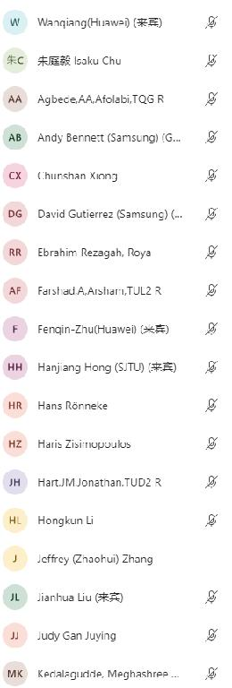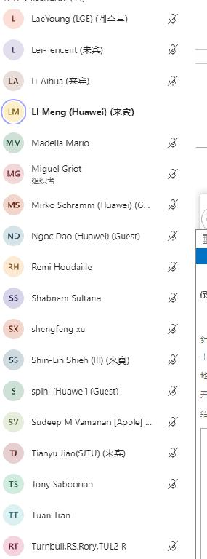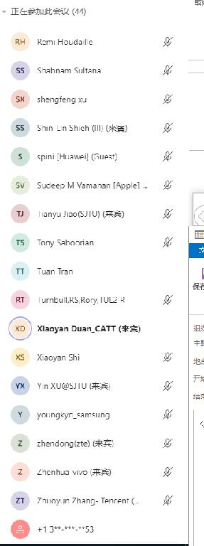

Minutes

0. Architectural assumptions

001: Converged architecture for 5MBS (Rapporteur).
Presented by LiMeng
Discussion
Better to rename the architecture, “5G MBS system architecture” could be fine.
David (Samsung): On the role of MBSF, if go with the first sentence of NOTE Y, then it is option #1, not combined.
Miguel (Qualcomm): But without that it would be option #2.
Jianhua (OPPO): If we agree on this document, how to deal with the current existing solutions?
LiMeng (Huawei): we can update the solutions since most of the solutions have ENs and they need to be updated anyway.
David: it would be better to first agree the commonalities of the table as the evaluation criteria.
Hans (Ericsson): What is the relationship between the solutions, and the description in the table? Will the solutions be determined once we figure out the description?
LiMeng: in the table we list both the commonalities and the specific aspects of each architectural options. Once we determine the solution, the description could be updated accordingly.
Fenqin (Huawei): having a combined architecture will be good for further discussion, e.g., solution can refer to the same architecture.
Shabnam (Ericsson): terminology may not be an issue.
Wanqiang (Huawei): If people agree the two architecture options have a lot of commonalities, then there should be no issue to have a converged architecture.
David: agree the benefit, on the architecture we can give it a try, but it would be hard.
Proposed way forward
Change the type of the document to a co-signed one, and work offline with active companies if any wording is acceptable.

002 Merged architecture (CATT)
Presented by Duan, Xiaoyan
Discussion
Miguel: How to guarantee the compatibility of legacy MBMS? Since there is no xMB/MB2 interface mentioned here.
LiMeng: the interfaces between MB-SMF/SMF, MB-UPF/UPF are not mentioned.
David: on the 2nd figure, what it the relationship between unicast? The unicast means the unicast PDU session, or 5GC Individual MBS traffic delivery method?
Hans: reference point based architecture is good.
Wanqiang: Same concern as Miguel, xMB/MB2 issue.
Duan, Xiaoyan (CATT): See commonalities with 001.
Proposed way forward
Off line check with companies, if possible merge with HW’s proposal (001) to have a single architecture document submitted.

1. KI1 (session establishment and management) solutions

101 Summary of feature list for 5MBS evaluation and conclusion (Vivo)
Presented by Zhenhua
Discussion
Zhendong (ZTE): Would like know the purpose of this document.
Zhenhua (vivo): Provide the criteria for evaluation and vivo will provide evaluation proposal for based on this analysis document.
Way forward
Update document and include the text proposal.

102 Principles for Categorization of Solutions for KI1 (Huawei)
Presented by LiMeng
Discussion
Shabnam: It is assumed that rapporteur will send LS to RAN for their feedback on RAN-related issues.
Judy (Ericsson): UP-based join method is included, besides IPTV, is there any other use cases requiring UP-based join? For IPTV the Rel-16 method will be used.
Jeffrey (Juniper): UP based join should be supported. It should be a criteria for evaluation.
Miguel: CP should be mandatory, neutral on UP.
David: supporting UP should be separated from supporting IPTV.
Tuan (Broadpeak): Support UP-based join.
Fenqin: For some other cases, UP-based join is still needed.
Jeffrey: Object the requirement on app knowing TMGI.
Way forward
Update contribution to address above comments.

103: Sol#3: Resolving the open issue(s) of sol.3 (Huawei)
Presented by LiMeng
Discussion
(No instant received).
Way forward
Further offline talking is welcome.

104: Sol#3: Resolving the open issue(s) of sol.3 related to UE leaves MBS (Huawei)
Presented by Fenqin
Discussion
(No instant received).
Way forward
Further offline talking is welcome.

105: Sol#16: Resolving ENs (CATT)
Presented by Xiaoyan
Discussion
LiMeng: the main change proposal of this document is to clarify that the message could be MBS session specific as well, right?
Xiaoyan: For SMF, yes, for PCF, the unicast services would be reused.
Way forward
Further offline talking is welcome.

2. KI3 (Levels of authorization) solutions

201 New solution (Juniper)
Presented by Jeffrey
Discussion
Fenqin: on step 4B, what is the meaning of IE “group”?
LiMeng: please clarify the wording “final result” in step 4C.
Hans: clarify ASP somewhere.
Lei (Tencent): ASP may not be able to differentiate UEs by using the IP address.
Fenqin: GPSI could be used as an alternative of IP address.
Way forward
Update document to address comments.

202 Way forward of KI #3 (Huawei)
Presented by LiMeng
Discussion
(No instant received).
Way forward
Further offline talking is welcome.

4. Other documents

401 Sol#17: Resolving ENs (CATT)
Presented by Duan, Xiaoyan
Discussion
Shabnam: AQP is mandatory?
Fenqin: on N4 rule, is there any specific aspect need to be addressed for multicast use case?
David: on source specific multicast, still not sure whether any enhancement need to be done for multicast on N4.
LiMeng: no need to mention Non-3GPP issue since it is already reflected in architecture assumption section.
Way forward
Consider the necessity of including AQP and update the document to address the comments.

Unhandled documents
- 402: Sol#18: Resolving ENs (CATT);
- 403: Sol#31: Resolving ENs (CATT);
- New Solution-delivery mode switching within single RAN or dual RAN (SJTU)

