SA WG2 Meeting #139E S2-200xxxx
1 - 12 June, 2020, Electronic (revision of S2-2004069, 3554 and 4186)
Source: Intel, Tencent, China Telecom
Title: KI#2, New Solution: UE Agnostic EAS IP address replacement for traffic subject to edge computing
Document for: Approval
Agenda Item: 8.3
Work Item / Release: FS_enh_EC / Rel-17
Abstract of the contribution: This contribution proposes solution for edge computing KI#2 in TR 23.748.

Discussion
This solution addresses the Key Issue #2: Edge relocation.
Based on the KI#2 description , there are 3 basic scenarios of EAS Relocation as following：
- EAS relocation with the same EAS IP address with or without DNAI change.
- EAS relocation with different IP address within the same DNAI.
- EAS relocation with different IP address along with DNAI change.
For the scenario 1), since the EAS IP address does not change, it is anticipated that no sepcial handling is needed and no standards change is needed. This scenario is clearly stated out of scope in the key issue #2:
NOTE 1: It is expected that change of the EAS with no change to the EAS IP address (e.g. due to load balancing, server maintenance) is handled by edge orchestration, and is outside the scope of this key issue, whereas change of EAS with a change to the EAS IP address is in the scope of this key issue.

The solution in this paper aims to solve the scenario 2) and 3) with proposing a UE agnostic solution when the EAS IP address is changed.

The scenario when AF Influence happens before an EC PDU Session is established is described below, but it’s not relevant to EAS relocation, as such it is listed in discussion part for better understanding.

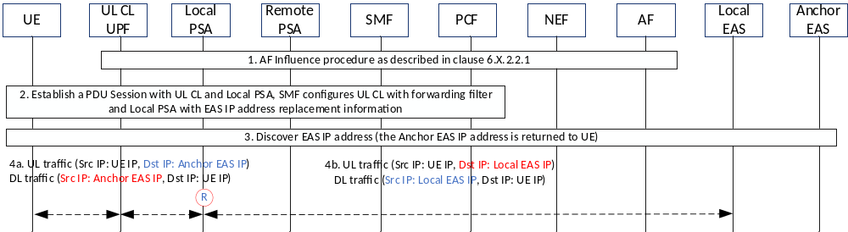
Figure 1: EAS IP address replacement in the beginning of EC Session
- AF Influence procedure as described in clause 6.X.2.2.1. The EAS IP address replacement information is sent to SMF.
- UE requests to establish a PDU Session, SMF decides to add UL CL and Local PSA for the PDU Session.
The UL CL is configured to forward the UL packet with the destination IP address equalling to the Anchor EAS IP address for each EC service to the Local PSA.
The Local PSA is configured to enforce the EAS IP address replacement between the Anchor EAS IP address and Local EAS IP address(es).
- UE discovers the Anchor EAS IP address via EAS Discovery procedure.
- Local PSA starts EAS IP address replacement:
- For UL traffic, the destination IP address is replaced with the Local EAS IP address at Local PSA;
- For DL traffic, the source IP address is replaced back with the Anchor EAS IP address at Local PSA.

* * * * Start of the 1st Change * * * *

6.0 Mapping of Solutions to Key Issues
Table 6.0-1: Mapping of Solutions to Key Issues
Solutions | Key Issues
Solutions | 1 | 2 | 3 | 5
#1: Provisioning URSP configuration to the UE to establish PDU Sessions for edge applications | X
#2: Local DNS based edge server address discovery | X
#3: DNS AF | X
#4: Providing the DNS authoritative server with IP addressing information about where the UE is located | X
#5: Server Discovery using DNS, IP Routing and URSP | X
#6: Discovery of EAS based on DNS | X
#7: SMF/I-SMF selection based on DNAI | X
#X: UE Agnostic EAS IP address replacement for traffic subject to edge computing |  | X

* * * * Start of the 2nd Change (all new text) * * * *

6.X Solution #X: UE Agnostic EAS IP address replacement for traffic subject to edge computing

6.X.1 Description
This solution addresses KI#2: Edge relocation, following aspect is covered:
- How to handle change of the serving EAS (without UE mobility) to support seamless change, e.g. preventing or reducing packet loss.
This solution assumes:
(1) The Edge Hosting Environment can handle the runtime session context mirroring for connection based Protocol (e.g. TCP and DTLS over UDP) with different IP addresses.
(2) There is one Anchor EAS deployed for each EC service.
(3) AF is configured to know the Anchor EAS IP address and can manage the runtime context mirroring between Local EAS and Anchor EAS and between source Local EAS and target Local EAS in order to guarantee the service continuity.
(4) Anchor EAS is introduced to serve several neighbouring Local DNs, when the UE moves within these Local DNs, network will not trigger the UE to re-discover the Anchor EAS.

6.X.2 Procedures

6.X.2.1 Example EAS IP address replacement procedures for different scenarios

6.X.2.1.1 EAS IP address replacement in the middle of EC Session

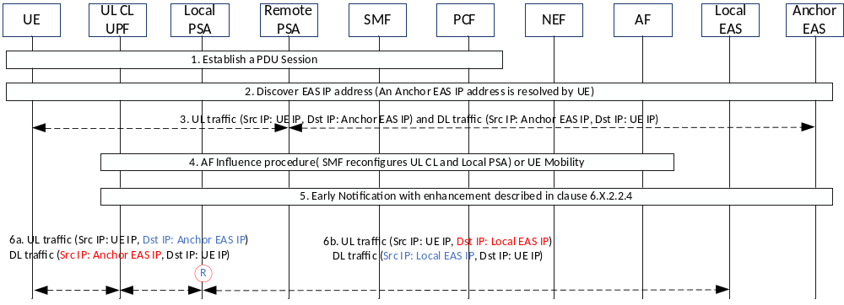
Figure 6.X.2.1.1-1: EAS IP address replacement in the middle of EC Session
- UE requests to establish a PDU Session.
- UE discovers the Anchor EAS IP address via EAS Discovery procedure.
- UE communicates with the Anchor EAS.
- AF Influence happens, the SMF reconfigures the UL CL UPF and Local PSA with EAS IP address replacement information. Or UE moves to an area where the Local PSA has been configured to enforce EAS IP address replacement.
UL CL is configured by SMF to forward the destination IP address in the UL packet equals to the Anchor EAS IP address to Local PSA.
Local PSA is configured by SMF to enforce the EAS IP address replacement as described in step 6.
Detailed enhancement to the AF Influence procedure is described in clause 6.X.2.2.1.
- Early Notification procedure with enhancement described in clause 6.X.2.2.4 is triggered, SMF notifies AF about the current serving EAS IP address (Anchor EAS IP address for this scenario), AF triggers to mirror the runtime context between Anchor EAS and Local EAS. Once the Local EAS is ready, AF responds to SMF about the Local EAS IP address. SMF reconfigures Local PSA for EAS IP address replacement between Anchor PSA and Local PSA.
- Local PSA starts EAS IP address replacement:
- For UL traffic, the destination IP address is replaced with the Local EAS IP address at Local PSA;
- For DL traffic, the source IP address is replaced back with the Anchor EAS IP address at Local PSA.

6.X.2.1.2 UE moves among EC Environments with DNAI and EAS IP address Change
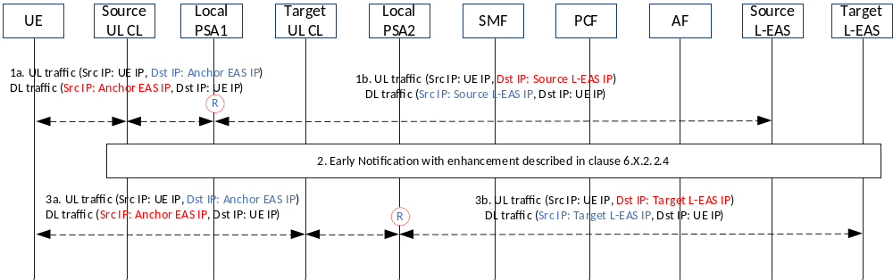
Figure 6.X.2.1.2-1: EAS IP address replacement procedure after DNAI and Local EAS IP address change
- For UL traffic, the destination IP address is replaced with the Source Local EAS IP address at Local PSA; for DL traffic, the source IP address is replaced back with the Anchor EAS IP address at Local PSA.
- Early Notification happens, the SMF notifies AF about the source EAS IP address and source and target DNAI, AF initiates runtime session context migration from source Local EAS to target Local EAS. When the resource in target Local EAS is ready, the AF responds with target Local EAS IP address to SMF. SMF decides whether to relocate UL CL and Local PSA and configures the EAS IP address replacement information in Local PSA2 if PSA relocation happens.
Detailed enhancement to the User Plane Management procedure is described in clause 6.X.2.2.4.
- Local PSA2 starts EAS IP address replacement:
- For UL traffic, the destination IP address is replaced with the Target Local EAS IP address at Local PSA;
- For DL traffic, the source IP address is replaced back with the Anchor EAS IP address at Local PSA.

6.X.2.1.3 EAS IP address Change under same DNAI due to EAS migration
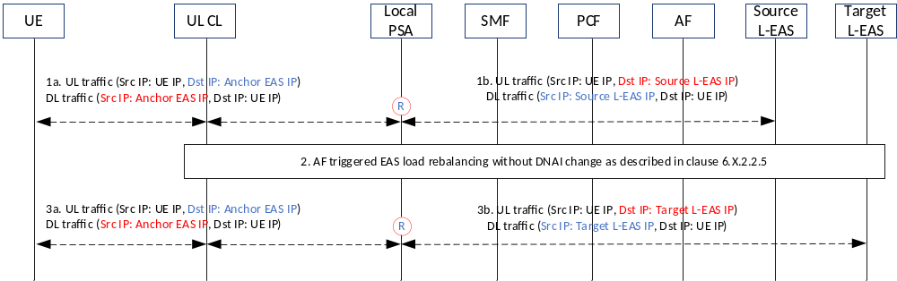
Figure 6.X.2.1.3-1: EAS IP address Change under same DNAI due to EAS migration
- For UL traffic, the destination IP address is replaced with the Source Local EAS IP address at Local PSA; for DL traffic, the source IP address is replaced back with the Anchor EAS IP address at Local PSA.
- AF triggered EAS migration without DNAI change as described in clause 6.X.2.2.5 with enhancement.
- Local PSA starts EAS IP address replacement again:
- For UL traffic, the destination IP address is replaced with the Target Local EAS IP address;
- For DL traffic, the source IP address is replaced back with the Anchor EAS IP address.

6.X.2.1.4 From EC to Non-EC Environment due to UE Mobility
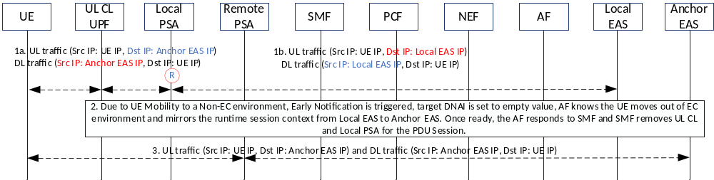
Figure 6.X.2.1.4-1: From EC to Non-EC Environment due to UE Mobility
1. Local PSA enforces EAS IP address replacement:
- For UL traffic, the destination IP address is replaced with the Local EAS IP address;
- For DL traffic, the source IP address is replaced back with the Anchor EAS IP address.
2. Due to UE Mobility to a Non-EC environment, Early Notification is triggered, target DNAI is set to empty value, AF knows the UE moves out of EC environment and mirrors the runtime session context from local EAS to Anchor EAS. Once ready, the AF responds to SMF and SMF removes UL CL and Local PSA for the PDU Session.
3. UL and DL traffic goes through Remote PSA, no EAS IP address replacement happens at Remote PSA.

6.X.2.2 Impacts to existing 5GS procedures

6.X.2.2.1 AF Influence procedure
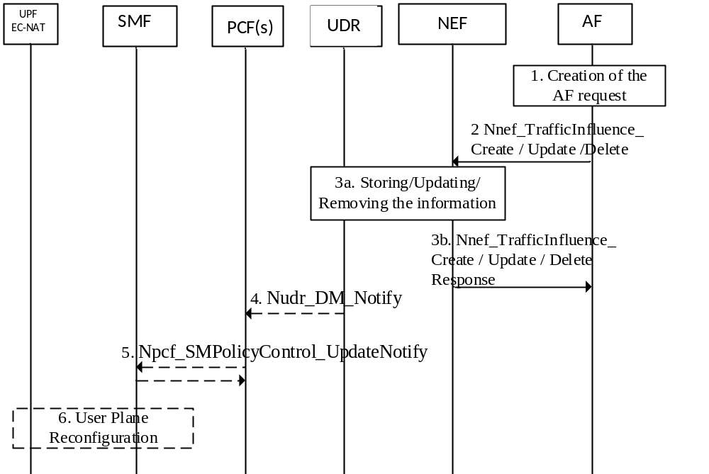
Figure 6.X.2.2.1-1: Processing AF requests to influence traffic routing for Sessions not identified by an UE address
The EAS IP address replacement information needs to be included in step 2, 3a, 4, 5 and 6 in the AF Influence procedure described above.

The SMF and Local PSA UPF need to maintain the following EAS IP address replacement information:
- Anchor EAS IP address: This is the IP address discovered by UE during EAS discovery procedure, from UE viewpoint, this IP address doesn’t change during the lifetime of a PDU Session, as such, re-discovery of EAS is not needed for the PDU Session.
- Serving Local EAS IP address per DNAI: For each target DNAI pointing to a local DN, where the outbound traffic will be routed to, the AF provides the IP address of a Local EAS in the local DN, which will be used for replacement in 5GC.

6.X.2.2.2 EAS IP address discovery
During the EAS IP address discovery procedure (based on the conclusion of KI#1), the Anchor EAS IP addresses is returned to UE, UE will always use this Anchor EAS IP address as the destination IP address for this EC service before another round of EAS discovery procedure is triggered by 5GC.
When the solution described in this solution is not deployed in the edge of 5GS, the traffic for this service is always between UE and the Anchor EAS; otherwise, the traffic for this service is always between UE and one of the local EASes by replacing the EAS IP address in Local PSA UPF.

6.X.2.2.3 Initial EAS IP address replacement in Local PSA UPF
In Local PSA UPF:
- For uplink traffic, the destination IP address equalling to Anchor EAS IP address is replaced with the Serving Local EAS IP address per DNAI;
- For downlink traffic, the source IP address of the current Serving Local EAS is replaced with the Anchor EAS IP address for the UE.

6.X.2.2.4 Triggering the EAS IP Address Replacement in Local PSA UPF after DNAI Change
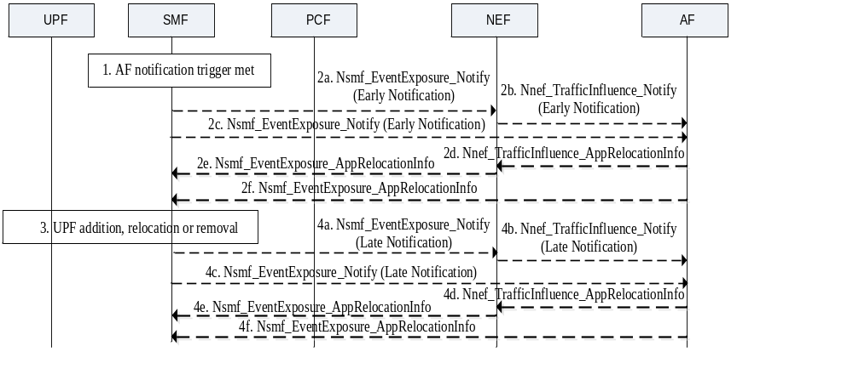
Figure 6.X.2.2.4-1 (Figure 4.3.6.3-1 in 23.502): Notification of user plane management event
The current serving EAS IP address for an EC service and source DNAI are included in step 2a, 2b 2c.
In case there are multiple EASs serving a DNAI, the AF selects the target EAS and the target EAS IP address need to be included in step 2d, 2e, 2f for Early Notification, or in step 4d, 4e, 4f for Late Notification.
SMF needs to send the Anchor EAS IP address and target EAS IP address to Local PSA UPF as described in step 6 of clause 6.X.2.2.1, and Local PSA UPF starts the EAS IP address replacement as described in clause 6.X.2.2.3.

6.X.2.2.5 AF triggered EAS migration in 5GC
For load balancing purpose, the AF may move some UE(s) from the source EAS to target EAS in the same local DN identified by the DNAI.

For the abnormal condition of EAS, the AF may move all the UEs being served by the source EAS to a target EAS in the same local DN.

The AF influence content information defined in clause 5.6.7.1 (table 5.6.7-1) of TS 23.501[2] needs to include following additional information:
- List of UE IP address and port number: The IP address and port number of the UE(s) whose traffic should be moved from source EAS to target EAS in the same local DN identified by DNAI.
- Source EAS IP address for the impacted DNAI: The IP address of source EAS in local DN identified DNAI which is currently serving the UE(s).
- Target EAS IP address for the impacted DNAI: The IP address of target EAS in local DN identified DNAI which the edge application traffic will be moved to.

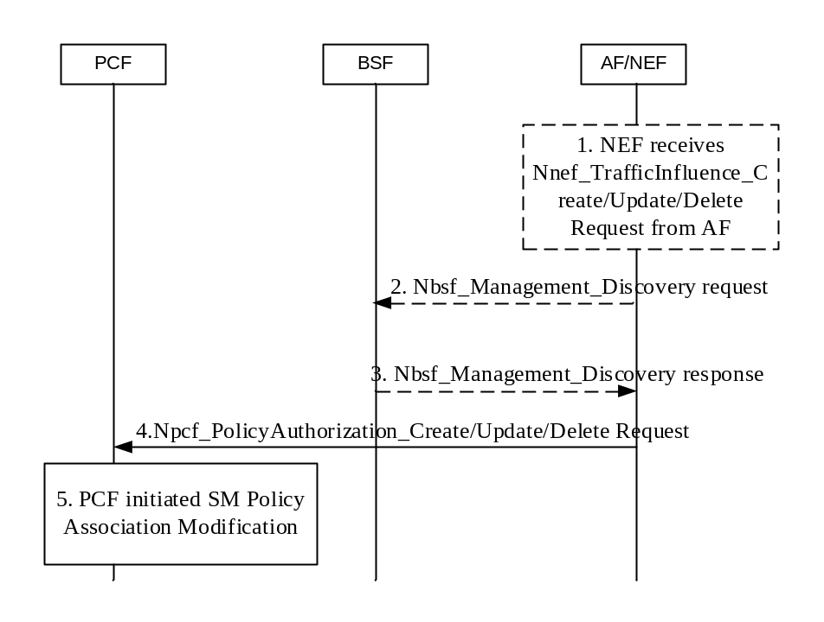
Figure 6.X.2.2.5-1: Handling an AF request targeting individual UE(s) to the relevant PCF
Depending on the AF deployment (see TS 23.501 [2], clause 6.2.10), the AF may send the AF request to PCF directly, in which case step 1 is skipped, or via the NEF.
1. [Conditional] If the AF sends the AF request via NEF, the AF sends Nnef_TrafficInfluenceCreate/Update/Delete Request targeting an individual UE address to the NEF. This request corresponds to an AF request to influence traffic routing that targets an individual UE address.
When NEF receives an AF request from AF, the NEF ensures the necessary authorization control and , as described in clause 4.3.6.1, mapping from the information provided by the AF into information needed by the 5GC. The NEF responds to the AF.
2. [Conditional] AF/NEF consumes Nbsf_Management_Discovery service operation (providing at least the UE address) to find out the address of the relevant PCF if the PCF address is not available on the NEF based on local configuration, otherwise step 1 is skipped.
NOTE: The AF/NEF finds the BSF based on local configuration or using the NRF.
3. BSF provides the PCF address in the Nbsf_Management_Discovery response to AF/NEF.
4. If step 1 was performed, NEF invokes the Npcf_PolicyAuthorization service to the PCF to transfer the AF request. If an AF sends the AF request directly to the PCF, AF invokes Npcf_PolicyAuthorization service and the PCF responds to the AF.
5. The PCF updates the SMF with corresponding new PCC rule(s) with PCF initiated SM Policy Association Modification procedure as described in clause 4.16.5.2. When a PCC rule is received from the PCF, the SMF may take appropriate actions, when applicable, to reconfigure the User plane of the PDU Session, such as:
- Adding, replacing or removing UPF(s) in the data path, e.g. to act as UL CL, Branching Point, and/or PDU Session Anchor e.g. as described in clause 4.3.5.
- Allocate a new Prefix to the UE (when IPv6 multi-Homing applies).
- Updating the UPF regarding the target DNAI with new traffic steering rules.
- Subscribe to notifications from the AMF for an Area Of Interest via Namf_EventExposure_Subscribe service operation.
- Updating the Local PSA UPF with the additional AF influence information to re-enforce the updated replacing EAS IP address(es) per DNAI and replace the source EAS IP address with the target EAS IP address for the specific DNAI for specific UEs identified by list of target UE identifier(s), or the list of UE IP address and port number.

6.X.3 Impacts on Existing Nodes and Functionality

AF:
- Receives source EAS IP address and source DNAI;
- Sends the EAS IP address replacement information to 5GC.
PCF/NEF:
- Forwards source EAS IP address and source DNAI to AF;
- Forwards the EAS IP address replacement information to SMF.
SMF:
- Notifies the source EAS IP address and source DNAI to AF (via PCF/NEF);
- Receives and stores the EAS IP address replacement information;
- Sends the EAS IP address replacement information to Local PSA UPF;
- Adds the Anchor EAS IP address into the packet forwarding filter.
Local PSA UPF:
- receives and stores the EAS IP address replacement information;
- Enforces the EAS IP address replacement.

* * * * End of Changes * * * *

