SA WG2 Meeting #139E S2-20xxxx
25 – 29 May 2020, Elbonia (revision of S2-20xxxx)

Source: China Mobile
Title: Solution on exposing UE mobility analytics for multiple NWDAFs case
Document for: Approval
Agenda Item: 8.2
Work Item / Release: FS_eNA_ph2 / Rel-17
Abstract: This contribution proposes a new solution to address Key Issue #2.

1. Introduction
This contribution proposes a solution to address Key Issue #2: Multiple NWDAF instances.
The UE mobility information is regarded as useful information for e.g. commercial usage for deriving commercial footprint between shopping centers, and therefore it would be very much beneficial to allow the AFs to consume UE mobility analytics.
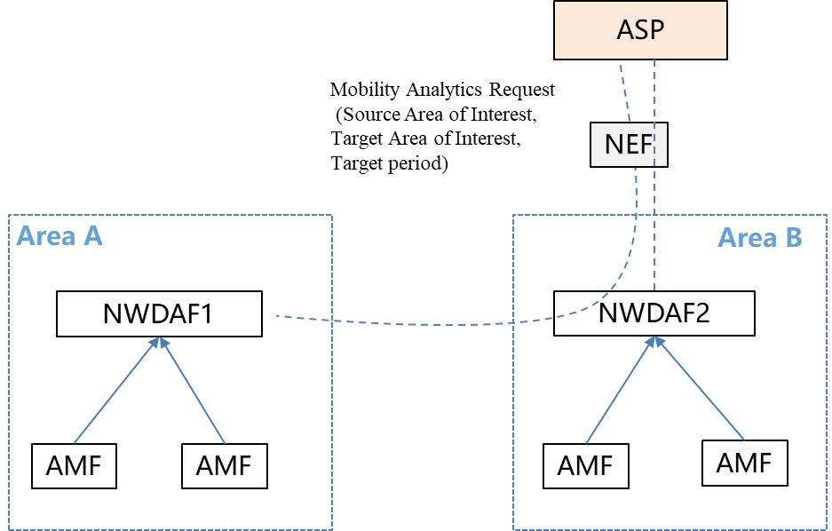
The awareness of users who even stayed in some areas may become useful e.g., the AFs inside Area B (Source Area of Interest) may need to enquiry the users who once stayed in Area A (Target Area of Interest) in target period as depicted in the below figure.
Figure: UE mobility analytics provided to NF/AF
To address the above use case, the solution is to enchance the existing mechanism of data collection and analytics generation for the scenario of multiple NWDAFs.

2. Text Proposal
It is proposed to capture the following new text in TR 23.700-91.

* * * * Start of Changes * * * *

6.X Solution #X: Exposing UE mobility analytics for multiple NWDAFs case

6.X.1 Introduction
This solution addresses Key Issue #2: Multiple NWDAF instances.
The UE mobility information is regarded as useful information for e.g. some certain commercial usage for deriving commercial footprint between shopping centers, and therefore it would be very much beneficial to allow the AFs to consume UE mobility analytics.
The awareness of users who even stayed in some areas may become useful e.g., the AFs inside Area B (Source Area of Interest) may need to enquiry the users who once stayed in Area A (Target Area of Interest) in target period as depicted in the below figure.
Figure 6.x.1-1: UE mobility analytics provided to NF/AF
To address the above use case, the solution is to enchance the existing mechanism of data collection and analytics generation for the scenario of multiple NWDAFs.
6.X.2 Procedures
Figure 6.x.2-1: Procedure for UE mobility analytics provided to NF/AF
1a. To obtain the SUPI list and their related mobility analytics, e.g., user location and time slot, who currently stays in Source Area of Interest and once stayed in Target Area of Interest in target period, the NF sends an Analytics subscription or request (Analytics ID = UE mobility, Analytics Filter information = Source Area of Interest, Target Area of Interest, Analytics Reporting information = Analytics target period) directly to the NWDAF1 serving the Source Area of Interest by Nnwdaf_AnalyticsSubscription_Subscribe or Nnwdaf_AnalyticsInfo_Request.
For these untrusted NFs, the NF sends the subscription or request via a NEF, where the NF invokes NEF service Nnef_AnalyticsExposure_Subscribe.
1b-1c. Authorization for the AF is performed in the NEF in case the NEF is used. The NEF will then convey the request to the NWDAF1 as defined in the clause 6.1.2.2, TS 23.288 [5].
2a-2e. Upon receiption of the request from the NF directly or via the NEF for untrusted NF, the NWDAF1 may subscribe/request to events from AMF/AF/OAM for UE location information, as the steps 2a-2e described in the clause 6.7.2.4, TS 23.288 [5].The NWDAF figures out the SUPI list who currently stays but once left in Source Area of Interest in target period.
2f-2g. To obtain UE mobility analytics in Target Area of Interest, the NWDAF1 sends Analytics subscribe/request (Analytics ID = UE mobility, Target of Analytics Reporting = list of SUPIs, Analytics Filter information = Target Area of Interest, Analytics Reporting information = Analytics target period) to the NWDAF2 serving Target Area of Interest. The NWDAF2 provides data analytics to the NWDAF1 including SUPI list and their related mobility analytics, who once stayed in Target Area of Interest in target period.
3. The NWDAF1 derives requested analytics.
4a-4b. The NWDAF1 sends the requested UE analytics to the NF. The details for UE analytics provided by the NWDAF are defined in the clause 6.7.2.3, TS 23.288 [5]. Based on the analytics provided by the NWDAF1, the NF derives the mobility related information for these UEs.
For these untrusted NFs, the NWDAF1 provides requested UE analytics to the NF via a NEF.

* * * * End of Changes * * * *

