SA WG2 Meeting # S2-20xxxxx

Source: Apple
Title: Solution for Key Issue #16: UP optimization for Edge Computing
Document for: Approval
Agenda Item: x.x
Work Item / Release: FS_eNA_ph2 / Rel-17
Abstract of the contribution: This contribution proposes a solution for Key Issue #16: UP optimization for Edge Computing

1. Introduction
Edge computing enables to locate resources near the consumers to provide low latency and high data volume. In order to support tremendous services/applications running in edge computing efficiently, 5GC need to consider edge computing deployment and hosted application/service characteristics. For most efficient utilization of resources and best experience for end user, NWDAF can be used to provide analytics to automate certain functions of Edge Computing application.
The following aspects are considered here:
- Analytics which could be exposed to AF (edge computing) and internal NFs to improve UP optimization and support edge computing operations efficiently.
- Data to be collected by the NWDAF to provide analytics information to support edge computing.
- Assisting UP path optimization considering DN characteristics.

The proposed new inputs to analytics provide insights which can then be used to improve the user experience of UE application in Edge Computing environment.

This solution is proposed for Key Issue #16.

2. Proposal
The following changes are proposed for TR 23.700-91.

* * * * First Change (All new text) * * * *

6.X Solution #X: UP optimization for Edge Computing

6.X.1 Functional Description

6.X.1.1 General
NWDAF supporting Edge Computing analytics and predictions shall be able to collect information about UE and EAS via NFs (e.g. AF, AMF, SMF, UPF, etc.) and perform data analytics to optimize the utilization and relocation of Edge Computing resources for respective Application instances.
The consumer of these analytics may indicate in the request the target of Analytics Reporting (single UE or a group of UEs and Application instances) and the Analytics Filter Information containing parameters such as:
- UE/UE group Mobility
- UE group Location
- QoS Parameter
- Application Status
- Server Resource Status

6.X.1.2 Input data
The information collected via 5GC NFs for UE group mobility behaviour is defined in Table 6.X.1.2-1:

Table 6.X.1.2-1: Input Data related to for UE mobility behaviour analytics

Information | Source | Description
UE/Group ID | AMF | UE Group IDs
UE locations (1..max) | AMF | UE positions
> UE location | AMF | TA or cells that the UE enters
> Timestamp | AMF | A timestamp when the AMF detects the UE enters this location
Type Allocation code (TAC) | AMF | To indicate the model and vendor information of the UE. The UEs with the same TAC may have similar mobility behaviour. The UE whose mobility behaviour is unlike other UEs with the same TAC may be an abnormal one.
Frequent mobility re-registration | AMF | A UE (e.g. a stationary UE) may re-select between neighbour cells due to radio coverage fluctuations. This may lead to multiple re-registrations if the cells belong to different Registration Areas. The number of re-registrations N within a period M may be an indication for abnormal ping-pong behaviour, where N and M are operator's configurable parameters.

Most of the information is already provisioned to be available from AMF for NWDAF, the new inclusion of Frequent Mobility Re-Registration for UE on border of Registration Areas. This will help to allocate respective resources for this group of UEs/UE serving application.

Table 6.X.1.2-2: Input Data related to for EAS application UP analytics

Information | Source | Description
UE ID | AF, UPF | GPSI or external UE ID
Application IDs | AF, UPF | Identifying Edge application providing this service
Trajectory | AF, UPF | Edge Relocations
> UE location | AF, UPF | Tracking Area Mapping to Edge Service Area
> Timestamp | AF, UPF | A timestamp when UE enters this Edge Service Area
> UE group App Session ID | AF, UPF | UE group Application ID served by respective EAS
List of resource status (1..n) | AF | List of observed load information for each EAS instance along with the corresponding EAS ID / EAS Set ID (as applicable)
> EAS type | AF | Type of the EAS instance
> EAS instance ID | AF | Identification of the EAS instance
> EAS status | AF | The availability status of the EAS on the Analytics target period, expressed as a percentage of time per status value (registered, suspended, undiscoverable)
> EAS resource usage | AF | The average usage of assigned resources (CPU, memory, disk)
> EAS load | AF | The average load of the EAS instance over the Analytics target period
> EAS peak load | AF | The maximum load of the EAS instance over the Analytics target period
> EAS Measurements | AF | RTT and other information related to measurements
> EAS Capability | AF | Capability of EAS processor, GPU, memory, etc.
QoS flow Bit Rate | UPF | The observed bit rate for UL direction; and  The observed bit rate for DL direction
QoS flow Packet Delay | UPF | The observed Packet delay for UL direction; and  The observed Packet delay for the DL direction
Packet transmission | UPF | The observed number of packet transmission
Packet retransmission | UPF | The observed number of packet retransmission

UE group Application Session ID, EAS Measurements and EAS Capability are new data inputs required to provide analytics and predictions for resource allocation and relocation depending upon resource usage and current state thus mitigating impacts of congestion and outages while also handling the switching up or down predictions depending upon resource usage and UE application statistics.

6.X.1.3 Output Analytics
The NWDAF supporting UP optimization for edge computing analytics shall be able to provide analytics and prediction to consumer NFs or AFs.
With this analytics information, NFs taking decision for UP optimization should be able to subscribe periodically or on event basis (Threshold based) or a one-time request for run time decision making. This analytics information can be used to improve the user experience of UE application with respect to EAS application.

Table 6.X.1.3-1: NWDAF provided statistics and analytics

Information | Target Node | Description
Resource Status | NF | List of predicted information for each EAS instance along with the corresponding EAS id / EAS Set ID with respect to UE groups served per application
> EAS resource relocation | NF | Relocation of assigned resources (CPU, memory, disk) for EAS application to respective UE groups
> EAS load distribution | NF | The average load of the EAS instance over the Analytics target period for different application aspects
> EAS TAC mapping | NF | Mapping of EAS area against mobility of same TAC(Type Allocation Code) for UE within different Tracking Areas
> EAS Applications’ state | NF | State of applications’ run on different EAS with respect to UE groups
> Confidence | NF | Confidence of this prediction

Predictions can be provided to intermediate or the final NF making decision for EAS resource relocation which can be on basis of past UE mobility behaviour and application usage over a period of time.

Table 6.X.1.3-2: NWDAF provided predictions

Information | Target Node | Description
Resource Update | NF | List of predicted information for each EAS instance along with the corresponding EAS id / EAS Set ID with respect to UE groups served per application
> EAS resource management | NF | Based upon Analytics model, prediction for whether resource for particular EAS need to be incremented or reduced / optimisation
> UE Group mobility | NF | Predicting the UE group mobility on basis of subscription data model & congestion period predictions
> Application state & load | NF | Application state and load prediction on basis of time of usage and number of users at particular instance
> Confidence | NF | Confidence of this prediction

6.X.1.4 Procedure
The NFs may request analytics from NWDAF for respective Edge computing user plane optimization. The analytics request may be subscription based on periodic or aperiodic with threshold defined for requesting the analytics. Further NWDAF may request information data points from different NFs (AMF, AF, SMF, UPF, etc.) to provide precise analytics and predictions for Edge resources relocation and allocations.
The following flow can be used as illustration of the request and response in the network:

EAS-LADN
NWDAF
NF
OAM
UPF
AF
AMF

1. Nnwdaf_AnalyticsInfo_Request/
Nnwdaf_AnalyticsSubscription_Subscribe
2. Naf_EventExposure_Subscribe/
UPF Traffic Usage Report
3. Naf_EventExposure_Notify/
Traffic Usage Response

4. Namf_EventExposure_Subscribe

5. Namf_EventExposure_Notify

6. Subscribe
EAS/UE(s) Information

7. Notification

8. NWDAF derives Analytics
9. Nnwdaf_AnalyticsInfo_Response/
Nnwdaf_AnalyticsSubscription_Notify

10. Trigger for new analytics/prediction Request or Periodicity

11. Naf_EventExposure_Notify/
Traffic Usage Response

12. Namf_EventExposure_Notify
13. Nnwdaf_AnalyticsInfo_Response/
Nnwdaf_AnalyticsSubscription_Notify

14. Analytics & Predictions for optimized UP performance between UE(s) & EAS

Figure: 6.X.1.4-1: NWDAF requested analytics/predictions for Edge computing
Initially UE groups are accessing multiple application through EAS which is connected to respective DN. AMF has the information of UE’s mobility within its Registration Area and AF has information about the resources with UPF closely monitoring the QoS of the User Plane connection.

1. NF sends Analytics Info Request or Subscription request to NWDAF with respect to UE/UE group and Application Session information.

2. NWDAF initiates Request and Subscription to EAS resources and QoS with respective AF & UPF with request to Application Session ID ongoing and UE group served for those applications.

NOTE 1: This request to UPF/AF will be forwarded with the same UE group ID & Application ID for which Analytics were requested by NF.

3. UPF and AF respond with the data requested by NWDAF for the analytics as per the table 6.X.1.2-2.

4. NWDAF initiates Event Exposure to AMF for mobility parameters and UE group mobility within the Registration Area and also requests the counter to check UE group mobility.

5. AMF responds with the data required by NWDAF as per table 6.X.1.2-1 with a Notify message.

6. NWDAF requests Subscription for EAS/UE information from OAM in compliance with specs.

NOTE 2: Request to OAM data would depend upon the precision required for analytics with respect to granularity in conditions of UE and EAS.

7. OAM responds with Notification for the information regarding the request NWDAF subscribed to
8. NWDAF derives analytics and also predictions with the available data with an appropriate confidence level.

9. This analytics and predictions are provided to the NF which is then responsible for user plane resources allocation and relocation for Edge Computing session.

10. Trigger or periodicity is defined to get these results in initial step. This trigger is waited upon which may be group UE mobility out of EAS serving area or Registration Area.

11. Notifications are received by NWDAF from UPF and AF, until the end/termination of the session from NF and later on NWDAF.

12. Notifications may further be received from AMF in case the mobility of UE(s) is concerned and trigger for the event.

13. Periodic or trigger based information is shared with NF with new session ID and analytics ID for respective Application session with EAS.

14. UE group and EAS resources are migrated and relocated on basis of analytics for best User Plane performance for Edge computing sessions.

NOTE 3: The EAS and Tracking area can be mapped as follows for ease of management of resources and trigger conditions for relocations as in Figure 6.x.1.4-2:

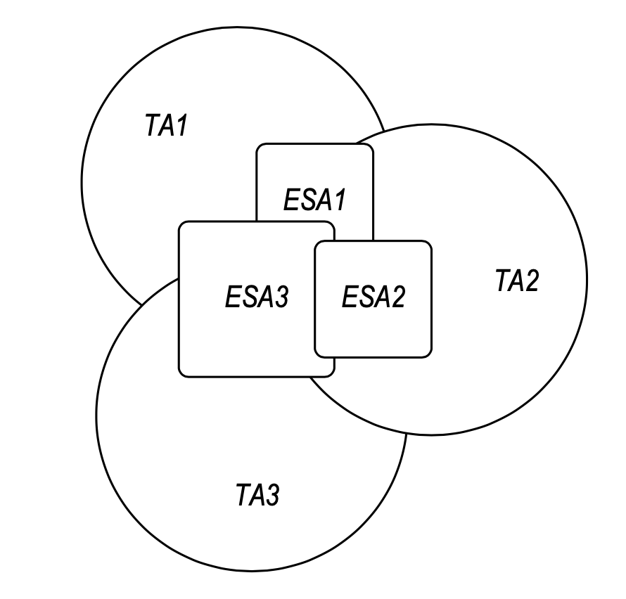
Figure: 6.X.1.4-2: EAS and TA mapping

6.X.2 Impacts
- Impact on SMF/PCF/AF: SMF/PCF/AF should be able to request information from NWDAF to make decision of Edge Relocation.

- Impact on AF/UPF: UPF shall have information of the Edge sessions ongoing and should be connected to multiple Edge resources.

6.X.3 Solution evaluation

* * * * End of Changes * * * *

