SA WG2 Meeting #S2-139e S2-200xxxx
1 - 12 June, 2020, Electronic Meeting (revision of S2-200xxxx)

Source: Ericsson
Title: Updates to solution 5
Document for: Discussion/Approval
Agenda Item: 8.4
Work Item / Release: FS_MUSIM
Abstract of the contribution: Updates to solution 5

1. Introduction
1) The solution is updated to remove some Editor’s Note
2) More clarification text is added.

2. Proposal
This paper proposes to remove the following ENs with new specific clarifications
Editor's Note: It is FFS whether further clarifications in this solution are required for subsequent data handling after the UE has left the system.
Editor’s Note: It’s FFS if NAS Service Accept message is mandatory or not in this leaving procedure
Editor's Note: The usage of the cause of release is FFS.
Editor's Note: How RAN decides the pause timer for UE is FFS.
Editor's Note: In current text, when pause timer expires and no resume request, the UE may move into in RRC-Idle and RAN moves into suspend state. It is FFS how to handle the misaligned state between the UE and RAN

* Start of change *

6.5 Solution #5: Graceful leaving and resumption solutions

6.5.1 Introduction
The solutions address the key issue 3: Coordinated leaving for multi-USIM device.
The solution aims to cover the following use cases for various durations of the UE "leaving" the system:
- The UE leaves for short time duration, e.g. a 100-500 ms, in order to send/receive an SMS in the target system, e.g. perform periodic registration/TAU or check the caller identity of incoming call;
- The UE leaves for long time duration, e.g. a couple of minutes, in order to make a call in the target system.
Editor’s Note: the short time duration range value is FFS and need to be synchronized with RAN group and CT1
One design principle of the solution is to minimize the signalling needed for coordinated leaving (including leaving and return) and to minimize the service interruption in the source system.
The solution applies to both 5GS and EPS.

6.5.2 Functional Description
For the single receiver multi-USIM device, if USIM1 is registered in 3GPP system (e.g. PLMN 1), and decides to establish connection for USIM 2 in 3GPP system (e.g. PLMN 2), either for a short stay (e.g. responding a MT service paging) or possibly a long stay in PLMN 2, the UE(USIM1) informs the PLMN 1 that UE(USIM1) is leaving and PLMN 1 may suspend certain DL services for UE(USIM1).
The UE/USIM(s) of the multi-USIM device first registered in PLMN(s) separately.
The leaving procedure can either be initiated at NAS level or at AS level. The UE(USIM) may provide MUSIM Release assistance Information (MUSIM-RAI) to the network to assist the network for MT service delivery.
The detailed handling of MT service in the current system after leaving procedure is described in the procedures in clause 6.5.3 below.
After UE/USIM2 ended the service in PLMN 2, or received notification (e.g. Paging or NAS level notification) indicating there is a MT service with higher priority in PLMN 1, the device resumes the service for UE/USIM 1 in PLMN 1.
NOTE: how device will receive MT service notification from PLMN1, is based on the outcome of the KI 1 and KI 2.
The service resumption procedure can also be done at the NAS level or at AS level. It can be the normal existing resumption procedures (e.g. NAS service request or RRC resume).
The solution can be used for both LTE and 5G.

6.5.3 Procedures

6.5.3.0 General
NAS procedures are documented in clause 6.5.3.1 (leaving) and 6.5.3.2 (resumption).
AS procedures are documented in clause 6.5.3.3 (leaving) and 6.5.3.4 (resumption).
The UE may determine whether to apply for short leaving (AS or NAS procedure to suspend the RRC connection) or long leaving (AS or NAS procedure to move to CM-IDLE mode). The decision may take into account the service type (either provided to UE in paging request, NAS notification, or realized by UE for MO service) at the target PLMN, and based on the supported or preferred capabilities exchanged between UE/USIM and network.
Editor’s Note: It’s FFS if both NAS and AS level solution is needed or only one level solution is needed. The messages and details used in the flow is also FFS.
After the procedures for leaving, the UE/USIM may end up in either CM-IDLE mode or RRC Inactive mode.

6.5.3.1 NAS Leaving procedure

6.5.3.1.1 NAS Leaving procedure in 5GS
Figure 6.5.3.1.1-1 is the call flow of NAS Leaving procedure in 5GS in CM-CONNECTED mode.
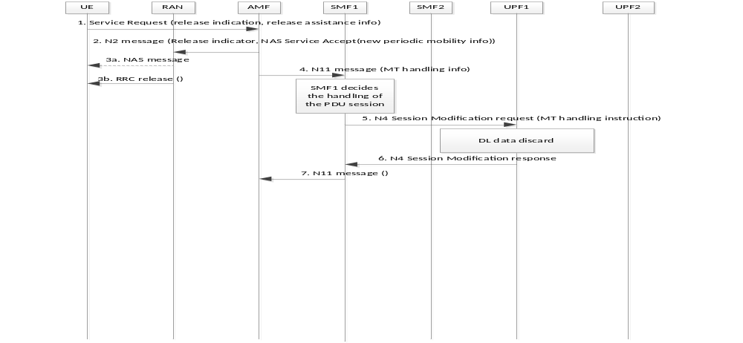
Figure 6.5.3.1.1-1: NAS Leaving procedure in 5GS
1. UE sends NAS Service request to AMF indicating the cause of release. The UE also optionally provides the release assistance info for MUSIM (MUSIM-RAI), which includes the following:
- PDU sessions or services that the UE want network to trigger (or not trigger) MT service delivery indication (the services indicated by the UE is corresponding to the services related to paging causes in solution 1);
- The time period expected by the UE that will be away from this serving network.
Editor’s Note: It’s FFS how UE sets a proper value of expected time period.
2. AMF responds with NAS Service Accept message. The N2 Message may also indicate the connection release.
If AMF does not have information to provide to UE, the Service Accept is optional. The UE may conclude the NAS procedure based on the indication from low layer when RRC connection release is released.
The AMF may either use UE context release towards RAN to move UE to IDLE mode directly or UE context modification towards RAN with release assistance info and RAN decides to move UE to RRC inactive or suspend mode as in TS 23.502 clause 4.8.1.
3. RAN delivers the NAS message and releases the RRC connection with UE.
In case of UE context modification with release indication, RAN decides if UE moves to RRC inactive mode or suspend mode (e.g. based on release assistance info).

4. Based on local policy and MUSIM-RAI provided by UE/USIM in step 1, AMF sends N11 message to SMF indicating the possible N3 tunnel release and also includes the MT data handling info. The MT data handling info shall include the following:
- PDU sessions on 3GPP access that may release the N3 tunnels;
- The possible MT data handling information (either discard/block or normal MT service delivery handling for certain PDU sessions/services, and optionally an applicable time period).
5. Based on the MT data handling info, policy from PCF, DNN/S-NSSAI info in the subscription or local configuration, the SMF decides how to handle the PDU sessions and informs relevant UPFs.
For example, for PDU session 1, the SMF1 may decides to discard/block the DL data transmission and send N4 Session Modification request message to UPF1 with data handling instruction information.
6. Based on the received data handling instruction information, UPF1 keeps the PDU session context but discard/block the DL data. The UPF1 send a response message to SMF 1.
7. The SMF1 sends response message back to AMF.
For a different PDU session, the SMF2 may decide to discard/block the DL data for certain period. After this period, DL data shall trigger the UPF request for the N3 tunnel setup as normal when there is no N3 tunnel.

6.5.3.1.2 NAS Leaving procedure in EPS
Figure 6.5.3.1.2-1 is the call flow of NAS leaving procedure in EPS.
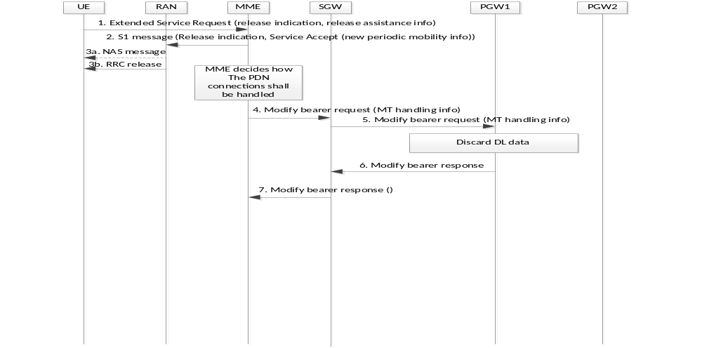Figure 6.5.3.1.2-1: NAS leaving procedure in EPS
1. UE sends NAS Extended Service request to MME indicating the cause of release. The UE also optionally provides the MUSIM-RAI which includes the following:
- PDN connections or services that the UE want network to trigger (or not trigger) MT service delivery indication.
- The time period expected by the UE that will be away from this serving network.
NOTE: services, that UE indicates to network, correspond to the paging causes as in solution 1.
Editor’s Note: It’s FFS how UE sets a proper value of expected time period.
2. MME responds with NAS Service Accept message. MME also indicate the connection release in the S1 message.
If MME does not have information to provide to UE, the Service Accept is optional. The UE may conclude the NAS procedure based on the indication from low layer when RRC connection release is released.
The MME may either use UE context release towards RAN to move UE to IDLE mode directly or UE context modification towards RAN with release assistance info, and RAN decides to move UE to suspend mode as in TS 23.401 clause 5.3.4A.

3. RAN delivers the NAS message and releases the RRC connection with UE.
In case of UE context modification with release indication, RAN decides if UE moves to RRC suspend mode (e.g. based on release assistance info).
Step 4 to Step 7 are the same as step 4 to step 7 in clause 6.5.3.1.1 with following differences:
MME replaces the role of SMF.

6.5.3.2 NAS Resumption procedure

6.5.3.2.1 NAS Resumption procedure in 5GS
Figure 6.5.3.2.1-1 is the call flow of NAS resumption procedure in 5GS.
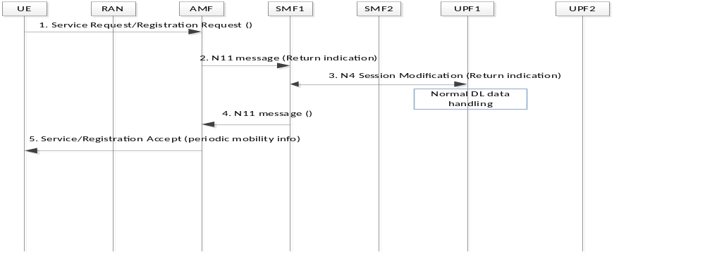
Figure 6.5.3.2.1-1 NAS Resumption procedure in 5GS
1. UE sends the NAS Service Request or Registration Request message to AMF.
2. AMF sends N11 message to SMF for different PDU sessions/Services indicating the return to normal MT service handling.
3. SMF sends the indication to UPF. UPF data handling becomes normal (e.g. DL data will trigger N3 tunnel setup request if there is no N3 tunnel for the PDU session).
4. SMF sends the response message to AMF.
5. AMF sends the NAS accept message to UE. The AMF may also provide normal periodic mobility info to UE, if the UE was provided with adjusted periodic mobility info in previous leaving procedure.

6.5.3.2.2 NAS resumption procedure in EPS
Figure 6.5.3.3.2-1 is the call flow of NAS resumption procedure in EPS.
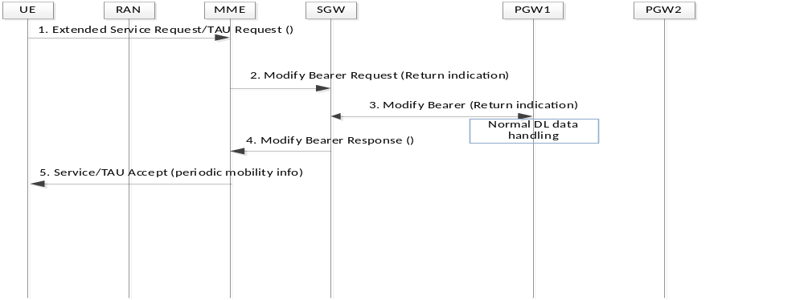
Figure 6.5.3.2.2-1 NAS resumption procedure in EPS
1. UE sends the NAS Extended Service Request or TAU Request message to MME.
2. MME sends S11 message to SGW for different PDN connections/services indicating the return to normal MT service handling.
3. SGW sends S5/S8 message to PGW with return indication. PGW data handling change to normal handling.
4. SGW sends the response message to MME.
5. MME sends the NAS service or TAU accept message to UE. The MME may also provide normal periodic mobility info to UE, if the UE was provided with adjusted periodic mobility info in previous leaving procedure.

6.5.3.3 RRC leaving procedure

6.5.3.3.1 RRC leaving procedure in 5GS
Figure 6.5.3.2.1-1 is the call flow of RRC Leaving procedure in 5GS.
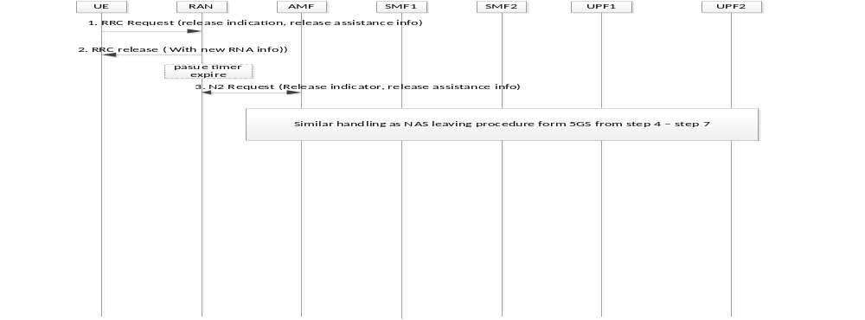
Figure 6.5.3.3.1-1: RRC leaving procedure in 5GS
1. UE sends RRC request to RAN indicating the cause of release. The UE also optionally provides the MUSIM-RAI, which includes the following, e.g.:
- PDU sessions or services that the UE wants network to trigger (or not trigger) MT service delivery.
- The time period expected by the UE that will be away from this serving network.
2. Based on the MUSIM-RAI from UE, RAN can either decides to move to RRC-Inactive state or to RRC Idle state. RAN sends RRC message to UE to release the RRC connection. In case of RRC-Inactive, RAN may also provide a pause timer e.g. based on local policy/configuration and timer received in step 1 for the UE/USIM and blocks the DL data transmission without paging UE if there are following DL data received except regulatory services, services that UE indicated in step 1, or operator decides to page (e.g. for control signalling). The RAN considers the UE leaves current network normally based on the cause of release received in step 1.

3. If pause timer activated in step 2 expires, and if RAN does not receive a resume request from the UE, RAN sends a N2 request message to AMF including the release assistance info if CN needs to handle MT data, and UE state in network enters either CM-IDLE or suspend state as in TS 23.502 clause 4.8.1. The UE/USIM also enters CM-IDLE or suspended mode, if it’s not able to resume the connection when the received timer expires.

In case of moving UE to RRC Idle state and consequently to CM-Idle, RAN sends UE context release indication. In case of moving UE to suspend state, RAN sends UE context suspend request. RAN provides also the release assistance info to the AMF.
4-7: similar to 6.5.3.1.1 step 4-7 with the following differences: AMF receives the MUSIM-RAI from N2 interface instead of NAS message. The MT data handling info provided by AMF to SMF may include the following:
- PDU sessions on 3GPP access that may release the N3 tunnels;
- The possible MT data handling information (either discard/block or normal MT service delivery handling for certain applicable time period).

6.5.3.3.2 RRC leaving procedure in EPS
Figure 6.5.3.2.2-1 is the call flow of RRC Leaving procedure in EPS.

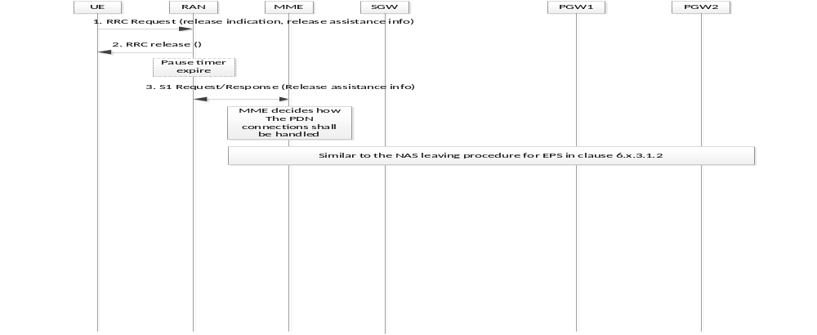 Figure 6.5.3.3.2-1: RRC leaving procedure in EPS
1. UE sends RRC request to RAN indicating the cause of release. The UE also optionally provides the release assistance info which includes the following, e.g.:
- PDU sessions or services that the UE want network to trigger (or not trigger) MT service delivery.
- The time period expected by the UE that will be away from this serving network.
NOTE: The RRC message may differ depending on the current RRC status.
2. Based on the release assistance info from UE, RAN can either decides to move to Suspend state or to RRC-Idle state. RAN sends RRC message to UE to release the RRC connection. In case of Suspend, RAN may also provide a pause timer for the UE e.g. based on local policy/configuration and timer received in step 1. The RAN considers the UE leaves current network normally based on the cause of release received in step 1.

3. If pause timer activated in step 2 expires, and if RAN does not receive a resume request from the UE, RAN may also move the UE to either to RRC-Idle or suspend state as in TS 23.401 clause 5.3.4A. The UE/USIM also enters CM-IDLE or suspended mode, if it’s not able to resume the connection when the received timer expires.
In case of moving UE to suspend state, RAN sends a S1 request message to MME including the release assistance info if CN needs to handle MT data, and enter suspend state.
In case of moving UE to RRC-Idle state and consequently to CM-Idle, RAN sends UE context release indication and provide the release assistance info to the MME.

4-7: similar to 6.5.3.1.2 step 4-7 with the following differences: MME receives the release assistance info from S1-C interface instead of NAS message.6.5.3.4 RRC Resumption procedure

6.5.3.4.1 RRC Resumption procedure in 5GS

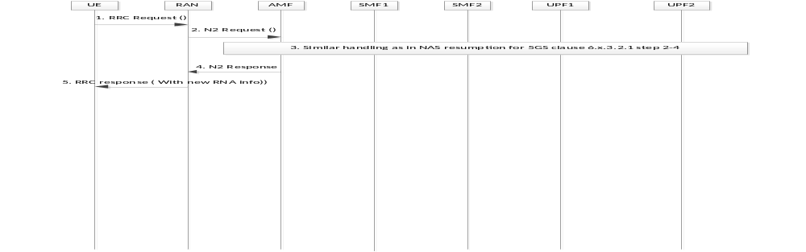
Figure 6.5.3.4.1-1 RRC Resumption procedure in 5GS
1. If the UE is in RRC-Inactive state, the UE/USIM sends RRC Request message (e.g. including resume indication) to RAN.
If the UE has transferred to CM-Idle state (e.g. due to expired pause timer), the UE performs NAS Resumption procedure as described in clause 6.5.3.2.
2. If the pause timer which is described in step 2 in Figure 6.5.3.3.1-1 is activated and not expired, step 2 to step 4 are skipped. Otherwise, RAN sends N2 request message to AMF to indicate the returning to CM-Connected mode and normal MT service handling.
3. AMF performs the step 2-4 similar to clause 6.5.3.2.1.
4. AMF sends N2 response message to RAN. CN tunnel info may be provided to RAN.
5. RAN sends RRC response message to UE/USIM.

6.5.3.4.2 RRC Resumption procedure in EPS
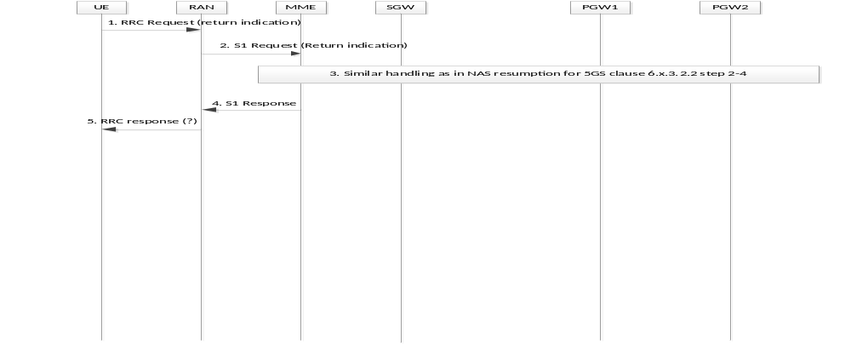Figure 6.5.3.3.2-1 NAS resumption procedure in EPS
1. UE sends RRC Request message to RAN. The UE may include return indication if leaving procedure was performed previously and new periodic mobility info has been received.
2. RAN sends S1 Request message to MME to indicate the returning to CM-Connected mode and normal MT service handling.
3. MME performs the step 2-4 similar to clause 6.5.3.2.2.
4. MME sends S1 response message to RAN. CN tunnel info may be provided to RAN.
5. RAN sends RRC response message to UE/USIM.
RAN may provide normal RNA provide periodic RNA info, if suspend is applied afterwards.

6.5.4 Impacts on services, entities and interfaces
SMF:
- decides how to handle the PDU session after receiving the MT data handling info, based on release assistance information from UE, in N11 message.
- initiates MT data handling instruction to UPF.
- receiving return indication and initiate normal MT data handling instruction to UPF.
UPF:
- block the DL data transmission according to SMF’s request.
AMF:
- receives the Release assistance info from UE through NAS message or from RAN through N2 message.
- provides NAS response to UE.
- provides MT data handling info, based on release assistance info from UE, to SMF.
NG-RAN:
- Supports UE initiated RRC leaving procedure with release assistance info according to clause 6.5.3.3.
- Provides release assistance info the AMF.
- Sends RRC response message to UE.
UE:
- Supports NAS leaving procedure with release assistance info.
- Supports RRC leaving procedure with release assistance info.
- Supports NAS Resumption procedure.
- Supports RRC Resumption procedure.

* End of changes *

