SA WG2 Meeting #1XX S2-200XXXX
XXX, XXX, Jun XX – XX, 2020 (revision of S2-200xxxx)
Source: China Telecom
Title: Solution for KI#3 on limitation of GBR data rate per network slice in UL and DL per UE
Document for: Approval
Agenda Item: x.x
Work Item / Release: FS_eNS_Ph2 / Rel-17
Abstract of the contribution: This contribution proposes a solution for KI#3.

1. Introduction
According to the requirement of GSMA, the rate limit of each UE on a network slice, includes GBR and non-GBR data streams.
Since Non-GBR and GBR data streams are two typical data streams with different QOS characteristics, it is proposed to continue the same data rate limit processing methods as that of 4G and 5G to control the Non-GBR and GBR data streams of a UE on the slice respectively.
This solution suggests the limitation controlled by PCF and enforced by (R)AN.

3. Proposal
It is proposed to adopt the following solutions for Key issue#3 into 23.700-40.

6.X Solution #x: Limitation of GBR data rate per network slice in UL and DL per UE

6.X.1 Introduction
This solution addresses the Key Issue #3: limitation of data rate per network slice in UL and DL per UE.
For GBR QoS Flows per slice, two attributes are introduced based on the 5G QoS Model as in TS 23.501, Clause 5.7.1.2:
- Guaranteed Slice Bit Rate (GSBR) - UL and DL, and
- Maximum Slice Bit Rate (MSBR) - UL and DL.

x.2 High-level Description
The suggested QoS attributes for GBR flows, GSBR and MSBR should be stored in UDM and can be retrieved by other NFs when needed.
- Guaranteed Slice Bit Rate (GSBR) - UL and DL
This attribute describes the guaranteed data rate supported by the network slice per UE (User Equipment), which is required to achieve a sufficient quality experience (dependent on the selected service type) and can be seen as a guaranteed throughput.
- Maximum Slice Bit Rate (MSBR) - UL and DL
This attribute defines the maximum data rate supported by the network slice per UE. The parameters could be used to offer different contract qualities like gold, silver and bronze.
In UE Registration or PDU Session Establishment procedures, AMF or SMF retrieve GSBR and MSBR from UDM or PCF and deliver them to (R)AN, which enforces the data rate limit per network slice in UL and DL per UE.

6.x.3 Procedures

6.x.3.1 (R)AN retrieves GSBR and MSBR in UE Registration
The first solution proposes the GSBR and MSBR are signalled to the (R)AN in UE Registration procedure. The (R)AN performs GSBR and MSBR enforcement.

The following changes to the existing procedures at UE Registration are proposed to enforce such a rate limit.

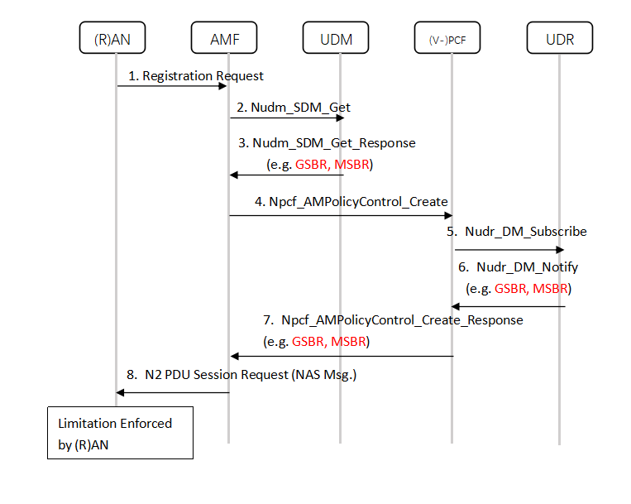
Figure 1 Procedures for GSBR and MSBR (in UE Registration Procedure)

Step 1: (R)AN sends N2 Message including Registration Request to seleccted AMF.

Step 2 and 3: The AMF retrieves subscribed GSBR(-UL/DL) and MSBR(-UL/DL) per S-NSSAI from UDM.

Step 4: The AMF provides the Allowed NSSAI and the subscribed GSBR(-UL/DL) and MSBR(-UL/DL) for each S-NSSAI in the Allowed NSSAI to PCF in roaming case.

Step 5: (V-)PCF performs the subscription to notification to the profile modified in the UDR by invoking Nudr_DM_Subscribe, as specified in TS 23.502.

Step 6: The UDR notifies the PCF on the UE profile by invoking Nudr_DM_Notify, providing new attributes, GSBR(-UL/DL) and MSBR(-UL/DL) , for limit data rate per UE per slice.

Step 7: The (V-)PCF responds to the Npcf_AMPolicyControl_Create service operation. The (V)-PCF provides Access and mobility related policy information (e.g. Service Area Restrictions) as defined in clause 6.5 of TS 23.503. In addition, (V)-PCF can provide GSBR(-UL/DL) and MSBR(-UL/DL) to AMF.

Step 8: If received from (V-)PCF, the AMF sends the Authorized GSBR(-UL/DL) and MSBR(-UL/DL) per S-NSSAI to (R)AN when needed. Otherwise the AMF sends the Subscribed GSBR(-UL/DL) and MSBR(-UL/DL) per S-NSSAI obtained from the UDM to (R)AN.

(R)AN is responsible for the enhancement of GSBR and MSBR limitation of data rate per network slice in UL and DL per UE thereafter.

6.x.3.2 (R)AN retrieves GSBR and MSBR in PDU Session Establishment
The second solution proposes the GSBR and MSBR are signalled to the (R)AN in PDU Session Establishment procedure. The (R)AN performs GSBR and MSBR enforcement.

The following changes to the existing Policy Association at PDU Session Establishment procedure (as stated in TS 23.502, Clause 4.16.4) are proposed to enforce such a rate limit.
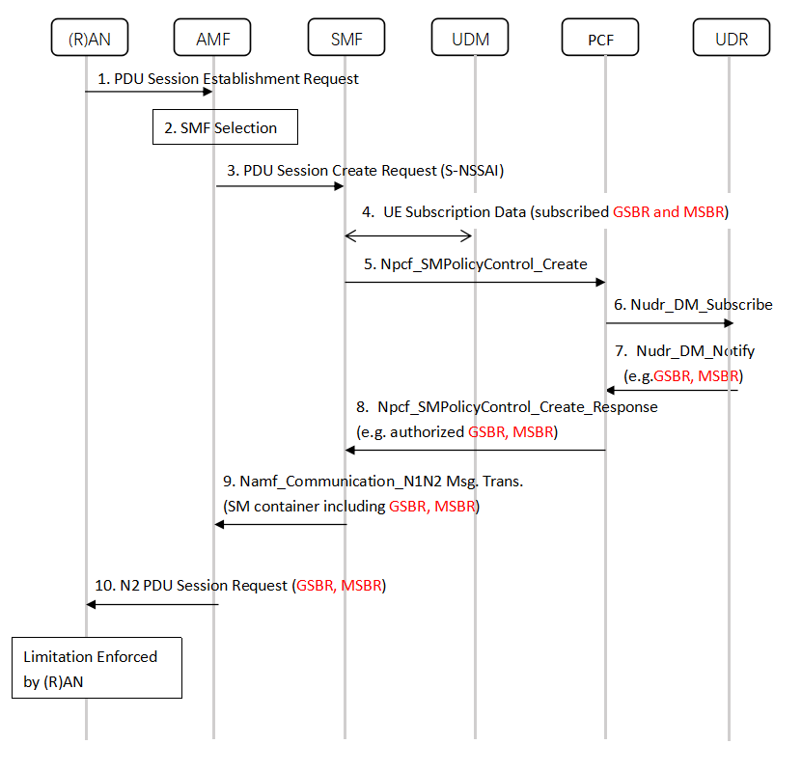
Figure 2 Procedures for GSBR and MSBR (in PDU Session Procedure)
Step 1 to 3: Same as specified in TS 23.502.
Step 4: The UDM stores subscribed GSBR(-UL/DL) and MSBR(-UL/DL) per S-NSSAI. SMF gets subscribedGSBR(-UL/DL) and MSBR(-UL/DL) from UDM as UE subscription data.
Step5: The SMF determines that the PCC authorization is required and requests to establish an SM Policy Association with the PCF by invoking Npcf_SMPolicyControl_Create operation
Step 6: If the PCF does not have the subscriber's subscription related information, it sends a request to the UDR by invoking Nudr_DM_Query. The PCF may also request notifications from the UDR on changes in the subscription information by invoking Nudr_DM_Subscribe.
Step7: The UDR notifies the PCF on the UE profile by invoking Nudr_DM_Notify, providing new attributes, GSBR(-UL/DL) and MSBR(-UL/DL) , for limit data rate per UE per slice.
Step 8: The PCF makes the authorization and the policy decision. The PCF may reject Npcf_SMPolicyControl_Create request when Validation condition is not satisfied.
The PCF answers with a Npcf_SMPolicyControl_Create response; in its response the PCF may provide policy information defined in clause 5.2.5.4 (and in TS 23.503 [20]), as well as GSBR(-UL/DL) and MSBR(-UL/DL).
Step 9: The SMF provides GSBR(-UL/DL) and MSBR(-UL/DL) to the AMF in order to forward it to the (R)AN.
Step 10: The N2 messages includes GSBR(-UL/DL) and MSBR(-UL/DL).
- AN is responsible for the enhancement of GSBR and MSBR limitation of data rate per network slice in UL and DL per UE thereafter. Whenever a UE initiate a GBR QoS Flow to be established or modified,
- Responsible PCF checks whether the sum of GBR (including the new/modified QoS Flow) is within the limitation of GSBR, and whether the MBR of requesting flow is within the limitation of MSBR.
- If not, the PCF reject the request. Otherwise, PCF authorized the GSBR and MSBR to (R)AN.
- It is up to (R)AN to decide whether to pre-empt existing GSBR Flow for the new flow according to their 5QI value .

6.x.3 Impacts on existing services and interfaces
- UDR/UDM: stores GSBR and MSBR per S-NSSAI attributes as UE subscription data.
- PCF: Stores subscribed GSBR and MSBR per S-NSSAI as UE authorized data
- AMF:Retrieve GSBR and MSBR and provide them to (R)AN.
- SMF: Retrieve GSBR and MSBR and provide them to (R)AN.
- (R)AN: Enforce GSBR and MSBR limitation.
- Nudr: supports GSBR and MSBR attributes transfer via Nudr_DM_Notify Service.
- N15/Npcf impacts: supports GSBR and MSBR attributes transfer via Npcf_AMPolicyControl or Npcf_SMPolicyControl Service.

