3GPP TSG-SA WG1 Meeting #99e S1-22XXXX
Electronic Meeting, 21 Aug. – 2 Sep. 2022 (revision of S1-22xxxx)

Source: ZTE
pCR Title: Pseudo-CR on Network assisted sensing to avoid UAV collision
Draft Spec: 3GPP TR 22.837 0.1.0
Agenda item: 7.2
Document for: Approval
Contact: xu.ling@zte.com.cn
han.zhiqiang1@zte.com.cn

Abstract: This contribution proposes a new use case for FS_Sensing which is about network assisted sensing to avoid UAV collision.
1. Proposal
It is proposed to agree the following changes to 3GPP TR 22.837 0.1.0.

* * * First Change * * * *

2 References
The following documents contain provisions which, through reference in this text, constitute provisions of the present document.
- References are either specific (identified by date of publication, edition number, version number, etc.) or non-specific.
- For a specific reference, subsequent revisions do not apply.
- For a non-specific reference, the latest version applies. In the case of a reference to a 3GPP document (including a GSM document), a non-specific reference implicitly refers to the latest version of that document in the same Release as the present document.
[1] 3GPP TR 21.905: "Vocabulary for 3GPP Specifications".
[2] 3GPP TS 22.125: “Uncrewed Aerial System (UAS) support in 3GPP Stage 1”
[3] W. Favoreel, "Pedestrian sensing for increased traffic safety and efficiency at signalized intersections," 2011 8th IEEE International Conference on Advanced Video and Signal Based Surveillance (AVSS), 2011, pp. 539-542, doi: 10.1109/AVSS.2011.6027406.
[4] Advances in Wildlife Crossing Technologies: https://highways.dot.gov/public-roads/septoct-2009/advances-wildlife-crossing-technologies.
[5] Protection Detection: Making Roads Safe for Drivers and Wildlife: https://onlinepubs.trb.org/onlinepubs/webinars/201118.pdf.
[6] F. Liu et al., "Integrated Sensing and Communications: Towards Dual-functional Wireless Networks for 6G and Beyond," in IEEE Journal on Selected Areas in Communications, doi: 10.1109/JSAC.2022.3156632.
[7] T. S. Rappaport, G. R. MacCartney, M. K. Samimi and S. Sun, "Wideband Millimeter-Wave Propagation Measurements and Channel Models for Future Wireless Communication System Design," in IEEE Transactions on Communications, vol. 63, no. 9, pp. 3029-3056, Sept. 2015, doi: 10.1109/TCOMM.2015.2434384.
[8] C. Han, Y. Bi, S. Duan and G. Lu, "Rain Rate Retrieval Test From 25-GHz, 28-GHz, and 38-GHz Millimeter-Wave Link Measurement in Beijing," in IEEE Journal of Selected Topics in Applied Earth Observations and Remote Sensing, vol. 12, no. 8, pp. 2835-2847, Aug. 2019, doi: 10.1109/JSTARS.2019.2918507.
[9] Moore, Erik George, "Radar Detection, Tracking and Identification for U AV Sense and Avoid Applications" (2019). Electronic Theses and Dissertations. 1544.

* * * Next Change * * * *

3.1 Terms
For the purposes of the present document, the terms given in 3GPP TR 21.905 [1] and the following apply. A term defined in the present document takes precedence over the definition of the same term, if any, in 3GPP TR 21.905 [1].
sensing measurement: obtaining sensing measurement data about a target object.
sensing result: the information about a target object or environment around a target object after processing, which may include being present and object dimension, e.g. position, moving speed of the target object, the size of obstacles around, and other moving objects nearby, which is related to a particular sensing service.

* * * Next Change * * * *
Followings are all new texts.

5.4 Network assisted sensing to avoid UAV collision

5.4.1 Description
With the help of current 5G networks, the commercialization of low-altitude UAV has entered a new stage. UAV can perform surveillance, early warning for many scenarios, and other tasks in low altitude airspace below commercial flights such as delivery. In the logistics industry, UAV delivery is developed very quickly and is estimated to become a nearly 10 billion euro market. UAV delivery can be widely used in food distribution, retail commodity delivery, postal delivery, provision of medical aids, precision agriculture delivery, industrial delivery, etc.
While the UAV is applied in so many industries, how to avoid collision and effectively manage the UAV traffic are key challenges. In general, the UAV can provide its moving information and surrounding dynamic environment sensed by its own sensors to UTM (Uncrewed Aerial System Traffic Management), then the UTM controls the flight trajectory of the UAV accordingly. But, the sensing range of a single UAV is limited and during a UAV flying, the UAV surrounding environment status may be not detected in time which may cause the UAV deviation or collision.
Using the wide coverage of 5G network, a UE on boarding UAV can be a subscriber of the 5G network and connect with UTM via the 5G network.
As shown in figure 5.4.1-1, through the communication connection between the 5G base station and the UE, the UE can provide its positioning information and UE ID. The 5G network and UTM can connect the UE positioning information, UE ID with UAV ID. Based on it, on one hand, the 5G RAN nodes can work together to send sensing signal toward specific direction, angle, area to track the flight of the specific UAV. On the other hand, the UE can collect the reflection signals from its environments and send these information associated with the UE ID to 5G network via the communication connection. Through this network assistant sensing procedure, some parameters like the flying environment, e.g. higher building, obstacles and other UAVs nearby, which may impact its safe flying can be collected and then reported to the UTM.
The UTM is using different inputs like classic radar, via systems currently used in general aviation like FLARM or ADS-B. In this sense, UTM already combines different sources of location information and could further use 5G sensing as additional source for the specific UAV to avoid it deviating from course and collision. When multiple UAVs appear in the same area, the base station also can sense them at the same time.

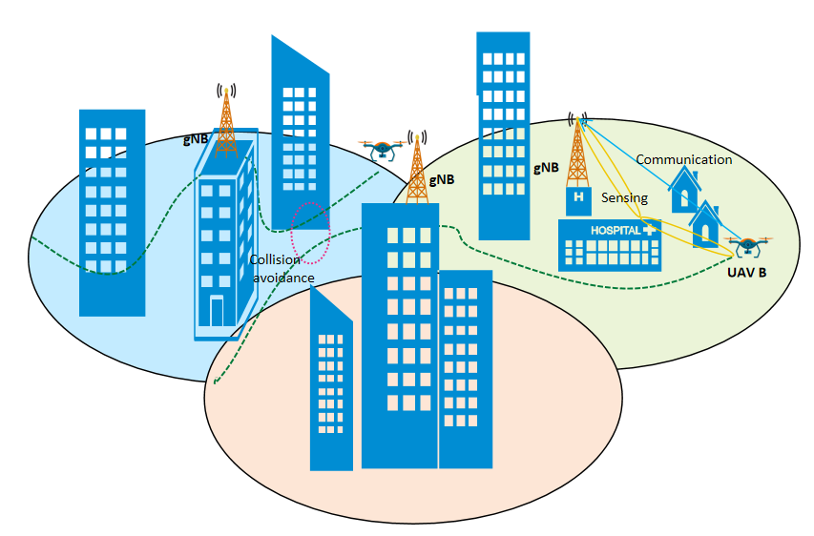
Figure 5.4.1-1 Network assisted collision avoidance for the UAVs
The following service flow gives an example of UAV delivery in retail goods delivery.

5.4.2 Pre-Conditions
Network Operator ‘MM’ provides a new 5G service named ‘5G Sensing Service’.
The UAV City Express ‘SS’ uses a specific UTM to assist its retail goods UAV delivery.
This UTM uses ‘5G Sensing Service’ provided by 5G network Operator ‘MM’ as additional source of information and navigate the UAVs.
Tom has ordered online daily necessities from a supermarket. Tom is living in downtown.
Jerry has also ordered online some food from a supermarket. Jerry is living in countryside.
The supermarket prepares the goods in packages and asks City Express ‘SS’ to deliver them to Tom and Jerry.
City Express ‘SS’ dispatches UAV A for Tom, and UAV B for Jerry.
UE A is on board UAV A and UE B is on board UAV B. Both UE A and UE B are subscribed to the 5G network of Operator ‘MM’.
Through the communication connections between the 5G base station and the UE A/ UE B, the UE provides its positioning information and UE ID. The 5G network and UTM connect the UE positioning information, UE ID with associated UAV ID.

5.4.3 Service Flows
The UAV A and UAV B are flying to their destinations under the directions of UTM with the assistance of the ‘5G Sensing Service’ provided by network Operator ‘MM’.
Considering that UAV A will fly to downtown, the UTM asks network Operator ‘MM’’s ‘5G Sensing Service’ to provide sensing service for UAV A, and the required sensing result includes the flying environment along its trajectory, e.g. altitude of the buildings, obstacles and other UAVs nearby.

Considering UAV B will fly to the countryside, the UTM asks network Operator ‘MM’’s ‘5G Sensing Service’ to provide sensing service for UAV B, and the required sensing result includes the flying environment along its trajectory e.g. obstacles, and other UAVs nearby.

The UTM configures the report period about UAV A and UAV B.
Each base station continuously sends sensing signaling along the UAV A’s trajectory, and the UE A on board of the UAV A can send the sensing measurement data of the UAV A back to the base station using the 5G communication connection. Then, the 5G network can acquire the UAV A’s flying environment sensing result e.g. building position, altitude, other nearby moving objects e.g. other UAV’s relative position, altitude, degree of moving angle, moving speed etc. to UTM.
Same sensing operation is also for UAV B.
The 5G network reports the sensing result periodically according to UTM’s configuration.
The UTM adjusts and directs the UAV flying trajectories considering the received sensing result and input from other sources (e.g. FLARM, ADS-B).
Considering UAV A is flying toward downtown, both the flying environment (e.g. many buildings) and wireless environment (e.g. many NLOS scenarios) are complex, the 5G network may need more transmission power to deliver sensing signals and exchange more information with the UE on boarding the UAV to determine sense result. So it is expected that the 5G system can provide an energy efficient sensing service for the UAVs.

5.4.4 Post-Conditions
The UAV A successfully delivers package to Tom and UAV B successfully delivers package to Jerry and return safely.

5.4.5 Existing features partly or fully covering the use case functionality

5.4.6 Potential New Requirements needed to support the use case

[PR 5.4.6 -1] The 5G system shall be able to provide a sensing service for a specific target object and the environment around the target object through interaction between base stations and UE on boarding the specific target object.
[PR 5.4.6 -2] The base station shall be able to sense multiple specific target objects and their environments at the same time.
[PR 5.4.6 -3] The 5G system shall be able to provide a mechanism for a trusted 3rd party to request the sensing service for a certain target object or multiple target objects of a certain area.
[PR 5.4.6 -4] The 5G system shall be able to report sensing result of the environment around a specific target object.
[PR 5.4.6 -5] The 5G system shall be able to support an energy efficient sensing of a target object.
[PR 5.4.6 -6] The 5G system shall be able to provide sensing service with follow KPIs.
Scenario | Sensing Distance |  |  | Sensing Angle/direction |  |  | Sensing Speed |  |  | Interval between two consecutive sensing fixes | Latency
Scenario | Accuracy | Resolution(m) | Distance(m)  Range | Accuracy | Resolution | Angle range | Accuracy | Resolution(m) | Speed range(m/s) | Interval between two consecutive sensing fixes | Latency
Network assisted sensing to avoid UAV collision | FFS | <1  (note 3) | 100  (note 3) | FFS | FFS | FFS | FFS | 1  /s  (note 3) | <= 90  (note 3) | FFS(note 1) | FFS  (note2)
NOTE 1: Time intervals between successive sensing result reports to a trusted third party application.
NOTE 2: Latency from the gNB to the application server via core network.
NOTE 3: the KPI values are sourced from [9]

