3GPP TR 22.837 V0.1.0 (2022-05)
Technical Report
3rd Generation Partnership Project;
Technical Specification Group TSG SA;
Feasibility Study on Integrated Sensing and Communication
(Release 19)
The present document has been developed within the 3rd Generation Partnership Project (3GPP TM) and may be further elaborated for the purposes of 3GPP.
The present document has not been subject to any approval process by the 3GPP Organizational Partners and shall not be implemented.
This Specification is provided for future development work within 3GPP only. The Organizational Partners accept no liability for any use of this Specification.
Specifications and Reports for implementation of the 3GPP TM system should be obtained via the 3GPP Organizational Partners' Publications Offices.

3GPP
Postal address

3GPP support office address
650 Route des Lucioles - Sophia Antipolis
Valbonne - FRANCE
Tel.: +33 4 92 94 42 00 Fax: +33 4 93 65 47 16
Internet
http://www.3gpp.org

Copyright Notification
No part may be reproduced except as authorized by written permission.
The copyright and the foregoing restriction extend to reproduction in all media.

© 2022, 3GPP Organizational Partners (ARIB, ATIS, CCSA, ETSI, TSDSI, TTA, TTC).
All rights reserved.

UMTS™ is a Trade Mark of ETSI registered for the benefit of its members
3GPP™ is a Trade Mark of ETSI registered for the benefit of its Members and of the 3GPP Organizational Partners
LTE™ is a Trade Mark of ETSI registered for the benefit of its Members and of the 3GPP Organizational Partners
GSM® and the GSM logo are registered and owned by the GSM Association

Contents
Foreword 4
Introduction 5
1 Scope 6
2 References 6
3 Definitions of terms, symbols and abbreviations 6
3.1 Terms 6
3.2 Symbols 7
3.3 Abbreviations 7
4 Overview 7
5 Use cases 7
5.1 Use case of intruder detection in smart home 7
5.1.1 Description 7
5.1.2 Pre-conditions 7
5.1.3 Service Flows 8
5.1.4 Post-conditions 8
5.1.5 Existing features partly or fully covering the use case functionality 8
5.1.6 Potential New Requirements needed to support the use case 8
5.2 Use case of pedestrian/animal intrusion detection in highway 9
5.2.1 Description 9
5.2.2 Pre-conditions 9
5.2.3 Service Flows 9
5.2.4 Post-conditions 10
5.2.5 Existing features partly or fully covering the use case functionality 10
5.2.6 Potential New Requirements needed to support the use case 10
5.3 Use case of rainfall monitoring 11
5.3.1 Description 11
5.3.2 Pre-conditions 11
5.3.3 Service Flows 11
5.3.4 Post-conditions 11
5.3.5 Existing feature partly or fully covering use case functionality 11
5.3.6 Potential New Requirements needed to support the use case 11
6 Considerations 12
7 Consolidated potential requirements and KPIs 12
7.1 Consolidated potential requirements 12
7.2 Consolidated potential KPIs 12
8 Conclusion and recommendations 12
Annex <Z> (informative): Change history 13

Foreword
This Technical Report has been produced by the 3rd Generation Partnership Project (3GPP).
The contents of the present document are subject to continuing work within the TSG and may change following formal TSG approval. Should the TSG modify the contents of the present document, it will be re-released by the TSG with an identifying change of release date and an increase in version number as follows:
Version x.y.z
where:
x the first digit:
1 presented to TSG for information;
2 presented to TSG for approval;
3 or greater indicates TSG approved document under change control.
y the second digit is incremented for all changes of substance, i.e. technical enhancements, corrections, updates, etc.
z the third digit is incremented when editorial only changes have been incorporated in the document.
In the present document, modal verbs have the following meanings:
shall indicates a mandatory requirement to do something
shall not indicates an interdiction (prohibition) to do something
The constructions "shall" and "shall not" are confined to the context of normative provisions, and do not appear in Technical Reports.
The constructions "must" and "must not" are not used as substitutes for "shall" and "shall not". Their use is avoided insofar as possible, and they are not used in a normative context except in a direct citation from an external, referenced, non-3GPP document, or so as to maintain continuity of style when extending or modifying the provisions of such a referenced document.
should indicates a recommendation to do something
should not indicates a recommendation not to do something
may indicates permission to do something
need not indicates permission not to do something
The construction "may not" is ambiguous and is not used in normative elements. The unambiguous constructions "might not" or "shall not" are used instead, depending upon the meaning intended.
can indicates that something is possible
cannot indicates that something is impossible
The constructions "can" and "cannot" are not substitutes for "may" and "need not".
will indicates that something is certain or expected to happen as a result of action taken by an agency the behaviour of which is outside the scope of the present document
will not indicates that something is certain or expected not to happen as a result of action taken by an agency the behaviour of which is outside the scope of the present document
might indicates a likelihood that something will happen as a result of action taken by some agency the behaviour of which is outside the scope of the present document
might not indicates a likelihood that something will not happen as a result of action taken by some agency the behaviour of which is outside the scope of the present document
In addition:
is (or any other verb in the indicative mood) indicates a statement of fact
is not (or any other negative verb in the indicative mood) indicates a statement of fact
The constructions "is" and "is not" do not indicate requirements.

Introduction
Editor’s Note: Introduction can be added as the second unnumbered clause.

1 Scope
The present document …

2 References
The following documents contain provisions which, through reference in this text, constitute provisions of the present document.
- References are either specific (identified by date of publication, edition number, version number, etc.) or non-specific.
- For a specific reference, subsequent revisions do not apply.
- For a non-specific reference, the latest version applies. In the case of a reference to a 3GPP document (including a GSM document), a non-specific reference implicitly refers to the latest version of that document in the same Release as the present document.
[1] 3GPP TR 21.905: "Vocabulary for 3GPP Specifications".
[2] W. Favoreel, "Pedestrian sensing for increased traffic safety and efficiency at signalized intersections," 2011 8th IEEE International Conference on Advanced Video and Signal Based Surveillance (AVSS), 2011, pp. 539-542, doi: 10.1109/AVSS.2011.6027406.
[3] Advances in Wildlife Crossing Technologies: https://highways.dot.gov/public-roads/septoct-2009/advances-wildlife-crossing-technologies.
[4] Protection Detection: Making Roads Safe for Drivers and Wildlife: https://onlinepubs.trb.org/onlinepubs/webinars/201118.pdf.
[5] F. Liu et al., "Integrated Sensing and Communications: Towards Dual-functional Wireless Networks for 6G and Beyond," in IEEE Journal on Selected Areas in Communications, doi: 10.1109/JSAC.2022.3156632.
[6] T. S. Rappaport, G. R. MacCartney, M. K. Samimi and S. Sun, "Wideband Millimeter-Wave Propagation Measurements and Channel Models for Future Wireless Communication System Design," in IEEE Transactions on Communications, vol. 63, no. 9, pp. 3029-3056, Sept. 2015, doi: 10.1109/TCOMM.2015.2434384.
[7] C. Han, Y. Bi, S. Duan and G. Lu, "Rain Rate Retrieval Test From 25-GHz, 28-GHz, and 38-GHz Millimeter-Wave Link Measurement in Beijing," in IEEE Journal of Selected Topics in Applied Earth Observations and Remote Sensing, vol. 12, no. 8, pp. 2835-2847, Aug. 2019, doi: 10.1109/JSTARS.2019.2918507.

3 Definitions of terms, symbols and abbreviations

3.1 Terms
For the purposes of the present document, the terms given in 3GPP TR 21.905 [1] and the following apply. A term defined in the present document takes precedence over the definition of the same term, if any, in 3GPP TR 21.905 [1].
sensing measurement: obtaining sensing measurement data about a target object.
sensing result: the information about a target object after processing, such as being present and object dimension, which is related to a particular sensing service.

3.2 Symbols
For the purposes of the present document, the following symbols apply:
<symbol> <Explanation>

3.3 Abbreviations
For the purposes of the present document, the abbreviations given in 3GPP TR 21.905 [1] and the following apply. An abbreviation defined in the present document takes precedence over the definition of the same abbreviation, if any, in 3GPP TR 21.905 [1].
<ABBREVIATION> <Expansion>

4 Overview

5 Use cases

5.1 Use case of intruder detection in smart home

5.1.1 Description
Sensing in smart home is a kind of the typical scenarios of indoor/local-area sensing. Considering people spends most of life time indoor, how to improve the user experience for indoor scenario is important. Nowadays, various 5G UEs, e.g. wearable device, sensor, smart phone and customer premise equipment (CPE), are deployed at home. In order to enjoy more comfortable and convenient indoor life, various devices are connected via wireless signals to build a smart home platform.
In addition to communication purposes, wireless signals can also be used for sensing, e.g., monitoring the home environment continuously.
For intruder detection in smart home scenario, due to the activities of indoor object or human, the 3GPP signal measured by UE or network would be influenced. By analysing and collecting the sensing information such as Doppler frequency shift, amplitude change and phase change, the behaviour of indoor object or human could be detected as shown in following figure 5.x.1-1 which takes sensing entity that trasceives (transmits and receives) the signal case as example.
. 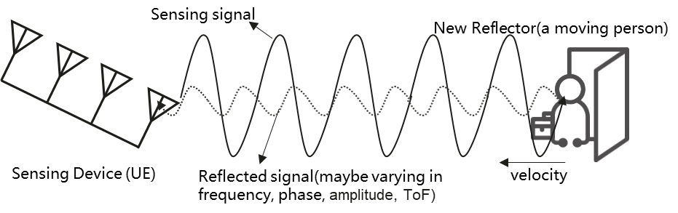
Fig. 5.1.1-1 An example of sensing operation of UE

5.1.2 Pre-conditions
Mary and her husband Tom live in a house with little daughter Alice.
On every working days, Mary and Tom have to leave home to work, and Alice needs to go to school. Since the community where the house is located is not stable, Mary and Tom have concern on the safety of their property.
In order to address their concerns, considering to protect the personal privacy and save family cost, Mary sets up some 5G CPEs (i.e. UE) in each room at home, which support sensing functionalities.

5.1.3 Service Flows
Mary and her all family members travel to Hawaii in a holiday. At this time, her house is empty. Since she worries about the safety of property, she enables the sensing service on intruder detection of the 5G CPEs (i.e. UE) at home.
Mary’s CPE (i.e. UE) in the living room is activated to perform the sensing operation. While the 5G CPE transmit 5G signals to provide communication services at home, the reflected signals are also be received and measured at the CPE as sensing information. The CPE reports the sensing information to 5G network or further process locally. Via the analysing the differences between the 5G signals and the received reflected signals provided by sensing service performed by 5G system, any potential intruder will not be missed.
Also Mary’s CPE in the living room can work with other 5G UEs in other rooms. The CPE discovers that the living room has another 5G device (i.e. UE) which could assist the sensing service as secondary device via direct device connection. The connectivity used in this case is direct device connection, and CPE and this 5G device play as the role of transmitter and receiver, respectively. The receiver measures the 5G signal (e.g., number of detected transmission paths), then provides sensing information to 5G network or further process locally. Via the analysing the differences between the 5G signals and the received reflected signals provided by sensing service performed by 5G system, any potential intruder will not be missed.
An intruder breaks into Mary’s house someday. The sensing service provided by 5G network system assists detecting that the presence of an intruder based on analysing the change of collected signals is aligned with the known feature of the activities of indoor human, and the alarm of intruder is sent to Mary’s smart phone. Mary calls the police for help, and the property is protected.

5.1.4 Post-conditions
Thanks to the sensing service provided by 5G UE and network, an intruder is found when Mary is out of home.

5.1.5 Existing features partly or fully covering the use case functionality
None.

5.1.6 Potential New Requirements needed to support the use case
[P.R.5.1.6-1] The 5G system shall provide a mechanism for an operator to authorize a UE for sensing.
[P.R.5.1.6-2] The 5G system shall be able to enable a UE to obtain sensing measurement data based on the 3rd party’s request.
Editor's Note: it is FFS to further improve the sentence of [P.R.5.1.6-2].
[P.R.5.1.6-3] The 5G system shall provide mechanisms for an operator to only collect or expose sensing information according to agreement.
Editor's Note: it is FFS to further improve the sentence of [P.R.5.1.6-3].
Editor’s Note: it is FFS to identify the potential KPIs.
Editor's Note: it is FFS whether other potential requirements will be identified.

5.2 Use case of pedestrian/animal intrusion detection in highway

5.2.1 Description
Transportation as a basic and essential industry plays one of the important roles in a human’s life. Making transportation smarter can make life more convenient and benefit economic development. Highways are an important part of smart transportation. Due to the strong road safety demand on smart transportation, it is necessary to monitor the road situation so as to make appropriate management of road traffic, give guidance or assistance information to vehicles and/or highway traffic safety administration [2].
For example, major accidents caused by pedestrians or animals crossing highways occur frequently [3] [4]. Currently, the highway supervision systems are mainly based on traditional sensors (e.g. radars, cameras) equipped in the roadside infrastructure, but there are still many problems in road supervision system, e.g. it only has partial coverage along the roadside, and the radar may be dedicated for a single usage which requires deploying different types of transportation radars in the same place to satisfy the respective sense use cases and requirements in the area of interest.
Base stations on the roadside are already used to provide 5G coverage for communication, and the radio signals can also be used to sense the environment for object detection. The base station as transmitter and receiver knows the detailed structure of the transmitted sensing signal, such as the allocation of sensing resource, the beam direction, the time/phase/amplitude differences between the sent and received signals. The distance, angles and Doppler information (i.e. velocity) can be extracted once sensing signals are received. Thanks to the native network-wide sensing capability and feasible resource cooperation, the cellular networks can become a ubiquitous radio sensing infrastructure.

5.2.2 Pre-conditions
Good partnership and cooperation are established between the road supervision department and Mobile Operator#A in City#B. Requested by the supervision departments for the sensing service, the suitable base stations around/along a highway are selected, which enable Mobile Operator#A to constantly sense the road situation including moving objects (e.g. vehicles and pedestrians). The sensing signal emitted from the base station arrives at vehicles/pedestrians/objects on the road and is bounced (reflected) back to the transmitting base station.

5.2.3 Service Flows

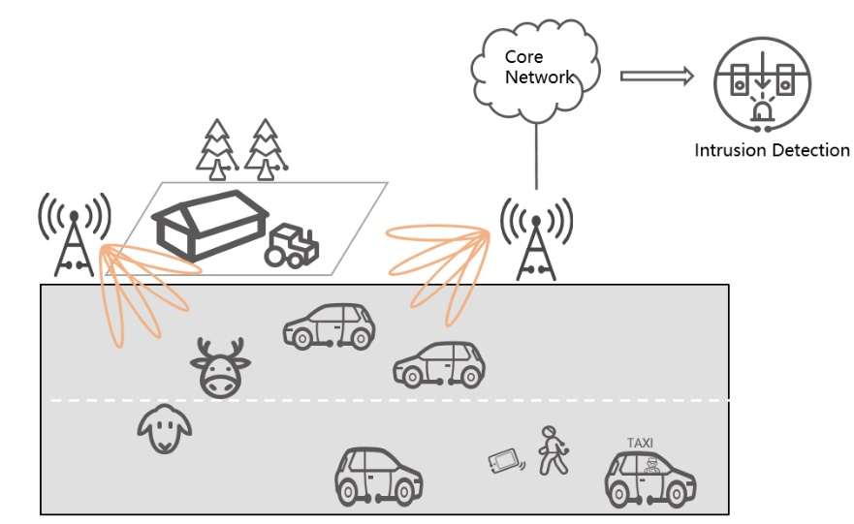
Figure 5.2.3-1: Pedestrian/animal intrusion detection
- Fei is a tourist, who is taking a taxi to enjoy the view around the highway in City#B. The base stations around/along the highway constantly sense the road situation. While the taxi is driving on the highway, Fei rolls down the window to take some pictures. Suddenly his mobile phone falls out the window.
- Fei tells the driver to stop and cautiously gets out of the taxi. He crosses the highway and wants to find his mobile phone. Meanwhile, some animals (e.g. sheep and deer) from a farm near the highway approach the road. More and more surrounding vehicles are passing at very high speed. The pedestrian and animals are detected and closely tracked with sufficient accuracy in the sensing area of a base station, and then the sensing measurement is transferred to the core network from the base station and further processed into the sensing results in the core network.
- The sensing results are exposed by the Mobile Operator#A to the road supervision departments and map provider. The map provider adds the position of the vulnerable pedestrian and animals into the HD dynamic maps and transmits warning messages to the vehicles approaching them. The staff working for supervision departments immediately responds to the emergency, launching temporary traffic management, and rushes to the emergency site to fetch the mobile phone for Fei and drive the animals away from the highway.
- Finally, Fei and animals leaves the highway safely. Potential road accident(s) caused by the pedestrian/animal intrusion are avoided.

5.2.4 Post-conditions
Thanks to the area-coverage, long-distance sensing capability of the base station (which provides a bird’s-eye-view for monitoring the highway environment) the precision and efficiency of highway management and safety supervision is improved. The network-based sensing can provide timely, continuous, accurate, and comprehensive sensing results, which is a reliable basis for highway safety services.

5.2.5 Existing features partly or fully covering the use case functionality
None.

5.2.6 Potential New Requirements needed to support the use case

[PR 5.2.6-1] The 5G system shall be able to support a base station to perform sensing.
[PR 5.2.6-2] The 5G system shall be able to support means to select suitable base station(s) to perform sensing, e.g. based on the base station’s location, sensing capability, and the sensing service information requested by trusted third party application.
Editor’s Note: The [PR 5.2.6-2] is FFS.
[PR 5.2.6-3] The 5G system shall be able to support means to configure the sensing operation of a base station(e.g. authorization, sensing activation and/or deactivation, sensing duration, sensing accuracy, target sensing area).
[PR 5.2.6-4] The 5G system shall be able to support means to enable a base station to transfer sensing measurement data to the core network.
[PR 5.2.6-5] The 5G system shall be able to support means to enable the core network to process sensing measurement data for obtaining sensing results.
[PR 5.2.6-6] Based on operator’s policy, the 5G system shall expose a suitable API to a trusted third party to provide the information regarding sensing results.
[PR 5.2.6-7] The 5G system shall be able to support charging data collection for the sensing services (e.g. considering service type, sensing accuracy, target area, duration) requested by a trusted third party application.
Editor’ note: The terminology of base station in the requirements is FFS.
Editor’ note: The KPIs for this use case are FFS.

5.3 Use case of rainfall monitoring

5.3.1 Description
Rainfall monitoring is a topic of great importance for several application contexts: hydraulic structure design, agriculture, weather forecasting, climate modelling, etc. At present, the most widely used measurement method is rain gauge.
Traditional rainfall monitoring use rain gauges, which are located at a particular location. Wide-area rainfall monitoring using traditional rain gauges would be costly. The base stations are deployed by the operators with radio cell planning that could cover a wider area. With base stations monitoring the rainfall, for example rain rate (mm/h), it could obtain a horizontally wider-area measurement.
Radio signals, as they propagate through the atmosphere, are reduced in intensity by constituents of the atmosphere. Oxygen and water vapor are the two major components which are responsible for the signal absorption. If it is a rainy day, an additional attenuation caused by rain further increases the propagation path loss. [7] The rain attenuation depends on the size and distribution of the water droplets, hence, by quantifying and modelling the base station signal measurements, we are able to know the rain rate.
The mmWave bands, such as 28GHz and 38GHz have been used to assess coverage, large-scale path loss, and fading and multipath effects [6]. Since the 28 GHz and 38 GHz bands are also licensed for wireless backhaul communications, these frequencies can used for rainfall monitoring [7].
The granularity of the rainfall monitoring could be smaller than the traditional measurements.

5.3.2 Pre-conditions
Peter is a farmer who takes care of a big farm that grows different crops. Peter needs to monitor the rainfall of his farm to manage reasonable irrigation, drainage and fertilizer. When there is less rainfall, Peter can select reasonable irrigation plans to improve the farmland water content condition. When there is high rainfall, Peter should improve the drainage system and fertilize the crops to avoid crop losses.

5.3.3 Service Flows
- Peter has a subscription for the premium service of rainfall monitoring for a more granular location.
- Peter is at daily working routine and wants to check the timely rainfall information from the weather application on his phone.
- The base station obtains the NR based sensing measurement data every hour and the 5G system exposes NR based sensing results to the weather application via the core network.
- Based on the results of the NR based sensing measurement data, the application server obtains the rainfall associated with location information.
- Peter obtains timely rainfall information from weather application on his phone.

5.3.4 Post-conditions
Peter could check the rainfall information at any time on his phone. Based on the timely rainfall information, Peter could plan the irrigation, drainage and fertilizer for the crops in his farm.

5.3.5 Existing feature partly or fully covering use case functionality
None

5.3.6 Potential New Requirements needed to support the use case
[PR. 5.3.6 - 001] The 5G system shall support collection of the NR based sensing measurement data.
[PR. 5.3.6 - 002] Based on operator’s policy, the 5G system shall support mechanisms to provide NR based sensing measurement capabilities to derive the sensing results.
[PR. 5.3.6 - 003] Based on operator’s policy, the 5G system shall provide mechanisms to expose NR based sensing results to a trusted 3rd party application via the core network.
Editor’s Note: These requirements are FFS.
Editor’s Note: Any KPIs is for further studied.

6 Considerations
Editor's Note: This clause can capture privacy, charging, public safety considerations.

7 Consolidated potential requirements and KPIs

7.1 Consolidated potential requirements

7.2 Consolidated potential KPIs

8 Conclusion and recommendations

Annex <Z> (informative):
Change history
Change history
Date | Meeting | TDoc | CR | Rev | Cat | Subject/Comment | New version
5.2022 | SA1#98e | S1-221249 | - | - | - | Initial Skeleton | 0.0.0
5.2022 | SA1#98e | S1-221250  S1-221251  S1-221252 | - | - | - | Output of approved pCRs from SA1 #98e | 0.1.0

