3GPP TSG-SA WG1 Meeting #98e S1-221160
Electronic Meeting, 9 – 19 May 2022 (revision of S1-220154)

Title: pCR on new use case: Intralogistics in automobile manufacturing
Agenda Item: 7.3
Source: Huawei, Hisilicon, Quanray, China Mobile, Orange, China Telecom
Contact: Shuang Zhang (zhang.shuang2@huawei.com)
Yishan Xu (xuyishan@huawei.com)

Abstract: This document provides a Text Proposal for the use case about using Ambient_IoT services for intralogistics in automobile manufacturing.

Text Proposal to TR 22.840
**************** First Change ******************

2 References
The following documents contain provisions which, through reference in this text, constitute provisions of the present document.
- References are either specific (identified by date of publication, edition number, version number, etc.) or non-specific.
- For a specific reference, subsequent revisions do not apply.
- For a non-specific reference, the latest version applies. In the case of a reference to a 3GPP document (including a GSM document), a non-specific reference implicitly refers to the latest version of that document in the same Release as the present document.
[1] 3GPP TR 21.905: "Vocabulary for 3GPP Specifications".
[x1] 3GPP TS 22.011: “Service accessibility”.
[x2] 3GPP TS 22.278: "Service requirements for the Evolved Packet System (EPS)".
[x3] 3GPP TS 22.368: "Service requirements for Machine-Type Communications (MTC)".
[x4] 3GPP TS 22.261: "Service requirements for the 5G system".
[y1] 5G for smart manufacturing: https://www.gsma.com/iot/wp-content/uploads/2020/04/2020-04_GSMA_SmartManufacturing_Insights_On_How_5G_IoT_Can_Transform_Industry.pdf
[y2] https://forcetechnology.com/en/articles/batteryless-electronics-energy-harvesting
[y3] https://www.gs1.org/standards/rfid

************* End of First Change ***************
**************** Second Change ****************

5.x Intralogistics in automobile manufacturing

5.x.1 Description
The automobile manufacturing industries are constantly looking for ways to increase productivity by improving inventory accuracy and material flows. Therefore, intralogistics for production facilities in automobile factories have been targeting at these goals by achieving timely visibility of inventories (a.k.a. precise materials scheduling) to achieve optimum efficiency in production. Specifically, it involves stocking, dispatching, and sorting. It is no surprise that there are competing technologies for supporting small-scale inventory, which at times would require human involvement. With the advent of Industry 4.0, manufacturing requires a much higher automatic intralogistics performance [y1]. This means more key areas inside large manufacturing facilities would require highly-efficient and automated inventory of materials and parts. Such upscaling would render most of the known competing technologies economically unviable. Ambient power-enabled IoT (Ambient_IoT) service provided by 5G can be expected to meet the demanding needs by providing communication to Ambient_IoT devices with good performance, with the Ambient_IoT solely dependent on harvested ambient energy, being maintenance-and-battery free, extremely small, thin, and of low complexity, very light-weight, and with a long life span. Additionally, the 5G system can provide Ambient_IoT devices with positioning services, as full automation would require AGVs or forklifts to fetch materials at accurate locations within the large storage areas. Moreover, the 5G system can provide intrinsic core network functions to manage and authenticate Ambient_IoT connections, enabling operators to build more interesting cases together with their business partners.

5.x.2 Pre-conditions
Alles-Sublime, a renowned automobile manufacturing company uses standardized load containers to realize flow of materials. The load containers are purchased, owned and managed by Alles-Sublime. With its business growing, Alles-Sublime is integrating the latest and advanced production and logistics management systems to ensure the production facilities are modernized for Industry 4.0. In quest of this, intralogistics at Alles-Sublime is expected to automatically identify and track individual goods and materials throughout production facilities: not only at the dock where materials enter the production facilities, but also in the large floor-level storage areas, further in the sorting areas and down at production lines. Similar to the norm of the automobile manufacturing industry, a typical production facility of Alles-Sublime covers a total area of around 600,000 square meters. Alles-Sublime use unique identifiers (e.g. 96 bit or 240 bit EPC codes) to distinctly identify load containers.
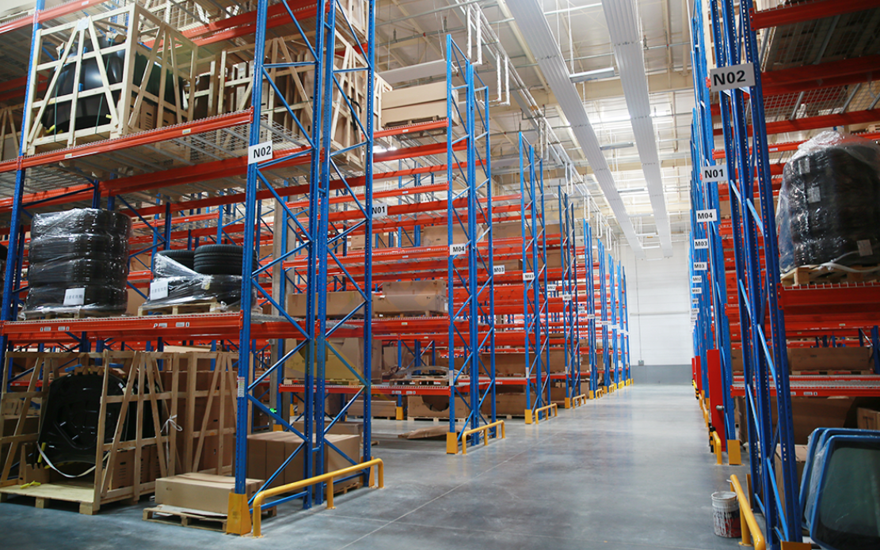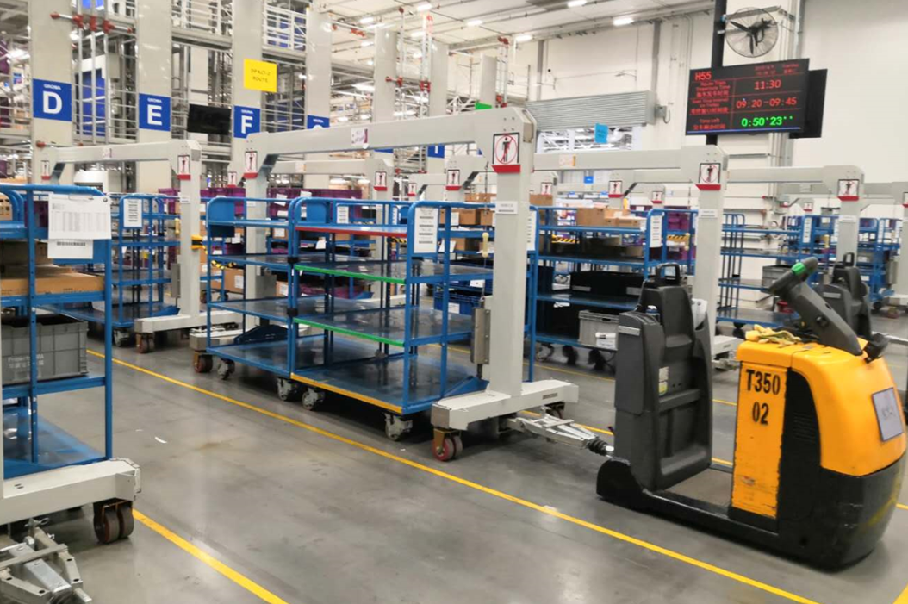
Fig. 5.x.2-1
Prior to deciding on a future-proof solution, a comprehensive analysis (e.g. ROI) is carried out by Alles-Sublime to verify Ambient_IoT’s suitability for the long-term business objectives. By virtue of many of Ambient_IoT’s attractive wireless communication characteristics, Alles-Sublime come to the conclusion of a positive case. To effectively meet their intralogistics demand, it entails installing around 1300 stationary “readers” strategically per typical production facility (600,000 square meters), where in total around 800,000 Ambient_IoT tags would be physically present at the same time. To keep track of the production process, normally 20 Ambient_IoT tags need to be read per second per “reader” (e.g. fast-moving AGVs passing a gate). After verifying with operator O, Alles-Sublime adopts Ambient_IoT by having a service contract with the operator, which is commissioned to design and deploy 5G network coverage within Alles-Sublime’s automobile production facilities and then to accordingly enable and manage Ambient_IoT service. Wherever needed in the production facilities, sufficient network coverage is assumed.
It is in the huge floor storage area where the loaded containers are kept, accurate positioning service is needed by AGVs for pick-up, once certain materials or parts are needed by a production line. At Alles-Sublime, the floor storage area is divided into blocks with the dimension of 18m by 18m, in each of which a stationary “reader” is deployed. Each block is further divided into grids of the size slightly larger than a load container, whose length is around 1.5m. To achieve uninterrupted material flow, Alles-Sublime decide to use the space of two grids for parking load containers holding the same materials. In this way, as a load container holding certain material at a given grid is carried away by an AGV, the same material loaded in another container would always be available at the grid just next to it.
The personnel Sylvain at Alles-Sublime attaches each of the load containers with an Ambient_IoT tag, where a unique code is written in its microchip. Ambient_IoT tags are very thin non-battery powered IoT devices, which instead function using an energy harvesting mechanism that produces a limited amount of power. A typical energy harvesting device can produce up to a few hundred microwatts [y2] (e.g. Less than 250 micro Watts). In the production facilities of Alles-Sublime, an Ambient_IoT tag can be connected to the 5G network and the communication is enabled.

5.x.3 Service Flows
- Advised by their CISO (Chief Information Security Officer, leading the company cyber security team) for compliance with the company security policy, Alles-Sublime may require to apply a specific authentication method for the Ambient_IoT tags. The method and the corresponding credentials (e.g. keys, certificate) are communicated to operator O. Each and every Ambient_IoT tag locally stores the credentials and a unique ID.
- Alles-Sublime maintain in its intralogistics management system the list of unique IDs for these Ambient_IoT tags. The personnel Sylvain attaches each of the load containers (owned by Alles-Sublime) with an Ambient_IoT tag, then send them to various suppliers in order to bring back ordered goods, materials and parts.
- By returning to Alles-Sublime’s automobile manufacturing facilities, large amount of load containers first enter the dock area. There the 5G network transmits signals intending to start inventory process. Since the Ambient_IoT tags harvest power from the environment, once detecting the signals from the 5G network the Ambient_IoT tags can respond by starting random access.
- 5G network negotiate the authentication methods with Alles-Sublime’s for authenticating and authorizing Ambient_IoT tags. Then 5G network performs the corresponding procedure to complete the registration. The security-related information (e.g. authentication method and the corresponding credentials) operator O received à priori from Alles-Sublime should be taken into account.
- Based on the requests issued by the application function, the 5G network performs the automatic inventory operation (read out pre-written unique IDs in Ambient_IoT tags) of the large number of incoming load containers entering the dock area fast and efficiently. The read-out information is sent by 5GC to Alles-Sublime’s inventory system (connected to ERP/APS), where the inventoried information is updated or saved.
- Once registered in the inventory system, load containers are stored in the floor storage areas. Thanks to the well-planned 5G network coverage, there these load containers (still loaded with various materials and parts) can be inventoried by Alles-Sublime either periodically or when requested.
- As automobile manufacturing process continues (almost non-stop), a picking list is automatically generated according to the production plan managed by the APS (Advanced Planning and Scheduling) system.
- According to the information in the inventory system, AGVs (or forklifts) with their respective picking lists are sent to the floor storage areas to pick up the corresponding load containers (holding different materials or parts). As the floor storage area is extremely huge, Alles-Sublime utilize the 5G network positioning service for AGVs to quickly fetch the target load containers holding the exact materials requested in the pick-up list. Since the floor storage area is divided into 18m by 18m blocks with each block being further divided into grids of 1.5m by 1.5m, the 5G system always provides the AGVs with the accurate positioning information of the target load containers.
- When AGVs find the needed load containers in the floor storage area, convey them further to the sorting areas. It is in the sorting areas that different materials and parts brought in by AGVs are grouped in accordance with precise manufacturing schedules to be followed at the production lines.
- At the production lines, materials and parts as logically grouped (at the sorting areas) are eventually fed into production. The empty load containers will be brought to the recycling area. These empty load containers await to be sent to suppliers at the next schedule determined by ERP/APS.
- In all the key areas (floor storage areas, sorting areas, production lines and empty container recycling area) inside the manufacturing facility, the load containers need to be inventoried efficiently, timely, fast, accurately. When AGVs enter these areas, step 5 is repeated and the precise material scheduling is updated in the inventory system.

5.x.4 Post-conditions
Thanks to the Ambient_IoT service provided by the 5G system, automobile manufacturing can enjoy automatic intralogistics, largely improve the efficiency and productivity.

5.x.5 Existing features partly or fully covering the use case functionality
SA1 has performed various studies on IoT in previous releases, where related normative stage 1 requirements are introduced in TS 22.011 [x1], TS 22.278 [x2], TS 22.368 [x3], and TS 22.261 [x4].

TS 22.011 introduces access control for MTC, examples of periodic network selection attempts are:

For UEs only supporting any of the following, or a combination of, NB-IoT, GERAN EC-GSM-IoT [18], and Category M1[13] of E-UTRAN enhanced-MTC, the UE shall interpret the interval value to be between 2 and 240 hours, with a step size of 2 hours between 2 and 80 hours and a step size of 4 hours between 80 and 240 hours.
In the absence of a permitted value in the SIM/USIM, or the SIM/USIM is phase 1 and therefore does not contain the datafield, then a default value of 60 minutes, shall be used by the UE except for those UEs only supporting any of the following, or a combination of: NB-IoT, GERAN EC-GSM-IoT [18], and Category M1 [17] of E-UTRAN enhanced-MTC. For those UEs a default value of 72 hours shall be used.
NOTE: Use of values less than 60 minutes may result in excessive UE battery drain.
TS 22.368 addresses features of MTC communication and service requirements related to MTC device triggering, addressing, identifiers, low mobility, small data transmission, infrequent MT communication, security, remote MTC device management, group-based MTC features including policing and addressing, etc. Example requirements are:

The system shall provide mechanisms to lower power consumption of MTC Devices.
The system shall provide mechanisms for the network operator to efficiently manage numbers and identifiers related to MTC Subscribers.

TS 22.261 captures some important service requirements for IoT, e.g.

The 5G system shall support a secure mechanism for a home operator to remotely provision the 3GPP credentials of a uniquely identifiable and verifiably secure IoT device.
The 5G system shall support a secure mechanism for the network operator of an NPN to remotely provision the non-3GPP identities and credentials of a uniquely identifiable and verifiably secure IoT device.
An IoT device which is able to access a 5G PLMN in direct network connection mode using a 3GPP RAT shall have a 3GPP subscription.
The 5G system shall allow the operator to identify a UE as an IoT device based on UE characteristics (e.g. identified by an equipment identifier or a range of equipment identifiers) or subscription or the combination of both.
An IoT device which is able to connect to a UE in direct device connection mode shall have a 3GPP subscription, if the IoT device needs to be identifiable by the core network (e.g. for IoT device management purposes or to use indirect network connection mode).
The 5G system shall support operator-controlled alternative authentication methods (i.e. alternative to AKA) with different types of credentials for network access for IoT devices in isolated deployment scenarios (e.g. for industrial automation).
The 5G system shall support a suitable framework (e.g. EAP) allowing alternative (e.g. to AKA) authentication methods with non-3GPP identities and credentials to be used for UE network access authentication in non-public networks.
NOTE: Non-public networks can use 3GPP authentication methods, identities, and credentials for a UE to access network. Non-public networks are also allowed to utilize non-AKA based authentication methods such as provided by the EAP framework, for which the credentials can be stored in the ME.
The 5G system shall enable an NPN to be able to request a third-party service provider to perform NPN access network authentication of a UE based on non-3GPP identities and credentials supplied by the third-party service provider.
In these specifications, albeit the service requirements addressing traits for IoT in terms of low device power consumption, small and infrequent data transmissions, long service lifetime, and resource efficiently, the IoT devices considered in 3GPP have been assumed to be powered by at least batteries up till now. To enable extremely small, thin, light-weight, battery-less or even disposable Ambient_IoT devices that provide basic IoT data transaction at appropriate performance level suitable for the target scenarios, new challenges to the 5G system are foreseen and need to be addressed.

5.x.6 Potential New Requirements needed to support the use case

5.x.6.1 Service requirements for use of Ambient_IoT devices for intralogistics in automobile manufacturing
[PR 5.x.6.1-001] The 5G system shall support communication for an Ambient_IoT device which do not have the capability to store energy, and thus should consume very low amounts of energy in establishing communication to the network as well as in transferring user data..
[PR 5.x.6.1-002] The 5G system shall support communication for Ambient_IoT devices using energy harvesting mechanisms and which do not have the capability to store energy?, which operate at a max continuous power of only a few hundred micro Watts [y2].
NOTE 1: In intralogistics scenarios and for inventory in general, no energy storage is assumed in Ambient_IoT devices.
[PR 5.x.6.1-003] The 5G system shall be able to provide indoor communication range for ambient-enabled IoT do not have the capability to store energy? communication of at least 30 meters.
[PR 5.x.6.1-004] The 5G system shall support application layer data in the uplink for ambient-enabled IoT communication for devices that do not have the capability to store energy, which is up to a few hundreds of bits [y3].
[PR 5.x.6.1-005]
[PR 5.x.6.1-006] The 5G system shall be able to provide the 5G indoor positioning services to Ambient_IoT device that do not have the capability to store energy with the horizontal positioning accuracy of 3 metres.
[PR 5.x.6.1-007] The 5G System shall provide light-weight mechanisms for an operator to manage (e.g. provision, authenticate, authorise, etc.) Ambient_IoT devices that do not have the capability to store energy .
[PR 5.x.6.1-008] The 5G system shall provide suitable means for an operator to negotiate with an authorized 3rd party the method for authenticating and authorizing Ambient_IoT devices that do not have the capability to store energy.
[PR 5.x.6.1-009] The 5G system shall provide mechanisms for an operator to authenticate and authorize the Ambient_IoT device using the credentials provided by an authorized 3rd party.

[PR 5.x.6.1-011] The 5G system shall support collection of charging information based on different charging policies, i.e. total number of communication per charging period, or total number of Ambient_IoT devices per charging period.

5.x.6.2 KPIs for the use of Ambient_IoT devices for intralogistics in automobile manufacturing
[PR 5.x.6.2-001] The 5G system shall be able to provide Ambient_IoT service with the following KPIs:
Table 5.x.6.2-1
Scenario | Max. allowed end-to-end latency | Max. instantaneous device power consumption | Service bit rate: user-experienced data rate | Message  Size | Communication  range | Device density | Service area dimension
Automatic Intralogistics in automobile manufacturing | [100] ms | 100 uW | < 5 kbit/s  (note 1) | [496] bits  (note 2) | 30 m  Indoors | < 1,5 Million/km2 (note 3) | 600 000 m2  (note 4)
NOTE 1: This value is calculated as the instant data rate for transmitting 496 bits within 100 ms time period. The need for data transmission is infrequent.
NOTE 2: EPC Tag Data standard [y3], 496 bit is the max size for business-related payload data, not the entire packet size.
NOTE 3: Daily around 1 million units of materials are used in the manufacturing area, but they are not used at the same time.
NOTE 4: A typical car manufacturing plant takes up to 600 000 m² in surface.

************* End of Second Change ***************

