3GPP TSG-SA WG1 Meeting #95e S1-213006

Electronic Meeting, 23 August – 2 September 2021
Source: SA1 Chair, MCC
Title: Guidelines for SA1#95e (e-meeting)
Document for: Information

Agenda Item: 1.1

Guidelines for SA1#95e (e-meeting)

General info
SA1#95e e-meeting will start on Sunday 22nd August 23:00 UTC and end on Thursday 2nd September 15:30 UTC.
It is an Electronic Meeting as defined in the 3GPP Working Procedures Annex F.4.2.
SA1#95e has the same power of decision as a regular meeting, e.g. agree or note documents.
Discussions are moderated by the chairman and the vice-chairmen, as explained below.

Before the meeting
Deadlines:
As indicated by e-mail by the Chair.
The pre-meeting tdocs submission follows the usual approach, i.e. using the 3GPP Portal with the deadlines indicated by the Chair (as usual, exceptions are possible, at Chairman's appreciation, in particular for answers to LSs).
Registration:
Registration is mandatory for participating at SA1#95e and shall be done before Tuesday 17 August 23:00 UTC. It follows the classical meeting registration process, i.e. through the 3GPP portal.
Only the people who registered to SA1#95e will have access to the reflector associated to the meeting (see below) and will receive an invitation to join the online sessions (via GoToMeeting, see below).

Registration does not count toward voting rights.

During the meeting
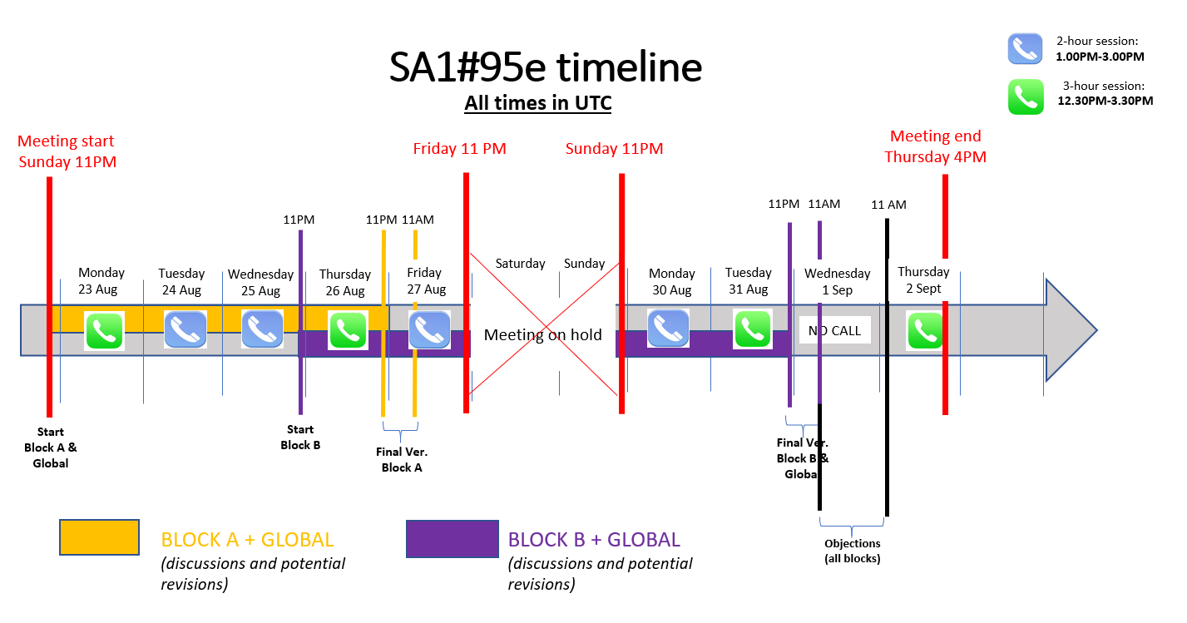
Overview of the timeline for SA1#95e

Both e-mail discussions and Online sessions will take place during SA1#95e, as explained below.
Discussion by e-mail:
Discussions related to SA1#95e will take place on a dedicated reflector:
3GPP_TSG_SA1_eMeet@list.etsi.org
This list is referred to as "SA1_eMeet list" below.
Unlike most 3GPP lists, the membership in the “SA1_eMeet list" will be handled by MCC only: the list will include all delegates who have registered to SA1#95e (individual attempts to register to this list via a request to "listserv" will be ignored).
This mailing list will be operating from August 18th till –September 8th 2021. All the mails received in the SA1_eMeet list will be processed and archived by MCC as any other mailing list.

- Prior to the meeting: the SA1 chairman will send a series of e-mails. There will be one e-mail per topic, with the following subject: [tdoc] Topic. Each e-mail will also tell which SA1 leader (chair or a vice-chair) will be chairing the discussion. These e-mails will trigger the discussions on each topic. All related discussions must be sent as "Reply" to these emails to the SA1_eMeet list.
- From Sunday 22nd August 23:00 UTC until Wednesday 1st September 11:00 UTC: Discussions and potential revisions of the electronic meeting contributions, with intermediate deadlines as shown in the figure above. "Block A", "Block B" and "Global" refer to sets of contributions. These sets will be defined prior to the beginning of the meeting by the Chair.
- From Wednesday 1st September 11:00 UTC until Thursday 2nd September 11:00 UTC: objections to the final versions shall be sent to the SA1_eMeet list. If no objection is received, the document(s) will be approved and will get an official SA1 number. If any objection is received, the document(s) will be discussed in the final conference call.
- On Thursday 2nd September from 12:30 to 15:30 UTC: Closing online session. In this session, only documents that have been objected will be discussed, in order for the chairman to explore if consensus can be declared or the documents should be noted. In case some documents will not be discussed due to time constrains, these documents will be postponed to the next SA1 meeting (up to the authors to re-submit them).
- Some hours after the closing online session: the SA1 chairman will publish the final agenda with the agreed and noted documents on the "normal" SA1 reflector. All documents will be processed as per their conclusion.
No work or action will be taken into account between Friday 27th August 23:00 UTC and Sunday 29th August 23:00 UTC.

Online sessions:
Most days, there will be either a 2-hours or a 3-hours online sessions. The planning is as shown in the figure "Overview of the timeline for SA1#95e".
The 3-hours online sessions are from 12:30 to 15:30 UTC.
The 2-hours online sessions are from 13:00 to 15:00 UTC.

These sessions will be carried out over the tool GoToMeeting. The chairman will publish an updated agenda that will contain all the decisions taken during the online sessions. Minutes will be taken by the SA1 secretary during these online sessions.
Invitations to join the GoToMeeting sessions will be sent to the eMeet reflector. When registering in GoToMeeting, please use as username: [your company name] - [your full name] (e.g.: "KPN - Jose Almodovar").
The content of each session will be announced at least 20 hours in advance. A new version of the Agenda will be sent at least one hour before each session.
The SA1 chairman will chair these sessions as a normal session at a physical meeting. These online sessions will follow the "classical" meeting procedure, i.e. documents will be presented and discussed under the chairman's moderation. During these online sessions, documents can be agreed, revised or noted, and this status will apply be for the full SA1#95e meeting, i.e. no further discussions on these contributions by e-mail.
Note that the time allocated to present and comment a document will be shorter than at a physical meeting, and the chairman will be strict into enforcing them.
To request for the floor during the online sessions and for queue control, the tool TOHRU will be used:
https://www.3gpp.org/tohru/
Meeting identity: 3GPP_SA1_95e. When registering in TOHRU, please use the same username as for GoToMeeting, i.e. : [your company name] - [your full name] (e.g.: "KPN - Jose Almodovar"). As an alternative, for companies having privacy issue, it is allowed to use only the first name in TOHRU (e.g. "Jose"), while keeping the full name in GoToMeeting.

Practical handling of tdocs:
- Only the author of the original document can provide revisions of his/her document ("Author's Revision").
Other delegates shall provide their comments as text in the body of an e-mail, following the discussions guidelines, and/or using "Company's Proposal", as explained below.
- Providing in the e-mail a hyperlink to the document is strongly encouraged. Documents shall not be sent as e-mail attachment – attachments will be removed by the system anyway.
- Folders where to upload documents:
Documents and Author’s Revisions in the “S1-21xxxx.zip” format shall be uploaded at:
https://www.3gpp.org/ftp/tsg_sa/WG1_Serv/TSGS1_95e_EM_August2021/inbox
Documents and Author’s Revisions in the “S1-21xxxxry.zip” format shall be uploaded at:
https://www.3gpp.org/ftp/tsg_sa/WG1_Serv/TSGS1_95e_EM_August2021/inbox/revisions
Informal documents (temporary draft, Company Proposal etc.) can be stored at:
https://www.3gpp.org/ftp/tsg_sa/WG1_Serv/TSGS1_95e_EM_August2021/inbox/drafts
Note that, to upload documents, an FTP client is needed, such as FileZilla. Upload is authorized with an EOL account. The EOL account credentials are the ones to log in to 3GU. Deletion and overwrite is not permitted (only by MCC).
These folders are also accessible by ftp, replacing https://www.3gpp.org/ftp/ by “ftp://ftp.3gpp.org/”
- Each time a new revision is uploaded, its author shall send an e-mail to the SA1 reflector using "Reply" to the corresponding discussion, as specified above, to tell which file has just been uploaded and explain in a couple of sentences what this new revision is about.
- "Author's Revision" versus "Company's Proposal"
  - "Author's Revision" is to be provided by the original author only.
Only Author's Revision increments the revision number. Example: If revised, "S1-204017.zip" shall be revised as "S1-204017r1.zip", then "S1-204017r2.zip", etc.
This type of document shall be uploaded to the "inbox/revisions" subfolder.
If a new SA1 tdoc number has been allocated, the file shall be uploaded to the root of the "inbox" folder. Note that the revision number is coded on one digit. Passed “r9”, letters will be used, i.e. “r9” is revised in “ra”, then in “rb”, etc.
  - "Company's Proposal" is when a company comments on an Author's Revision using revision marks. Company's Proposal shall not change the revision number. E.g. if Nokia wants to use a Company's Proposal to comment on S1-204017r3 from LG, Nokia shall do that in a file called "S1-204017r3_Nokia.zip". If vivo wants to comment on the Nokia version "S1-204017r3_Nokia.zip", the file name becomes "S1-204017r3_Nokia_vivo.zip”. Etc. (Then it is up to LG to issue "S1-204017r4.zip", taking into account Nokia's, Vivo's and all other companies' comments.)
The "Company's Proposal" documents shall be uploaded to the "inbox/drafts" subfolder.
- When the electronic meeting is completed, all final revisions of approved documents will get a proper SA1 tdoc number. All other revisions (intermediate revisions, not approved versions, etc.) will be placed by MCC in a dedicated temporary folder. If a delegate wants a non-approved revision to get an official, permanent, SA1 tdoc number, he/she has to mention it before the end of the meeting (the status of the document with new tdoc number will be the same status as the status of the latest revision). The list of new numbers will be provided by the chair and/or the secretary within one hour of the closing of the meeting. The authors will have 23 hours after the list of new numbers to produce their tdoc with the new numbers (or the tdoc will be marked as "not available").

Pre-agreement of tdocs
(notes that, in the examples, dates do not correspond to actual meeting dates)
The moderators will evaluate and suggest documents which are potentially ready for agreement (e.g. there was no new comment on the latest rev for a certain period of time). Each of these documents will be marked as "pre-agreed" on the agenda for Day D.
In the agenda for Day D+1, all documents marked as "pre-agreed" will be changed to "agreed", unless there has been a new comment received up to 2 hours before the start of the session of Day D+1.
Example: if S1-204017r3 seems to be agreeable, the agenda produced for Monday 17th May will mark it as "pre-agreed". Then, if no comment has been sent on the thread that contains S1-204017 by Tuesday 18th May 11 AM CET, S1-204017r3 will be marked as "agreed" and a new number will be given at the end of the meeting. If a comment leads to revise again the document, then the pre-agreement process is interrupted and the discussion resumes on S1-204017r4.
All agreed tdoc that contains a revision will be given a proper SA1 tdoc number.

After the meeting
Once final numbers have been provided, delegates shall not provide any further revision of their document. If they forgot to include some comments, they should contact the SA1 officials (Chair and MCC) to check how to solve the problem.
By about Friday 3rd September, the SA1 chairman will publish the final agenda with the agreed and noted documents on the "normal" SA1 reflector. All agreed documents will be processed as required.

