**3GPP TSG-SA WG1 Meeting #94bis-e S1-212056r6**

**Electronic Meeting, 5 – 12 July 2021** *(revision of S1-21xxxx)*

Title: new use case Multi-Modality Motion control system

Agenda Item: 2.6.1

Source: Xiaomi

Contact: Jianning(Carry), [liujianning@xiaomi.com](mailto:liujianning@xiaomi.com)

*Abstract:* This use case introduces multiple UEs coordination in the Motion Control system over 5GS

# Discussion

Currently the motion control system is introduced in TR 22.804, which is the most challenging and demanding closed-loop control applications in industry. A motion control system is responsible for controlling moving and/or rotating parts of machines in a well-defined manner, for example

A schematic representation of a motion control system is depicted in Figure 1. A motion controller periodically sends desired set points to one or several actuators (e.g., a linear actuator or a servo drive) which thereupon perform a corresponding action on one or several processes (in this case usually a movement or rotation of a certain component). At the same time, sensors determine the current state of the process(es) (in this case for example the current position and/or rotation of one or multiple components) and send the actual values back to the motion controller. This is done in a strictly cyclic and deterministic manner, such that during one communication cycle time *T*cycle the motion controller sends updated set points to all actuators, and all sensors send their actual values back to the motion controller. Nowadays, typically Industrial Ethernet technologies are used for motion control systems. Examples for such technologies are Sercos®, PROFINET® IRT or EtherCAT®, which support cycle times below 50 µs. In general, lower cycle times allow for faster and more accurate movements/rotations.



Figure 1-1Schematic representation of a motion control system

The Motion control system can be also seen as Multi-Modality system, which consisting of multiple inputs from Sensors, multiple outputs to the Actuators, and the multi-modality service processor – Motion Controller. However in this Motion control system, each sensor and actuator work separately without coordinating with each other.

When the Motion control system (i.e., Multi-Modality service) is served by 5GS in figure 2, the Actual Values are delivered over 5GS from Sensors to Motion Control, and the Set Points are delivered over 5GS from Motion Controller to Actuator. However in this case, 5GS cannot guarantee all the Actual Values from the Sensors to arrive at Motion Controller at the same time due to network conditions (e.g., network resources allocation), so Motion controller has to wait additional T2 (*Tmax2 - Tmin2*) toreceive all the Actual Values and determines/sends the next Set Points to Actuators. The similar way, the Actuators have to wait additional T1 (*Tmax1 - Tmin1*)to receive all the Set Point before processing.

Tmax1/ Tmin1 is max/min transmission time that the Set Point is delivered from Motion Controller to Actuator.

Tmax2/ Tmin2 is max/min transmission time that the Actual Value is delivered from Sensor to Motion Controller.

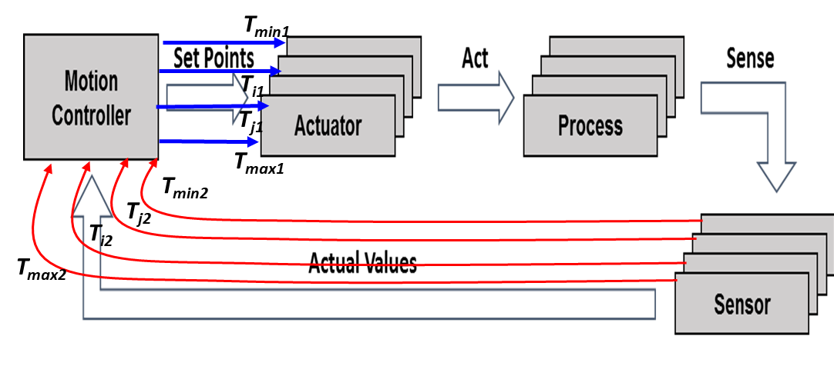

Figure 2 Motion Control system over 5GS

Taking one loop for example, when the coordination between Sensors is supported by 5GS, the T2 cannot be minimized or reduced to 0. The same way for T2 to be minimized or reduced to 0 when the coordination between Actuators is supported by 5GS.

So with coordination between multiple Sensors/Actuators, the Motion Control system can use less time for one loop, and can achieve higher efficiency/performance.

# Proposal

##### Capture following new use case into TR 22.847 0.2.0

## x.1 Multi-Modality– Motion Control

### x.1.1 Description

This paper describes one new tactile and multi-modality communication service use case, which introduces multiple UEs coordination in the Motion Control system over 5GS in order to achieve higher performance and efficiency.

In Current motion control system specified in TS 22.104, the multiple UEs (e.g., Sensors, or Actuators) are not coordinating with each other, even with highly time synchronization for each UE, due to e.g., the uncertainty of the waiting time for available slots for each UE, and the uncertainty of  transmission time difference for each UE when different flows are allocated for different routing path to the Controller, the E2E latency for each UE’s flow are variable, e.g., 3.5ms, 4ms, 4,3ms, 5ms, all within 5ms. But the current motion control system **cannot guarantee** all the flows of different UEs can take the same time consumption (e.g., 5ms) to arrive at the controller.

However with network assistance, e.g., based on the coordinated Policy, 5GS adjusts the resources, so that all the multi-modality UEs flows can be coordinated.

The Multi-modality Motion Control system shown in Figure3, which consists of:

* Multi-Modality Motion controller, to receive the Actual Values from Sensors, and determines and sends the next instructions for executors.
* Sensors, to monitor the executor’s movement and send the Actual values to Motion controller.
* Executors, to receive the instructions from Motion controller and process

### x.1.2 Pre-conditions

Sensor-1, Sensor-2, and Sensor -3 are 5G capable UEs that can monitor the performance of executors and sends the Actual values to Motion controller.

Executor-1, executor-2 and executor-3 are 5G capable UEs that can receive the instructions from Motion controller.

Multi-Modality Motion controller is outside of 3GPP

### x.1.3 Service Flows

1. 5GS and Multi-Modality Motion controller are exchanging the assistance information between each other, which including:
   1. *network capability* that network supporting multi-modality service from network to the Multi-Modality Motion controller; and
   2. the *policy* for the multi-modality Motion control system from controller to network, in order for network to identify the multiple transmission from multiple UEs that serving the same multi-modality motion control system, and adjust the network resources for multiple transmissions from multiple UEs that serving the same multi-modality motion control system, e.g., network performs adjustment on QoS, or schedule network resources if needed. .
2. Sensor-1, Sensor-2 and Sensor-3 are collecting the performance data of each corresponding executor-1, executor-2 and executor-3. And sending the monitoring information (Actual values) to Multi-Modality Motion controller.

5GS adjusts the resources for Sensor-1, Sensor-2 and Sensor-3, e.g., allocating dedicated RAN/CN resources for delivering the Actual Values based on the coordinated result (i.e., policy or configuration) between 5GS and Multi-Modality Motion controller

1. Multiple-Modality Motion controller determines and sends the next instructions to executors when receiving all the Actual Values from Sensors

5GS adjusts the resources for executor-1, executor -2 and executor -3, e.g., allocating dedicated RAN/CN resources for delivering the instructions, based on the coordinated result (i.e., policy or configuration) between 5GS and Multi-Modality Motion controller.

1. Executor-1, executor -2 and executor -3 are processing based on the instructions.

After the executors finish the process, repeat step 1-3.

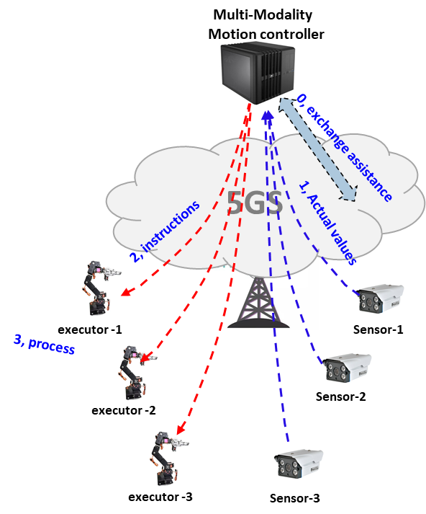

Figure 2 Multi-modality Motion control system over 5GS

### x.1.4 Post-conditions

Multiple-Modality Motion controller receives all the Actual Values from Sensor-1/2/3 at the same time

Executor-1/2/3 receive the instructions from Multiple-Modality Motion controller at the same time

### x.1.5 Existing features partly or fully covering the use case functionality

The exiting requirements and KPI for motion control are defined in the TS 22.104 as below, which UEs perform separately without coordination with each other.

**Table 5.2-1: Periodic deterministic communication service performance requirements**

| **Characteristic parameter** | | | | **Influence quantity** | | | | | |  |
| --- | --- | --- | --- | --- | --- | --- | --- | --- | --- | --- |
| **Communica­tion service availability: target value (note 1)** | **Communication service reliability: mean time between failures** | **End-to-end latency: maximum (note 2)** | **Service bit rate: user experienced data rate** | **Message size [byte]** | **Transfer interval: target value** | **Survival time** | **UE  speed** | **# of UEs** | **Service area  (note 3)** | **Remarks** |
| 99,999 % to 99,99999 % | ~ 10 years | < transfer interval value | – | 50 | 500 μs | 500 μs | ≤ 75 km/h | ≤ 20 | 50 m x 10 m x 10 m | Motion control (A.2.2.1) |
| 99,9999 % to 99,999999 % | ~ 10 years | < transfer interval value | – | 40 | 1 ms | 1 ms | ≤ 75 km/h | ≤ 50 | 50 m x 10 m x 10 m | Motion control (A.2.2.1) |
| 99,9999 % to 99,999999 % | ~ 10 years | < transfer interval value | – | 20 | 2 ms | 2 ms | ≤ 75 km/h | ≤ 100 | 50 m x 10 m x 10 m | Motion control (A.2.2.1) |
| 99,9999 % | – | < 5 ms | 1 kbit/s (steady state) 1,5 Mbit/s (fault case) | < 1500 | < 60 s  (steady state) ≥ 1 ms (fault case) | TBD | stationary | 20 | 30 km x 20 km | Electrical Distribution – Dis­tributed automated switch­ing for isolation and service restoration (A.4.4); (note 5) |

### x.1.6 Potential New Requirements needed to support the use case

[PR X.1.6 - 1] 5GS shall provide means to exchange assistance information with tactile and multi-modality communication service provider to:

* Identify 5GS capability to assist tactile and multi-modality communication service;
* Identify multiple UEs and multiple streams in one tactile and multi-modality communication service;

~~NOTE: Multi-modality service provider is out of scope of 3GPP.~~

NOTE: Multi-modality application server/controller is out of scope of 3GPP.

~~[PR X.1.6 - 2] Based on policy that coordinated between operator and service providers, the 5G system shall be able to support for coordinating multiple transmissions of multiple modality UEs associated with the same application~~.

[PR X.1.6 - 2] 5GS shall provide means to dynamically negotiate policy with tactile and multi-modality communication service provider for adjusting network resources for multiple streams from multiple UEs in one tactile and multi-modality communication service.[PR X.1.6 - 3] Based on the coordinated configuration~~/pre-configuration~~, the 5G system shall be able to identify the multiple streams from multiple UEs in one tactile and multi-modality communication service. [PR X.1.6 - 4] Based on the coordinated policy, ~~/pre-configurati~~, the 5G system shall be able to adjust the network resources for multiple transmissions from multiple UEs in one tactile and multi-modality communication service, e.g., network performs adjustment on QoS.

[PR X.1.6 - 5] The 5G system shall be able to provide Multi-Modality periodic deterministic communication with the service performance KPI in the following table:

|  |  |  |  |  |  |  |  |
| --- | --- | --- | --- | --- | --- | --- | --- |
|  |  |  |  |  |  |  |  |
|  |  |  |  |  |  |  |  |
|  |  |  |  |  |  |  |

Table X.1.6 multi-modality periodic deterministic communication service performance requirements

| **Characteristic parameter** | | | | **Influence quantity** | | | | | | |  | |
| --- | --- | --- | --- | --- | --- | --- | --- | --- | --- | --- | --- | --- |
| **Communica­tion service availability: target value** | **Communication service reliability: mean time between failures** | **End-to-end latency: maximum** | **Service bit rate: user experienced data rate** | **Message size [byte]** | **Transfer interval: target value** | **Survival time** | **Arriving time difference between multi-modality UEs** | **UE  speed** | **# of UEs** | **Service area** | **Remarks** |
| 99,999 % |  | <2ms |  |  | 2ms |  | 500us | ≤ 5 km/h | ≤ 50  NOTE1 | 50 m x 10 m x 10 m | Multi-modality Motion control |
| 99,999 % |  | <5ms |  |  | 5ms |  | 500us | ≤ 5 km/h | ≤ 50  NOTE1 |  | Multi-modality Motion control |

NOTE1: these UEs are working in one tactile and multi-modality communication service.