

have the pleasure of inviting you to 3GPP SA1#73 in Okinawa, Japan, from Monday 1 to Friday 5, February 2016

3GPPSA1#73 | 1-5 February 2016

3GPP SA1#73

Dear Delegates,

The Japanese Friends of 3GPP, Ericsson Japan, Fujitsu, Hitachi, Huawei Technologies Japan, KDDI, KYOCERA, MITSUBISHI ELECTRIC, NEC, Nokia Networks Japan, NTC, NTT DOCOMO, OKI, Panasonic, Qualcomm Japan, SHARP, SoftBank, and Sony Mobile Communications Japan have the pleasure of inviting you to the above-mentioned meeting.

The meeting will start on Monday at 9:00 and is expected to end on Friday at Chairman's discretion.

We look forward to seeing you all in Okinawa.

Yours sincerely,
"Japanese Friends of 3GPP"

Meeting Registration
Please register for the meeting online via 3GPP website.
SA1#73 https://portal.etsi.org/webapp/MeetingCalendar/MeetingDetails.asp?m_id=31722

Meeting Venue
Bankoku Shinryokan
1792 Kise, Nago-shi, Okinawa 905-0026, Japan
TEL: +81-980-53-3155

English Page: http://www.shinryokan.com/menuIndex.jsp?id=21545&menuid=6407&funcid=28
Access Page: http://www.shinryokan.com/detail.jsp?id=22317&menuid=6619&funcid=1

Meeting Rooms
 |  | Room
SA1#73 | Main | Ocean Hall
SA1#73 | Breakout | Sunset Lounge

Host Contacts
For any questions about the meeting, please contact our meeting coordinators.

ILCC Co., Ltd
Ms. Tomoko Sudo, Mr. Koji Sugawara
E-mail: jf3wgs_sec@ilcc.com Tel: +81-3-5562-3665

*New Year holidays in Japan start from 28 December and last till 4 January. Meeting coordinators may not be able to reply you in a timely manner during this period.

Access to Okinawa and to Bankoku Shinryokan
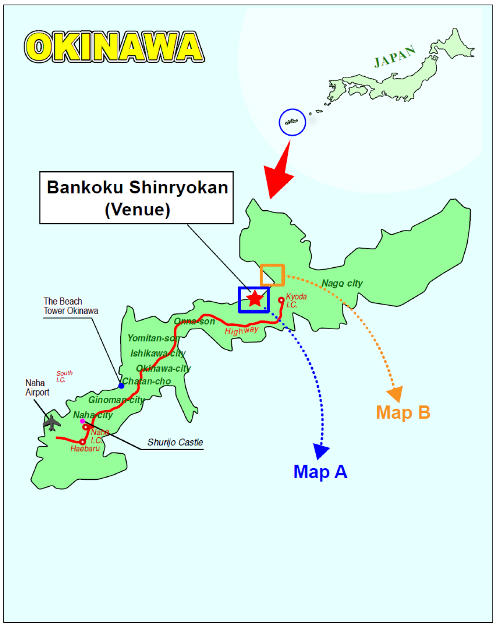

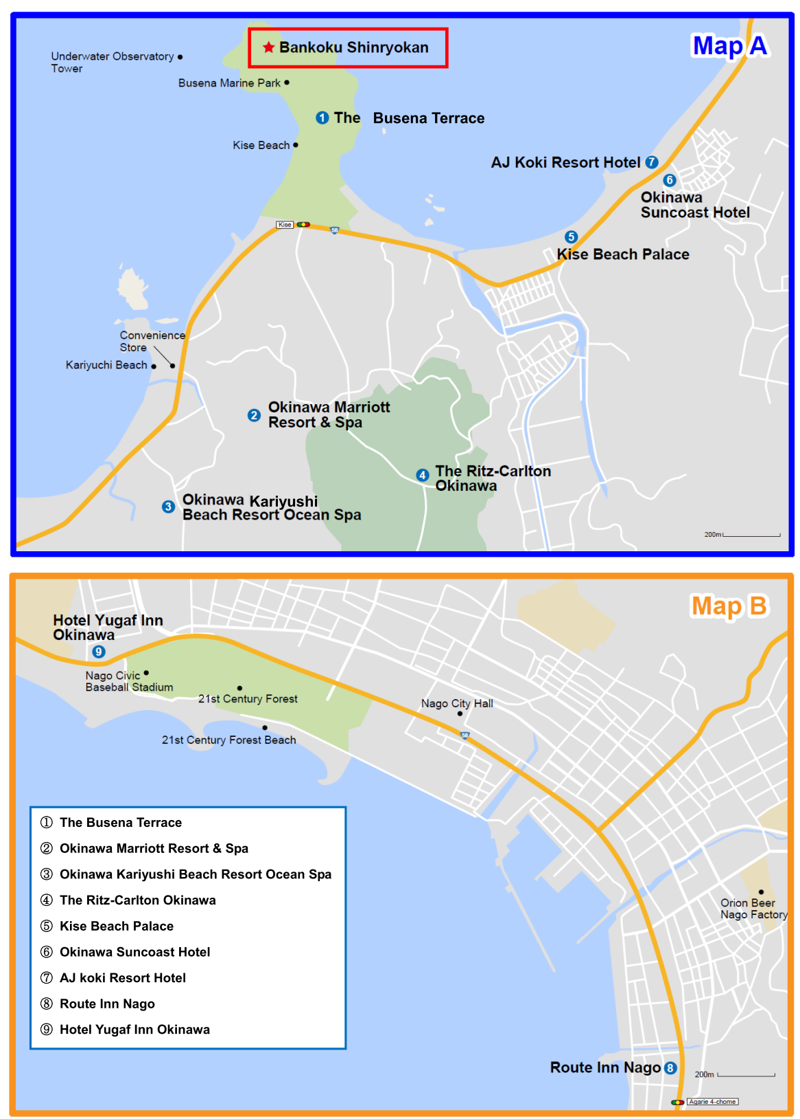

You can reserve hotels ①-③ through our official travel agent, JTB GMT.
Hotels ④-⑨ are listed for your reference. From hotels ⑧ and ⑨, you must take the local scheduled bus No.20 or No120 about 15minutes.To reserve these hotels, please contact them directly.

Transportation to the Venue
Bankoku Shinryokan (meeting venue) is located 60 kilometers (37.5 miles) away from Naha Airport. You can access to the venue by using following local transportations.

- Airport Limousine Bus (About 90 min., \2,000)
Please take a bus bound for Area D at the Naha Airport. Please get off at ‘The Busena Terrace’. It’s about 4 minutes’ walk to the venue.
http://okinawabus.com/en/ls/

Timetable from Airport to Hotels
Bus Line | Naha Airport  (domestic / international terminals) | Naha Bus Terminal (Downtown) | Kariyusi Beach Resort Ocean Spa | The Busena Terrace  Beach Resort | Okinawa Marriott Resort & Spa | The RITZ Carlton | Kise Beach Palace
Area D  (West Coast, North Onna & Nago) | 11:00/11:02 | 11:10 | 12:15 | 12:21 | 12:26 | 12:29 | 12:35
Area D  (West Coast, North Onna & Nago) | 12:30/12:32 | 12:40 | 13:45 | 13:51 | 13:56 | 13:59 | 14:05
Area D  (West Coast, North Onna & Nago) | 14:10/14:12 | 14:20 | 15:25 | 15:31 | 15:36 | 15:39 | 15:45
Area D  (West Coast, North Onna & Nago) | 15:45/15:47 | 15:55 | 17:00 | 17:06 | 17:11 | 17:14 | 17:20
Area D  (West Coast, North Onna & Nago) | 17:15/17:17 | 17:25 | 18:30 | 18:36 | 18:41 | 18:44 | 18:50

Timetable from Hotels to Airport
Bus Line | Kise Beach Palace | The RITZ Carlton | Okinawa Marriott Resort & Spa | The Busena Terrace | Kariyusi Beach Resort Ocean Spa | Naha Bus Terminal (Downtown) | Naha Airport  (domestic & international terminals)
Area D  (West Coast, North Onna & Nago) | 8:30 | 08:36 | 08:41 | 08:47 | 08:56 | 10:01 | 10:11/10:16
Area D  (West Coast, North Onna & Nago) | 10:00 | 10:06 | 10:11 | 10:17 | 10:26 | 11:31 | 11:41/11:46
Area D  (West Coast, North Onna & Nago) | 11:40 | 11:46 | 11:51 | 11:57 | 12:26 | 13:11 | 13:21/13:26
Area D  (West Coast, North Onna & Nago) | 13:15 | 13:21 | 13:26 | 13:32 | 13:41 | 14:46 | 14:56/15:01
Area D  (West Coast, North Onna & Nago) | 14:45 | 14:51 | 15:02 | 15:11 | 15:16 | 16:26 | 16:31

- Local Bus (120 - 150 min., \1,720)
It takes about 150 minutes from the airport. It is an inexpensive way to get to the venue.
Please take local bus No.20 or No.120, operated from Naha airport to Nago Bus Terminal, and get off at the ‘Busena Resort Mae’ Bus Stop. It’s about 15 minutes’ walk to the venue.
Buses run every 30 minute from morning to evening. Please note that there is no lavatory in the bus.
http://okinawabus.com/en/wp-content/uploads/sites/7/2014/02/20.120en.pdf

- Taxi (75min., about \16,000)
Taxi: If you prefer taking a taxi, it takes about 75 minutes by expressway or 90 minutes by local roads. The fare is about \16,000.

- Rental Car
If you would like to rent a car, there are many rental car companies near the Naha Airport.

FYI:
Hertz Naha Airport https://www.hertz.com/rentacar/location/OKAT50
OTS Rent-a-Car http://www.otsinternational.jp/otsrentacar/en/okinawa/

The Busena Terrace: Free parking service.
Okinawa Marriott Resort and Spa: \500 per car per night (\1,000 for more than 2 nights).
Okinawa Kariyusi Beach Resort Ocean Spa: \500 per car per night (\1,000 for more than 2 nights).
Please refer to below URL for information on direct flights from China, Taiwan, and Korea to Naha Airport.
http://www.naha-airport.co.jp/en/terminal/international/

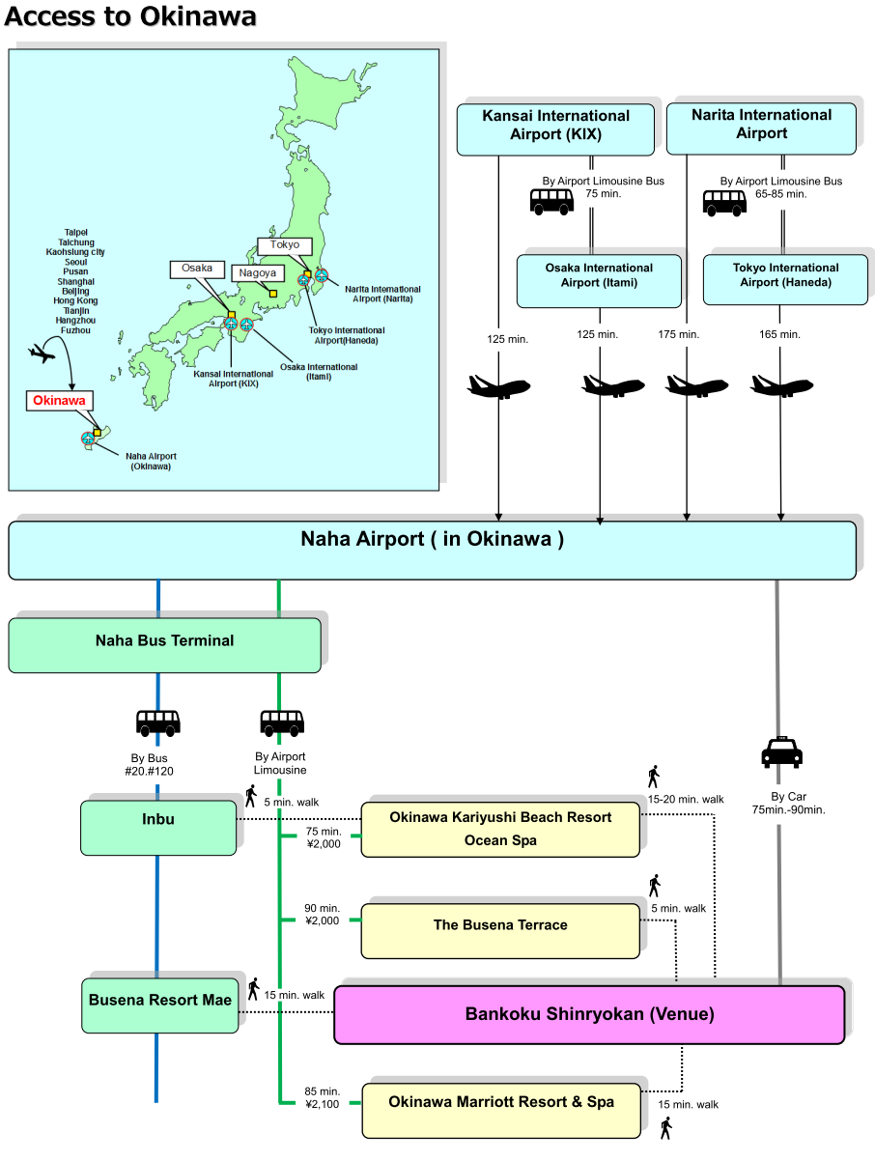

Accommodation

JTB Global Marketing & Travel Inc. (JTB GMT) has been appointed the official travel agent for the meeting and will handle accommodation.

Block bookings have been arranged at the following hotels for the meetings. Note that the ‘Japanese Friends of 3GPP (JF3)’ is not responsible for reservation confirmations, cancelled or changed reservations or no-shows.

No. | Hotel Name  (Check-in & out time) | Room Type | Rate per night  Single Occupancy (**) | 1) Address  2) Phone  3) Access to the airport  4) Access to the venue
1 | The Busena Terrace  (14:00/11:00)  Complimentary internet access (LAN/Wi-Fi)  (LAN cable provided) | Twin Room  (36 m²) | JPY29,700  (Except Jan. 31, Feb. 5 & 6) | 1) 1808 Kise, Nago, Okinawa 905-0026  2) +81-980-51-1333  3) 75 min from Naha Airport by car  4) 5 minutes’ walk to the venue
1 |  | Twin Room  (36 m²) | JPY27,540  (Jan. 31)
1 |  | Twin Room  (36 m²) | JPY32,400  (Feb. 5 & 6)
2 | Okinawa Marriott Resort & Spa  (14:00/11:00)  Complimentary internet access  (Wi-Fi) | Twin Room  (44.6 m²) | JPY19,440  (Except Feb. 5 & 6) | 1) 1490-1 Kise, Nago, Okinawa 905-0026  2) +81-980-51-1000  3) 70 min from Naha Airport by car  4) 15 minutes’ walk to the venue
2 |  | Twin Room  (44.6 m²) | JPY28,080  (Feb. 5 & 6)
3 | Okinawa Kariyusi Beach Resort Ocean Spa  (14:00/11:00)  Complimentary internet access  (Wi-Fi) | Twin Room  (30-42 m²) | JPY18,360  (Except Feb. 6) | 1) 2591-1 Ya-shibaru, Nakama, Onna, Okinawa 904-0401  2) +81-98-967-8731  3) 70 min from Naha Airport by car  4) 5 min by taxi or 15-20 minutes’ walk to the venue
3 |  | Twin Room  (30-42 m²) | JPY19,440  (Feb. 6)
Note: Room rates include breakfast, service charge and an 8% consumption tax.
*The above room rates are only applicable to reservations handled by JTB GMT. Please do NOT contact the hotels directly regarding your reservations and the above room rates – all enquiries and booking requests should be made directly to JTB GMT.
**Room rates for double occupancy are offered in the online reservation site below.

Online Reservation
Please access the URL below for online application operated by JTB Global Marketing & Travel Inc. (JTB GMT) to make your hotel reservations.

https://mice.jtbgmt.com/3gpp2016Feb

Application and Payment for Hotel
Participants wishing to reserve hotel accommodation should apply online no later than 12:00 (JST=UTC+9) 14 January, 2016.
Application should be accompanied by the details of your credit card to guarantee your reservation. No deposit will be charged to the credit card. Please pay all hotel expenses directly to the hotel. No reservation will be confirmed in the absence of your credit card details.

*Delegates are strongly advised to make their reservations as early as possible. Reservations will be accepted on a first-come, first-served basis.

Confirmation
Your reservation would be completed upon receipt of your credit card details.
The Confirmation button will be displayed when you complete your reservation.
Please print your confirmation slip by clicking the Confirmation button and bring it with you to the reception desk upon checking-in at the hotel.

Cancellation
In the event of cancellation, the following cancellation fees will be deducted before any refund is made.
Up to 10 days before the first night of stay -------------------------------------------------- None
9 to 4 days before ------------------------------------------------------ 20% of daily room charge
3 to 2 days before ------------------------------------------------------ 50% of daily room charge
1 day before---------------------------------------------------------------80% of daily room charge
On the day of arrival or no notice given ------------------------- 100% of daily room charge
*Please revise and/or cancel your reservation by logging in to your Personal Page.

Inquiry Desk for Online Hotel Reservation
JTB Global Marketing & Travel Inc.
Convention Center (CR146986-042) Fax: +81-3-5495-0685
2-3-11 Higashi-Shinagawa, Shinagawa-ku, Phone: +81-3-5796-5445
Tokyo 140-8604 Japan E-mail: 3gpp2016Feb@gmt.jtb.jp
Office hours: 10:00 – 17:30
Except Saturdays, Sundays and National Holidays
*New Year holidays in Japan start from 28 December and last till 4 January.

Visa Request
To find out whether you need a visa for entry to Japan, please consult http://www.mofa.go.jp/j_info/visit/visa/faq.html#q1-1 and click the link "the List of Countries and Regions That Have Visa Exemption Arrangements with Japan" in the Q&A No.1. The list shows "Arrangements of Exemption of Visas". If your home country’s name is not shown on the list, you need a visa.

If you need a visa, please fill out the attached invitation letter request form (Annex 1) and send it to visa1@ttc.or.jp by 12:00 (JST=UTC+9), 18 December 2015.

For any questions, please contact visa1@ttc.or.jp (attn. Mobile WGs secretary in TTC)].
For members in a company who are in the same office facility, it is suggested that you make your requests as a group, if possible.

If you prefer, you can obtain a public key for e-mail encryption simply by sending an e-mail to visa1@ttc.or.jp with the subject "Public Key request" BEFORE sending your personal information in an attachment.

WLAN
Wireless LAN (802.11 g/b) is available in the meeting rooms.

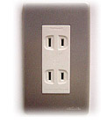
Voltage
100V/60Hz. Japanese plugs are two flat pin type (A-type) plugs. Please make sure you have correct adapters. Voltage converters or adapters will NOT be provided at the meetings.
Please bring your voltage converters and plug adapters! (100 volts/60hertz)

Currency
Yen (\) http://finance.yahoo.com/currency?u
ATTENTION!!
Credit cards can be taken at hotels in Okinawa, but not at some restaurants, taxis, and small shops.

ATM cash advance service in Naha (Okinawa) Airport
http://www.naha-airport.co.jp/en/image/international_floorguide02.pdf

Time Zone
JST=UTC +9 hours

GSM / W-CDMA/LTE coverage
Only W-CDMA and/or LTE are available. For availability of GSM chip-roaming, please check with your operator. cdma2000 and/or LTE are also available in the area.

Weather
http://www.jma.go.jp/en/yoho/353.html

Sightseeing
Japan National Tourism Organization : http://www.jnto.go.jp/eng/
Okinawa Travel Guide : http://www.okinawa-information.com/
- The meeting venue is located in Nago. Motobu and Onna are suitable destinations for short trip from the meeting venue.
(ANNEX 1)
Visa support letter application form

Please fill in the form below and e-mail it to visa1@ttc.or.jp by 12:00 (JST=UTC+9), 18 December 2015.
(Note: you can obtain a public key for e-mail encryption simply by sending an e-mail to visa1@ttc.or.jp with the subject "Public Key request" BEFORE sending your personal information in an attachment.)

Given name (First name) | alphabetical
Given name (Last name) | alphabetical
Date of Birth (dd/mm/yy)
Gender (Male/Female)
Nationality
Valid passport number
Passport Valid until (dd/mm/yy)
Address (Home Country)
Occupation and Job title
Name of Company/Organization
Company/Organization mailing address |  | Address
 |  | Postal Code
 |  | Country
Telephone number |  |  | +
Fax number |  |  | +
Email address
Schedule for your stay |  |  | Please fill in your itinerary below

Itinerary (refer to examples shown in the table.)
D/M/Y | Schedule | Address and Phone number to reach | Hotel
ex) 31/ January/ 2016 | Arrival from Paris to Naha Airport, Flight xxx | *1 | *1
ex) 1-5/ February/ 2016 | Attending SA1#73 meeting | *1 | *1
ex) 6/ February / 2016 | Departure from Naha Airport to Paris, Flight xxx
Fill in your Itinerary below
*1 The Busena Terrace Beach Resort :
Address : 1808 Kise, Nago, Okinawa 905-0026 Japan
Phone : +81 980 51 1333
Fax : +81 980 51 1331

