3GPP TSG-SA WG1 Meeting #64 S1-135051
San Francisco, USA, 11thNov – 15th Nov, 2013

Title: CSIPTO Always-on Dual PDN Connection
Agenda Item: 9.4 FS_CSIPTO: Co-ordinated P-GW change for CSIPTO (SP 130417)
Source: Samsung Electronics, Intel, NEC, Acer, ITRI
Contact: Alper Yegin (alper.yegin@partner.samsung.com)

Introduction
This contribution proposes a use case for study in FS_CSIPTO

Proposal
It is proposed to add the following to TR 22.828 (FS_CSIPTO)

4.X CSIPTO Always-on Dual PDN Connection Use Case

4.X.1 Description

There is a trade-off between data-path optimization and IP address preservation (a.k.a. IP session continuity) when it comes to using SIPTO at the Local Network (LN). Using SIPTO at LN provides a more direct data-path between the UE and its communicating Remote Ends compared to using a PGW in the core network. On the other hand, UE handovers are more likely to break the IP sessions as the UE may end up changing IP subnets when changing LGW with SIPTO at LN.
The choice between data-path optimization and IP address preservation depends on the applications. Certain applications prefer data-path optimization because either their flows are short-lived and they do not need any IP address preservation (e.g., DNS lookups), or they handle session continuity at a higher layer (e.g., Instant Messengers). Certain other applications prefer IP address preservation because an IP session break yields unacceptable user experience (e.g., live video streaming).
When the UE establishes a single PDN connection for a given PDN, it runs the risk of causing suboptimal results and/or disruption for its running applications. If the PDN connection is established with a PGW in the core network, it causes unnecessary transmission delay and core network load for the applications that are not in need of IP address preservation. On the other hand, if the PDN connection is established with an LGW, this causes disruption for the applications that require IP address preservation when the UE changes LGW.
This contribution suggests a use case for establishing both types of PDN connections by default (when an LGW is available) and performing PDN connection selection on a per-application/flow basis.

4.X.2 Pre-conditions
Operator X has deployed SIPTO at the LN in its network.
LGW may be available to the UE depending on the location of the UE.

4.X.3 Service Flows

UE establishes two PDN connections for the same PDN when an LGW is available – one connection with the LGW in the LN, another connection with the PGW in the core network.
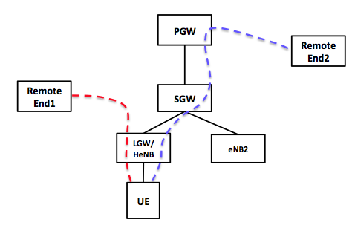
Figure 4.x.3-1: Dual PDN Connection.

When an application that does not require IP address preservation attempts to establish an IP flow (e.g., an Instant Messenger session), then the UE binds that flow to the PDN connection with the LGW (see the dashed red line in Figure 4.x.3-1). Consequently, the traffic flow enjoys the shortest data-path between the UE and its communication peer (Remote End1) without having to go through the core network.
If the UE attaches to another eNB where serving LGW is not available but a new LGW is available, then the previously established local PDN connection is terminated and another local PDN connection is established with the new LGW. The new PDN connection is likely to have an IP address different than the previous one. Given that the application bound to the PDN connection with the previous LGW did not require IP address preservation, the change of IP address would not constitute a problem for that application.
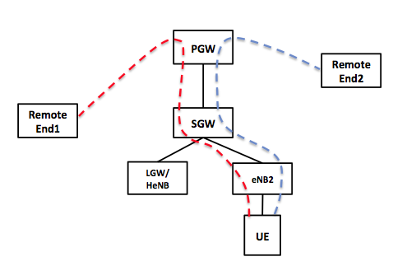
Figure 4.x.3-2: Falling Back to Single PDN Connection in the Absence of an LGW.

If the UE attaches to an eNB where there is no LGW available (e.g., eNB2 in Figure 4.x.3-2), then the local PDN connection is removed and not replaced by another one. Instead, the UE is left with a single PDN connection with the PGW. Applications that have been using the local PDN connections before can now start using the only available PDN connection (which is the one via the PGW in the core network).
When an application that requires IP address preservation attempts to establish an IP flow (e.g., a live video streaming session with Remote End2), then the UE binds that flow to the PDN connection with the PGW in core network (see the dashed blue line in Figure 4.x.3-1). Such applications and their flows are not affected by presence/absence/change of any local PDN connection with the LGWs.

4.X.4 Post-conditions

The network was able to improve network efficiency by selectively utilizing SIPTO at the LN without penalizing flows that required IP address preservation.

4.X.5 Potential Requirements

The requirements derived from this use case are:
- In presence of established PDN connection that supports IP address preservation, the system shall be able to establish an additional PDN connection for the same service type that does not support IP address preservation, when this is possible.
- The system shall be able to bind a flow to the PDN connection with no IP address preservation, if such a PDN connection is available and the flow does not require IP address preservation.
- The system shall be able to bind a flow to the PDN connection with IP address preservation, if the flow requires IP address preservation or that PDN connection is the only available one at that time.

4.X.6 Potential Impacts or Interactions with Existing Services/ Features

This scenario requires ability to establish and simultaneously use two PDN connections with the same PDN (i.e., using the same APN). This is the basic impact of CSIPTO feature on the 3GPP system.
The IP stack on the UE shall be able to bind each UE-initiated flow to one of the two PDN connections. The determination of the target PDN connection is outside the scope of this contribution.

