3GPP TSG-SA WG1 Meeting #109 S1-250xxx
Athens, Greece, 17 – 21 Feb 2025 (revision of S1-250021)

Source: vivo, China Mobile, China Unicom
pCR Title: Update Use case on end-to-end energy efficiency improvement for the network and UE
Draft Spec: 3GPP TR 22.870
Agenda item: 8.1.1(FS_6G-REQ)
Document for: Approval
Contact: Yanchao Kang, kangyanchao@vivo.com
Zhuoyun Zhang, zhangzhuoyun@vivo.com;
Hank Yu, yuhang.txyjy@vivo.com

Abstract: This pCR proposes to update clause 5.5 use case on end-to-end energy efficiency improvement for the network and UE.
1. Introduction
This contribution proposes to update clause 5.5 use case on end-to-end energy efficiency improvement for the network and UE.
2. Reason for Change
a. Energy efficiency improvement service could be provided by the operators to the subscribers. In order to make it more clear to the subcribers, it is proposed to change the service name to UE energy saving service. The definition of the UE energy saving service is also added in clause 3.1. The related reuqirement [PR-5.5.6-5] is added.
b. As decribed in clause 5.5.1, energy efficiency shall be a quantifiable metric of sustainability and is important for the success of IMT-2030 technology. The energy efficiency KPIs are important and helpful to both the operators and the subscribers. It is proposed to add [PR-5.5.6-2] and [PR-5.5.6-3] to reflect the requirements.
c. In fact, the majority of energy consumption in a communication network comes from radio access network, and the radio conditions would affect the energy consumption of the UE for the same amount of data volume transmission. So in order to improve the accuracy of the energy consumption caculation, it is proposed to consider the RAN energy consumpion on a per UE basis based on the radio resource usage (e.g., Physical Resource Block (PRB) usage). A new [PR-5.5.6-4] is added to reflect the requirement.
3. Conclusions
None.
4. Proposal
It is proposed to agree the following update to clause 5.5 of 3GPP TR 22.870 for FS_6G-REQ.

* * * First Change * * * *

3.1 Terms
For the purposes of the present document, the terms given in 3GPP TR 21.905 [1] and the following apply. A term defined in the present document takes precedence over the definition of the same term, if any, in 3GPP TR 21.905 [1].
example: text used to clarify abstract rules by applying them literally.

UE energy saving service: a service provided by 6G network to 6G users, utilizing the resources in 6G network (e.g., communication resources), with mechanisms to guarantee the quality of the service (e.g., data rate, latency) and to extend the period of the UE getting the 6G services (e.g. minimize the UE power consumption for getting the 6G services).
NOTE x1: certain UE energy saving service is related to certain subscription and corresponding to certain charging policy.

* * * Second Change * * * *

5.6.1 Use case on end-to-end energy efficiency improvement for the network and UE

5.6.1.1 Description
In the ITU-R Recommendation "Framework and overall objectives of the future development of IMT for 2030 and beyond" [39], sustainability is considered as the design principles commonly applicable to all usage scenarios. Supporting end-to-end energy efficiency is an important design target for the sustainability of 6G system.
Regards to end-to-end energy efficiency of 6G system, UE energy efficiency is an important part. Power consumption of modem (including both baseband and RF) has contributed more and more to total UE power consumption due to the large number of power consuming features supported, e.g. AI and computing as well as the strong demand of high data volume transmission. Energy efficiency design for UE could further extend UE battery life while guaranteeing certain service quality. In the 6G system, it is expected that the network could assist the UE to improve energy efficiency as one of the services, e.g. UE could subscribe to energy efficiency services to realize power saving based on network assistance. The network could apply energy saving technologies to improve the UE energy efficiency.
The UE could also assist the network to improve the system energy efficiency to further reduce operation cost for mobile operators. The UE could also support certain mechanisms to help the network to reduce network energy consumption or improve the energy efficiency. So, the UE and network could mutually benefit from the coordination for energy efficiency improvement.
Considering the above, the energy efficiency and energy saving should consider the end-to-end performance including both the network and the UE. Considering the sustainability target of the 6G system, it should greatly improve the end-to-end energy efficiency compared to the 5G system.
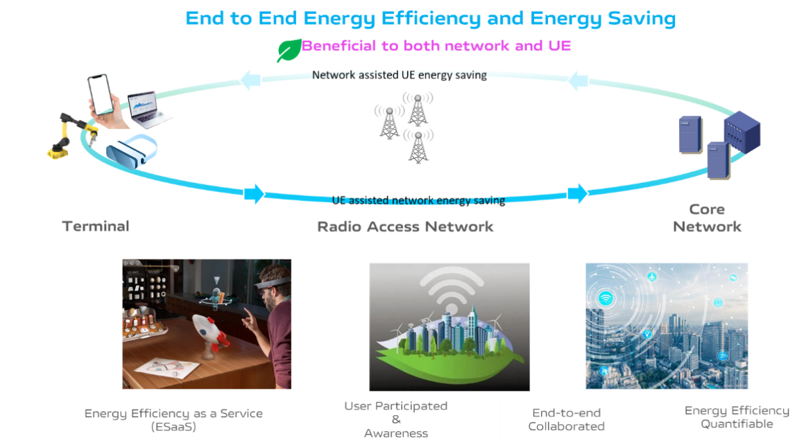
Figure 5.6.1.1-1: Supporting end-to-end energy efficiency and energy saving
Energy efficiency shall be a quantifiable metric of sustainability and is important for the success of IMT-2030 technology. The energy efficiency KPIs should be defined to ensure that IMT-2030 is designed in an energy efficient way. From the operator's point of view, the KPIs help the operator to decide how much the network energy efficiency is improved by applying a specific energy-saving technology. It is also important for the network to obtain the UE energy efficiency. Then, based on the quantified energy efficiency KPIs, the network could provide energy saving services for the subscribers. From the subscriber's point of view, the energy efficiency KPIs clearly show that the energy saving services are important for them to reduce the power consumption for the data transmission, so they are more willing to subscribe to the services from the network. This would also be a new business model for the operators. In general, the energy efficiency KPIs are important and helpful to both the operators and the subscribers.
Energy efficiency should be defined taking into account both communication performance metric and energy consumption. According to the GSMA study [3] and TR 32.972 [4], several measurements means for energy efficiency are proposed by considering the energy consumption and the data transmission. Communication related performance (e.g. data volume, latency, data rate, etc.) of data transmission should be considered for the energy efficiency measurements. For example, energy saving by reducing the data rate cannot always satisfy the subscribers' requirements. It is also important for the network to realize energy saving with guaranteed QoS.
Regarding end-to-end energy efficiency, the energy related information collection from radio access network, e.g. at per UE, or per application granularity, should also be considered. In fact, the majority of energy consumption in a communication network comes from radio access network. Furthermore, radio conditions would affect the energy consumption of the UE for the same amount of data volume transmission. For example, the UE location in the Cell affects the energy consumption, e.g. the UE located at the cell edge consumes more energy compared to the one located at the cell centre for the same amount of data volume transmission. Therefore, it is more accurate for the 6G network to calculate the RAN energy consumption on a per UE basis based on the radio resource usage (e.g., Physical Resource Block (PRB) usage), comparing to the calculation based on the data volume. The accurate RAN energy consumption on a per UE basis based on radio resource usage helps the network to make better policy control to reduce the network energy consumption.
Considering the energy efficiency at the UE, it is closely related with the user experience. Based on different technologies in the 6G network to improve the energy efficiency, the operator could offer different energy saving services to the subscribers. Based on UE's preference or subscription, the network may apply certain power saving technology to improve energy efficiency at the UE to satisfy the user's requirement on energy efficiency. The operators could charge the users for subscribing the service. This energy saving service for the subscribers is also a new business model for the operators in 6G system. The new business model is also the driven for the 6G system deployment. The energy saving service would further benefit the operators and subscribers to achieve the energy efficiency target in the 6G system.

5.6.1.2 Pre-conditions
The operator has offered a series of energy saving services in the 6G network for the UE to save energy and extend the battery life. Different energy saving services may be provided to the subscribers at different prices or incentives. The subscribers may order certain energy saving services.
For example, the operator A may offer the following two kinds of energy saving services:
- Energy saving service A: Improving the energy efficiency by reducing UE energy consumption while maintaining the service experience (e.g. low latency, high throughput). Energy saving service A will improve the UE energy efficiency by extending the UE battery life (e.g. the UE battery life is extended from two hours to four hours.) without compromising the quality of use service experience. The network will evaluate the service performance based on the quantified UE energy efficiency KPI. Please note that this service comes with a higher fee.
- Energy saving service B: Improving the energy efficiency by reducing UE energy consumption for essential service access, e.g. voice call only. The essential service list is based on the agreement between the subscriber and operator. Energy saving service B will extend the UE battery life with limited communication service. Please note that this option comes with a reasonable fee.
Bob buys a pair of AR glasses and wants to wear it to access AR content during the trip. Normally, the battery of his AR glasses can last for two hours. Since it is not possible to charge the AR glasses during the trip, he orders the energy saving service A for the glasses from the operator. While Tom travels with Bob and also has a pair of AR glasses which can last for two hours too. However, Tom hasn’t ordered the energy saving service A for his AR glasses.
Bob also has a cell phone. Sometimes his cell phone is about to run out of battery, but he does not want to miss some important calls, or still wants to access certain applications (e.g. navigation map application). He prefers the network to provide network access for essential services (e.g. voice call) for his cell phone in order to improve the energy efficiency and extend the battery life. So, he orders the energy saving service B from the operator and provides his preference on the essential service list for his cell phone.

5.6.1.3 Service Flows
1. When visiting the pyramids, Bob wears his AR glasses to access specific AR tour guide information. Usually, the battery of his AR glasses can last for two hours. Considering that the tour might last for four hours, in order to save power for this AR glasses, Bob indicates to the network to apply energy saving service A to minimize the power consumption of the AR glasses while ensuring the specific QoS. Based on the indication, the network applies energy saving service A for Bob's AR glasses.
2. After the long trip, Bob needs to take the bus to go back home. It takes nearly one hour. He finds that the battery of his cell phone is below 10% and he cannot charge his cell phone on the bus. So he indicates to the network to apply energy saving service B for his cell phone. Based on the indication, the network applies energy saving service B for Bob's cell phone. The network only provides limited network access to the essential services (e.g. voice call) as predefined by Bob in order to reduce the UE energy consumption.

5.6.1.4 Post-conditions
During the visit to the pyramids, Bob is able to watch AR tour guide information with his AR glasses with good service experience. The AR glasses is used for four hours with good service experience due to the energy saving service A. However, Tom’s AR glasses are only used for two hours during the trip, because he doesn’t order the energy saving service for his glasses.
During the trip back home, due to energy saving service B, although the battery of Bob’s cell phone is below 10%, it could still access the basic services (e.g. voice call) for nearly one hour.

5.6.1.5 Existing features partly or fully covering the use case functionality
The energy efficiency requirements for 5G system have been defined in clauses 6.15 and 6.15a of TS 22.261 [14], including the general requirements, requirements for energy related information as service criteria, requirements for energy states, requirements for monitoring and measurement, requirements for information exposure, requirements for network actions leveraging energy efficiency as service criteria.
The study on Energy Efficiency as service criteria Phase 2 is under study in SA1 R20. The related use cases and requirements to the 5G system are introduced in TR 22.883 [44].
Some of the procedures and network functions proposed in TR 23.700-66 [5] can be used to realize part of the 5G requirements and service flows described in TS 22.261 [14].
The 6G system requirements on the energy efficiency and energy saving are based on the existing requirements in the 5G.

5.6.1.6 Potential New Requirements needed to support the use case
[PR 5.6.1.6-1] The 6G system shall improve energy efficiency of 6G system compared to 5G system.
[PR 5.6.1.6-2] The 6G system shall be able to provide mechanisms to support measurable and quantifiable energy efficiency information.
NOTE: Energy efficiency is related with the communication performance (e.g., data volume, latency, data rate, etc.) and energy consumption.
[PR 5.6.1.6-3] The 6G system shall be able to provide mechanisms to support measurable and quantifiable energy efficiency on a per UE basis.
[PR 5.6.1.6-4] The 6G system shall support mechanism to improve the calculation accuracy of the network energy consumption on a per UE basis, e.g., considering the radio resource usage.
[PR 5.6.1.6-5] The 6G network shall be able to provide the UE energy saving services to the subscribers.
* * * End of Change * * * *

